Regional Colour coded (Level C) incorporating Essex & Suffolk Schools League (ESSOL) – final details. Highwoods Country Park, Colchester - Sunday 28th January 2024
Courses:  General guidance: | Colour coded from White to Blue. SI electronic punching will be used, with SIAC enabled. Courses are suitable for all levels of ability and experience - ask for advice if you are unsure which is the right course for you. Course details:  Course No. Controls Course Length Climb  White 12 1.5 km 45 m  Yellow 12 2.7 km 90 m  Orange 14 3.1 km 70 m  Light Green 13 3.3 km 70 m  Short Green 14 3.5 km 75 m  Green 18 5.1 km 80 m  Blue 27 7.2 km 90 m  The wood is open to the public and there will be runners, walkers, cyclists, dogs and other users, especially on the paths and tracks. Parents & teachers should consider this before allowing their children to participate unsupervised in the event. Please give other users plenty of room when passing.  Children under 11 should only be permitted to run alone if they have successfully completed orienteering events in the past and their parents/ teachers consider them to be competent to navigate at the chosen level. Parents & teachers must explain to their children what they should do in the event of becoming disorientated. All competitors are asked to be aware of children that may be lost and assist them if necessary.  Please ensure that your clothing and footwear is appropriate for the time of year, terrain and anticipated weather conditions. All courses (especially white) are likely to experience areas that are very muddy. Full leg cover and carrying a whistle are strongly advised. In the event of particularly inclement weather, wearing a jacket may also be necessary. A compass must be carried by each junior competing as an individual or at least one compass between a pair of competitors. They will be asked to show it to the volunteers at the start prior to departing.  BOF rules permit mobile phones to be carried for emergency use and all competitors (including children) are encouraged to carry them, although the phones remain the responsibility of the owner. Parents of younger children are encouraged to install tracking software so that they can monitor their children’s location remotely. If competitors are found to be using phones for navigation, their run will become non-competitive.  A detailed risk assessment has been completed by the organiser, but you must consider your own and your children’s abilities prior to undertaking this adventurous activity, as orienteering can result in injuries and you are responsible for your own safety.
Location: | Parking at Tesco Extra, Highwoods, Colchester, CO4 9ED  Google link  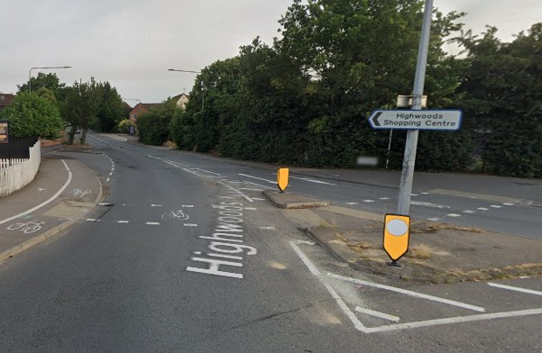  Grid Ref: TM 009 274  W3W ///crate.sprint.panic  The Tesco store is signposted from the junction of the A1232 (Ipswich Road) and Highwoods Approach at The Rovers Tye pub as shown on the photo (right). Orienteering signage will not be installed.  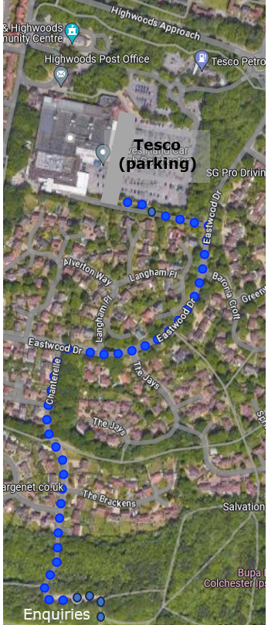  Free parking is available for up to 3 hours at the Tesco store and has been agreed by the store manager. There is a £70 penalty for exceeding this duration. If you cannot avoid being longer than 3 hours you can register your car beforehand inside the store at the Customer Services Counter. Please park at the far end (south side) of the car park. For those arriving before 11:15, there will be a marshal to direct you towards the start.  Parking for vehicles larger than a mini-bus would be difficult, so please contact the organiser if you are bringing a coach or other large vehicle.  The walk from Tesco to the Enquiries Point is about 1km and should take less than 15 minutes. Car keys can be left at the Enquiries Point.  The Enquiries Point (and Download) will be located just south of Chanterelle car park. Chanterelle car park will not be available for parking by competitors.  Public transport should be available via Colchester North railway station, then the number 8 bus.  To Enquiries and Start, please follow the route along Eastwood Drive and Chanterelle shown on the map. This route will be marked with tape, fixed to street furniture, trees etc.  The start will be just south of Chanterelle car park.
Maps: | Maps have been updated by Chris Childs & Kevin Machin for the event.  1:10,000, 5m contours for Blue, Green, Short Green, Light Green and Orange courses.  1:7,500, 5m contours for Yellow & White courses.  Maps will be printed on waterproof paper, with control descriptions both printed on the map and as separate loose descriptions.  All courses will use a single sided map.  The various Out of Bounds areas must be respected to ensure continued use of the woods.  The phone number of the organiser/planner will be printed on the map, for use in the event of an emergency.  A previous O map of Highwoods Country Park and routes can be found on Routegadget.
Entry /  Times: | Online registration will be via RaceSignUp. Late entries (after 25th Jan) may be available, but will be subject to map availability and increased entry fees. Online entries close at 12:00 on 27th Jan and there will be no entry on the day.  Please contact the organiser in advance of the entry deadline if you are bringing a large number of competitors or a school/youth group.  The Enquiries Point will be open from 10:00. Starts will be between 10.30 and 12.30 and will not be pre-allocated. ESSOL competitors from the same school (that are not running as a group) must leave 4 minutes between each start. Less experienced and slower competitors should consider starting their course as early as possible within the start window.  Courses close at 14:30. You must report to download even if you retire to ensure all participants are accounted for. Download will be located close to the Enquiries Point.  Members of SOS who are prepared to assist with the event should contact the organiser prior to entering the event on RaceSignUp.
Fees: | Level C event  From 9th December:  Members of British Orienteering  Senior: £8.00  Junior/Student: £3.00 (Juniors are under 21 on race day)  Late entries (from 26th Jan & subject to availability of maps):  Members of British Orienteering  Senior: £10.00  Junior/Student: £4.00 (Juniors are under 21 on race day)  Unaffiliated runners £2 surcharge Seniors, £1.00 surcharge Juniors  SI card (dibber) hire £1. Hired dibbers will be available for collection from the Enquiries Point. Please note a charge of £30 will be levied if a hired SI card is lost. SIACs are not available for hire.  If you need to make a payment at the event, only cash can be accepted and there will be a very limited amount of change available, so please try to bring the correct amount.  The event has been subsidised by a grant from Active Essex. It would be appreciated if any participants with an Essex postcode could complete their questionnaire, linked here, choosing “orienteering” in the second drop down box.
Medical: | First Aid facilities will be available at the Enquiries Point.  There are defibrillators at the Tesco store, in the Visitor Centre and at the start.  If you have a medical condition that we need to know about please download, print, and complete a medical form. Place the form in a sealed envelope with associated medicine, and write your name clearly on the outside. Prior to commencing the event, hand this to the Enquiries Point in the assembly area where the First Aiders will keep it in confidence. It can be collected unopened at the end of the event. Medical forms can be downloaded using this link.  Please do not attend this event if you are showing any signs or symptoms of COVID.
Facilities: | Guidance for beginners will be available from the Enquiries Point. Members of the club won’t be available to shadow children around courses, this will remain the responsibility of parents & teachers.  There is a café at the Tesco store and at the Visitor Centre in the car park off Turner Road. Drinking water will not be provided as part of the event.  Toilets are available in the Tesco store from 10:00 and competitors are encouraged to use them, as portable toilets will not be available at Chanterelles car park. Please do not use the woods.  Bags can be left at the Enquiries Point; the start will be approximately 80 metres away.
Misc: | SIAC will be enabled, but with a punching start and finish for all competitors.  It will be necessary to cross roads when travelling between the Tesco car park and the assembly area. Those aged under 16 should be accompanied by an adult when making this journey.  Should you be bringing a dog, please note Colchester CC’s rules, including the requirement to use a lead whilst in Chanterelle’s car park.  Essex Stragglers are grateful for Colchester City Council’s permission to use the area.
Officials: | Organiser – Marc Owen (m_d_owen@hotmail.com)  Planner – Chris Childs (SOS)  Controller - Mike Bickle (WAOC)  Document dated 20th Jan 2024. Version 9.

