 | Essex Stragglers Orienteering Society (SOS) |   accredited

Newsletter Volume 20 Number 11

November 2008
Editors: Geraldine Russell and Andrew Cordle - editors@stragglers.info
Club website - http://stragglers.info

Editorial - Andrew Cordle 2
Chairman's Chat - Martin Sellens 3
Captain's Corner - Jenny Collyer 4
Schools League Report - Julie Laver 6
Stragglers' League - Andrew Cordle 6
SOS Notice board 7
Situations Vacant - Andrew Cordle 7
Permanent Course Officer Update - John Collyer 8
Chair’s Annual Report 2007-8 - Martin Sellens 9
Minutes of the Annual General Meeting - Clive Tant 10
Fixtures in East Anglia and Nearby Regions 14
Emails to the Editors 16
"Yet another newsletter" 16
Discounts 16
Heard at the Karrimor Mountain Marathon? 16
A New Way to explore Hanningfield Reservoir - Becky Gibson 17
The Original Mountain Marathon - Martin Sellens 18
Queuriosity - Jack Isbester 19
Frantic 'O' - Julie Laver 19
Some Essex Bunroes - Derek Keeble 20
Frequently Asked Questions - about the Cows! - Joan Pinch 21
British Schools Score Championships 2008 - Dave Birkett 23

Photographs by Essex Wildlife Trust, Geraldine Russell, Jack Isbester, Dave Birkett, Andrew Cordle, Joan Pinch and MBC.

  Essex Stragglers support the Woodland Trust and its objectives |   Essex Stragglers' development activities are supported by Awards For all


Essex Stragglers will be hosting the 2009 British Schools Score Championships - See Dave Birkett's article

Editorial - Andrew Cordle
Welcome to our annual bumper Christmas Edition. Thanks to everyone who has contributed. Could I ask a few favours of future contributors?
1 - Please try to submit your work early (i.e. within a few days of the "deadline"). It takes many hours to prepare the Newsletter, and my plans for early/semi- retirement are not going well so I may not have much free time between the "deadline" and publication.
2 - Please send pictures as pictures - if you put them in a Word document I have to take them out again, which is tedious and can lead to a loss of quality.
3 - Please tell me who or what the pictures are of. Preferably rename the images to something meaningful.
4 - If you send material which is not your copyright, either get permission to use it or give me the information I need to get permission AND time enough to do it. But don't not send anything if you think this is too difficult - we may not need permission anyway.
Sorry about the rant, but the Newsletter is due to be compiled, edited, printed, collated and addressed in the next 38 hours, and I would rather be doing something else an a Friday Evening.
To leave on a more positive note, I quite enjoy putting the Newsletter together. I'm still glad there is only four more to do before the position is rotated, though!

Chairman's Chat - Martin Sellens
Hullo. It’s me again. The AGM on 3rd October brought no Obama-style new direction at the helm, so here’s to more of the same for another year. However, all is not lost. The Byzantine process of Stragglers democracy did produce a re-shuffled team and one or two new faces. So, adieu to the treasury for Hilary Sellens who now takes over from Julia Robertson as Equipment Officer, and farewell to Clive Tant who relinquished the post of Secretary to concentrate on the day job and to Lyn West who bowed out of the role of Publicity Officer. Many thanks to these stalwarts of the club’s administration for their largely unsung contributions over the past few years. At least a succession was established for the position of Chair. Jack Isbester was coerced into taking on the Vice Chair position with responsibility for working behind the scenes to ensure a new face, not necessarily his, to take over as Chair in 2009. Another new face with a long history of service to the Club joined the Committee as Secretary - welcome back to Derek Keeble, one of our founding fathers, without whose efforts the club would have been still- born in the late 1960s. When I first joined the Stragglers in about 1982 Derek’s name was on virtually all our maps and he seemed to organise most of the club’s events. His invaluable contribution to the Stragglers development in those early years was recognised at the meeting by the award of the Mike Powell-Davies Shield, presented by Nancy P-D who also took over as Treasurer after a brief rest from committee duties. We are still looking for someone to take on the job of Publicity Officer and for a Junior Captain. If you are a closet journalist with a suppressed ambition to spread the word about our wonderful sport and inspire a reluctantly couch-bound public to hot foot it to the Essex forests, then please offer your services. The minutes of the AGM and a copy of my annual report are elsewhere in this newsletter. In summary, the club is in good shape in terms of finance, membership and orienteering activity. Recent highlights include the successful Awards for All bid put together by John Collyer, which provides nearly £6000 to develop orienteering in the Chelmsford area. This should result, over the next year or two, in the production of several new maps of schools and parks and the establishment of a number of permanent courses. It is good to see more orienteering in the western part of our area, reflected perhaps by the fact that the last three committee meetings have taken us to Tillingham, Hatfield Peverel and Chelmsford and our last two events have been at Danbury and Hatfield, with Baddow Ridge to come. On the orienteering front, Chris Sellens is the new Club Champion after an impressive run at Danbury Park, confounding (or perhaps vindicating) the calculations of the Planner to take all the controls in the score event with minutes to spare. Jenny Collyer organised a highly successful Regional event at Hatfield Forest in October, with numbers boosted by glorious weather and the concurrent qualifier for Interland. Well done to all the organising team and to Steve Robertson for his flawless planning and updating of the map, all achieved during flying visits to the UK from his busy international business life. If you want something doing, ask a busy person (providing that it isn’t me). Our junior members deserve a special mention for their performance in the Yvette Baker qualifying round at Reynold & Holcot Wood on 5th October. Although the team of largely inexperienced runners didn’t qualify for the final, they posted some excellent performances, with Thomas Birkett an impressive second on the Orange course.
Finally, congratulations to the Stragglers who straggled to the CompassSport Trophy final at Sutton Park. Club Captain, Jenny Collyer, assembled a very strong team that challenged for the podium places, finishing a creditable 4th out of 12 teams. I do seem to say it every year, but could 2009 see us once again taking the top prize? However you measure your success, I wish you great Orienteering in the new season. For myself, I’ll be happy if I can avoid mispunching.

Captain's Corner - Jenny Collyer
38 Stragglers travelled to Sutton Park, near Birmingham, on the 19th October to take part in the Compass Sport Trophy Final. We finished in a very creditable fourth place out of the 12 clubs taking part in the competition for small clubs. The best 13 scores are used for the total club score but all competitors play their part by pushing down competitors from other clubs. Well done to everyone who made the journey to the Final and also to those who ran in the qualifying round in January to enable us to win the local Round. We start our challenge again next year on the 29th March so keep that date free.
The British Championships are quite early next year with the Relays on the 1st March in the New Forest. I don't know the closing date yet but I think it will be quite soon in the new year. If you know now that you will be going and want to be entered in a SOS relay team, please let me know now.
The JK Relays are on the 13th April in Northumberland and I will be entering SOS teams at this event.

A variety of running styles were on show in Sutton Park
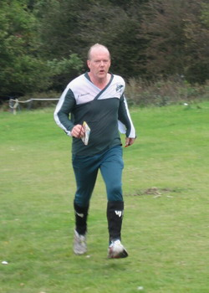 | 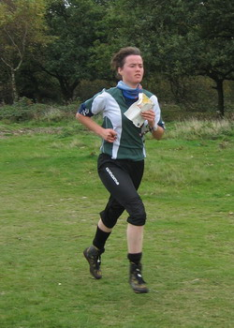 | 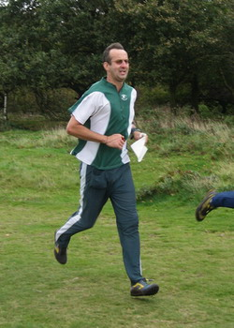
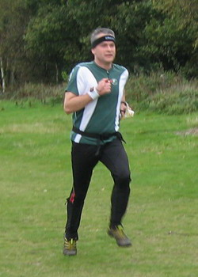 | 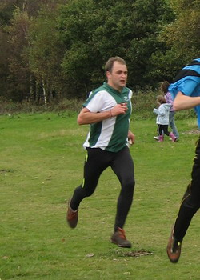 | 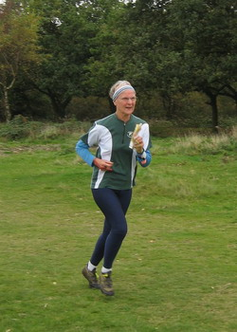
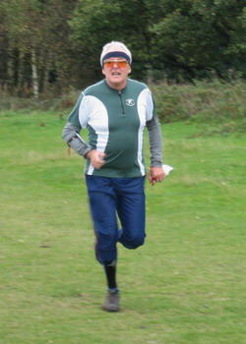 | 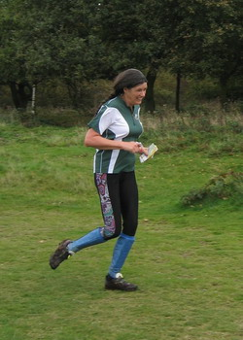 | 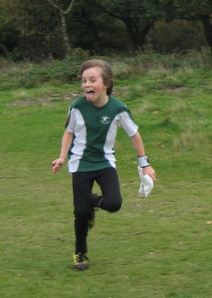
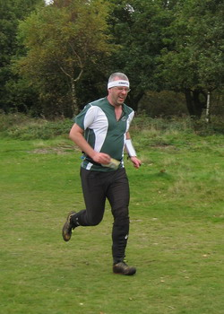 | 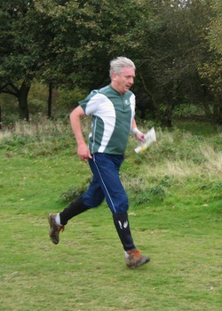 | 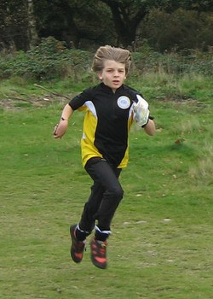

Schools League Report - Julie Laver
The results after the first meeting of the new season are as follows -
Up to Y6 Boys | Up to Y6 Girls
Kit Phillips | Lucy Holder
Gregory Robinson | Olivier Jones
Jack Gilby | Bronwen Mansel
Y7/8 Boys | Y7/8 Girls
Bryn Wilkinson | Rhiannon Ware
Heugo Seacombe | Rachael Harrison
Roderick Mansel | Matilda Selby
Y9/10 Boys | Y9/10 Girls
Alex Ware | No entries
Ben Armitage
Michael Archer
Y11/12/13 Boys | Y11/12/13 Girls
No entries | No entries
Well done to all who have taken part so far.
As can be seen there are some classes for which there were no entries so far so if you are in this age group please make sure you are entered for the league by recording your school and year on your registration form. You do not have to be entered via your school.

Stragglers' League - Andrew Cordle
Now that the League is over a year old, the earliest events are being dropped from the points calculation. Consequently, Jenny Collyer needs to gain maximum points from the next two events to maintain her perfect score.
There are two newcomers to the Top Ten since the last newsletter - Steve Robertson through having completed his sixth event, and Claire Harrison through sheer perseverance!
The next League events are -
 | 16 Nov 2008 | NOR Lynford
 | 23 Nov 2008 | SUFFOC Rendlesham
 | 29 Nov 2008 | WAOC Rowney (Night)
 | 13 Dec 2008 | HAVOC Thorndon Park South
 | 1 Jan 2009 | SOS Wivenhoe
 | 18 Jan 2009 | SUFFOC Sutton Common
 | 25 Jan 2009 | SOS Roman Valley
 | 7 Feb 2009 | CUOC Cambridge City
 | 8 Feb 2009 | WAOC Croxton
 | 15 Feb 2009 | SMOC Silverstone
 | 22 Feb 2009 | SUFFOC Knettishall
... subject to change. Check the website http://www.stragglers.info/league for latest information and scores.

SOS Notice board

Situations Vacant - Andrew Cordle
As you will know if you have read the rest of the newsletter, Stragglers has a vacancy for a Publicity Officer.
The position doesn't have a job description yet, so you can do the job in your own way. Basically, it involves making non-orienteers in our area aware of our events and encouraging them to give it a try.
The salary is nil, but expenses are covered, and you can't put a value on satisfaction, can you? There isn't a set budget, but I'm sure the Committee will favourably consider expenditure that will attract and retain newcomers (personally, I think that spending almost nothing in the past has failed, and we could constructively spend more).
You will need to work with the Development Committee and event organisers, who will welcome your contributions with open arms.
No previous experience necessary. Would suit an individual, a partnership, or a family who might combine orienteering knowledge, administrative and writing skills, and a knowledge of our target market. Or just two of these. Or only one!
More information from a Committee Member, or apply to the Chairman.

Permanent Course Officer Update - John Collyer
Awards for All Grant
The Club has been awarded a grant to be used to encourage orienteering development; the Club also has to make a contribution.
There are four main areas that we shall be using the grant for:
- Developing three new permanent courses, including the provision of maps for each area. The chosen locations are: Hylands (Chelmsford), Notley park (Braintree) and High Woods (Colchester). Planning is well advanced and we hope to have all three opened by Easter.
- Encouraging Schools participation in the Chelmsford area. We have money for four maps of school campuses and three parks within the Borough. The agreed parks are: Springfield Hall, Admirals and Central (1 map), and Melbourne. There will also be introductory days for staff and pupils.
- Equipment. We shall be buying:
  - A laptop for field mapping.
  - A GPS unit.
  - Extra copies of OCAD.
  - Extra SI cards to go with our introductory kit.
Fordham Hall Estate
We hope to have this area available for use within a few weeks. The Woodland trust has put in the posts; all we need to do now is update the map and fix markers.

Chair’s Annual Report 2007-8 - Martin Sellens
At the risk of sounding repetitive (at least to those who have read previous reports) this has been another busy year in the life of the club. The number of events fell a bit from the peak of 13 last year, but only to 11. Given that we operate with a relatively small pool of experienced event organisers and planners this is still a pretty impressive programme and amounts to about one a month excluding the summer off-season. To put this into an historical context, we could manage only 5 events in 2001. As well as 3 district events we hosted the East Anglian Schools Championships at Wivenhoe Park; once again dominated in the younger age groups by Barnardiston. We were also involved in planning and controlling a major Army event that provided a new map of Middlewick Ranges produced by Chris Sellens. This interaction with the Army promises to make it easier in the future to access Roman Valley and Donyland Woods, one of our best areas but hitherto beset by difficulties in dealing with the Crown Landowners.
The whole orienteering programme is co-ordinated by the hapless Fixtures Secretary and I would like to thank Dave Skinner for the efficient and unassuming job that he has done since taking over from Jack Isbester at the last AGM. Jack’s years of service to the club were marked at the last AGM by the well deserved award of the Mike Powell-Davies Shield (though that doesn’t mean he should now rest on his laurels). Of course, the events wouldn’t happen without the tireless work of mappers, planners, organisers and their willing teams of helpers. My thanks also to them for some splendid days of smoothly organised and well planned local orienteering. In addition to the Middlewick extension of the Donyland map, several smaller projects have also been undertaken by a growing pool of cartographers; notably Dave Birkett’s maps of schools and Maldon, and Steve Cartwright’s schools and village maps in on the Tendring peninsula. Kevin Machin continues to do a magnificent job as editor and printer behind the scenes and his commitment and reliability is a major contribution to the club. My thanks to all of them.
The Development Committee, under the enthusiastic leadership of Julie Laver, has once again provided a full programme of coaching activities and has continued to be the engine room of the club in terms of promotion, recruitment and coaching. My thanks to this committee for their splendid efforts in taking the club forward. A highlight of the year has been the successful ‘Awards for All’ bid co-ordinated by John Collyer, who overcame a variety of fiendish administrative barriers to secure a grant of almost £6000 to take forward the development of several permanent courses. This will undoubtedly raise the profile of the sport and the club as well as providing an invaluable resource for training and small events. Lyn West and her team did their customary brilliant job of putting together the summer series, including, for the first time, a sprint event in Castle Park. Thanks to Jenny and John Collyer for this initiative and to Lyn, Julie and the rest of the team for their ‘off season’ efforts that provide much needed year-round continuity to our programme of events.
Despite Jenny Collyer’s sterling efforts as Club Captain we still didn’t win the final of the CompassSport Trophy, last year held in the relics of Sherwood. However, we are once again the representatives of East Anglia in the Trophy final in a few weeks time at Sutton Park in the Midlands. I make no predictions other than lots of us will be there and we’ll put up a good showing.
Geraldine Russell and Andrew Cordle have maintained the excellent quality of the Newsletter, available in three different formats on the web, and as hard copy for those with an attachment to old technology. I particularly recommend the on-line version for its great photos.
Finally, thanks to Hilary who is stepping down as Treasurer, to Clive, who is relinquishing the post of Secretary and Lyn who will no longer be seeking publicity for the club’s activities.

Minutes of the Annual General Meeting - Clive Tant
Friday 3rd October 2008, Somakam, Roman Hill, Colchester
Present: Martin Sellens, Hilary Sellens, David Skinner, Clive Tant, Julie Laver, Kevin Machin, Stephen Cartwright, Geraldine Russell, John Russell, Nancy Powell-Davies, David Birkett, Jenny Collyer, John Collyer, Jack Isbester, Lyn West, Derek Keeble, Julia Robertson.
1 Apologies for absence
There were apologies from Andrew Cordle and Colin West.
2 Approval of previous minutes
The minutes of the 2007 AGM were agreed.
3 Matters arising
There were no matters arising.
4 Chairman's Report
The chairman, Martin Sellens, read his report which was accepted by the meeting.
In particular, Martin drew attention to the following points:-
- 4.1 Compared to previous years the club is now offering several more events. 13 during 2007/08 and 12 planned for the current year.
- 4.2 Yet again Barnardiston was dominant in the East Anglian Schools Championships.
- 4.3 Various officers were thanked for their efforts during the year.
- 4.4 Martin noted the success of the Awards for All application which will provide £5845 to club funds to take forward the development of several permanent courses and particular thanks were expressed to John Collyer and Hilary Sellens for the work they did with the application.
- 4.5 Despite the efforts in the CompassSport Trophy final, the club missed out on success again but has another opportunity in the final this year at Sutton Park.
5 Treasurer's report
The Treasurer, Hilary Sellens, circulated copies of the accounts.
Hilary reported a profit of £955 compared to £206 in the previous year. Funds will be transferred from the current account to a deposit account.
Lyn West advised that, as last year, she had many junior T shirts in stock.
It was only the summer series events which made a small loss; all other events made profit.
There was discussion about the necessity to provide a donation to National Trust at Hatfield. This will be considered further by the committee.
The meeting expressed thanks to Hilary for her work and to John Russell for acting as Honorary Examiner.
6 Subscriptions
The meeting discussed subscription rates for the coming year and agreed not to make any change and to ratify the decision made at the committee meeting in September.
It was suggested that the committee review subscriptions during the course of the year.
7 Election of Chairman
Clive assumed the Chair for a short while. Martin was thanked for his work as Chairman and without any alternative proposal for Chairman, Martin was re-elected as proposed by the Committee and accepted unanimously by the meeting.
9 Election of Other Officers
Hilary Sellens, Clive Tant and Lyn West resigned their positions of Treasurer, Secretary and Publicity Officer respectively.
Jack Isbester was nominated as Vice Chairman by Martin Sellens, seconded by Geraldine Russell and appointed unopposed.
Derek Keeble was nominated as Secretary by Martin Sellens, seconded by Jack Isbester and appointed unopposed.
Nancy Powell Davies was nominated as Treasurer by Julia Robertson, seconded by Clive Tant and appointed unopposed.
The positions of Publicity Officer and Junior Club Captain were not filled The meeting authorised the committee to appoint a Junior Club Captain and Publicity Officer - as required.
All other officers were unanimously re-appointed to their current positions.
Chairman | Martin Sellens
Vice Chairman | Jack Isbester
Secretary | Derek Keeble
Treasurer | Nancy Powell Davies
Club Captain | Jenny Collyer
Newsletter Editors | Geraldine Russell and Andrew Cordle
Schools Liaison and ESSOL | Julie Laver
Fixtures Secretary | David Skinner
Permanent Course Officer | John Collyer
Publicity | Vacant
East Anglian Rep | David Birkett
Equipment officer | Hilary Sellens
Membership Secretary | Geraldine Russell
Map Officer | Kevin Machin
Web Master | Andrew Cordle
Head Coach | Stephen Cartwright
Junior Club Captain | Vacant
Honorary Examiner | John Russell
The Chairman paid special thanks to Julia Robertson for her work over several years in looking after the club equipment.
10 Any Other Business
- 10.1 The Awards for All award was acknowledged and a letter of thanks will be written to Helen Etherington who acted as an independent referee.
- 10.2 A first aid course programmed for 10/11 January 2009 will be subsidised by the Club at an amount to be determined by the committee. Julie Laver was authorised to commit up to £200 to secure the booking of the course with the expectation that at least 3 people will be attending.
- 10.3 It was recommended by Steve Cartwright that members might be actively encouraged to participate in the activities of the Development Committee without being members of the Development Committee. This will be discussed at the next Development Committee meeting.
11 Presentation
The Mike Powell-Davies Shield for Senior Club Member of the year was presented to Derek Keeble.
The Mark Johnson Trophy for Junior Club Member of the Year was awarded to James Lyne last year but only received by him this last Easter. The Committee will consider suitable candidates for the award and the timing of the award.
The meeting was concluded and followed by a buffet.
  New Secretary and  Senior Club Member of the Year  Derek Keeble | 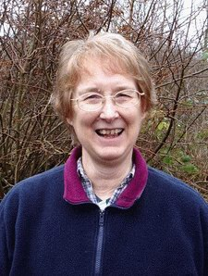  New Treasurer  Nancy Powell Davies

Fixtures in East Anglia and Nearby Regions
The information provided below normally consists of Event Date, Region (eg EA = East Anglia), Event Grade and Type (Grade 1 is highest grade, Grade 5 is lowest. Type C is a conventional Cross Country event in which controls must be visited in the sequence listed on the description sheet). Event & Location Names and map reference. Organiser's contact details. Contact details, costs, closing date etc. for Pre-entry when provided. Whether Entry on the Day (EOD) is possible and the surcharge payable. The range of courses offered. The address of a website from which additional information can be obtained. Additional information in plain language.
At Essex Stragglers' events registration normally opens at 1000hrs, starts are from 1030hrs until 1230hrs and courses close at 1430hrs.
November 2008
16th | EA | NOR District Event & EA League Event. Lynford, Thetford. TL819940.
 | C4 | Alan W Bedder, 01603 424589. alan.bedder@virgin.net Fees TBA. String course.
23rd | EA | SUFFOC District & EA League & ESSOL Event. Rendlesham Forest, Woodbridge. TM355482.
 | C4 | Rob Coulter, 01473 258430. rob.coulter@ntlworld.com £7.00/£2.00. EPS-SI. Dogs allowed on leads only. www.pdl.demon.co.uk/suffoc
27th | SE | LOK London's West End Night Street Score Event. Bloomsbury College, Malet St, London WCE 7HX. TQ298820.
 | C5N | David Rosen, 07870 653321. dandmrosen@btopenworld.com Free. 1830-1915. No dogs. www.londonorienteering.co.uk
30th | EA | WAOC Rowney Weekend District Event. Rowney Warren, Ampthill.
 | C4 | Ursula Oxburgh, 01223357199. uoxb00@esc.cam.ac.uk £7.00/£2.00. EPS-SI. String course. Dogs allowed in car park on lead. www.waoc.org.uk
December 2008
7th | EA | NOR District Event & Yvette Baker Trophy Final. Sandringham, Kings Lynn. TF690290.
 | C4 | Alan Bedder, 01603 424589. alan.bedder@virgin.net £6.00/£1.50 Groups £7.50. EPS-SI. String course. Dogs allowed on lead please. www.norfolkoc.co.uk
13th | EA | HAVOC Local Event. Thorndon Park South, Brentwood. TQ633899.
 | C5 | Chris Shaw, 01375 677377. chrisshaw77@hotmail.co.uk £4.00/£2.00. EPS-SI. W, Y, O, LG & Blue. Parking £2.00. Starts 10.30-12.00AM. www.orienteering-havoc.co.uk

14th | SE | HH SE Score Champs. Northaw Great Wood, Cuffley / Potters Bar. TL282040.
 | S4 | Jenny Gostick, 01707 890283. jngostick@ntlworld.com EPS-SI. Parking £1.00. Further details closer to event on website. www.happyherts.org.uk
21st | SC | TVOC District & SCOA League Event. Wendover Woods, Wendover. SP889090.
 | C4 | Jeremy Hill. Fees TBA. EPS-Emit. String course. www.tvoc.org.uk
26th | SE | LOK Boxing Day Score Event. Trent Park, London. TQ289969.
 | S5 | Neil Brooks, 01494 872578. neilbrooks@msn.com £4.50/£2.50. EPS-SI. www.londonorienteering.co.uk
28th | SC | SN Regional Event & SN Trophy. Long Valley North, Aldershot. SU852519
 | C3 | Organiser: John Brown, 01483 720903.
 |  | Postal Entries: Long Valley Trophy, c/o Paramali, Bagshot Road, Brookwood, Surrey, GU24 0EY. CD: 10/12/08. £10.00/£3.00 (less £2.00 BOF & SN Seniors). Lim EOD & late entries +£3.00/£1.00. Chq: Southern Navigators. EPS-SI. Free String Course. Colour Coded courses (White to Light Green) – EOD only - £7.00/£3.00. Online entry preferred via: www.southernnavigators.com/sntrophy2008.html. www.SouthernNavigators.com
January 2009
1st | EA | SOS New Year Novelty Score Event. Wivenhoe Park, Colchester. TM034241.
 | C5S | Andrew Cordle, 07968 567529. andrew@cordle.net £5.00/£2.00. EPS-SI. www.stragglers.info
4th | SE | SAX Regional Event. Eridge.
 | C3 | Jerry Purkis, 01892 536332. jerry.purkis@shell.com £9.00/£4.00. EPS-SI. Saxons 24 hour infoline on 01303 813344. Parking £1.00. www.saxons-oc.org
18th | EA | SUFFOC District Event & ESSOL. Sutton Common, Woodbridge. TM306476.
 | C4 | Louise Walker, 07917 555949. £7.00/£2.00. EPS-SI. Dogs on lead. www.pdl.demon.co.uk/suffoc
22nd | SE | LOK Street-O. Hampstead Heath, London. TQ274854.
 | C5 | Glen Jones, 020 8450 0444. glen@glenandfelicity.co.uk Free/Free. EPS-SI. String course. www.londonorienteering.co.uk
25th | EA | SOS District Event & Essex & Suffolk Schools League (ESSOL). Roman Valley, Colchester.
 | C4 | David Skinner, 01245 381266. dave.skinner@btinternet.com Fees TBA. EPS-SI. www.stragglers.info
 |  | Full registration pending

Emails to the Editors

"Yet another newsletter"
Hi Editors
"Yet another newsletter" from 38 years ago, heralds the cover. Yet indeed to read and reminisce through the 1970 wordage was enjoyable. I knew it not then, as I was living and orienteering in Nottingham.
Ron mentions the formation of EAOA being discussed, and although I did not know it, a year later I was heavily (see "Work & Social" same edition) involved with establishing that Association, and the next year was recruiting to burgeon the S.O.S and associate thereto.
It was year-to-year survival then. I was not laying foundations for the wonderful world of 2008/9; I merely wanted orienteering nearer to Clacton-on-Sea in 1973/4 than trips to North Downs and/or Chilterns I might otherwise be enduring. What was needed in EA was maps, so I became a mapper - not a good one apparently, but the only one available at the time.
I am grateful to Keith for storing these works and to the Editors for airing them. I recall the mentioned Ron Russell, Mike Down and Sophie Rex with affection: and "R.B.Y.C." could be the Royal Burnham Yacht Club but more likely is the Robert Beard Youth Centre of Hornchurch.
Keep happy feet
Derek Keeble

Discounts
Further to Dave Birkett's imformation in the June newsletter, I can confirm that Blacks, the retail outlet specialising in outdoor gear, is offering all SOS members 10% discount on anything in any of their stores or online purchases. This does not apply to goods that have already been reduced.
You must ask for the discount and show your membership card.
Geraldine Russell

Heard at the Karrimor Mountain Marathon?
“Damn it, the event’s been abandoned.”
“Don’t worry, if we blast back to Colchester we can be in time for NOR’s Corston and Marsham Heaths event”.
Jack Isbester

A New Way to explore Hanningfield Reservoir - Becky Gibson
Reproduced with permission from the Essex Wildlife Magazine
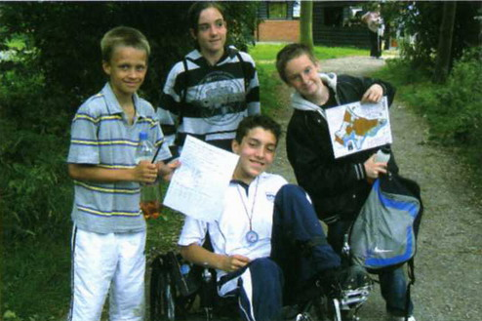
A permanent orienteering course has recently been unveiled at Hanningfield Reservoir nature reserve. The course has already been used on a number of occasions by individuals visiting the reserve, youth groups, schools (primary and secondary) and families. There are three different courses around the reserve, which range in length and difficulty. Essex County Council Sports Competition team have arranged a number of sessions on the reserve with secondary schools from Canvey Island. The events have been very successful and the students really enjoy finding their way around the reserve with a map and compass, taking in the range of habitats and wildlife on the way. The course has been developed by David Birkett of the Essex Stragglers Orienteering Club. I first met David when I led a (wildlife birthday party) for his son and we got talking about orienteering. I had wanted to develop a course on the reserve for sometime, as I thought it would diversify the activities we offer, and would attract new groups to the reserve. David has contributed a huge amount of his time and skills into developing the course as a volunteer. We are very grateful for all his hard work and enthusiasm. I would also like to thank Essex and Suffolk Water for funding the mapping of the reserve and the control markers.
David, myself and volunteer Brian Gale fitted the control markers onto posts and sited them at their various locations around the reserve. The posts are produced from wood harvested on the reserve. Orienteering is an activity which young, old, fit and not so fit can take part and can be done at any standard. So why not pop in and purchase an activity pack, from the visitor centre, we ask for a £2.00 donation and explore the reserve from a different perspective. We even made the 'Anglia Tonight' programme with a short film about the sport at the nature reserve.
Becky Gibson, Hanningfield Reservoir Education Officer

The Original Mountain Marathon - Martin Sellens
A brief report of an abbreviated event
Stragglers Martin and Chris Sellens, and Clive Tant are pleased to announce that they survived the 41st Karrimor, aka the Original Mountain Marathon. Media reports of 1700 runners unaccounted for on the windswept fells made it onto the National News on the first day of this 2 day race, but only exposed a gross misunderstanding of the nature of the event and contributed to unnecessary anxiety among the friends and family of competitors. The media circus that followed, largely initiated by the proprietor of an establishment on the top of Honister Pass who wasn’t expecting so much passing trade, resulted in some of the most outrageously misleading reporting I have ever witnessed. Read everything with scepticism! It’s true that exceptionally heavy rainfall was accompanied by winds gusting to 110 mph on the exposed ridges. I was blown over more than once and reduced to hands and knees to avoid further airborne excursions on a couple of occasions, but hey, it’s an adventure race. However, the fact is that over 99% of the almost 3,000 competitors that started made it safely off the fells under their own steam. There were fewer than 10 cases of hypothermia and I understand that four enjoyed a helicopter ride following an incident in which orienteer Lizzie Britton was swept away during a stream crossing and spent an uncomfortable few hours (with injuries that turned out not to be serious) sheltering in a tent on an island in the middle of the torrent. There are more injuries on a typical weekend in the premier league. Over half the teams that started on Saturday morning completed their day 1 courses, and this would have been more except that some teams learned of the event being called off at radio controls and retired. Among those completing day one were myself and partner Steve Jones of Eryri, who were lying in 12th position on the A course, and Clive Tant and partner Matt Dickinson who were 15th in the C class. Chris Sellens and Ed Kelleher from NOR retired to the assembly area after 6h, having suffered minor falls and cuts and bruises on a treacherous scree slope.
Chris and Martin then spent a comfortable night in the Borrowdale YHA before fending off ravenous (ravening?) reporters at the Event Centre whilst waiting for Clive and Matt to return from their overnight billet in Ulverston. Having parked as instructed, Clive’s trusty Honda only required a little help from a tractor to get out of the mud and we were all back safely in Essex by midnight on Sunday. A good time was had by all and we urge you to enter early for next years event as an upsurge in applications is confidently expected.

Queuriosity - Jack Isbester
Readers of CompassSport will be aware of their Phot-O competitions - you are given a map of some impossibly complex terrain, with just the Start and Finish marked, and the control descriptions. From pictures of the control sites, you are invited to recreate the course. Many Stragglers are unable to spend the required two weeks or so of peering at the map, so, here in the first of an occasional series, Jack presents a simpler puzzle.
Test your powers of observation
Which of these queues is for Wilf's and which for the loos?
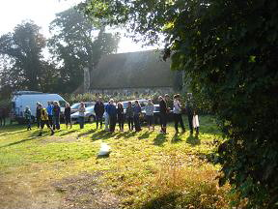  Queue 1 | 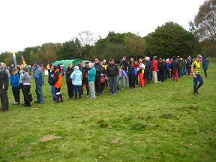  Queue 2

Frantic 'O' - Julie Laver
It is good to know that the Essex Stragglers are at the cutting edge of Orienteering with the development of a new form of our sport. You have all heard of Park ‘O’, Trail ‘O’, MTBO etc now comes Frantic ’O’! It came about when intrepid coaches Dave Birkett and Julie Laver were contacted by Sport Essex to run a taster session as part of the Essex Corporate Games they were organising. Companies from all over Essex were invited to send teams of 5 participants to Essex University for a day of sports and games followed by an evening social and prizegiving.
Sport Essex wanted minority sports such as archery, frisbee golf , handball and orienteering. Our brief was to explain orienteering to two groups of 5 at a time, send them off on a score course collect and collate the scores and move them on to the next activity – not so bad so far – by the way you only have 20 minutes to achieve this!!!!
There is nothing like pressure to focus the mind on the matter in hand and by the end of the day we had the patter down to 5 minutes, 10 minutes for the course then onto the next group. We were shattered but the organisers seemed pleased with our efforts SO …………“By the way we are hosting an adventure sport day at Black Notley next Friday – can you help there?”
“We’ll see if we are free”.
“That would be great – the groups will be school children aged 14. About 40 at a time - five groups of eight but you have 30 minutes per session this time.” No problem!!
To see our 30 seconds of fame go to http://www.sportessex.com/content_nboard.php?page=Essex_Corporate_Games.

Some Essex Bunroes - Derek Keeble
(Have you visited them all: do you really want to?)
Places in Essex 120 metres, or more, Above Ordnance Datum and separated by a drop below the 120m contour, also having public access are included in this Mapjog compilation.
No. | metresAOD | Parish | Place | Map reference | Featured Long Distance Walk
01. | 147 | Langley Upper Grn-Chrishall border | Oldfield Grove Pickerton Green | TL443363 | The Harcamlow Way
N.B. 147 metres is 428 feet 4 inches approximately
02. | 131 | Chrishall | Crawley End | TL446394 | The Icknield Way
03. | 125 | Berden | Park Green | TL460286 | Abounding Essex
04. | 124 | Helions Bumpstead | Sage End | TL635417 | Abounding Essex
05. | 122 | Debden | Hamperden End | TL570307 | Anita's Mucking Ugley Ways throu' Messing, Essex
06. | 120 | Ashdon | Winsey Farm | TL617411 | Abounding Essex
'Bunroes' is a play on the Scottish idea and title of Munroe Listed Mountains. Essex hills are bun-sized in exaggerated comparison with The Highlands.
There are some peaky outliers, such as Langdon Hill in Basildon 118m, Ambresbury Bank in Epping Forest 117m, and St John's Green in Danbury 112m. Once the list is extended to include all places at these heights the listing becomes occluded by its length.
Additions, alterations, comments to Derek please.

Frequently Asked Questions - about the Cows! - Joan Pinch
The Tiptree Heath warden explains why there are new fences all over a previously fence-free map
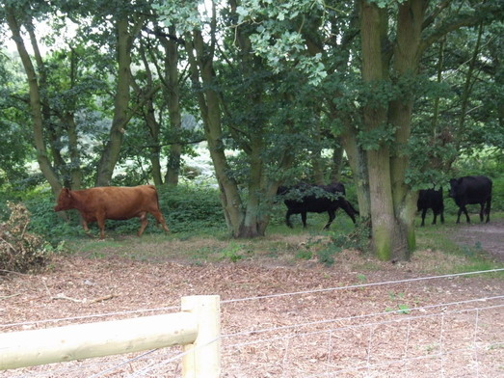
Now that the cows are grazing away there are more visitors to the heath, and they are mainly asking the same questions. I thought it would be a good idea to put them here and give as many answers as possible.
- Why do you need cows on the heath?
Work parties using hand tools and more recently supported by tractor and digger work have been working throughout every winter for the last 30 years to try to keep under control the scrub which continually threatened the heathland. Although there has been more machine work since 2004 when the restoration project started, we are still fighting a major battle against birch, brambles and other scrub which regenerates during every summer after having been cut down the previous winter. Cows are the last resort to try to keep the heath open and in a more sustainable way.
- Who is paying for the fencing and water supply?
Natural England, a government department, recommended that the most effective tool we could use on the heath would be grazing, and they have agreed to give a substantial amount of funding. We have also been awarded funds from the Essex Environment Trust and Cory Environmental Trust (Colchester) and part of the Heritage Lottery Fund money awarded to the project has gone towards gates. A further charitable trust, the Charles S French Trust has also given us money.
Council money has not been used, although our general maintenance is, and has been for many years, supported by Tiptree Parish Council and Colchester Borough Council.
- Why use barbed wire?
We decided that any open sections with a lot of public use should have plain wire, and the sections in the undergrowth where the fenceline had been cleared but scrub would return should have barbed wire strands on top to discourage cows from leaning on the fence (to reach greenery on the other side) and breaking it down.
- Where did the cows come from?
The cows are owned and grazed by a smallholder from West Hanningfield. He visits the heath regularly and we check on the welfare (and numbers!) of the cows twice every day and report to him any concerns.
- You’ve only got 4 cows. Why not more?
The optimum number for the size of site was recommended by GAP (the national Grazing Animals Project) as 6 or 7. Since the cows will only be here for a few weeks this year and transporting animals is complicated and costly, the grazier decided to only send one trailer load of cows. Next year he will send 7.
- Is the fencing legal?
I don’t think we would have got this far if it wasn’t. Contrary to a suggestion in a letter in an Essex newspaper, all legal hurdles have been covered, taking 2 years altogether to get final permission from the Secretary of State for the Environment, and with the full support of the Open Spaces Society which guards the rights of people who wish to use the countryside.
I hope that clears up a few mysteries. If you need any further information please contact me.
Joan Pinch 07842 110051

British Schools Score Championships 2008 - Dave Birkett
Silver medal for Tom
Stragglers had four representatives at this year’s event - Tom and Alex Birkett and Alex and Rhiannon Ware. The event took place at Sherwood Pines near Ollerton. It was an ideal area for most of the competitors who were largely from schools and not necessarily club runners. The area was made up of block woodland reminiscent of Thetford and was crisscrossed with numerous straight forest roads and tracks looking like motorways making it very difficult to get lost. The course consisted of 28 controls which could be visited in any order within the 45 and 60 min minute time limits depending on age year group. There was a series of controls placed out constituting a white standard point to point course which was ideal for novice orienteers or those new to the score set up. The event was hosted by Nottinghamshire Orienteering Club who had organised numerous volunteers from all of the regional clubs and the event went very smoothly.
Alex and Tom lead off representing Meadgate School, Chelmsford. Alex was running up a year group to Y5 and had a very smooth if short 22.15 minutes in the wood. Enough time to collect 12 controls and return not out of breath. He really enjoyed the score set up and wanted to go out again at the end. His 120 points put him in a respectable 15 place out of 31 runners, his early return to the finish being probably due to forgetting to set the stop watch on his new, specially purchased, Casio watch at the start.
Tom as usual ran like the wind and collected 22 of the 28 controls also finishing early in a time of 39 minutes. Prior to the start we had discussed actual running speed whilst collecting controls and had settled on a slow one minute per 100 metres. I think being anxious not to lose points brought him back to the finish area earlier than wished but then this is all part of the challenge of estimating time over distance whilst making route choices to collect as many controls as possible. Tom finished in Silver medal position splitting two strong young Octavian Droobers runners. As expected Tom was very pleased with his medal and podium finish.
Alex and Rhiannon had enjoyable races. Rhiannon let time get away and was out for longer than she wanted collecting some penalty points and finishing 27th in the Year 8 Girls race. Alex finished in a creditable mid table position coming 46th in the Year 10/11 Boy’s race. Afterwards the SOS contingent returned to the woods for stick fighting and fun on the Forestry commissions climbing frames.

As Stragglers will be hosting the 2009 Champs at Hylands Park, the event gave me a chance to see what is involved in putting on the event. It all looked like good fun and the young runners all seemed to enjoy the score format.
All club members please put a note in your diary for Saturday 10th October 2009. We will need all the help possible to put on a successful event. There are lots of non technical helping jobs which any one can do and you will get a free run afterwards.
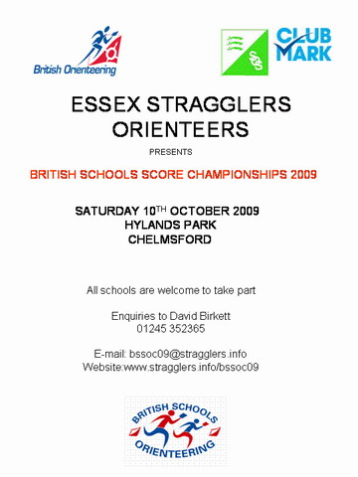

SOS Newsletter Volume 20 No. 12
The next edition of the newsletter will be available on the 25th January 2009. Copy for this edition should be sent to the Editors editors@stragglers.info before 16th January.

