 | Essex Stragglers Orienteering Society (SOS) |   accredited

Newsletter Volume 20 Number 13

April 2009

Editors: Geraldine Russell and Andrew Cordle - editors@stragglers.info
Club website - http://stragglers.info

Editorial - Geraldine Russell 3
Chairman's Chat - Martin Sellens 3
Captain's Corner - Jenny Collyer 5
Schools League Update - Julie Laver 7
Stragglers' League - Andrew Cordle 8
SOS Notice board 9
New for 2009 9
Permanent Course Update - John Collyer 9
Castle Park Colchester Event, Saturday May 9th - Julie Laver 9
Fixtures in East Anglia and Nearby Regions 10
Photoquiz 13
Maldon Training Course 14

Photographs by Kath Birkett, Rachel Archer and Andrew Cordle

  Essex Stragglers support the Woodland Trust and its objectives |   Essex Stragglers' development activities are supported by Awards For all

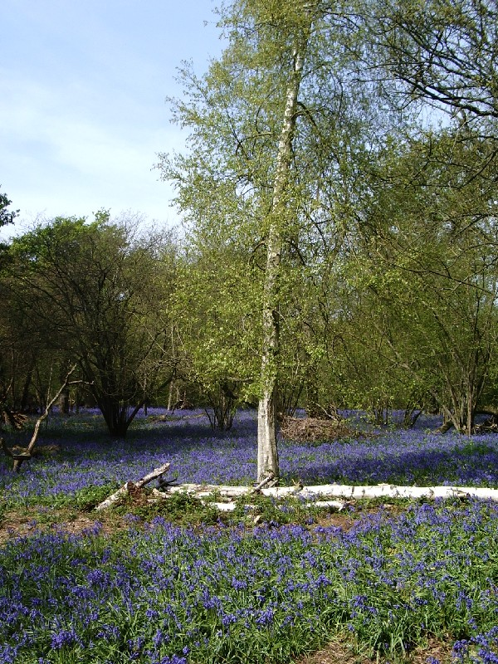
Springtime in Essex

Editorial - Geraldine Russell
We have a very pictorial edition thanks to Kath who diligently took all the photos at the British Championships and the Compass Sport Trophy despite cold fingers.
We have yet again won the heats of the Compass Sport Trophy with some very fine runs by our members helped by the sheer force of numbers who turned out. Well done everybody. Now we can look forward to a great day out to the Compass Sport Trophy Final on October 18th (See Captain's Corner). This should be a good social event with a coach being laid on and there will also be hot soup and rolls and cake after your run! Put the date in your diaries now so we have maximum turnout.
It is hoped that some specific technical training can be organised over the next six months to help members fight the gremlins that haunt a lot of us out in the forest to help us bring the Trophy to SOS.

Chairman's Chat - Martin Sellens
Well, the 'big event' season is now in full swing. At the British Orienteering Championships, held in the New Forest at the end of February, 28 Stragglers completed the individual event (though, admittedly, six contrived to get themselves disqualified by mis-punching) with excellent results coming from Alex and Thomas Birkett, Stephanie and Rhiannon Ware, Jenny Collyer and Geraldine Russell. Chris Sellens also managed a top 20 place in the elite men's event, covering most of Hampshire in just over an hour. Our valiant relay teams, (how shall I put this?) also managed some, er, notable performances underlining the club's adherence to the philosophy that it's the taking part that matters and not the winning. Almost half the teams managed not to get disqualified and the Junior Ad hoc team of Ellen Sanderson with Alex and Rhiannon Ware achieved a creditable top ten place. Congratulations to us all, and many thanks to club captain Jenny Collyer for managing the increasingly tricky intellectual gymnastics necessary to formulate the relay teams!
A mere four weeks later, at the Saxons' Millbank event, Stragglers came through to win, yet again, the regional heats of the Compass Sport Trophy against strong opposition and despite some key runners being unavailable due to international commitments or injury. Particularly notable performances came from the fast, blue women (not in any risqué sense) with Daniela Brohm leading home in first place followed by storming runs from Suzy Robertson in 3rd and Nina Tant, Jo West and Claire Harrison in very creditable 4th, 5th and 6th places. The blue men also managed some solid performances with David Sanderson excelling in 5th place and a spooky dead heat in 8th for Steve Robertson and Clive Tant.
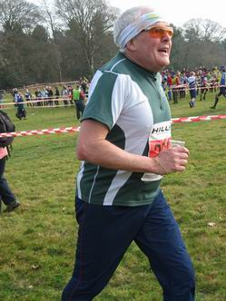 | 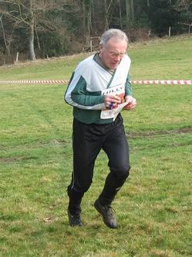 | 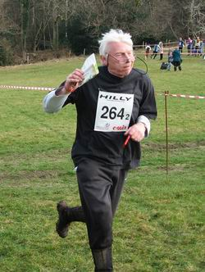
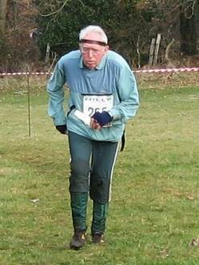 | 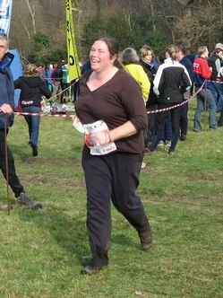 | 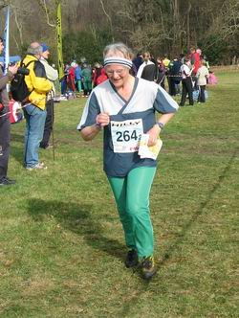
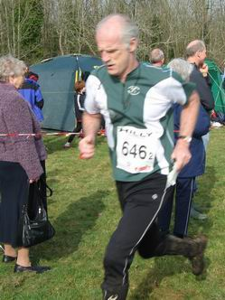 | 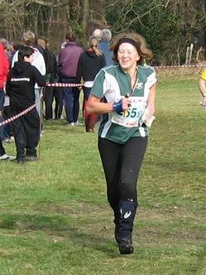 | 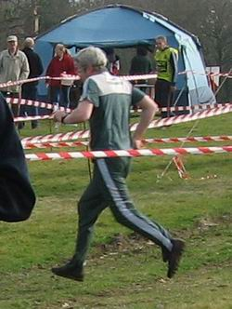
The run-in at the British Relay Championships

Our more mature, but ever-green women also pulled out all the stops with Lyn West and Sue Carton bringing home the points in 3rd and 4th places. James Lyne, super fit from his "studies" in Edinburgh, was 4th on the brown with Duncan Harrison in 10th. Invaluable points were contributed on the light green course by juniors James Park (2nd) and Hannah Newton (4th), and on the Orange by Thomas Birkett (2nd) and Nicholas Harrison (3rd). I hope you're keeping up! Fantastic performance by all runners and well done to you all, whether you counted or not. Of course, this means that we shall once again be flying the flag for the region in the final in October in deepest Leicestershire. To make this a real club occasion we shall be hiring a charabanc, investing in a crate of Newcastle Brown and carousing up the A14. Put the date (Sunday 18th October) in your diary now as attendance is compulsory.
Next on the calendar is the JK and many of us will be enjoying the traffic jams on the A1 en route to Northumberland in the next day or two. Hope to see you there. Meanwhile, Julie Laver has been busy again on the development front and has won for the club more resources from Sport England, via BOF, to develop our coaching structure and bring on local juniors, some of whom currently don't even know they are destined for Orienteering greatness. If you have any ambitions to become a coach, then keep your eyes glued to the web pages and newsletter as opportunities are imminent. And if not, but you are prepared to help at low-key coaching events, then please let Julie know. Many thanks to Julie for her invaluable contribution to the club. Finally, and along similar lines, event organisers are always looking for willing assistants. If you have not yet experienced the untrammelled joy of contributing to the enjoyment of others as well as having your own hour or so of fun and games in the forest, then rectify the situation soon by making yourself known to the organiser of an imminent event (see fixtures list in this newsletter or on the Stragglers' web pages) or to Dave Skinner, fixtures secretary extraordinaire.
And finally finally, tip of the month is "check the control code before, or even after, punching". May you always run in sun filled forests. But if not, run anyway.

Captain's Corner - Jenny Collyer
SOS did extremely well at the Compass Sport Round winning by a good margin. Well done to everyone - by just turning out you will have helped the scoring. There were a lot of high scores and congratulations to Dani for winning the Blue Women's course.
The date to keep free now is the 18th October when the Compass Sport Final takes place in Fineshade Woods near Corby. A coach will be organised with many pick up points. The more people who go to this event the better our score will be jcollyer48@btinternet.com.
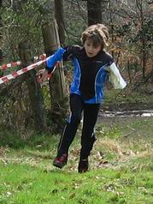 | 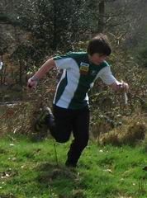 | 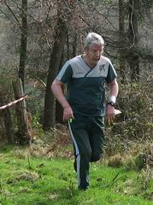 | 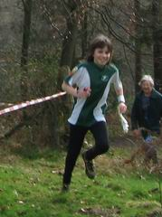
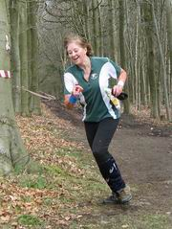 |  | 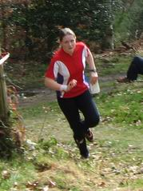 | 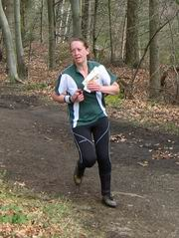
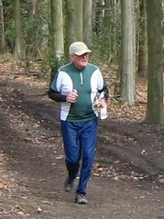 | 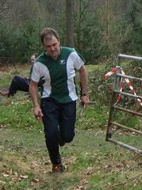 | 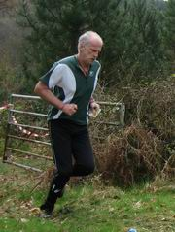 | 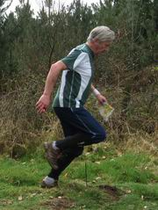
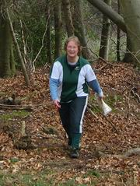 | 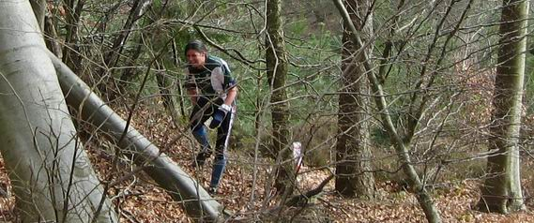
The run-in at the CompassSport Trophy heat

Schools League Update - Julie Laver
The results after six events are as follows -
Up to Y6 Boys | Up to Y6 Girls
Thomas Birkett | Bronwen Mansel
Kit Phillips | Olivia Jones
Timmy Harrison | Lucy Holder
Y7/8 Boys | Y7/8 Girls
Nicolas Harrison | Rachael Harrison
Bryn Wilkinson | Rhiannon Ware
Roderick Mansel | Charlotte Leake
Y9/10 Boys | Y9/10 Girls
Alex Ware | Isobel Chandler
Michael Park | Bethany Heybrock
Will Hooton
Y11/12/13 Boys | Y11/12/13 Girls
James Park | Hannah Newton
Jonathan Cronk | Ellen Sanderson
Connor Weed | Jacqueline Heybrock
Top Three Schools
Barnardiston Preparatory
Beyton Middle
Copleston High
Well done to all who have taken part so far. Please make sure you are entered for the league by recording your school and year group on your registration form. You do not have to be entered via your school.
For the full list of competitors please visit the ESSOL pages of our website at http://www.cordle.net/essol. If I have missed your details please contact me and I will amend them.
The remaining ESSOL events are as follows -
17th May, Highwoods (SOS)
14th June, Wivenhoe (SOS).
There will be a grand prize giving at the end of the Wivenhoe event. Certificates will be sent to all the schools whose details I have recorded so please ensure yours are up to date.

Stragglers' League - Andrew Cordle
Top ten positions are (position at time of last newsletter in brackets) -
Posn | Prev Posn | Name | Best 6 | Number of qualifying Runs
1 | (1) | Richard Bonnett | 598 | 11
2 | (2) | Jenny Collyer | 582 | 7
3 | (20) | Martin Sellens | 571 | 6
4 | (4) | Hannah Newton | 564 | 13
5 | (6) | Claire Harrison | 560 | 16
6 | (5) | Geraldine Russell | 559 | 10
7 | (3) | Chris Childs | 556 | 14
7 | (17) | Tracey Apperley | 556 | 13
9 | (7) | Duncan Harrison | 543 | 17
10 | (8) | John Collyer | 517 | 8
Congratulations to those on the way up. Those on the way down can make amends at these events -
 | 19 Apr 2009 | HAVOC Belhus Woods
 | 17 May 2009 | SOS Highwoods
 | 31 May 2009 | WAOC Cambridge
 | 7 Jun 2009 | SUFFOC Nowton Park
 | 14 Jun 2009 | SOS Wivenhoe
 | 26 Jul 2009 | HAVOC Epping SW
Check the website http://www.stragglers.info/league for latest information and scores.

SOS Notice board

New for 2009
Bring your good quality unwanted 'O' kit to the enquiries point at our events and we will display it for sale.
All items to be marked with the price and sellers name and contact number. Please collect unsold kit before you leave as we cannot store items.
Also for sale are some club T-shirts and sweatshirts. For New Club 'O' kit see Lyn West.

Permanent Course Update - John Collyer
Progress continues with the projects based around our A4A award project:
- The High Woods, Colchester permanent orienteering course is now up and running. Maps can be obtained free-of-charge from the Visitor Centre at the Turner road entrance during normal opening hours.
- Notley Park, Braintree should be having the posts and markers put in within 10 days. Once maps are checked and printed, it too will be available.
- The official opening of the High Woods course, will be performed by Bob Russell MP, at our May 17th. event. We are arranging a small social event to go with this.
- Caroline Louth (WAOC) has started the process of mapping the remaining Chelmsford area schools, whilst Chris Sellens and Kevin Machin will be taking up the local parks.

Castle Park Colchester Come-And-Try-It Event, Saturday May 9th, 10.30 to 15.00 - Julie Laver
If there are any new or inexperienced club members of any age who feel they would benefit from an informal coaching session, please pop along to Castle Park where there will be White to Orange courses available and experienced club members on hand to give advice on any aspect of your orienteering.
This is a low key event to encourage new participation so if you have friends or relatives who might enjoy a romp around the park please bring them along.
See website for more details.

Fixtures in East Anglia and Nearby Regions
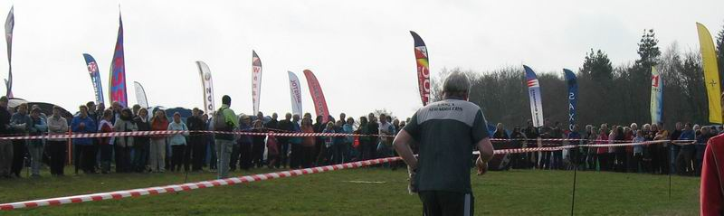
So many clubs' events for the Straggler to choose from...
The information provided below normally consists of Event Date, Region (eg EA = East Anglia), Event Grade , Event & Location Names and map reference. Organiser's contact details. Contact details, costs, closing date etc. for Pre-entry when provided. Whether Entry on the Day (EOD) is possible and the surcharge payable. The range of courses offered. The address of a website from which additional information can be obtained. Additional information in plain language.
At Essex Stragglers' events registration normally opens at 1000hrs, starts are from 1030hrs until 1230hrs and courses close at 1430hrs.
April
26th | EAOA  WAOC  Local | WAOC Short Races, Ampthill Park Ampthill, TL024382  Organiser: Peter Allen, science@huccombe.org.uk, 01954 211446 . Entry On Day: Senior £8.00, Junior £3.00, Student £3.00. , Punch Type: SI, Dogs: Dogs allowed on a lead. Start Times: 10.30 to 12.05 Second race starts for Short Races: 1.00 to 3.00 pm www.waoc.org.uk
May
9th | EAOA  SOS  Local | SOS Come & Try It (CATI) Event , Castle Park Colchester, TL999258  Organiser: Julie Laver, julie.laver@virgin.net, 01206 826152 . Entry On Day: Senior £2.00, Junior £1.00, Student £1.00. , Punch Type: None, No dogs allowed. www.stragglers.info
10th | EAOA  NOR  Local | NOR Colour Code Event , Holt Country Park & Holt Lowes Holt, TG083372  Organiser: Alan Bedder, alan.bedder@virgin.net, 01603 424589 . Entry On Day: Senior £TBC, Junior £TBC, Student £TBC. , Punch Type: SI, Dogs: On leads please www.norfolkoc.co.uk
17th | EAOA  SOS  Local | EA Schools Championship, SOS Colour Code Event & Essex & Suffolk Schools League (ESSOL), Highwoods Colchester, TM007281  Organiser: Lyn West, orienteering@grovehillhouse.wanadoo.co.uk, 01206 322905 . Entry On Day: Senior £TBC, Junior £TBC, Student £TBC. , Punch Type: SI, No dogs allowed. www.stragglers.info
30th | SEOA  CHIG  Local | Hainault in conjunction with National Family Week , tbc Hainault  . Entry On Day: Senior £TBC, Junior £TBC, Student £TBC. , Punch Type: None, No dogs allowed.
31st | EAOA  WAOC  Local | WAOC Cambridge Urban-O Event , Cambridge Cambridge, TL450585  Organiser: Helen Bickle, HNBickle@hotmail.com . Entry On Day: Senior £TBC, Junior £TBC, Student £TBC. , Punch Type: SI, No dogs allowed. Start Times: TBC www.waoc.org.uk
June
7th | EAOA  SUFFOC  Local | SUFFOC Come & Try It (CATI) Event , Nowton Park Bury St Edmunds, TL865622  Organiser: Alan Anstead, alan_anstead@yahoo.co.uk , 07704 616909 . Entry On Day: Senior £TBC, Junior £TBC, Student £TBC. , Punch Type: None, Dogs: On Leads Start Times: Registration: 10:00 - 12:00 Starts: 10:30 - 12:30 www.pdl.demon.co.uk
7th | EAOA  NOR  Local | NOR Score Event & NOR AGM , Bacton Wood North Walsham, TG318312  Organiser: Alan Bedder, alan.bedder@virgin.net, 01603 424589 . Entry On Day: Senior £5.50, Junior £1.50, Student £1.50. , Punch Type: None, No dogs allowed. Start Times: Registration open 10.15 to 11.00am; Orange Starts from 10.20 to 11.00am 60 min Score event, one Mass start at 11.00am www.norfolkoc.co.uk
13th | EAOA  HAVOC  Local | HAVOC CATI Follow up, Thorndon North Brentwood, TQ604928  Organiser: Chris Shaw, fixtures@orienteering-havoc.co.uk, 01375 677377 . Entry On Day: Senior £3.00, Junior £1.50, Student £1.50. , Punch Type: None, Dogs: On leads Start Times: 10.30 - 12.30
14th | EAOA  SOS  Local | SOS Colour Code Event & Essex & Suffolk Schools League (ESSOL) , Wivenhoe Park & Woods Colchester, TM030240  Organiser: Geraldine Russell, geraldine@russell2.fsnet.co.uk, 01206 272761 . Entry On Day: Senior £7.00, Junior £2.00, Student £2.00. , Punch Type: SI, No dogs allowed. www.stragglers.info
27th | SEOA  DFOK  Local | DFOK Local Event Shorne , Shorne near Gravesend , TQ682699  Organiser: Sean Cronin, seancronin1001@hotmail.com, 07974 267425 . Entry On Day: Senior £TBC, Junior £TBC, Student £TBC. , Punch Type: SI, Dogs: On leads only Start Times: 11 am to 12:30 pm www.dfok.co.uk
July
5th | EAOA  SOS  Local | SOS Relay Event, The Naze Walton on the Naze, TM263234  Organiser: Nancy Powell Davies, powell.davies@btinternet.com, 01376 562657 . Entry On Day: Senior £5.00, Junior £2.00, Student £2.00. , Punch Type: SI, No dogs allowed. www.stragglers.info
12th | SEOA  SLOW  Local | Wimbledon Common Frolics, Wimbledon Common Wimbledon, TQ231713  Organiser: Don McKerrow, don@mckerrow.org.uk . Entry On Day: Senior £TBC, Junior £TBC, Student £TBC. , Punch Type: None, No dogs allowed. www.sloweb.org.uk
26th | EAOA  HAVOC  Local | HAVOC FROLIC , Epping South West Chingford, TQ394949  Organiser: Chris Shaw, fixtures@orienteering-havoc.co.uk, 01375 677377 . Entry On Day: Senior £TBC, Junior £TBC, Student £TBC. , Punch Type: SI, Dogs: On lead

Photoquiz
Our industrious juniors have built a club teepee at the CompassSport Trophy event. What happened next?
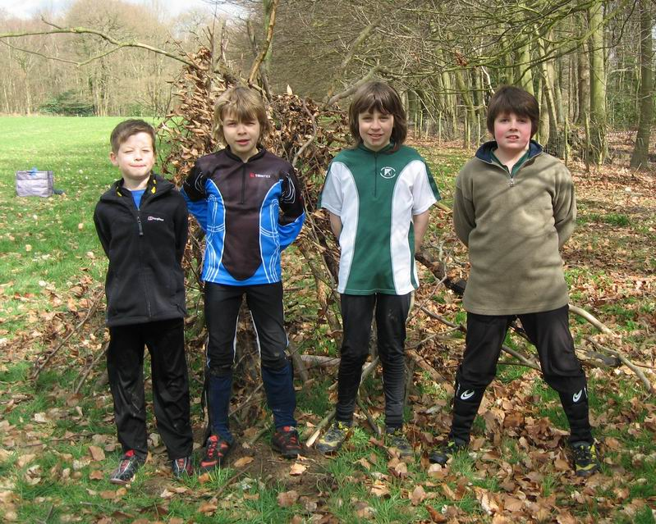
Turn the page for the answer!

Maldon Training Course
The Development Committee ran a successful five week training course at Maldon Promenade Park recently which was funded by development money directed at Clubmark Clubs of which we are one. Clubmark is a quality assurance scheme to show we meet or exceed nationally agreed standards of child protection, junior coaching and other guidelines aimed at encouraging safe and appropriate participation for juniors of all ages and abilities.
The club coaches, along with volunteers from within the club ranks, delivered five successive Saturday morning sessions targeted at Families and Juniors in the Maldon and surrounding areas. Leaflets from the new advertising range offered by British Orienteering were distributed to local schools and our publicity officer, Rachael Archer, managed to get coverage in local newspapers. The sessions were linked and progressive from stars and loops on the first week to a fun score at the last. The results of this are on our website and the picture shows some of the participants with certificates awarded at the end. Free run vouchers were also issued to encourage further participation at future events.
A big thank you must go to the coaches and volunteers who made this event possible. It has hopefully resulted in some new participants being enthused to take up our sport and who will get as much enjoyment as the rest of us from getting lost in the woods on a Sunday morning!!
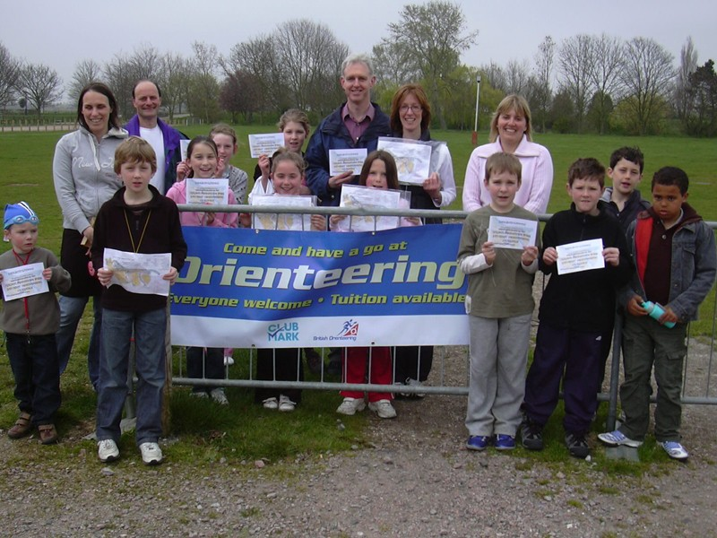
Graduates of the Maldon course with their certificates

Photoquiz Answer
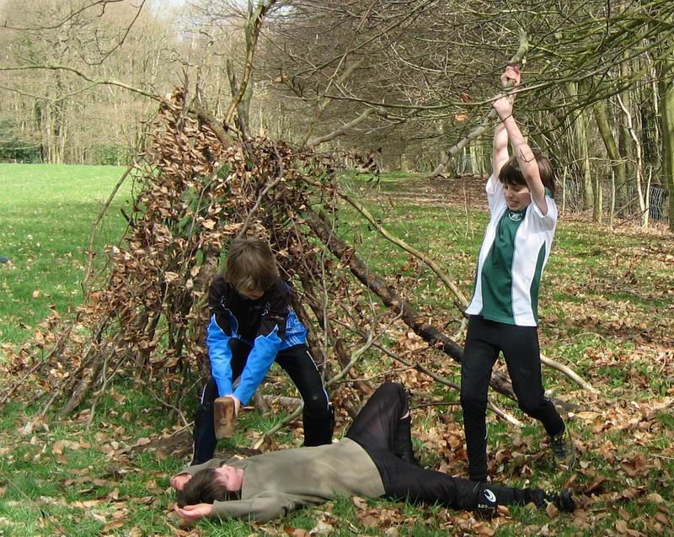
Boys will be boys!

SOS Newsletter Volume 20 No. 13
The next edition of the newsletter will be available on the 5th July 2009 at the Stragglers’ Relays. Avoid blank spaces like the one above by sending copy to the Editors editors@stragglers.info before 25th June.

