 | Essex Stragglers Orienteering Society (SOS) |   accredited

Newsletter Volume 20 Number 15

September 2009

Editors: Geraldine Russell and Andrew Cordle - editors@stragglers.info
Club website - http://stragglers.info

Editorial - Geraldine Russell 2
Editorial - Andrew Cordle 2
Chairman's Chat - Martin Sellens 3
Captain's Corner - Geraldine Russell 5
Essex & Suffolk Schools Orienteering League - Julie Laver 5
Stragglers' League - Andrew Cordle 6
SOS Notice board 7
Meet your club mates - Club Activity Mornings 7
Annual General Meeting 8
British School Score Champs 2009, Hylands Park Chelmsford 7
'O' kit for sale 8
Fixtures in East Anglia and Nearby Regions 8
Tay 2009 - by Catherine Mole 11
Gőteborg 2009 - Jack Isbester 14

Photographs by Jack Isbester, Catherine Mole, and Duncan Harrison.

  Essex Stragglers support the Woodland Trust and its objectives |   Essex Stragglers' development activities are supported by Awards For all

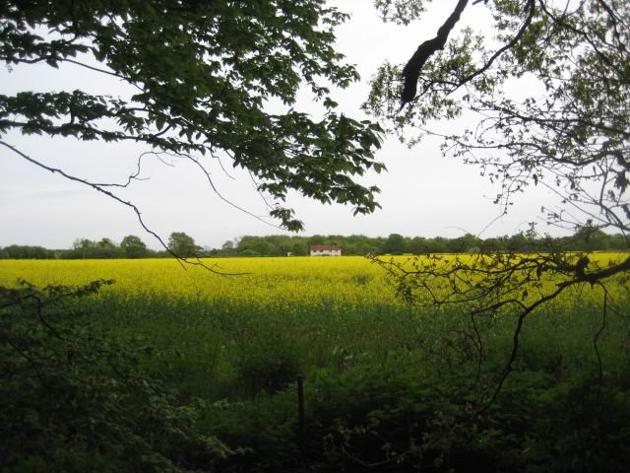
Layer wood from Pods Wood

Editorial - Geraldine Russell
We had an excellent start to the season with a training event at Bridge Wood under the guidance of Richard Barker ably assisted by Tracy Apperley and Julie Laver. All abilities were catered for and it turned out to be a social occasion as well. The next training event is on 3rd October at 10am in Fordham.
Captain's Corner has the details of Compass Sport Trophy on 18th October. We need everyone whatever your ability.

Editorial - Andrew Cordle
Gerraldine and I have been co-editing the newsletter for three years, and at the AGM on 16th October we will be tendering our joint resignations. I'm looking forward to spending more time with the website, and the enticing prospect of getting it up to date, and Gerry will be continuing with all her other official and unofficial Stragglers' roles. I can honestly say that the editorship has been both rewarding and educational. Have a look at the Job Description at http://www.stragglers.info/resources/roledescs.php, talk to the retiring incumbents, and prepare your speech for the hustings at the AGM!

Chairman's Chat - Martin Sellens
Well the nights are drawing in, the leaves are turning brown and the brambles are at their brambliest, but decorated with blackberries that make a satisfying purple stain on maps and hands. It must be Orienteering season. I speak fresh from the experience of a battle with the rampant undergrowth that makes the forests of North Yorkshire such an, (how shall I put this politely?) interesting challenge. A small coterie of mature Stragglers ventured northward for the annual White Rose, based in the middle of the Dalby Forest on what used to be the Moors of North Yorkshire. In years gone by the Straggler's contingent was more numerous, but a succession of wet bank holiday weekends, indifferent orienteering and noisy, Somme-like camp sites seems, oddly, to have put most of us off. Can't remember when the Sellenses last braved the A1 bank holiday parking lot. Anyway, though the areas remain physically tough, with path runs generally a better option than life-threatening blood loss, the organisation was excellent this year and the camp site civilised and well drained. Dalby and it's surrounding area offer great mountain biking and wonderful views and the North Yorkshire coast is an easy and scenic drive (or more strenuous bike ride) away. For the single minded there were two regional events, one night O, a hill race, a mountain bike O and a compass and pacing competition. Geraldine and John Russell flew the Straggler's flag (metaphorically) with Geraldine first overall on both days, and John managing an outstanding second overall showing characteristic grit and (I should talk) uncharacteristic consistency. Well done to them both!
Forgive me for this rather selective reporting of orienteering activities over the summer. Perhaps elsewhere in this edition of the newsletter there are reports of the Scottish and other navigational delights.
I am writing this on 09.09.09 and so far there is no obvious sign of the universe imploding or swine flu mutating into an anti-viral drug-resistant fatal strain that will wipe out Homo not-very-sapiens. However, the day is yet young. On the other hand, if the editors are not in receipt of this copy by the end of the day, (or Universe, whichever comes first) then the presses will roll without, for the first time in living memory, the random thoughts and jottings of the Chairperson. Given that this is my last contribution to this unbroken stream of furniturely consciousness I would like to come up with something meaningful with which to leave you. Unfortunately the best I can come up with is a reminder that the AGM is on Friday 16th October and the compass sport trophy final on Sunday 18th. Please look elsewhere in this newsletter, or on the Straggler's web site, for details of the agenda and venue of the former and the arrangements for getting to the latter by charabanc. Suffice it to say at this point that all are welcome to both events. The danger of attending the former is that you will be so carried away by enthusiasm that you will find yourself elected to the chair. There is no danger whatever in attending the latter, only the chance of a day of untrammelled glory. Who, after all, will wish to admit to their grandchildren that they were not there, on the fields and in the woods of Stamford, to contribute to the victory of the Stragglers against overwhelming odds. At least, it should be a good day out. May you tangle successfully with brambles and bracken and run with the graceful ease of a gazelle/dachshund (delete whichever does not apply).

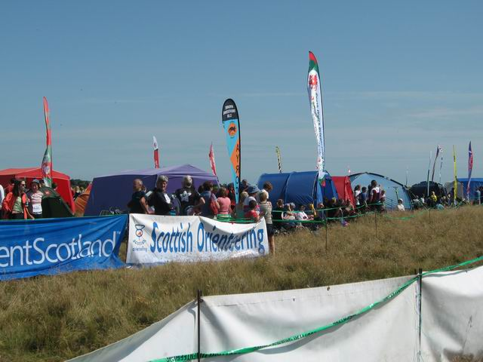
The empty run-in at the Scottish 6 Days.
Just add a Straggler from below!

 | 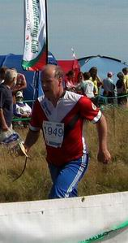

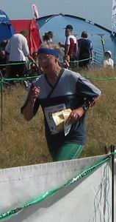 | 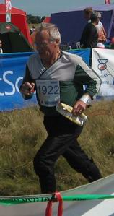 | 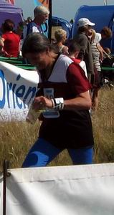

Captain's Corner - Geraldine Russell
Calling ALL members for the Compass Sport Trophy on 18th October
We need as many runners (or walkers) to take part because everyone comes will play an important role if we are to win the coveted trophy. The more the merrier. Even if you don't think you are good enough - we need you!
Half of the entry fee is being paid for by the club therefore members only pay £5 adults and £2 juniors. There will be a coach leaving Chelmsford about 8am on 18th October with pick ups along the A12 and A14. The cost is also being heavily subsidised and will be £5 adults and £2.50 juniors with a cap of £10 per family (only 2 adults though).
Please let me know as soon as possible -
a) whether or not you intend to come
b) if you will be travelling on the coach
c) where you would like to get on it
- by email to geraldine@russell2.fsnet.co.uk, or telephone 01206-272761. Cheques should bemade payable to Essex Stragglers and sent to G.Russell, Brookfield, Workhouse Hill, Boxted, Colchester CO4 5TT or find me in the tent at Roman Valley on 13th September.

Essex & Suffolk Schools Orienteering League - Julie Laver
Briefly, pupils who singularly or in pairs run an age appropriate course unaided by adult or other person score points for each ESSOL designated event. The best 5 scores through the season are added to make their total for that season. The highest scoring participants receive trophies or medals, the others receive certificates if their total score exceeds 100 points. The scoring system enables appropriate reward for pupils running up a class.
The competition is open to any pupil in the SOS, SUFFOC or WAOC catchment areas. The full rules can be viewed via the ESSOL link on our club website as can the current position of all participants which is updated after each event. No special entry is required above the normal event entry but may I request registration details are filled out clearly and in full as it makes collating the data much easier.
If you have any queries about the league please contact me julie.laver@virgin.net or phone 01206 826152.
ESSOL Fixtures 2009-10
2009
13 September | Roman Valley | SOS
11 October | Hatfield Forest | SOS
08 November | Ickworth | SUFFOC
29 November | The Broaks | SOS
2010
07 February | Chalkney | SOS
25 April | Ickworth | SUFFOC
09 May | Danbury | SOS
20 June | Wivenhoe | SOS
Please note these are preliminary fixtures and participants are advised to check Club websites before travelling -
SOS - http://stragglers.info
SUFFOC - http://pdl.demon.co.uk/suffoc.

Stragglers' League - Andrew Cordle
Top ten positions are (position at time of the last newsletter in brackets) -
Posn | Prev Posn |  | Best 6 | Runs
1 | (1) | Richard Bonnett | 600 | 14
2 | (2) | Jenny Collyer | 589 | 12
3 | (3) | John Collyer | 578 | 12
4 | (4) | Martin Sellens | 571 | 6
5 | (7) | Tracey Apperley | 567 | 14
6 | (5) | Hannah Newton | 562 | 12
7 | (6) | Geraldine Russell | 559 | 11
8 | (9) | Claire Harrison | 539 | 14
9 | (7) | Chris Childs | 536 | 16
10 | (10) | Duncan Harrison | 522 | 15
There wasn't much movement at the top over the summer, but there will be plenty of opportunity for progression (or otherwise) at the next league events -
 | 13 Sep 2009 | SOS Roman Valley
 | 11 Oct 2009 | SOS Hatfield Forest
 | 17 Oct 2009 | CUOC Cambridge (City)
 | 18 Oct 2009 | LEI Fineshade (CompassSport Trophy)
 | 25 Oct 2009 | WOAC Mildenhall
 | 8 Nov 2009 | SUFFOC Ickworth
 | 22 Nov 2009 | CHIG Epping E
 | 29 Nov 2009 | SOS Broaks
 | 6 Dec 2009 | HAVOC Langdon Hills
 | 1 Jan 2010 | SOS High Woods?
Check the website http://www.stragglers.info/league for updated information and latest scores.
SOS Notice board

Meet your club mates - Club Activity Mornings
The Development Committee are planning activity mornings with coaching and other social events to take place on the first Saturday of each month. The first has already taken place at Bridge Wood, Suffolk, run by Head Coach Richard Barker and assisted by newly-qualified coach Tracey Apperley. There was a good turnout by new and experienced, young and old members alike with a few participants who were coming along to try orienteering to see if they liked it. I can report that as a result we now have a new member. A drink in a local pub after finished the day with a chance to chat with other club members.
We would like to repeat the experience so for your chance to take part in some light-hearted sessions (and also possible improve your orienteering!) come along to the Permanent Course at Fordham, Colchester on Saturday 3rd October at 10am for circuit and sprint training (subject to confirmation - check the website before travelling). There will be a drink in a local pub for those who wish to socialise after and meet your fellow club members. The following session will be on 7th November at 10am at Highwoods Park, Colchester - meet at the Chanterelle car park.
For more details of either of these events please contact Julie Laver julie.laver@virgin.net telephone 01206 826152. All welcome. If you know of anyone who is not a member but would like to have a go please bring them also.

British School Score Champs 2009, Hylands Park Chelmsford
The club is hosting a prestigious National event this year at Hylands Park, Chelmsford on Saturday 10th October. It is not often an event of this size is within easy travelling distance so if there are any juniors who would like to experience such a large event but were put off by the travelling now is your chance.
Although it is a schools competition you do not have to be accompanied by a member of staff from your school. There are individual as well as team prizes. Just go to the event website http://stragglers.info/bssoc09/, download the entry form, get it signed by your school and return it to me with your entry fee. Final details will be sent after the closing date to your home address if you supply it.
For those who are unsure, a score event is where all the controls are marked on the map and you must find as many as possible in a given time. The younger age classes may run in pairs - see event rules on the website.
For further details please contact julie.laver@virgin.net or telephone 01206 826152.

Annual General Meeting
The club's AGM will be held on Friday 16th October.
Unfortunately, the venue hasn't been decided yet (have you got a room seating 15-20 people for a short meeting probably followed by socialising and a pot-luck supper, convenient to most Stragglers?).
The venue will be announced on the stragglers website http://www.stragglers.info by 25th September.
Put the date in your diary now, and check on the website for the location.

'O' kit for sale
Avaliable at most club events
T-shirts £5 each
Sweatshirts £7 each
With club logo
ALSO
Bring your good quality unwanted 'O' kit to the enquiries point at our events and we will display it for sale.
All items to be marked with the price and sellers name and contact number.
Please collect unsold kit before you leave as we cannot store items.
For New Club 'O' kit see Lyn West

Fixtures in East Anglia and Nearby Regions
The information provided below normally consists of Event Date, Region (eg EA = East Anglia), Event Grade , Event & Location Names and map reference. Organiser's contact details. Contact details, costs, closing date etc. for Pre-entry when provided. Whether Entry on the Day (EOD) is possible and the surcharge payable. The range of courses offered. The address of a website from which additional information can be obtained. Additional information in plain language.
At Essex Stragglers' events registration normally opens at 1000hrs, starts are from 1030hrs until 1230hrs and courses close at 1430hrs.

September
19th | EAOA  WAOC  Local | WAOC Come And Try It Event, Wimpole Hall Cambridge, TL343511  Organiser: Peter Heybrock, peter.heybrock@ntlworld.com Entry On Day: Senior £TBC, Junior £TBC, Student £TBC. , Punch Type: SI, No dogs allowed. Start Times: 10:30 to 12:30 www.waoc.org.uk
20th | EAOA  NOR  Local | NOR Try-O Event & Score Event, U.E.A Norwich, TG196078  Organiser: Alan Bedder, alan.bedder@virgin.net, 01603 424589 Entry On Day: Senior £TBC, Junior £TBC, Student £TBC. , Punch Type: None, Dogs: Dogs on Lead Start Times: Registration:10.00 to 12.00Starts from: 10.30 to 12.30Courses Close at 14.00 www.norfolkoc.co.uk
20th | EAOA  HAVOC  Local | HAVOC Score Event, Bedfords Park Romford, TQ520925  Organiser: Janet Biggs, chairman@orienteering-havoc.co.uk, 020 8883 2338 Entry On Day: Senior £7.00, Junior £2.00, Student £2.00. , Punch Type: SI, Dogs: Under control. Please clean up after your pet. Start Times: 10.30 to 12.30 www.orienteering-havoc.co.uk
26th | SEOA  HH  Local | HH Local, Stanborough Welwyn Garden City, TL228112  Organiser: Penny Parkes Entry On Day: Senior £0.00, Junior £0.00, Student £TBC. , Punch Type: SI, No dogs allowed. Start Times: 10.00-11.00 happyherts.org.uk
27th | SEOA  LOK  Local | Hampstead Heath, Hampstead Heath Hampstead, TQ276862  Organiser: Neil Brooks, neilbrooks@msn.com Entry On Day: Senior £7.50, Junior £2.00, Student £2.00. , Punch Type: SI, No dogs allowed. Start Times: Registration: 0930-1130.Start: 1000-1200.Courses close at 1400. www.londonorienteering.co.uk
October
3rd | SOS  Training | Fordham Permanent Course 10 am  Circuit & sprint training + other orienteering skills
4th | EAOA  SMOC  Local | SMOC Colour Code Event & EA League, Stockgrove & Rammamere Heath Leighton Buzzard, SP917294  Organiser: Keith Downing, keith@keith-o.demon.co.uk, 01234 270018 Entry On Day: Senior £TBC, Junior £TBC, Student £TBC. , Punch Type: SI, No dogs allowed. www.smoc.info
10th | EAOA  SOS  Regional | British Schools Score Championships, Hylands Park Chelmsford, TL680048  Organiser: Julie Laver, julie.laver@virgin.net, 01206 826152 Postal Entry: Julie Laver, Ford House Ford Lane, Alresford, CO7 8BB, 01206 826152, julie.laver@virgin.net. Cheques payable to Essex Stragglers OC No Entry On Day. Entries Close: 21/09/2009. Senior £0.00, Junior £4.00, Student £0.00, Punch Type: SI, No dogs allowed. www.stragglers.info
11th | EAOA  SOS  Local | SOS Colour Code Event & Essex & Suffolk Schools League (ESSOL), Hatfield Forest Bishops Stortford, TL547203  Organiser: Jack Isbester, IsbesterJ@aol.com, 01621 815501 Entry On Day: Senior £7.00, Junior £2.00, Student £2.00. , Punch Type: SI, No dogs allowed. www.stragglers.info

17th | EAOA  CUOC  Regional | CUOC Cambridge City Race & Icenian Trophy, Cambridge City Cambridge, TL453592  Organiser: Clare Sutherland, cs492@cam.ac.uk, 07789871376 Online entry through www.fabian4.co.uk No Entry On Day. Entries Close: TBC, Punch Type: SI, No dogs allowed. www.cuoc.org.uk
18th | EMOA  LEI  National | Compass Sport Cup Final, Fineshade Stamford, SP990985  Organiser: Chris Phillips, onecphillips@lineone.net, 0116 255 0330 Postal Entry: Chris Phillips, 25 Henley Road Leicester, LE3 9RD, 0116 255 0330, onecphillips@lineone.net. Cheques payable to Chris Phillips No Entry On Day. Entries Close: 09/10/2009. Senior £11.50, Junior £5.50, Student £5.50, Punch Type: SI, Dogs: On Lead Start Times: 10.30 to 13.30 www.leioc.org.uk
25th | EAOA  WAOC  Local | WAOC Colour Code Event & Yvette Baker Trophy Regional Qualification Round, Mildenhall Woods Thetford, TL728750  Organiser: Catherine Pennington Entry On Day: Senior £8.00, Junior £3.00, Student £3.00. , Punch Type: SI, No dogs allowed. Start Times: 10:30 - 12:30 www.waoc.org.uk
November
7th | SOS  Training | Highwoods Chanterelle car park 10 am  Organiser Julie Laver
8th | EAOA  SUFFOC  Local | SUFFOC Colour Code Event, EA League, Essex & Suffolk Schools League (ESSOL), Ickworth Park Bury St Edmunds, TL815615  Organiser: Peter Warland Entry On Day: Senior £7.00, Junior £2.00, Student £TBC. , Punch Type: SI, Dogs: On leads Start Times: Registration from 10:00. Starts from 10:30 until 12:30 www.pdl.demon.co.uk/suffoc
15th | EAOA  NOR  Local | NOR Colour Code Event, Sandringham Country Park Kings Lynn, TF689287  Organiser: Julia Paul, juliacpaul@aol.com, 01485 541031 Entry On Day: Senior £0.00, Junior £0.00, Student £0.00. , Punch Type: SI, Dogs: Dogs on Lead Start Times: All courses:10.30 to 12.30courses close at 14.30 www.norfolkoc.co.uk
22nd | SEOA  CHIG  Regional | Regional Event, Epping E Loughton, TQ428985  Organiser: Ray Curtis, curtis.rosemount@sky.com, 01279 418699 Entry On Day: Senior £TBC, Junior £TBC, Student £TBC. , Punch Type: SI, Dogs: Keep on a lead. Start Times: 10.30 - 12.30 www.chig.org.uk
29th | EAOA  SOS  Local | SOS Colour Code Event, Essex & Suffolk Schools League (ESSOL) and SOS Club Championships, The Broaks Halstead, TL790306  Organiser: Mark Lyne, m.lyne@writtle.ac.uk, 01787 478524 Entry On Day: Senior £7.00, Junior £2.00, Student £2.00. , Punch Type: SI, No dogs allowed. Start Times: 10.30-12.30 www.stragglers.info

December
5th | SEOA  HH  Local | HH Local Event, Verulamium St Albans  Entry On Day: Senior £TBC, Junior £TBC, Student £TBC. , Punch Type: None, No dogs allowed.
6th | EAOA  NOR  Local | NOR Colour Code Event & NOR Club Championships, Kelling Heath Holt, TG110415  Organiser: Alan Bedder, alan.bedder@virgin.net, 01603 424589 Entry On Day: Senior £TBC, Junior £TBC, Student £TBC. , Punch Type: SI, Dogs: Dogs on Lead Start Times: Registration: 10.00 to 12.00Starts from: 10.30 to 12.30Courses close at 14.30 www.norfolkoc.co.uk
6th | EAOA  HAVOC  Local | HAVOC Langdon Hills, Langdon Hills Basildon, TQ696861  Organiser: Janet Biggs, chairman@orienteering-havoc.co.uk Entry On Day: Senior £7.00, Junior £2.00, Student £2.00. , Punch Type: SI, Dogs: Under control. Please clean up afterwards if necessary. Start Times: 10.30 to 12.30 www.orienteering-havoc.co.uk
13th | SEOA  SAX  Regional | Regional Event, TBC TBC  Entry On Day: Senior £0.00, Junior £0.00, Student £0.00. , Punch Type: None, No dogs allowed.
20th | SEOA  MV  Local | MV Local Event (inc SE Vets & Families Comp), St Leonards Forest Horsham/Crawley, TQ194314  Organiser: Neil Lewer Entry On Day: Senior £TBC, Junior £TBC, Student £TBC. , Punch Type: None, No dogs allowed. www.mvoc.org
27th | EAOA  NOR  Local | NOR Informal Xmas Score Event , Horsford Heath Norwich, TG184176  Organiser: Alan Bedder, alan.bedder@virgin.net, 01603 424589 Entry On Day: Senior £5.50, Junior £1.50, Student £1.50. , Punch Type: None, Dogs: on leads please Start Times: Registration open 10.15 to 11.00am; Orange starts from 10.20 to 11.00am. 60min Score Event, one Mass Start at 11.00am. www.norfolkoc.co.uk

Tay 2009 - by Catherine Mole
My first visit to a big orienteering event was the 2009 Scottish 6 Days in Tayside. I was running W10A, which was the same as the Yellow courses that I run in East Anglia. This is my diary for the week, which Dad helped me write.
Day 1 Sunday 2nd August Dalrulzion (Near Bridge of Cally)
It was our first day running and there was a huge walk to my start that was very tough underfoot so we were almost late. Just as we arrived at the Start they called me up, four minutes before my start time. Dad explained all that was going on, and I set off. Running quickly from the start I jumped a log, but landed badly and hurt my ankle so I hobbled the rest of my course. When I finished I was the only SOS member back at the tent until Nick came in just in time to help me peg the tent back up to stop it from blowing away. When the rest of my family came back we had an ice cream. After a while of chatting about our courses we packed up the tent and went home, which was only 6 miles away.
Day 2 Monday 3rd August Kinnoull Hill (near Perth)
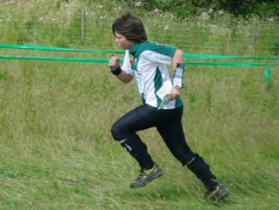
When I woke up my ankle was still hurting and so Mum and I went to see the first aiders when we arrived at Kinnoull Hill. They put a cold pack on it for ten minutes then a fizzyman (physiotherapist) looked at my ankle. He said it was sprained so I should not run today. Mum and I sat outside the tent in the sunshine and watched the runners come in. We took this picture of my brother racing up the run-in.
Day 3 Tuesday 4th August Tullochroisk (near Loch Tummell)
Today we had a long drive in the rain and had to queue for ages to get into the car park as the cars were slipping in the mud. We found the SOS tent and got ready to run. My ankle felt good enough to run, but we went to check with the physiotherapist. We said goodbye to my Dad as his start was in the other direction and went off to our start. My brother was off first, then me and my Mum. The land was hilly and open and we had to cross through a stream near the finish, which was quite deep because of the rain. When we got back to the tent Henry and Nick were all ready there. My Dad was last to come in. When we got home I had a hot chocolate after we had tea I went to bed.
Day 4 Thursday 6th August Tentsmuir (South side of Tay Estuary)
We had to drive across the Tay Bridge today, and arrived in plenty of time as we had to eat lunch before we ran. I was feeling tired by the time we arrived. We ate our lunch, and had quite a long walk to the start, but at least it was flat and sunny! I was first in our family to start my course, but when I finished, I found I had mis-punched. I had thought I was at number 5, when I was at 4 and so missed out number 5. When we got back home we had a really early bed time, as we had early starts the next day.
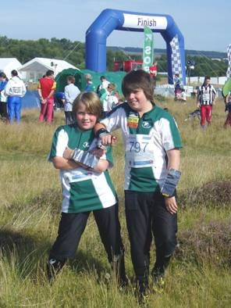
Today we woke up really early and arrived at the event at 8:40am. Here is me and my brother waiting to go straight to the start as I was the first competitor on my course.

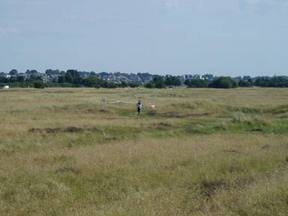

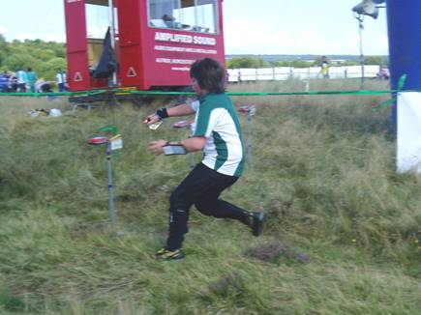
It was very sunny and flat on the sand dunes and I was the first to finish in only 20 minutes. The commentator called out my name as I came down the run in. Here is a photo me leaving the last control.

I finished before Henry had started, so I went to see him start. Here is my brother showing his finishing style “I watched the elites and they grab the finish stake…”
After every one had come in, we packed up the tent as it was our family’s turn to take it home.
Day 6 Saturday 8th August Loch Ordie (near Pitlochry)_
We had to get there early today to set the club tent up near the finish. We set off for the start in good time as it was a long walk and uphill, but we ended up having to wait ages in the sun for our start times. The course was hilly and easy at first, but got harder at the end. I saw a stag deer on my way down the hill. He came running towards me and off through the open fields. We watched his antlers disappear over the long grass. When I finished I was exhausted. I had some lunch while waiting for Dad to finish and then I went round the off-string course with Dad and the string course with Nick. I was given a frisbee as a prize for completing the off-string course. We saw the prize giving for the elite runners and heard the bagpipes. We said goodbye just as the rain was starting and headed back to our cottage. When we got home I went to bed.

Gőteborg 2009 - Jack Isbester
Stragglers who participated in the SOS Swedish O Tours of1986 or 1990 (a small and select group) will be distressed to learn that the fine Skatås Sports Centre ('Motioncentralen') on the Eastern fringe of the city has been razed to the ground though their distress may be eased when I explain that an even better centre has been built to replace it on an adjacent site.
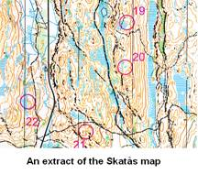 |  |  |  | My grandson Tom and I started a ten day holiday in Scandinavia at the end of June with two days in Gőteborg for the purpose of using those excellent facilities. The centre is situated in an area of fine orienteering countryside with crags, marshes, boulders, thickets, clearings and footpaths. Orienteering maps are available at Reception and 40 permanent controls are in place allowing you to plan a course — anything from 2k to 20k — to suit yourself. I think that an even more extensive map was available too, though I didn't pursue that.
The permanent controls are 20x20 cm plastic cards attached to trees and are not to be confused with the occasional conventional orienteering markers forgotten by previous event planners! |  | 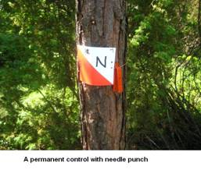 |  |  |  |  |  | 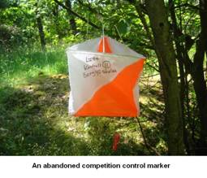
The changing rooms are pristine, lockers for clothing and valuables are provided, with users expected to provide their own padlocks,though a small number of padlocks can be borrowed from Reception.  The showers, sauna and cold plunge are all excellent. Towels cannot be hired but can be bought, if you don't have one with you. Tom tells me that the facilities in the gymnasium were impressive though I didn't use them after my orienteering session. |  |  |  |  | 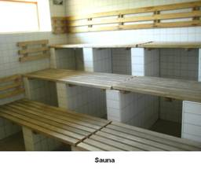  
I did use the cafeteria where the range of baked potatoes, pasta, pizzas and salads was wholesome and reasonably priced. | 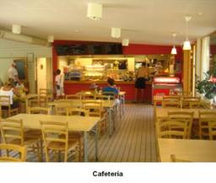 |  |  |  |  |  | 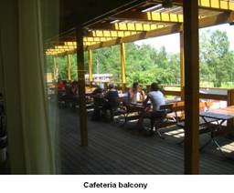
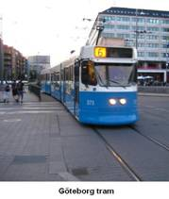 |  |  | Travel by public transport in Gőteborg is cheap and convenient. We took the airport bus from the City airport to Central Station and used the excellent tram service thereafter.  I didn't keep a note of prices but use of the sports centre was about £3, cafeteria meals were about £7, the O-map about £1, airport bus £6 and a multiple journey tram ticket about £1
A SOS Club trip? It makes the idea of an orienteering weekend in Gőteborg an interesting proposition. Early Saturday morning Stansted/Gőteborg by Ryanair, orienteer in the afternoon at Skatås, evening letting down your hair in the Liseberg Gardens, overnight at a B&B (under £50 for twin beds), on Sunday morning back to Skatås or one of the other Gőteborg sports centres - there used to be five - then back to Stansted on the evening flight.  Dave Skinner suggests we hold the SOS championships there next year. In the winter the orienteering is replaced by skiing but you can probably orienteer from April to October. If the idea tempts you let me know and I will probably ask to accompany you. |  |  |  |  |  | 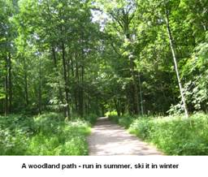

NEXT SOS Newsletter
The next edition of the newsletter will be available on the 29th November 2009 at the Broaks Wood event. Copy to the Editors editors@stragglers.info before 20th November.

