 | Essex Stragglers Orienteering Society (SOS) |   accredited

Newsletter Volume 20 Number 8

April 2008

Editors: Geraldine Russell and Andrew Cordle - editors@stragglers.info
Club website - http://stragglers.info

Editorial - Andrew Cordle 2
Editorial - Geraldine Russell 3
Chairman's Chat - Martin Sellens 3
Schools League Report - Julie Laver 7
Stragglers' League - Andrew Cordle 8
SOS Notice board 9
Summer Series - Julie Laver 9
Saturday Coaching Sessions - Julie Laver 9
National Badge Scheme - Dave Birkett 10
Fixtures in East Anglia and Nearby Regions 11
Letters and emails 13
EMIT cards - Further correspondence collated by Jack Isbester 13
Sport Essex Coaching Conference - Steve Cartwright 14
A Stragglers Newsletter from 1970 - Ron Russell 15

Photographs by Lyn West, John Burgess and Geraldine Russell

 Essex Stragglers support the Woodland Trust and its objectives

Editorial - Andrew Cordle
Welcome to this Double Edition of the Newsletter, containing both the normal words and pictures you expect, and the entire text of the Oldest Stragglers Newsletter In Existence (unless you know better). How times have changed! We now get electronic contributions from Southern Europe (thanks, Jack) and one person doesn't have to write the entire newsletter. That's where you come in ...
One question a get asked a lot (often by the same people) is why people do or don't get emails from Essex Stragglers. There are two ways this can happen -
- You receive official club communications (newsletter, Notice of AGM, occasional pleas for help, etc.) at the email address notified to the Membership Secretary geraldine@russell2.fsnet.co.uk either directly or via your membership renewal. You can opt out of this if you like, but more importantly for Family Members, you can provide Geraldine with an email address for each of you so that none of you miss out if you are not talking to each other.
- You can join the Stragglers Email Group (SOSMembers) at http://groups.yahoo.com/group/sosmembers or by email to sosmembers-subscribe@yahoogroups.com, or on the Members Resources page of the Stragglers Website at http://stragglers.info/resources. Anyone who is a member can send a message to everyone in this group, either from the groups.yahoo or stragglers websites, or by email to sosmembers@yahoogroups.com. You can use this group for arranging lifts to events, criticising the committee, selling your out-grown O-kit, or anything else Stragglers-related. Only group members can see your posts, and only club members can join the group, so its just like a chat at an event, really. If you have trouble joining, contact andrew@cordle.net who will try to sort it out.
There was a small but fatal error in the Membership List sent with the last newsletter. Eddie Banks' email address end in .gotadsl.co.uk rather than .gotads.co.uk . More membership news soon!

Editorial - Geraldine Russell
A big thank you to everyone who has contributed to this newsletter. Photos of our stalwart members at the JK over Easter will show those, who stayed in their warm homes or flew off to sunnier climes, just what a treat they missed. Trying to read the map and compass covered with a thick layer of snow whilst looking for a control with streaming eyes due to the cold wind and sleet was definitely an initiation in polar survival - let's hope global warming is not too far away!!! | 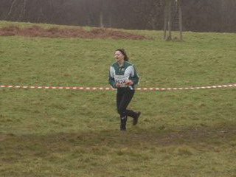  Gerry enjoying the Easter weather
Remember to take your cameras to events and keep the piccys coming not to mention any news or articles you want to submit. You don't HAVE to wait until the final week before publication to send them in - let us have them asap and make Andrew a happy man.

Chairman's Chat - Martin Sellens
The cycle of the year is ticked off by the coming and going of ancient and religious festivals; the autumn equinox, the winter solstice, Christmas (ostensibly to cheer us up a bit), Easter (a bit of a downer really), Divali and Ramadan in these multicultural times etcetera etcetera. Or if you’re an orienteer, the CATI season, Compass Sport Trophy, Cordle’s post-Christmas Capers, East Anglian Champs, JK, British, O-Ringen for the jet-set, Welsh or Scottish for those with a size 7 carbon footprint, the White Rose….. Somehow it’s all quite reassuring. We are creatures of habit. And so it was that a stalwart band of Straggler’s eschewed egg rolling and bunnies in favour of snow and noisily flapping nylon (canvas having been consigned to the landfill of history) in the bleak hills of Leith and Ashdown to pay homage to the memory of Jan Kjellstrom. Easter came early this year and winter late, just to be awkward. You may have noticed. It might have felt like the coldest ever JK, but those of us with long memories and longer teeth can recall camping in Sutton Park for a Cannock JK back in the early 80s where the milk froze solid overnight, a Lakeland JK when the relays on Ulpha Moor were cancelled because of snow and a Welsh JK in more recent times when Day 1 was cancelled on account of snow and ice on the rocks of some windblasted moor or or other near Dolgellau. But isn’t that what memories are constructed from? So congratulations to all those who enjoyed the icy blasts and slithery mud of JK08. Some have already booked their accommodation for Northumberland next year. And for those of you who have so far resisted the siren call of the multi-day event; stop it now! Give in! Join us in the Stragglers tent, where good cheer prevails despite the planner’s best efforts and the vagaries of the English weather. You know it makes sense.
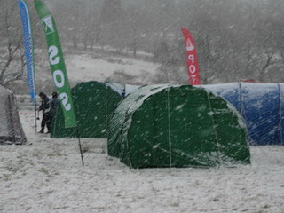  The club tent at the JK | 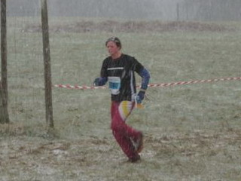  Jo West encounters some snow
So, what else has been happening? In the East Anglian Championships, back in February, we had 8 winners against 14 for WAOC, 6 for NOR and 1 for HAVOC. It was particularly good to see Thomas Birkett, Hannah Newton and Ellen Sanderson winning their first regional trophies in M12, W14 and W16 respectively, and James Park (now M18) picking up his third win in four years; results that surely bode well for their futures in the sport. At the other end of the age range Jenny Collyer won her 4th championships in 5 years and (to Geraldine’s disappointment) shows no sign of slowing down. Somewhere in the middle, (journalistic integrity overcomes modesty here) Hilary, Martin and Chris Sellens managed a family hat-trick. Congratulations to us all!
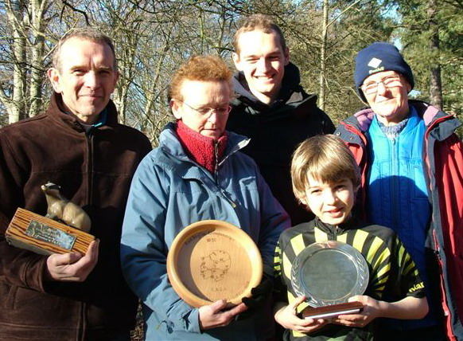
Martin, Hilary and Chris Sellens, Tom Birkett and Jenny Collyer at the EA Championships
Since the last Newsletter the club has put on local events at Chalkney and Hockley and I would like to take this opportunity to thank the planners (Steve Cartwright and Clive Tant) organisers (Geraldine Russell and Dave Birkett) and controllers (Bert Park and John Collyer) for their sterling efforts on our behalf. Other Stragglers too numerous to mention also willingly gave of their time to help out at these events and, as absentee chair on both occasions, I thank you all on behalf of the hundreds of orienteers from throughout East Anglia who came to our small but beautiful pockets of woodland and left tired but satisfied. Or just tired, but that’s their problem.
Behind the scenes I must just mention the hard work that John Collyer is putting into applying for a lottery-funded grant through the Awards for All (A4A) scheme. The £7000 bid is to support the development of permanent orienteering courses at Hylands, Notley Park and High Woods as well as a Schools’ Day in the Chelmsford area, mapping costs and equipment. If successful, this would be a major boost to our efforts to promote Orienteering in North East Essex and a serious threat to our continued status as a small club! Permission has also been secured for the mapping of Writtle forest after breakthrough discussion with Lord Petre, the landowner and Lord Lieutenant of Essex. Many thanks to Geraldine Russell, whose initial approach to Lord Petre opened the door to this exciting development which will have a huge impact on our ability to host major events. Julie Laver’s development committee and the SOS coaching team under head coach Steve Cartwright have a full programme of coaching in place and the summer series (another landmark of the passing of time) will soon be upon us. So, what are you waiting for? Knock the mud off those O shoes and get out into a forest or country park near you, where our dedicated coaches will help you hone your skills and fitness. Or just join like minded folks with a love of fresh air and meandering about looking for controls for a good natter.
There may be much of import that I have forgotten to say. There is ample evidence, often commented upon my family, that dementia beckons. But everything of note can be found on the club website at http://stragglers.info. Over 50,000 hits so far. That many people can’t be wrong. Give it a click.
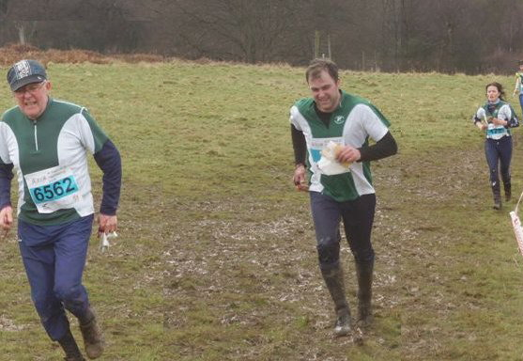

John Collyer, Duncan Harrison and Daniela Brohm on the JK Relay run-in
Captain's Corner - Jenny Collyer
A very cold and snowy JK is behind us now. I entered 9 teams in the relay and owing to illness and injury 8 teams competed on the day. Our teams included the mini relay for the 12’s and under, men’s and women’s open, senior and veteran classes. Notable performances came in the mini relay where Tom Birkett and Nick Harrison were in 3rd place and a brilliant performance by Tom Burgess, fairly new to orienteering and standing in at the last minute, brought the team home in 4th place. Another good performance came from Ann Roller who came in 2nd place on the 1st leg of the W120+ a few seconds behind the leader despite managing to tear her map in half through the start triangle while pulling it out of the bag!
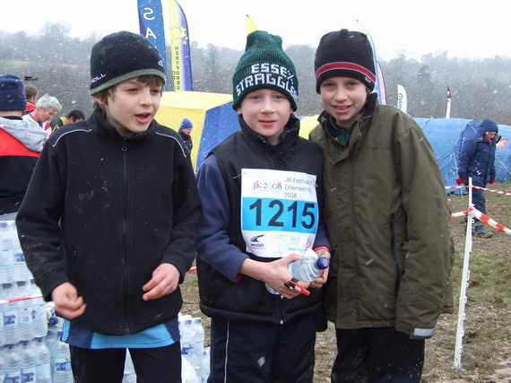
The Mini-Relay team
Entries for the British Relay Championships in Scotland close this week and it looks as though we will not be entering any teams this year. John and I will be making the much shorter journey to Warwickshire for the British Short and Middle Distance Championships on the 5th and 6th April. I recommend this event to you – the sprints particularly are great fun – you don’t have to run any faster just concentrate harder.
Please remember to keep the 19th Oct free for the Compass Sport Trophy Final at Sutton Park, near Birmingham.

Schools League Report - Julie Laver
With one more ESSOL event to go for this season the competition is getting exciting with most of the classes still open. I can't wait to see who the final winners will be at Wivenhoe Park on June 15th.
After the runs there will be a prize giving ceremony for the winners of each class and a shield for the overall winning school team.
Participation certificates will be sent to the schools of all pupils who earned over 100 points to be presented in assemblies. The latest leaders of the league are as follows -
Up to Y6 boys | Up to Y6 girls
Thomas Birkett | Rachael Harrison
Bryn Wilkinson | Isabella Coutts
Nicolas Harrison | Elspeth Harrison
Y7/8 boys | Y7/8 girls
Joshua Jones | Rhiannon Ware
Rory Coutts | Lucinda Wilkinson
Thomas Hemmingway | Emma Vidler
Y9/10 boys | Y9/10 girls
Michael Park | Alice Rigby
Will Hooton | Sarah Roach
Alex Ware | India Hayes
Y11/12/13 Boys | Y11/12/13 girls
James Park | Sarah Park
Conor Weed | Hannah Newton
Dean Miller | Ellen Sanderson
School Team Trophy
Barnardiston Preparatory
Coppleston High
Meadgate Primary
To ensure that everyone receives their certificates and medals please check your details on the ESSOL page of the website and let me know if there is anything amiss. This is especially important if I don’t have your school name as I cannot send your certificates. Good luck to all competitors and see you at Wivenhoe!

Stragglers' League - Andrew Cordle
After six more events, the top 11 scorers (it seemed churlish to leave Duncan off, being only one point away from the Top 10) are -
Posn | Name | Best 6 | Runs
1 | Jenny Collyer | 597 | 9
2 | Richard Bonnett | 569 | 8
3 | Geraldine Russell | 554 | 11
4 | Hannah Newton | 551 | 12
5 | John Russell | 545 | 11
6 | Martin Sellens | 544 | 6
7 | Chris Childs | 536 | 10
8 | Bert Park | 531 | 11
9 | James Park | 526 | 13
10 | John Collyer | 507 | 10
11 | Duncan Harrison | 506 | 12
Now that many of the more competitive Stragglers have completed six events, the leader board is less fluid, but there is still the opportunity to improve positions with a good run. Further down to table with 20 runners in the 400-499 point range, there is more room for movement.
The next League events are -
 | 6 Apr 2008 | HAVOC Bedfords Park
 | 27 Apr 2008 | WAOC Chicksands (Sprint)
 | 10 May 2008 | SOS Castle Park (Sprint)
 | 15 Jun 2008 | SOS Wivenhoe
Tacticians will note that Jenny Collyer is planning the Castle Park event, so there may be a chance to pick up a big score there!
I haven't included the Stragglers Relays. Looking at last year's results, there were only four teams which could have been included in the calculation - unfortunately its not the sort of event where all the helpers can get a competitive run. Let me know if you think the event will be more competitive this year - we can add the event to the League any time up to the next Newsletter.

SOS Notice board

Summer Series - Julie Laver
As normal the development committee are organising a Summer Series of ‘Come and Try It’ events. These low key events are aimed at enticing new and inexperienced participants to have a go and hopefully get them hooked ready for the new season in the Autumn.
The difference this year is we thought it unfair that there was nothing for the more experienced club member who might be wanting a little something to keep them going so we are offering the following -
May 10th, Castle Park - Sprint race using the park and some surrounding streets. Planned by Jenny Collyer this will be in two parts, the time of your second run will depend on how well you did in the first. As some of the course uses the estate roads and carpark we are suggesting that under 16’s are accompanied by an adult unless authorised by the organiser.
There may be a small trophy for the winner!
May 31st, Notley Country Park - Have you ever wanted to help at a club event but did not have the skills? We are going to use this CATI to train club members in the arts of SI, organising, setting string courses, and other useful tasks. This will enable you to volunteer with confidence and claim your free run at the event you help at. Do not forget we cannot put on these events without willing volunteers and the more people who help the easier it is for everyone.
July 12th, Highwoods - Norwegian event. This is a fun and challenging way of testing your navigation and map memory skills to the full. Come and see how good you are!
Full details of these events will be published on the website nearer the time. If there is a particular skill you would like to see covered at the training event please contact me julie.laver@virgin.net or any member of the Development Committee.

Saturday Coaching Sessions - Julie Laver
How is YOUR orienteering? Did your last run go to plan or did you waste valuable minutes looking in the wrong place for the control? Could you technique do with some improvement?
Do not worry – help is at hand!!
The SOS coaching team will come to your rescue!!
We are running Saturday morning coaching sessions for all club members in a variety of techniques for all abilities from young beginner to experienced veteran.
We meet at various venues from 10 am to 12.30 on the first Saturday of the month.
There is NO CHARGE for this valuable service (except car parking at some venues) – just dress in normal orienteering kit suitable for the weather conditions, bring a drink and snack and your ENTHUSIASM.
You will be coached by members of our experienced team and get a chance to meet some of your fellow club members in an informal and fun session.
The next dates are -
April 5th - Wivenhoe park
May 3rd - Bridge Wood
June 7th - Highwoods
As ever these are subject to change so please check website for final details nearer the time.

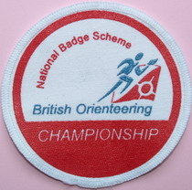
National Badge Scheme - Dave Birkett
For those of you debriefing your JK experience would a plan to achieve a coveted Championship Badge have made any difference? It’s an incentive to do well and along with the other badges provides a ready-made goal to form an action plan to improve your orienteering.

The main points of the scheme are:
- Four grades – Championship, Gold, Silver and Bronze.
- Championship requires completing three events within the winner’s time + 25%. At least one of the events must include the British Championships or JK, with the other(s) being achieved at a National event.
- Gold, Silver and Bronze require completion of three Regional events or above within base time + 25%, 50%, 100% respectively. Base time depends on the number of starters and length ratios.
- Certificates and cloth badges available from BOF badge scheme secretary.
- See http://www.britishorienteering.org.uk/event/about.php#badges for further details.
You also get your name in lights in British Orienteering's magazine focus.
This could be yours...
So why not go for a badge and see if it provides the incentive to do better.

Fixtures in East Anglia and Nearby Regions
The information provided below normally consists of Event Date, Region (eg EA = East Anglia), Event Grade and Type (Grade 1 is highest grade, Grade 5 is lowest. Type C is a conventional Cross Country event in which controls must be visited in the sequence listed on the description sheet). Event & Location Names and map reference. Organiser's contact details. Contact details, costs, closing date etc. for Pre-entry when provided. Whether Entry on the Day (EOD) is possible and the surcharge payable. The range of courses offered. The address of a website from which additional information can be obtained. Additional information in plain language.
At Essex Stragglers' events registration normally opens at 1000hrs, starts are from 1030hrs until 1230hrs and courses close at 1430hrs.

April 2008
13th | SE | SO Regional Event & SE League. Houghton Forest, Arundel. TQ001108.
 | C3 | Organiser: Dave McTurk, 01243 782991. dave.mcturk@googlemail.com
 |  | Entries: Jaquie Drake, East Cottage, Vuggles Farm, Newick, East Sussex, BN8 4RU, 01273 400603. entries@vuggles.co.uk CD: 30/03/08. £10.00/£3.00 SO juniors free. Late entry + £1.50 on senior fees (no junior surcharge). Colour coded EOD only - seniors £7.00, juniors £3.00. Lim EOD + £3.00. Chq: Southdowns Orienteers. EPS-SI. Light Green, Orange, Yellow & White, String course. Parking £1.00. SO 24-hr Ansaphone - recorded event information 01903-239186. On line entries at http://www.vuggles.co.uk/entries.htm. www.southdowns-orienteers.org.uk
17th | SE | LOK Score Event. Hyde Park, London. TQ274804.
 | S5 | Glen Jones, 020 8450 0444. glen@glenandfelicity.co.uk £7.00/£3.00 £2 deduction for BOF/local members. EPS-SI. No dogs. Mass start at 19:00hrs. www.londonorienteering.co.uk
20th | EA | NOR District Event. Pretty Corner, Sheringham. TG152413.
 | C4 | Mike George, 01603 408269. £5.50/£1.00, Family Units & Groups £6.50. EPS-SI. String course. Dogs allowed on lead please. www.norfolkoc.co.uk
27th | EA | WAOC Sprint Event. Chicksands, Bedford.
 | O4S | Ursula Oxburgh, 01223 357199. uoxb00@esc.cam.ac.uk £7.00/£2.00. EPS-SI. String course. Dogs allowed in car park on lead. www.waoc.org.uk
27th | SC | BKO District & SCOA League Event. Yateley Heath, Camberley. SU812585.
 | C4 | Liz Yeadon, 0118 934 5412. EPS-Emit. String course. Courses: White to Brown. Courses close at 15:00. Registration 09:30 - 12:00. Starts 10:00 - 12:30.

May 2008
3rd | EA | SOS Coaching, Bridge Wood, Ipswich. Contact Richard Barker
 |  | barkersuff@aol.com
10th | EA  C5 | SOS Local Sprint Event & Come and Try It. Castle Park, Colchester. TM999258. Julie Laver, 01206 826152. julie.laver@virgin.net £4.00/£2.00, CATI £2.00/£1.00. White-Orange for CATI entrants. www.stragglers.info
11th | EA | NOR ? Possible C4 event ? to be confirmed
17th | SC | JOK Chasing Sprint. Bloom Wood, High Wycombe. SU883894.
 | O3S | Pauline Sinclair, 01865 779471. pauline.sinclair@physics.org Fees TBA. Parking £1.00. www.jok.org.uk
18th | EA | SMOC ? Possible C5 event ? to be confirmed
31st | EA | SOS Come and Try It plus coaching day ? Great Notley Country Park and Discovery Centre

June 2008
1st | SC | BADO District Event & SCOA League. Chawton Park, Alton. SU670373.
 | C4 | Mike Broderick, 01256 351624. wbroderick@lineone.net £7.00/£2.50. EPS-Emit. String course. There will be a punching start. www.bado.org.uk
7th | EA | SOS Coaching, High Woods, Colchester. Contact Julie Laver julie.laver@virgin.net
8th | EA | NOR ? Possible C5 event ? to be confirmed
15th | EA | SOS District Event and East Anglia School Championships. Wivenhoe Park & Woods, Colchester.
 | C4 | Colin West, 01206 322905. orienteering@grovehillhouse.wanadoo.co.uk £7.00/£2.00. EPS-SI. White to Blue, String course. www.stragglers.info
22nd | EA | SMOC ? Possible C5 event ? to be confirmed

Letters and emails

EMIT cards - Further correspondence collated by Jack Isbester
From: jcollyer48@btinternet.com

Hi Jack and Dave

I have just read your "article" in the newsletter. I am actually in possession of 2 EMIT cards. My original one (basic type) I bought in Finland last July at the World Masters as they were charging 10 Euros to hire one. After that John ordered one with a display and was sent 2 (and charged for) so I decided to take over one of those. I therefore have the basic version one for sale. I am willing to accept an offer (£20 or less). However I am unable to give a guarantee that it will make you run faster!

Jenny

From: Ian Ditchfield
To: Dave Skinner
Subject: EMIT and Newsletters

Hi,

I was browsing your site primarily to see how you present your Newsletter.
Mole Valley are considering whether to continue producing a paper Journal, supplemented with more frequent email bulletins, or whether to abandon paper communication altogether (except for printing and posting emails for the few who have no computers). How have SOS members received your web-based newsletter, which seems excellent to me? Do you print and post to anybody?

I also noticed your EMIT v SI debate. If buying a brikke, I would strongly urge forking out for the version with the display. The nuisance with early versions of EMIT is having to fit the brikke into the socket. With a display, you simply poke the end of the brikke vertically at the base of the socket, no intricate fitting required, and check while running away from the control that the display is indicating a recent punch. With practise, you will be able to work out exactly how little you need do to get a punch recorded, saving seconds, and awkward twisty wrist motions, at each control. The other advantage of a display comes at score events, your elapsed time is displayed on the brikke, very useful if like me you forget to set your watch when starting score events.

Ian

[Jenny's offer is still open - it's the basic model with no display. Dave decided he did not need an EMIT card, Jack bought a new card with a display - just see who has the better results!]

Sport Essex Coaching Conference - Steve Cartwright
Being the planner for Chalkney I was unable to attend this years BOF Coaching Conference (to the disapproval of the coaching hierarchy it seemed) so opted for the reasonably local general version at Benfleet. Sport Essex are required to oversee the development of Sport in Essex and to ensure there is a helpful sporting legacy following the 2012 Olympics. Apart from the seminars it was great to be able to chat with people from a whole range of sports and to listen to good and bad.
For myself the main interest was probably the theories surrounding motivation and since the conference I’ve specifically read a couple of books on the subject too.
The motivation seminar was a very full hour led by a sports psychologist with one of the most memorable quotes being ‘To be elite you need elite motivation’. In a way whatever we do we are motivated – but it may be of course be motivated not to do something. It is considered an enormously complex subject, some people thinking that it is impossible to understand what is going on in someones life or in a team at a particular time. However we do need to try and as coaches to help.
Motivation: Intrinsic – natural and from within, Extrinsic – involving external influence and reward. Intrinsic motivation is better for longer term success as external influences and rewards can come and go. We all like to demonstrate competence so the things we do need to be optimally challenging and not over demanding so we don’t get fed-up and lose heart/stop. We like to feel in control of what we do and this sense of control tends to increase motivation. Is success for us based on personal improvement or judged relative to the performance of others? Although it is nice to compete against others and some love it, longer term development in the sport is probably better served by working on personal improvement rather than continual comparing ourselves to others. We could be getting better yet looking at others possibly always seem to fail and so get discouraged.
Many factors come into play: Health, personality, social circumstances/variables including finance, and our thoughts and beliefs (including self belief and affections), etc.
Do we love what we do? Do we genuinely enjoy it? What really are the problems, what discourages us and what can we do where we don’t enjoy things? Chatting to others including the committee and appropriate goal setting may help. The psychological prominence of perceived ability is considered the distinguishing feature of achievement motivation.
Achievement behaviour is distinguished by four variables:
Task choice, trying hard, persistence and performance outcomes.

A Stragglers Newsletter from 1970 - Ron Russell
(This is the first of three newsletters from 1970 sent to the current Chairman by contemporary member Keith Marshall. The document speaks for itself with little explanation needed, other than to explain that the R.B.Y.C. was the Robert Beard Youth Centre in Hornchurch, the birthplace of the Stragglers - Ed.)
S.O.S. | S T R A G G L E R S O R I E N T E E R I N G | S.O.S.
 | S O C I E T Y
Happy New Year!
And at this early stage of it, our official membership totals 5 (paid up members), whereas we finished 1969 with a round dozen.
It's a strange fact, that most of these keen 5 will be practically unknown to the 'old (R.B.Y.C.) gang'. Besides myself, still unable to get a replacement as Secretary; we have a new member in Keith Marshall of Blackmore, who was introduced to the sport at a course in the Lake District last summer; Major P. D. Templeman-Evans, whose free time seems to be as limited as my own now; Eric Burgar from the distant corner of Leigh-on-Sea; and young 'old-stager' Dennis Seabeck who is yet another to find very little time to be active. Despite this prevailing inability to follow the sport as most of us would like to, the indications are that most of us are reluctant to lose touch entirely with the world of Orienteering. Remember! There's always the veteran's races when we're old enough to retire!
The performance of 1969 must surely go to Michael Down, who while still a Junior Man, finished 2nd (repeat second!) in Medway Maunderers Event at Eridge, Kent on 23/11/69 on tho Senior Man's Course. International Tony Walker was the only one to beat him, while John Disley ('the father of British Orienteering'), Mike Davis (winner of many mountain trials), McNeill, Raynsford and Russell(?) wore amongst the vanquished. My own previous long lay-off was immediately apparent - 3/4 hour elapsed before I even located the 1st control! Actually, the only reason for my presence on this occasion was that I had been helping on a course for Youth leaders and teachers in the area.
I came across Mike Down again at a 'Norwegian" style event at Haslemere, Surrey on 28/12/69, where by having a mini-master map at each control, a small but contour ridden area produced an enjoyable afternoon's sport. Mike did well here too, to again finish 2nd on the Junior Man's course, this time to Happy Hert D.Rosen. This latter club is in fact putting on an event in Epping Forest on 22/3/70, when I've been 'lumbered' with the unenviable job of Controller (If the courses are not absolutely correct, then I'm the one to blame!)
Finally, here's one item of news that should give hope to just about all of us 'also-rans.' Mike Down's Praises have been sung so often that I'm sure that he won't mind when I point out that he gave us a first class example of the uncertain and variable nature of the sport. Having just related his tremendous success at Eridge when everything obviously went just right for him, it will do the rest of us good to see that he's only human after all. At the Southern Navigators event on 2/11/69, he was one of 58 competitors on Course Three - he finished 51st! For somebody of his ability this is the sort of day he must dread. I think, for the rest of us, the reverse is the case. But, at least, in the sport of Orienteering, there is a chance, though faint, for even the lesser lights to sparkle on some rare occasion.
Don't forget, when B.O.F. stop sending out these Newsletters and the printed envelopes to those of you that have not renewed your subscriptions then you can expect to hear no more from us.
Ron Rusell,
19, the Limes,
Ingatestone,
P.S, It's 30/- a year for over-18's and 20/- for those under.

SOS Newsletter Volume 20 No. 9
The next edition of the newsletter will be available at the Wivenhoe Park event on the 15th June. Copy for this edition should be sent to the Editors editors@stragglers.info before 5th June.

