 | Essex Stragglers Orienteering Society (SOS) |   accredited

Newsletter Volume 20 Number 9

June 2008

Editors: Geraldine Russell and Andrew Cordle - editors@stragglers.info
Club website - http://stragglers.info

Editorial - Andrew Cordle 3
Chairman's Chat - Martin Sellens 4
Captain's Corner - Jenny Collyer 5
Schools League Report - Julie Laver 6
Stragglers' League - Andrew Cordle 7
SOS Notice board 7
Saturday Coaching Sessions 7
Fixtures in East Anglia and Nearby Regions 8
Letters and emails 9
Use of Satnav for orienteering - Jack Isbester 9
Discounts - Dave Birkett 10
Permanent Orienteering hits Hanningfield Reservoir - Dave Birkett 10
Emergency Procedures - Steve Cartwright 12
Another Stragglers Newsletter from 1970 - Ron Russell 13
New Forest at Elmstead Market, deep in SOS territory - Jack Isbester 15
Elmstead Appeal 15

Photographs by Steve Cartwright, Dave Birkett, Andrew Cordle and the Woodland Trust


Essex Stragglers support the Woodland Trust and its objectives


Bluebells at the Hanningfield Permanent Course

Editorial - Andrew Cordle
What a difference a couple of months makes - the last edition had photos of orienteering in the snow, and this time we have spring bluebells. We've even had a couple of days of summer. (In fact, we might have had all of it...). We're now well into the Summer Events season, with (as well as Stragglers events), low-key events organised by SUFFOC (http://www.pdl.demon.co.uk/suffoc /newsfix.html#Fixtures), HAVOC/CHIG (http://www.orienteering-havoc.co.uk), WAOC (http://homepage.ntlworld.com /n.humphries/waoc/events_index.htm) and the London area clubs (http://www.londonorienteering.co.uk/frolic2008 /frolicsflyer2008v5.pdf). Then there is the Welsh 6Days (http://www.croesomultiday.org.uk) and the White Rose (http://www.whiteroseweekend.org.uk) to look forward to. How about a short article on how you spent your orienteering summer (or some photos) for the next newsletter?
Meanwhile, I'll be spending the summer trying to get fit before undertaking the Three Peaks Challenge on the middle weekend in August. I'm not sure how it happened, but I was persuaded to join a team from Colchester solicitors Goody Burrett to attempt the Ben Nevis/Scafell Pike/Snowdon-in-24-hours stroll, a decision I regretted almost immediately. I'm looking at it as a 40km Long-O with 3000m of climb, with an interesting night leg in the Lake District and two sessions of trying to sleep in damp clothes in a cramped minibus for extra fun. I started training back in April with an extensive programme of looking at maps and browsing the internet. Sue and I did manage a holiday in Scotland to find out what a mountain was, which gives me an excuse for another snow picture!
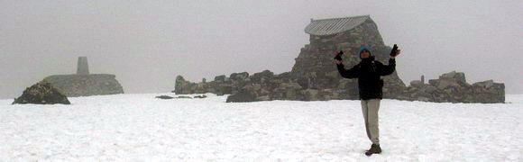
Ben Nevis in May
We are raising money for the Anthony Nolan Trust, a life-saving charity I urge you all to support. As well as making a donation at http://www.justgiving.com/andrewcordle, you could join their Bone Marrow Donor Register (they are especially keen on 18- to 40-year-old men).


Chairman's Chat - Martin Sellens
I have been pondering the thorny issue of prioritisation. This is largely because I have to mark about 80 Exercise Physiology scripts before tomorrow, Kevin is waiting for me to send him the Green and Blue courses for the Wivenhoe Park event that is now only 5 days away (plus I still have some corrections to do on the map), and on top of all that the deadline for this article was last week. More immediately, my stomach is reminding me that it’s breakfast time. What shall I do? A nice cup of tea and some toast and marmite seem irresistible. Given the difficulty of making these life changing decisions I have decided to compromise, in a very English way, and do all of them, but badly. Perhaps I should be more Mediterranean and just go hunting for some strong coffee and croissants and forget about the planning and authoring.
Actually, there isn’t much to report from Chairland, so the brevity of this report can be justified on the basis of the lack of news. So far two very successful summer series events have been run, in every sense of the word, at Castle Park and the re-modelled Notley Country Park with its splendid new play installations and Bistro. Castle Park included our first Sprint-O event, planned by Jenny Collyer, and although the field was small, the racing was fast and furious with international Anthony Squire from Interlopers dropping by to beat the opposition by a remarkable 7 min. Perhaps next year a Sprint Series? We have been talking about this for ages; who would like to take it on?
Notley was Julie Laver’s first foray into planning and she made excellent use of this compact (and soggy) area to put on a 20 min score as well as the usual White to Orange of these introductory events. The Harrison and Burgess families were also flexing their organising muscles and helped the experienced Birkett team put on a very popular and blisteringly fast string course. From an outsiders perspective it looked primarily like a good way to spend a convivial morning chatting in the sunshine and enjoying watching others run sweatily around the park! The whole event was an opportunity for club members who wanted to get a bit of organising experience in a low key event where it didn’t matter too much if things went wrong. There was a great turnout of helpers and the sea of orange organising team shirts looked very professional and certainly raised the profile of the sport locally! I hope that those of you who cut your organising teeth will be keen now to offer your services at a bigger event. Jenny Collyer is already recruiting for the Hatfield event in October, so book your job with her by e.mailing jcollyer48@btinternet.com.
Unfortunately I haven’t been able to attend any of the Saturday coaching events, but it is excellent to see this initiative of the development committee going so well. The efforts of the Development Committee and the Coaching Team have really transformed the club in the last couple of years by attracting new members and providing lots of opportunity for members old and new to improve their orienteering skills. Their energy is an inspiration to us all. Keep up the good work!

Meanwhile, in the Sellens household, excitement is beginning to rise in anticipation of attending the Swedish O Ringen in late July. The scale of this event boggles the imagination and I understand that over 20,000 will be attending, though not all, perhaps, competing. I’ll be happier with rather smaller numbers at Wivenhoe Park this weekend. Your orienteering destinations this summer might not be so “exotic”, but I wish you that elusive perfect run. Or if not, then at least don’t get too lost and enjoy your purposeful wander through the forest. Bon “O” (as the French, or U2, are unlikely to say).

Captain's Corner - Jenny Collyer
We are at the time of year where in this part of the world we have to fight the brambles, bracken and nettles etc. but with the warmer weather and light evenings you have no excuse not to get out running in our forests and parks.
It is time to get yourselves fit now as we want all our members to take part in the Compass Sport Trophy Final at Sutton Park, Birmingham on Sunday 19th October. Make sure you have this date in your diaries now. This could be our turn to win. There are various small events and training sessions being put on during the summer months so please check the newsletter and web page and make an effort to attend.
Make best use of whatever plans you have for your summer orienteering. We are making good use of our first summer of both being retired and are soon off to the World Masters in Portugal followed a little later with the ORingen (5 Days in the ski resort of Sälen, Sweden), then the Welsh 6 Day and rounding this off with our annual trip to the White Rose Weekend on the North Yorkshire Moors. This last event is particularly enjoyable if you camp - the campsite is always adjacent to the assembly area and you only need to roll out of bed and get to the start each day!
Enjoy the summer months with plenty of orienteering.

Schools League Report - Julie Laver
There has been no ESSOL event since the last newsletter so the results are still as follows:
Up to Y6 boys | Up to Y6 girls
Thomas Birkett | Rachael Harrison
Bryn Wilkinson | Isabella Coutts
Nicolas Harrison | Elspeth Harrison
Y7/8 boys | Y7/8 girls
Joshua Jones | Rhiannon Ware
Rory Coutts | Lucinda Wilkinson
Thomas Hemmingway | Emma Vidler
Y9/10 boys | Y9/10 girls
Michael Park | Alice Rigby
Will Hooton | Sarah Roach
Alex Ware | India Hayes
Y11/12/13 Boys | Y11/12/13 girls
James Park | Sarah Park
Conor Weed | Hannah Newton
Dean Miller | Ellen Sanderson
School Team Trophy
Barnardiston Preparatory
Coppleston High
Meadgate Primary
Wivenhoe Park on June 15th is the final event of this season.
After the runs there will be a prize giving ceremony for the winners of each class and a shield for the overall winning school team.
Participation certificates will be sent to the schools of all pupils who earned over 100 points to be presented in assemblies.
To ensure that everyone receives their certificates and medals please check your details on the ESSOL page of the website and let me know if there is anything amiss. This is especially important if I don’t have your school name as I cannot send your certificates. Good luck to all competitors and see you at Wivenhoe!

Stragglers' League - Andrew Cordle
After four more events the most improved in the Top 20 are Hannah Newton (from 4th position up to 3rd), Chris Childs (from 7th to 4th), Duncan Harrison (from 11th to 6th) Claire Harrison (from 16th to 11th), Kevin Machin (from 31st to 14th) and Perry Mole (from 27th to 19th). Well done all of you! Kevin and Perry (no, not Harry Enfield and Kathy Burke) demonstrated the progress you can make by completing your 6th event and Claire and Duncan demonstrated their persistence - they have completed more events than anyone else. I think Hannah and Chris are just getting better.
Attendances at the last few League events have been a bit disappointing. OK, it did snow a bit at the Bedfords Park event. You might have thought the Sprint Races (which turned out to be Short Races) at Chicksands was a bit far away, but you missed an excellent competition with head-to-head racing in the Chasing Start. And most of you missed the excellent inaugural Stragglers Sprint in Castle Park. Oh well, you can publish a fixture list but you can't tell orienteers where to go.
Next events are the Stragglers events at Wivenhoe Park and Woods on 15th June and High Woods on 12th July. After the summer break the events will continue from 21st September, and after that the League scoring moves into a new era, with events over a year old being dropped from the Best 6. Exciting times!

SOS Notice board

Saturday Coaching Sessions
As some of you may know the coaching team have been running Saturday coaching sessions on the 1st Saturday of the month for the last few months. These are open to ANY club members who wish to come along regardless of ability and age.
We have been very pleased with the turnout and enthusiasm so will continue to run these.
We will have a break for the next 2 months as our schedules are already quite full but we hope to return in September so watch this space (or the website).
We have covered a wide range of techniques but are always open to suggestions for topics to cover so please get in touch – see contacts on website - or catch us at an event near you!

Fixtures in East Anglia and Nearby Regions
The information provided below normally consists of Event Date, Region (eg EA = East Anglia), Event Grade and Type (Grade 1 is highest grade, Grade 5 is lowest. Type C is a conventional Cross Country event in which controls must be visited in the sequence listed on the description sheet). Event & Location Names and map reference. Organiser's contact details. Contact details, costs, closing date etc. for Pre-entry when provided. Whether Entry on the Day (EOD) is possible and the surcharge payable. The range of courses offered. The address of a website from which additional information can be obtained. Additional information in plain language.
At Essex Stragglers' events registration normally opens at 1000hrs, starts are from 1030hrs until 1230hrs and courses close at 1430hrs.
June 2008
18th | EA | SUFFOC Summer Evening Series, Christchurch Park, http://www.pdl.demon.co.uk/suffoc/
22nd | SE | SN District Event. Frith Hill, Camberley. SU905580.
 | C4 | Sarah Francis.sarah@sillimanite.co.uk EPS-SI. Parking £1.00. Dogs in car park only. www.southernnavigators.com
29th | SE | SLOW Frolic Series - Race No 1. Putney Heath, Putney. TQ233737.
 | C5 | Don McKerrow, 0208 871 3518. £4.00/£1.00. EPS-SI. String course. Based at Telegraph pub for registration and toilets Courses Light Green, Yellow and White plus extra loop for those wanting a longer run. www.sloweb.org.uk.
July 2008
2nd | EA | SUFFOC Summer Evening Series, Bridge Wood, http://www.pdl.demon.co.uk/suffoc/
6th | EA | SOS Relays. Hylands Park, Chelmsford. TL680048.
 | R5 | Nancy Powell Davies, 01376 562657.powell.davies@btinternet.com £5.00/£2.00. EPS-SI. www.stragglers.info
9th | EA | HAVOC Summer Evening Event. Bedfords Country Park, Romford. TQ520925.
 | C5 | Chris Shaw, 01375 677377.fixtures@orienteering-havoc.co.uk £2.00/£1.00. Yellow, Green, Blue. Starts 6-7.30PM. www.orienteering-havoc.co.uk
12th | EA | SOS Come & Try It, High Woods, Colchester, www.stragglers.info
13th | SE | LOK Local Frolic Event. Alexandra Park, London. TQ295896.
 | C5 | Neil Brooks, 01494 872578. neilbrooks@msn.com £7.50/£2.00. EPS-SI. www.londonorienteering.co.uk
26th | EA | HAVOC Limited District Event. Hadleigh Castle Country Park, Hadleigh. TQ799870.
 | C4 | Chris Shaw, 01375 677377. fixtures@orienteering-havoc.co.uk £2.00/£1.00. Yellow, Orange, Green & Blue. Parking £2.00. Starts 10.30-12.30. Please note that the event is at Hadleigh Castle Country Park and not at Hadleigh Castle. www.orienteering-havoc.co.uk
August 2008
17th | EA | SMOC Summer Series, Salcey Forest, www.smoc.info

Letters and emails

Use of Satnav for orienteering - Jack Isbester
Recent correspondence in The Guardian IT Supplement provided information that may be of interest to orienteers. For those wanting to programme their satnav to find the event carpark it may be useful to know that the TomTomGo and the Garmin Nuvi both accept National Grid references.
The Garmin Nuvi accepts a 12 digit input [TU1230045600] offering the potential to navigate to the nearest metre. When entering the normal 8 digit address it is necessary to add zeroes, as in the example above, to complete the address.
The Garmin Nuvi will also convert Grid References to Lat. and Long. or vice versa and on the internet a co-ordinate converter which will do the same job is to be found at http://www.nearby.org.uk/coord.cgi.
Also described in the same article was a procedure "very helpful in producing a map of our field archery target placements in their woodland locations". Used for this purpose was "an XDA Orbit PocketPC (which has GPS) running TomTom and also running GPSMap-OS, a freeware program which shows your position on a jpg picture of the OS map downloaded from OS Get-a-Map site or on a Google Earth screen grab". This is a bit too technical for me, but sounds as though it might be of interest to Planners and Controllers. Perhaps a reader could have a look at it and report back to the Newsletter.

Discounts - Dave Birkett
Andrew,
I was in Blacks Chelmsford branch yesterday and the manager will give 10% off for British Orienteering members. Apparently this is not the same with other branches.
I think we may have promoted this before but may be worth a short note in the newsletter.
Regards,
Dave
Does anyone else know of discounts available? - Ed.

Permanent Orienteering hits Hanningfield Reservoir - Dave Birkett
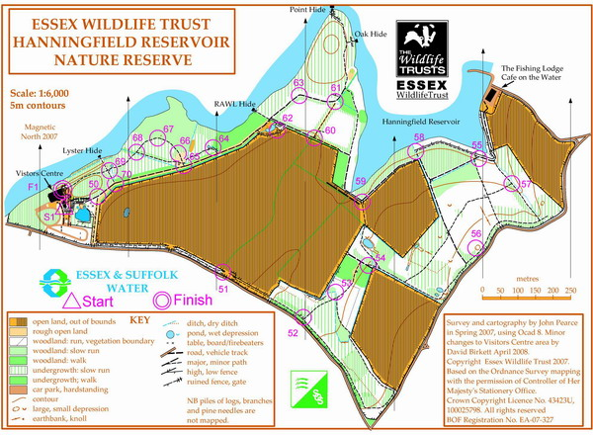
A new permanent orienteering course (POC) was unveiled at Essex Wildlife Trust Hanningfield Reservoir Nature Reserve recently. Essex Wildlife Trust working in partnership with Essex Stragglers put together the courses, fitting the control markers and posts with the help of local volunteers. The cost of the mapping and markers was funded by Essex and Suffolk Water.
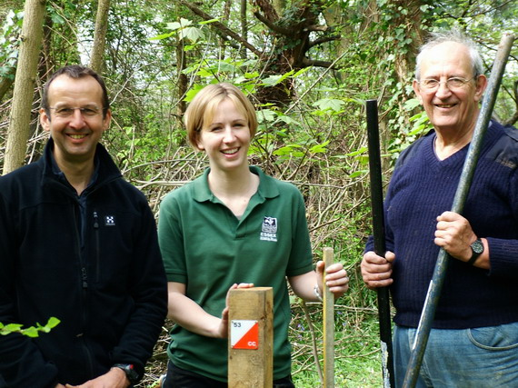
Young people from the Cornelius and Furtherwich Secondary schools were the first to try out the courses. Having a great time finding there way with map and compass around the Nature Reserve in the fastest time possible.
The courses were the brain child of Essex Wildlife’s Trusts educational Officer Becky Gibson who is delighted with the outcome,” It’s another activity the Trust can put on to encourage a wide range of visitors to the Reserve” she said.
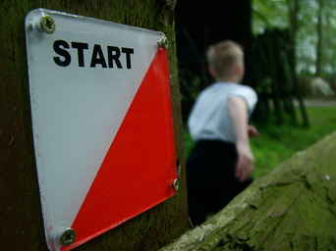
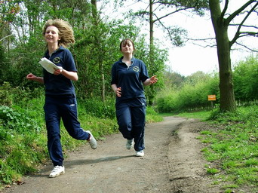
Orienteering is an activity that young, old, fit and not so fit can take part in and can be done at any standard. So why not pop in and purchased an activity pack, cost £2.00, and explore the reserve from a different perspective.
The POC even made the 'Anglia Tonight' programme with a short film about the sport at the Nature Reserve.

Emergency Procedures - Steve Cartwright
At Development Committee it was decided to look again at the SOS Emergency Procedures prepared for Clubmark and to conduct the Emergency Scenario we had been thinking of for some time.
Along with some prior work an interesting discussion ensued picking up many things that were a little out of date or could do with changing or expanding. Obviously there are arguments that the Emergency sack is too big and cumbersome, and the First Aid kit suitable for the JK, however it was thought best to keep them both general and somewhat bomb proof. Believe it or not we had no official method of checking and restocking the First Aid kit, or checking the batteries of the head torch in the Emergency Sack. A card detailing the procedure for the First Aid kit is to be added to it.
While the Notley CATI was in progress I went off pretending to be injured on one of the courses. The Organiser following the existing procedures asked if anyone had seen me, and then proceeded to summon available help and to mount a search. The searchers went off in pairs, one group narrowly missing me, but another group finding me some time later.
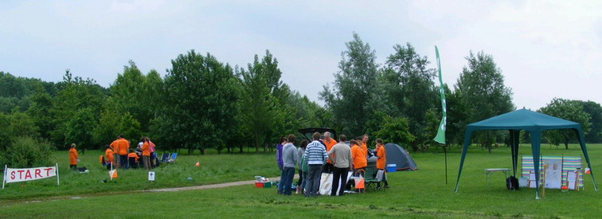
At the Notley Come and Try It event
Lessons were learned:
- The importance of trying to get to a control or reasonable path if possible for ease of rescue when injured. However further damage and injury must not be sustained if its not possible relatively easily.
- All controls maps with courses marked would be helpful to searchers but may be impractical at larger events.
- Incidents should be approached calmly and sensibly.
- Walky talkies do not always work, similar to mobile phones.
Technical items need to be worked quickly and with ease.
- Search cut-off times should be strictly adhered to.
- For ease of rescue participants and rescuers may be best dressed in in brightly coloured Orienteering kit or other, and if possible noisy.
- It is important not to forget to carry a whistle and a watch and to return to download prior to the course close time. Whistle protocol is of course 6 blasts every now and again in an emergency, responded to by 3 blasts from a potential rescuer.
If anyone has any particular concerns or thinks it may be best to approach a certain type of situation in a particular way please feel free to shout.

Another Stragglers Newsletter from 1970 - Ron Russell
(This is the second of three newsletters from 1970 sent to the current Chairman by contemporary member Keith Marshall.)
S.O.S. | S T R A G G L E R S O R I E N T E E R I N G S O C I E T Y | S.O.S.
Easter! and our membership continues to increase!
For an inactive club, this is astounding. Two more members give us almost another 30% growth Rate this month (although we only total 9 now, it's only two down on last year's total).
So, welcome back to Barry James, who deserves a medal for sheer persistence, and must be one of Britain's most isolated orienteers - Felixtowe seems an awful long way away, even from here (mid-Essex; and welcome too, to 'new-boy' Martin Stephens (of Chingford) who has already created club History - by becoming our first "Veteran Man," on top of this he's probably competed more than any of us already this season.
What with Mike Down's parents, my wife and Keith Marshall's sister all successfully taking the plunge for the first time at the Happy Herts Epping Forest Event, maybe there are a few other new members in the offing too(?) - ("Hint - hint.")
This event went off very well in fact, with another sunny day blessing a rare Essex fixture. Without the results sheets to hand yet, I only noticed all the above mentioned people (with the exception of Barry James, but) as well as Barry Faiers, who despite his long spell of inactivity did quite well on the long course.
Mike Down, surprisingly, did not have an exceptional day in his "own backyard," but then both he and Barry had difficulty with the most criticised control, "At the head of the re-entrant," which was not really at the head at all, but well and truly in (Pundit, Chris Brasher, confirmed this error in description).
As Controller, I was very pleasantly surprised to hear more than one experienced competitor say that despite the aforementioned error, they had enjoyed the long course (as I had held some reservations about it). I was sure that the Novice's Short Course was a good one, but felt that far too many tracks led from one control to another, to spoil any sort of challenge on the medium course (My fault, for noticing this too late).
Finally, despite our club's outstanding record of inactivity, I was nevertheless disappointed at not seeing a few more familiar faces there.
This Sunday, "Jan Kjellstrom" Week-end for the expert orienteers, I'm involved with yet another competition in almost the same area as last week, and its rumoured that there MAY BE over 500 scouts competing!
Good Straggling!
Ron Russell (19, The Limes, Ingatestone)
p.s. The first paid-up members will find their new-style membership card enclosed (others to follow). Un-paid-up types can expect to hear no more, unless you fork out to cover the postage.

New Forest at Elmstead Market, deep in SOS territory - Jack Isbester
The Woodland Trust is campaigning to raise two million pounds for the purchase, planting and maintenance of a new area of woodland near Elmstead Market. The SOS committee has agreed to support the campaign by distributing leaflets at SOS events and bringing the campaign to the attention of our members and others sympathetic to the objectives of the Woodland Trust.
The Woodland Trust's campaign brief is printed below and we expect to receive their leaflets in coming weeks.
Please give generously when the appeal literature reaches you or, if you cannot wait until then, visit the Woodland Trust website (www.woodlandtrust.org.uk) and make a donation now.

 | Elmstead Appeal

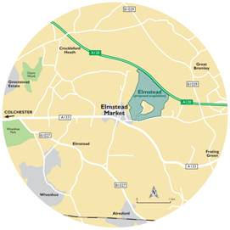
Located just to the west of Elmstead Market and off the A12, we have been offered 250 acres of land at Lodge farm to create a woodland for the wildlife and people of Elmstead Market and Colchester. This will enable us to plant approximately 200,000 trees creating a wonderful tranquil wooded area for the future. The area contains many features with streams and ancient woodlands, these are woods that have been around since at least the 1600’s.
We will manage this area to secure and protect it for future generations living in and around Elmstead Market and Colchester.
But to make this vision a reality, we have to raise £2 million by September 2008. We cannot do this alone! But without achieving this we will not be able create this woodland.
Please can you help?
Of course you may ask why is it so important to support this campaign when there are so many other worthy causes?
Well, trees and woodland are crucial to life on our planet. They generate oxygen for us to breathe, store carbon, provide homes to a spectacular variety of wildlife, provide us with raw materials and help stabilise the soil. They offer us quiet places to relax within, inspire our imagination & creativity and refresh our spirits.
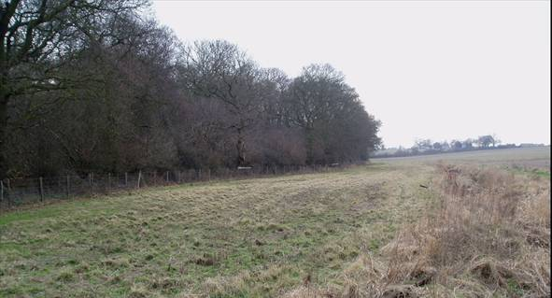
A world without trees and woodland would be barren, impoverished and intolerable. And yet the simple fact is that the UK is one of the least wooded places in Europe with an average of only 13% woodland cover, with only 5.7% of woodland cover in Essex Only 3.5% of the County has Ancient woodland. This scheme will buffer some of this and will create a larger tract of new woodland that could become home to some of the associated animals and plants of woodland, such as water vole and Barn owls, all species that are on the UK priority biodiversity action plan list.

SOS Newsletter Volume 20 No. 10
The next edition of the newsletter will be available on the 7th September. Copy for this edition should be sent to the Editors editors@stragglers.info before 28th August.

Mapping based on Ordnance Survey reproduced by permission of Ordnance Survey on behalf of The Controller of Her Majesty's Stationery Office. © Crown copyright. All rights reserved. Licence number WL10059.

