 | Essex Stragglers Orienteering Society (SOS) |   accredited

Newsletter Volume 21 No. 10

March 2012

Editors: Geraldine Russell and Rachel Barford- editors@stragglers.info
Club website - http://stragglers.info

Editorial - Geraldine Russell 2
Notes from the Chair - John Collyer 2
East Anglian League Winners 2011 3
Captain's Corner - Jenny Collyer jcollyer48@btinternet.com 3
SOS Activities 2011 - Dave Skinner 4
Club Activity Evenings - Julie Laver 4
Club Juniors 5
ESSOL News - Julie Laver 8
Photos taken at the New Year Novelty 9
Saturday Activities 11
Fixtures - David Skinner 11
Photos of SOS members taken at the Compass Sport Trophy 14
A Baddow Ridge Experience - Perspective of a Fixtures Secretary and Organiser - Dave Skinner 16
Club T-Shirts 18

  Essex Stragglers support the Woodland Trust and its objectives |   Essex Stragglers' development activities are supported by Awards For all

Editorial - Geraldine Russell
When the articles for this newsletter arrived I realised just how successful our club is nowadays especially so our Juniors who won half of the EA League categories in 2011. It's all down to our hardworking team of coaches for inspiring and training them. SOS also had five winners in the EA adult classes.
As I write this on a beautiful spring day, albeit the last day of February, we must spare a thought for our team of officials who had to cancel the Baddow Ridge event - namely Dave Skinner, Clive Tant and Colin West. Read about their trials and tribulations on page 16.

Notes from the Chair - John Collyer
Thank you to all members who turned up to run at the recent Compass Sport match at Thetford, and a particular one for the four hardy souls (Nancy Powell-Davies, Jack Isbester, Peter Warland and Dave Skinner) who took turns as marshals at the road crossing. It was a cold day and if you weren't in the sun, standing doing a job was hard.
Having just returned from a visit to Sweden, I was struck by how restricted their competitive season is, they have not yet returned after the winter break! We are lucky to be able to orienteer throughout the year, and rarely have interruptions for bad weather. Our projected Baddow Ridge event was of course, one of those rare exceptions, and was deeply frustrating for the main officials. Firstly for Dave Skinner, who arranges all the permissions (in this case in excess of a dozen), and who as event organiser had an early start and ended up badly stuck in the fresh snowfall.
Having to cancel does not simply mean that nothing happens in the forest preparations. Clive Tant as Planner, along with his helpers, had got all the controls out before we cancelled. They were left with the miserable job of retrieving everything.
Colin West as Controller, had made a large input into the arrangement of the courses, whilst Kevin Machin had brought the map up-to-date. We hope to use the courses and maps in the future, we did consider simply moving the event to replace Hockley, but some landowners were away and could not be contacted, whilst some of the main officials would have had to have made considerable personal changes.
I offer my personal thanks to these club members and sincerely hope that we can use the maps and courses as soon as possible.

East Anglian League Winners 2011
Joshual Buist M10  Daisy Partridge W12  Rhiannon Ware W16  Beth Albon W18 |  |  | Hazel Tant W21  Tracey Apperley W40  Hilary Sellens W55  John Collyer M65  Jenny Collyer W65
 |  | 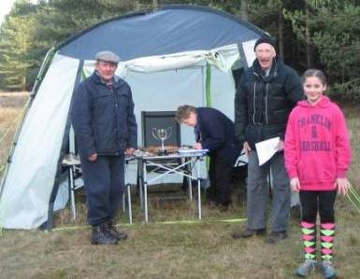 |  | 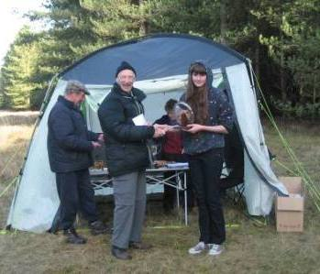

Captain's Corner - Jenny Collyer jcollyer48@btinternet.com
Firstly thanks to all who came to our Compass Sport Trophy round at Thetford Warren. Unfortunately we were beaten by CHIG and LOG but we had a lot of good scores with all our 13 scorers having points of 90 and above.
I have entered five relay teams in the JK at Easter. We have one incomplete team so hopefully that place will get filled. I have entered the teams as follows but I can still make changes if necessary -
G. | Veteran Men (165+) | Peter Warland | John Russell | David Sanderson
G. | Veteran Men (165+) | Colin West | Dave Skinner | Steven King
N. | Mixed ad hoc | John Collyer (long green) | (short green) | Ben Warland (orange)
F. | Senior Women (120+) | Jo West | Sharon Warland | Lyn West
H. | Veteran Women (165+) | Geraldine Russell | Bridget King | Jenny Collyer
In all but the ad hoc the middle leg is shorter.
I will need to send in the entries for the British Relays by the middle of March. This event is the day after the Individual Championships in the Lake District on the 6th May with an Urban race in Kendal on the Monday. The teams are more difficult to sort out for this as we run in age classes and we have a great mixture in our club which means some will need to run up one or two age classes. We have enough for five teams at the moment. If you haven't already please let me know very soon if you would like a run in this.

SOS Activities 2011 - Dave Skinner
While most of our members regularly enjoy our main programme of orienteering events, perhaps some members are not fully aware of the background Activities that Julie Laver and her club Development Team lay on to progress the development of the sport within our area. As your Fixtures Secretary I both register these Activities with British Orienteering (primarily to ensure Insurance cover, but also to promote publicity if the Activity is open to all) and also record participation numbers which are viewed by British Orienteering to monitor efforts being made to develop orienteering across the piece.
In the 2011 calendar year some 60 unique Activities were organised or supported by SOS and the total participation was 914 people sessions, a significant increase on 2010 (717). Examples of the Activities facilitated are -
- Regular weekly Club Nights at Wivenhoe
- After-school coaching for St Andrew's School, Halstead, instrumental in their success at National level
- Come And Try it events in Colchester, Chelmsford, Hadleigh and Burnham-on-Crouch
- Advanced coaching on contours, running on a bearing, night running, etc
- Support to the annual Essex Games schools competition, the Olympic Weekend in Sible Hedingham and the Fresher's Fair at Essex University.
Julie and her team are congratulated on the exceptional and successful efforts they made in 2011 to ensure the success of the development of orienteering within Essex, a record of achievement which will be difficult to surpass in 2012!

Club Activity Evenings - Julie Laver

Club Activity Evenings Every Wednesday from 6.30 at the Glass pavilion Wivenhoe Park (University of Essex) from 29 February.
I have just booked the Glass Social Area for another 12 week run of clubnights. It's a new day and time - Wednesdays 6.30.
The format will be a bit loose to try to please all the people all the time (I wish!). There will be an organised session from 6.30pm, either coaching activity or timed course. Also there will be a self lead run/trail/course for those who don't want to join in with an organised activity or cannot make the earlier start.
As before refreshments will be available after for informal chat/discussion of past events etc.
Cost £2/£1. Dress for weather condition. Headtorch recommended.
Non-members welcome so if you know anyone who might be interested please pass this on.
For further details contact JULIE LAVER julie.laver@virgin.net 01206 826152.

Club Juniors
As a THANK YOU for representing the club in competitions both regional and national the club juniors will be given club t-shirts.
Daisy Partridge, Alex and Rhiannon Ware, Ben Warland and Nick Harrison all represented us in the Compass Sport Trophy Competition at Thetford.
All except Daisy have already been awarded T-shirts but if any are too small let me know.
If I miss you out please let me know.
There is a new incentive scheme launched from January 1st by British orienteering intended to supersede the colour code badge scheme. There are two elements - navigation challenge and racing.
 | 
It is awarded automatically if you are on the British Orienteering database and have an email address registered. There is no badge but you will get a downloadable certificate. For full details see http://www.britishorienteering.org.uk/index.php?pg=94#incentives_scheme.
As a club we will still be awarding colour-coded badges to all who qualify. You need to have run 3 courses of that colour in par time unaided. More explicit rules are being developed by the EAOA committee and will be published when available.

We are still running the Explorer Challenge for beginners. You are awarded one point for evenry control visited whether you complete the course or not. Shadowing is allowed.
For every 25 points gained a certificate is earned up to 100 points.
For further details and a log book come to enquiries at any SOS event. Other clubs also run this scheme and you can earn points at any club's event.
The following Juniors from St Andrews and the Ramsey after-school club have been awarded colour-coded badges and Explorer Challenge Certificates.
Tree Explorer Challenge  Ben Partridge  Rahma Kahn  Becky Howard  George Wash  Hannah Peters  Olivia Baldwin  Oscar Clarke  Zoe Hartnup  Copse Explorer Challenge  Ben Partridge | White colour code badge  Joshua Buist  Johnathan Quin  Joshua Palmer  Jack Edwards  Dominic Emmerson  Thomas Turner  Callum Turner  Benjamin Harrington  Luke Harrington  Lewis Crow  Daisy Partridge  Chloe Cracknell  Lucy Edwards  Lily Amos  Georgia Gower  Amelia Juniper  Elena Gower  Lily Swainsbury  Georgia Burr  Madeline Press  Jordan Findlater  Amber Greaves  Jodie Smith  Kieran Palmer | Yellow colour code badge  Callum Turner  Daisy Partridge  Chloe Cracknell  Lucy Edwards  Georgia Gower  Dominic Emmerson  Joshua Buist

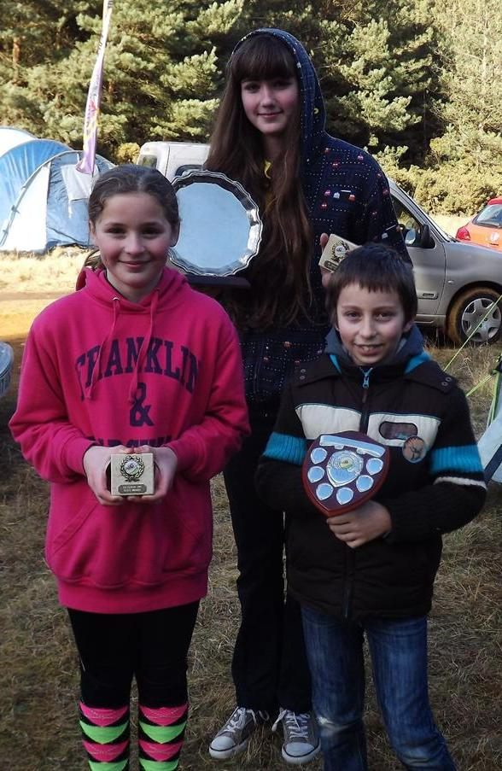
Daisy Partridge, Rhiannon Ware and Joshua Buist collecting trophies at the Thetford presentation of EA league and championship awards.

ESSOL News - Julie Laver
After the SUFFOC event at West Harling Heath the results are as follows. The best five scores count towards your league total.
Up to Y6 Boys |  |  |  | Up to Y6 Girls
1st | Matthew Clarke | Barnardiston Prep | 1st | Daisy Partridge | St Andrews, Halstead
2nd | Joshua Buist | St Andrews, Halstead | 2nd | Chloe Cracknell | St Andrews, Halstead
3rd | Jack Edwards | St Andrews, Halstead | 3rd | Lily Amos | St Andrews, Halstead
Y7/8 Boys |  |  |  | Y7/8 Girls
1st | Kieran Palmer | CRGS | 1st | Bronwen Mansel | Beyton Middle
2nd | Timmy Harrison | Barnardiston Prep | 2nd | Georgia Gower | The Ramsey College
3rd | Callum Turner | The Ramsey College | 3rd | Lucy Edwards | The Ramsey College
Y9/10 Boys |  |  |  | Y9/10 Girls
1st | Bryn Wilkinson | Copleston High | 1st | Rachael Harrison | The Perse
2nd | Andrew Stemp | Impington College
3rd | Roderick Mansel | County Upper
Y11/12/13 Boys |  |  |  | Y11/12/13 Girls
1st | Alex Ware | Colchester 6th form | 1st | Rhiannon Ware | Colne Community
2nd | Sam Bolam | St Helena | 2nd | Beth Albon | Saffron Walden CHS
 |  |  | 3rd | Elena Lumby | CRGS
Whole Team Trophy Places after 6 rounds
1st - St Andrews, Halstead
2nd - Barnardiston Preparatory School
3rd - The Ramsey College
Well done to all of the above!
For full listings please go to ESSOL page on the SOS website http://stragglers.info/schools.
If you know any schools which might be interested in the League I would be happy to send further details.
To be included in the League you do not have to enter through your school but please ensure your school and year are included on the registration form when you fill it in. No shadowing is allowed, although junior pairs are.
Full details and comprehensive rules are available on the SOS website http://stragglers.info/schools but I can deal with any enquiries or corrections. julie.laver@virgin.net or phone 01206 826152.

Preliminary ESSOL fixtures for the remainder of this season
18th March | Hockley | SOS
22nd April | Thorndon North | HAVOC
13th June | Hylands | SOS
Please note these are preliminary fixtures and participants are advised to check Club websites before travelling
http://stragglers.info
http://www.suffoc.co.uk
http://www.waoc.org.uk
http://www.orienteering-havoc.co.uk

Photos taken at the New Year Novelty

Wivenhoe Park 1 Jan 2012

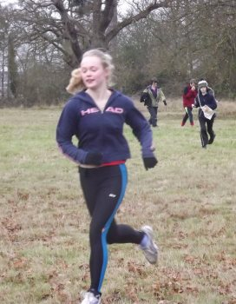 | 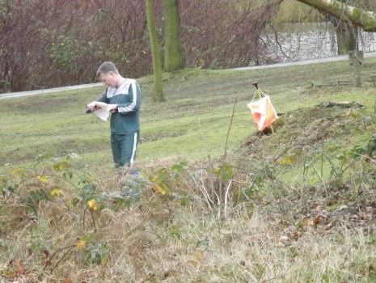

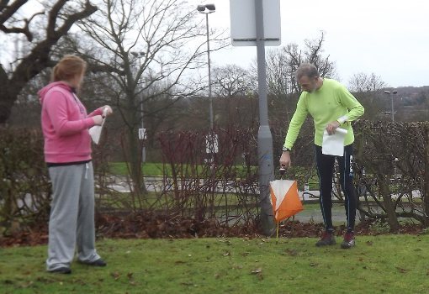 |  | 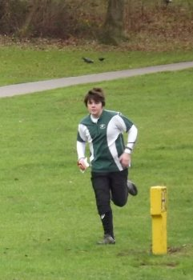
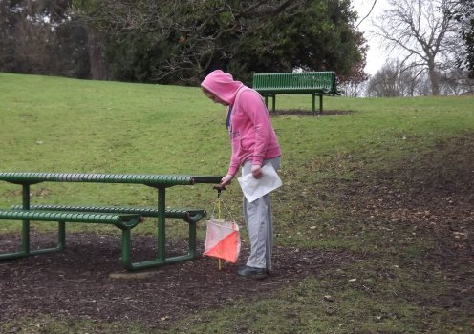

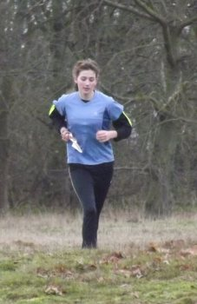 | 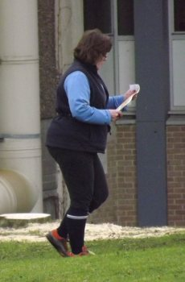

Saturday Activities

24th March Castle Park, Colchester
Street O and CATI
10.30 - 14.30
£2/£1
We would like to put on more of these low key events and activities so if you would like to have a go at planning or even if you just have an idea for someone else to do please contact the Development Committee.
There will be plenty of help and support for those who have not had experience of event planning and is a great way to start without the stress of taking on a mainstream event.

Fixtures - David Skinner
Fixtures in East Anglia and Nearby Regions - National Events which SOS members regularly attend are also included
The information provided below normally consists of Event Date, Region(eg EA = East Anglia), Event Grade , Event & Location Names and map reference. Organiser's contact details. Contact details, costs, closing date etc. for Pre-entry when provided. Whether Entry on the Day (EOD) is possible and the surcharge payable. The range of courses offered. The address of a website from which additional information can be obtained. Additional information in plain language.
At Essex Stragglers' events registration normally opens at 1000hrs, starts are from 1030hrs until 1230hrs and courses close at 1430hrs, but this may vary.
SOS Club Nights are generally not included - see SOS website for details.
2012
March
3rd | HH  SEOA  Level D | HH Saturday Series & Youth League, Sherrardspark Woods, Welwyn Garden city, TL236139  Entry times: Registration: From 10h00 to 11h15. Last start 11h30. Courses close at 12h30.. Dogs: Dogs: Sorry, dogs are not permitted in the school grounds, but you are welcome to take them with you in the woods..  Organiser: Roger Moulding , sherrardspark-03-03-12@happyherts.org.uk  www.happyherts.org
4th | SMOC  EAOA  Level C | SMOC Holcote & Reynolds Wood EAOA League event, Holcote and Reynolds Wood, Brogborough, SP968392  No dogs allowed.  Organiser: Ros James , ros.james@btinternet.com  www.smoc.info
10th | WAOC  EAOA  Level D | WAOC Wimpole Hall Colour Coded, Wimpole Hall, Cambridge, TL343511  Entry times: Registration 10.00 to 12.00. Starts 10.30 to 12.30.. Dogs: Dogs are allowed but they must be kept on a lead at all times as there are cattle and sheep in Wimpole Park ..  Organiser: Helen Bickle  www.waoc.org.uk
11th | HOC  WMOA  Level A | Midlands Championships, Foxley and Garnstone, Hereford, SO423471  Organiser: Anthony Clerici , 01905 26078  www.harlequins.org.uk/marchinthemarches.html
11th | NOR  EAOA  Level C | NOR Colour Coded, Cawston and Marsham Heaths, Aylsham, TG167250  www.norfolkoc.co.uk
14th | DFOK  SEOA  Level D | DFOK Kent Night Cup, Bexley, tbc
18th | SOS  EAOA  Level C | Hockley Woods Colour Coded inc. ESSOL, Hockley Woods, Hockley, TQ833924  Entry times: 10.00-12.30. Dogs: Dogs under control permitted on courses.  Organiser: Nancy Powell Davies , powell.davies@btinternet.com , 01376 562657  stragglers.info
22nd | SAX  SEOA  Level D | Sax KNC, Millbank, Sevenoaks  www.saxons-oc.org
24th | EBOR  YHOA  Level A | British Sprint Orienteering Championships, York University, York, SE620504  No dogs allowed.  Organiser: Keith MacDermott , 01904 761120  www.york2012orienteering.org.uk
24th | SOS  EAOA  CATI | Come and Try Orienteering, Castle Park, Colchester  Organiser: Julie Laver
25th | EBOR  YHOA  Level A | British Middle Distance Orienteering Championships, Srensall Common, York  No dogs allowed.  Organiser: Mike Ridealgh , 01904 761120  www.york2012orienteering.org.uk
31st | SAX  SEOA  Level D | SAX KOL, Challock, Ashford  Organiser: Nigel Hills  www.saxons-oc.org
31st | HH  SEOA  Level D | HH Saturday Series, Stanborough Park, Welwyn Garden City, TL227114  Entry times: 10.00 to 11.30. Dogs allowed.  Organiser: David Hodson  www.happyherts.org
April
1st | CHIG  SEOA  Level C | CHIG District Event, Hainault forest Country Park , Hainault, TQ 478929.  Entry times: 10:30 - 12:00. Dogs: Keep under control.  Organiser: Ray Weekes , RayWeekes@BTIntenet.com  Hainault Forest Country Park
1st | SMOC  EAOA  Level D | Keyne-O , Linford Wood, Milton Keynes  www.smoc.info/
6th | SOA  Level A | JK Weekend - Day 1 - Sprint, Livingston Centre, Livingston, NT048667  No dogs allowed.  Organiser: Kenneth Daly , colin.matheson@scottish-orienteering.org  www.scottish-orienteering.org/jk2012/
7th | SOA  Level A | JK Weekend - Day 2, Dunalastair, Tummel Bridge, NN712594  No dogs allowed.  Organiser: David Nicol , colin.matheson@scottish-orienteering.org  www.scottish-orienteering.org/jk2012/
8th | SOA  Level A | JK Weekend - Day 3, Craig a'Barns, Dunkeld, NO021433  No dogs allowed.  Organiser: David Kershaw , colin.matheson@scottish-orienteering.org  www.scottish-orienteering.org/jk2012/
9th | SOA  Level A | JK Weekend - Day 4 - Relays, Newtyle Hill, Dunkeld, NO065412  No dogs allowed.  Organiser: Angela Dixon , colin.matheson@scottish-orienteering.org  www.scottish-orienteering.org/jk2012/
9th | SAX  SEOA  Level D | SAX Easter Score, Mote Park, Maidstone, TQ774553  Organiser: Nick Hope , chairman@saxons-oc.org , 01634 231487  www.saxons-oc.org
15th | NOR  EAOA  Level C | NOR Colour Coded, Ken Hill, Snettisham., Hunstanton, TF675349  Entry times: 10.00 to 12.00. Dogs: Dogs only allowed in Parking Area Only.  Organiser: Julia Paul , 01485 541031  www.norfolkoc.co.uk
21st | WAOC  EAOA  Level C | Huntingdon Town Race, Huntingdon Town Centre, Huntingdon, TL241716  No dogs allowed.  Organiser: Ian Lawson , ianh.lawson@ntlworld.com  www.waoc.org.uk
22nd | HAVOC  EAOA  Level C | Thorndon North SWELL Event, Thorndon North Country Park, Brentwood, TQ611914  Dogs: If under control.  Organiser: Tim Jones , juniorrep@orienteering-havoc.co.uk  orienteering-havoc.co.uk
28th | SO  SEOA  Level D | SO SOG 18 - The Hyde Estate, Handcross (south of Crawley), The Hyde Estate, Handcross, south of Crawley, TQ250305  Entry times: Registration 9.45-10.45, Start-times from 10am-11am, courses close 12.30. No dogs allowed.  Organiser: Patrick Windsor Brown  www.southdowns-orienteers.org.uk/index/events
28th | DFOK  SEOA  Level D | DFOK North West Kent Series, Foots Cray Meadows, tbc
May
5th | NWOA  Level A | British Orienteering Championships, Dalegarth, Seascale, NY170000  Organiser: John Slater , runningmarra@googlemail.com  www.boc2012.org.uk
6th | NWOA  Level A | British Relay Championships, Heslington Burrows, Kendal  Organiser: Ann Smith , roger.smith100@btinternet.com  www.boc2012.org.uk
12th | DFOK  SEOA  Level D | DFOK Kent Orienteering League, Mereworth, Wrotham  www.dfok.co.uk
13th | SOS  EAOA  Level C | Hylands Park Colour Coded inc. ESSOL and EA School Champs, Hylands Park, Chelmsford  Organiser: Edwin Banks , banksy.eddie@gmail.com , 01376 321658  stragglers.info
16th | DFOK  SEOA  Level D | DFOK Summer Park Race, Danson Park, tbc
20th | SUFFOC  EAOA  Level D | Chantry Park Local ( limited) Colour Code Event, Chantry & Gipperswk Parks , Ipswich, TM139442  Entry times: Starts : 10:30 to 12:30 - Registration from 10:00. Dogs: Dogs welcome but must be kept under control.  Organiser: Simon Hooton , s.hooton@phonecoop.coop  www.suffoc.co.uk
24th | SOS  EAOA  Level D
  Summer Series 1,Hilly Fields, Colchester
  Organiser: Colin West, colin&grovehillhouse.wanadoo.co.uk, 01206 322905
  stragglers.info

Photos of SOS members taken at the Compass Sport Trophy

Thetford Warren 19 Feb 2012
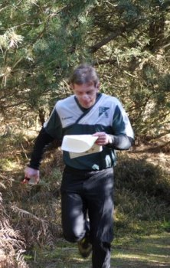 | 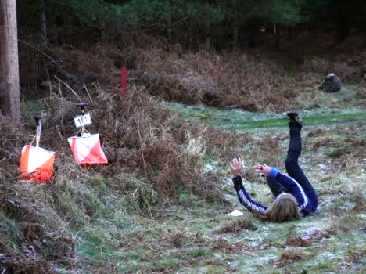

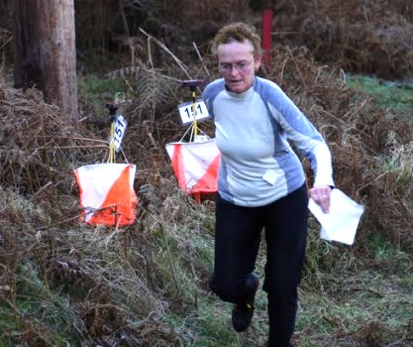 | 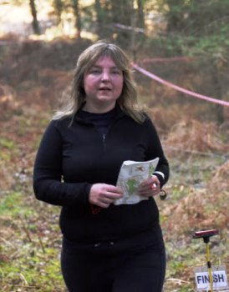

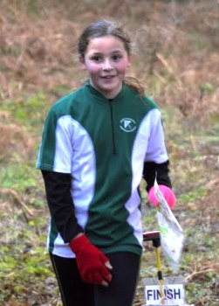 | 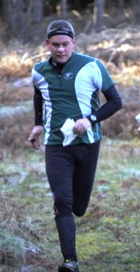 | 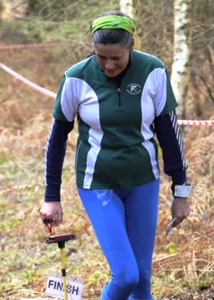

A Baddow Ridge Experience - Perspective of a Fixtures Secretary and Organiser - Dave Skinner
Dateline..........
09/11/10 - Bid made for event at Baddow Ridge on 5 Feb 12.
16/04/11 - Event approved at EAOA Fixtures meeting convened at the SOS Highwoods event.
Sometime in Dec 11 - Permissions for the event secured from numerous landowners. Car parking agreed. Slight panic when I realise that we have no Officials allocated to this event - Clive Tant and Colin West step in to Plan and Control respectively - I volunteer to Organise. Kevin Machin suggests we have a 'remote' start for longer courses to make best use of the eastern area and minimise 'dead' running - he has access to a minibus to transport competitors - agreed, while noting that this may further stretch helper resources.
31/01/12 - Equipment picked up from SOS store. Worry about the fact that we currently have no generator. Andrew Cordle assures that we can run SI computers and printers off car battery.
02/02/12 - Pick up keys for access to assembly area and Cedar Park (required for access to one of the Starts). Walk through Blakes Wood to establish the best point where we can set up temporary stile (straw bales courtesy of Lyn West) to cross fence from Cedar Park to Start. Given that Met Office forecast is looking worrying I visit East Start to take a view on Clothing Dump possibilities.
03/02/12 - My phone rings at 07.30 - the Portaloo delivery man is on-site (I expected two hours' notice of delivery but was very grateful that I did not receive a call at 05.30!). I arrive at 08.00 to provide access. Helper Plan finalised - could do with a couple more hands but we will cope. Feeling good - everything under control.
04/02/12 - Kevin confirms he has printed 285 maps. Met Office forecast is now looking even worse - arrange via Andrew for a warning of potential event cancellation to be put up on SOS website. After hanging all controls at Baddow, Clive Tant delivers SI computers to me set up with event details. I pack car with all but the most valuable items of equipment. Go to bed early and notice some gentle snowfall.
05/02/12:
- 03.00 wake up, look out of window and think "oh s**t" - looks like Met Office forecast on this occasion was spot on. Try to go back to sleep but don't really succeed.
- 07.00 - car packing completed.
- 07.10 - get stuck in snow 5m up my road! - dig myself out.
- 08.10 - having taken a circuitous but still hazardous route towards Baddow (normally a journey of about 12 minutes!) I get totally bogged down in snow. Blocking the Riffhams Chase/Ridge Road junction it becomes absolutely clear to me that the event must be cancelled. Simultaneously Jack Isbester phones me to say that he had checked out the route by which competitors had been asked to approach the event - he had made it through to Assembly but the road was very hazardous. Phone Clive/Colin - they join me - we move (after I had dug myself out again!) to a 'safe haven', agree cancellation, arrange for website update and phone as many helpers as we can.
- subsequent timings are hazy but 'happenings' are pretty clear: Colin sets off on foot from the 'safe haven' to collect all controls in the Eastern sector. The 'safe haven' proves a challenge for my low profile tyres and Clive tows me out so I could move to an 'even safer haven'. I then travel with Clive who would collect the controls in the Western area - en route we discover Jack stranded in his car at the Riffhams Chase/RIffhams Lane junction - rescue services arrive (a standard AA van with pretty flimsy chains on front wheels) - in summary these initial attempts to move Jack on fail but there was a magic moment when an approaching 4x4 braked and in true slow motion movie style drifted towards the AA van - thankfully the ensuing collision was very minor. The AA man frees Jack and launches him up Riffhams Lane but then, while following, gets stuck himself and has to be towed out. Jack takes about ten attempts at the steeper part of Riffhams Lane but grinds to a halt every time, and finally is towed out by 'Rover Rescue', two public-spirited citizens in a Range Rover.
I join Clive in Blakes Wood after he had finished collecting controls and we make our way towards the original 'safe haven' where Colin is waiting. We confirm that all SI equipment had been recovered. Colin struggles to exit from the 'safe haven' - we dig/push him out and he sets off, straw bales in his boot. Clive takes me back to the 'even safer haven' where I too struggle to exit but make it eventually. I arrive home about 14.00, Clive arrives soon thereafter to transfer the SI controls, canes and kites to me.
06/02/12 - phone the Portaloo company to advise that there is no way their vehicle will be able to get to the site to recover loos. They reschedule for Wednesday.
08/02/12 - receive call from Portaloo company driver - he is on site (once again no two hours' notice!) - I get to the site within 20 mins to discover that the driver has decided that he will not take his lorry down track for fear of getting stuck in the snow (he personally would have to carry any recovery costs). Portaloo company phones me to remind that we are liable for any damage to (or loss of) loos while in our custody - apparently the pumps in portaloos are valuable and sometimes are stolen.
12/02/12 - at CHIG's Claybury Park event I transfer SI equipment to HAVOC and WAOC for use at the Compass Sport Cup/Trophy event at Thetford Warren.
13/02/12 - Portaloo company phones me to say they will recover tomorrow. I inform that snow still persists and agree to visit the site to update them on conditions.
14/02/12 - visit site at 08.00 - snow has thawed and track is clear. Thankfully loos are fine. Phone Portaloo company to advise. Driver communicates well with me and he arrives at site just a minute or so before I do. Return keys. Take the opportunity to recover some tape I had put in Blakes Wood to help mark out the route to the Start.
Quite an adventure really! I received tremendous support from Colin. Clive and Jack on the day, and form Kevin prior to the event, and thank them for the considerable contributions they made. A big thank you too to Andrew for swiftly updating our website (I sincerely hope that this was done in time to avoid any wasted journeys) and to all those who volunteered to help at the event. We are looking at the possibilities for rescheduling this event but it may well be some considerable time before this becomes possible.

Club T-Shirts
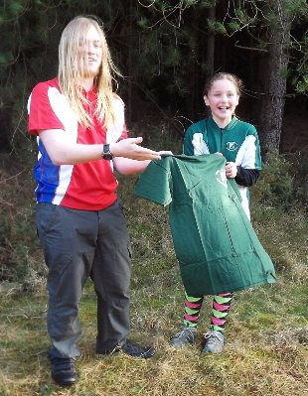 | 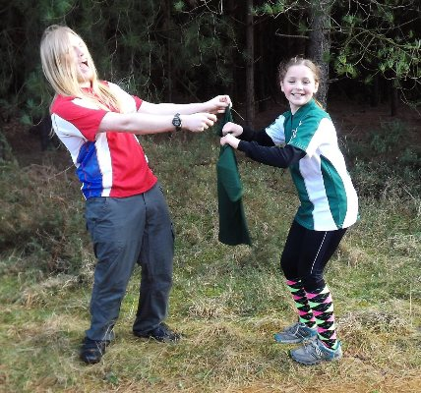

If you want to buy a T-shirt there are some adult and junior sizes for £5 each and sweat shirts for £7.
Second-hand kit can be brought along to events and left at enquiries for sale but must be collected at the end of the event as I don't want to end up with a shed load of stuff!
All items to be marked with the price and sellers name and contact number.
For New Club 'O' kit see Lyn West.

