 | Essex Stragglers Orienteering Society (SOS) |   accredited

Newsletter Volume 21 No. 11

June 2012

Editors: Geraldine Russell and Rachel Barford- editors@stragglers.info
Club website - http://stragglers.info

Editorial - Geraldine Russell 1
Notes from the Chair - John Collyer 2
Captain's Corner - Jenny Colyer 3
Services to Schools Orienteering Awards - Alison Cracknell 3
Awards - Julie Laver 5
ESSOL News - Julie Laver 6
Fixtures - David Skinner 7
An Essex Bunroe run - John Williams 11
Malvern Urban Race (March 2012) - John Collyer 12
Our first experience of the British Orienteering Championships - Daisy Partridge and Chloe Cracknell age 11 13

Editorial - Geraldine Russell
  Essex Stragglers support the Woodland Trust and its objectives |   Essex Stragglers' development activities are supported by Awards For all
Many thanks to those of you who sent in photos and articles for this edition. After the busy period including the JK and British Championships the summer series is now in full swing so please keep taking those photos to share in the next newsletter.
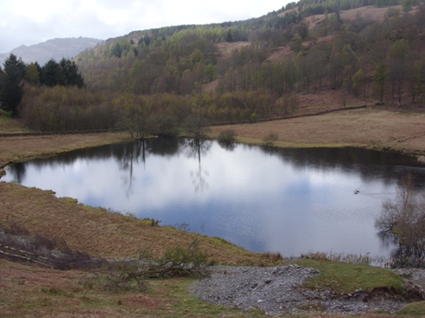
View from JK Assembly area

Notes from the Chair - John Collyer
With rain beating down on the conservatory roof, it is hard to think that summer is just around the corner. However, our Summer Series (co-ordinated this year by David Lumby) will soon be kicking off, fortnightly on Thursdays, interlaced with Suffolk's on alternate Wednesdays. I know many of you with busy lives and some distances to events may not be able to take part, but on a pleasant evening a run around a local area may be just what many people need.
Also coming up are some of the holiday events, many of which are abroad and listed in CompassSport. The home-bred ones in Surrey for Jubilee Weekend (there are others in Cornwall and Scotland), the Welsh 6-days and the White Rose provide runs in interesting areas that help test our Essex skills and fitness!
I must also mention the work that Julie Laver and Nancy Powell-Davies have been doing with St. Andrews in Halstead. The parents have been so appreciative that they nominated them (along with teacher Sue Hartley) for a British Schools Orienteering Association, Certificate of Appreciation. It was presented at a recent after-school club.
I was particularly impressed with the youngsters at the recent British Champs in the Lake District, where after surviving the open fells of Dalegarth in the individual races, they produced stirling performances in the Mini-Relay (coming 6th and 8th) on a limestone area which once again, provided a new set of challenges.
P.S. Thanks also to the parents who did all the travel and domestic sides.

Captain's Corner - Jenny Colyer
At Easter we entered five teams in the JK Relays near Dunkeld in Scotland. The assembly area was an arena with wonderful views over the surrounding hillside with scattered woods and good for watching the progress of the teams.
Four weeks later seven SOS teams ran in the British Relays on limestone moorland near Kendal in Cumbria. Again the assembly area provided good views especially of the later stages of the competition. As usual proceedings began with the "mini relay" for M/W12's and under and we had two teams of juniors in this - a girls team with Daisy Partridge, Chloe Cracknell and Lucy Edwards and a boys team with Jack Edwards, Joshua Buist and Dominic Emmerson. Not only was this a competition between our two teams where the boys just beat the girls (the girls were in the lead after the second leg) but against teams from clubs all over the UK. Our two teams did brilliantly and finished in 6th and 8th out of 21 teams.
The club is planning to enter a team or teams in the Harvester Relays on the 1st July near Aldershot. This has night and daytime legs. Peter Warland is putting teams together so contact him (smwarland@aol.com) or me (jcollyer48@btinternet.com) if you are interested.
We are off to the Surrey Jubilee Weekend - 4 days of orienteering while others will be going to the more far flung events either in Scotland and Devon. At the end of June we are off to the World Masters in the Harz Mountains in Germany and then hopefully will meet up with lots of Stragglers at the Welsh 6 Days at the end of July.
I hope you all enjoy a summer of sunlit forests and good orienteering.

Services to Schools Orienteering Awards - Alison Cracknell
Julie Laver, Nancy Powell Davies and Sue Hartley (PE teacher at St Andrews Primary School) were presented with BSOA Services to Schools Orienteering Awards at a recent Monday after-school Orienteering Club session which Julie and Nancy run.
They were nominated for the award as a sign of appreciation and to say a 'huge thank you' for all the time and effort they put in helping the children - they really do appreciate it. I can honestly say Julie, Nancy and Sue were all taken by surprise and, I hope, very pleased.

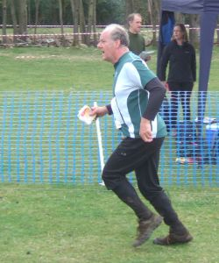 | 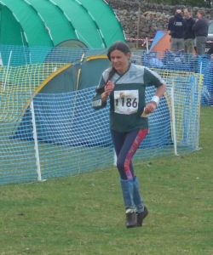 | 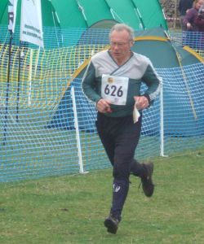
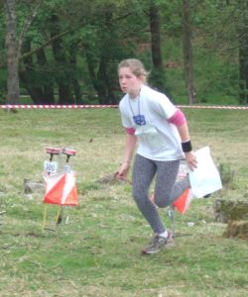 | 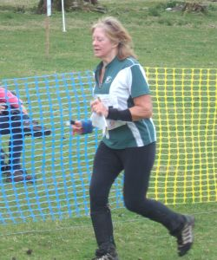 | 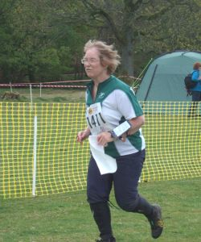
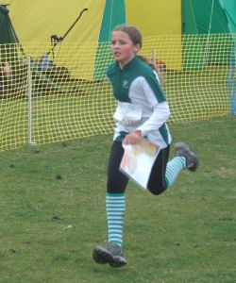 | 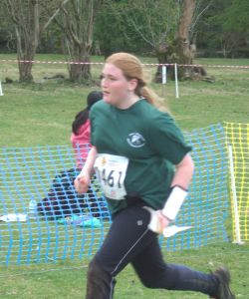  BOC Individual Day | 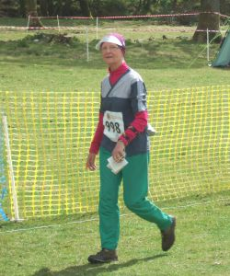

Awards - Julie Laver
The following SOS Juniors and members of the St Andrews and the Ramsey after school club have been awarded colour code badges and Explorer Challenge Certificates -
Tree Explorer Challenge | Owen Tuthill
 | Phoebe Pearse
 | George Pearse
Copse Explorer Challenge | Becky Howard
 | Olivia Baldwin
Wood Explorer Challenge | Ben Partridge
 | Zoe Hartnup
White colour code badge | Zoe Hartnup
 | Olivia Baldwin
 | Phoebe Pearse
Yellow colour code badge | Jack Edwards
 | Josh Partridge
Orange colour code badge | Georgia Gower
 | Daisy Partridge
 | Kieran Palmer
To enter for the Explorer Challenge you need to pick up a log book from enquiries at any SOS event, record the number of controls you visit in your first run (even if you do not complete the course), then for every 25 points you get a certificate is awarded. Participants may be shadowed for this award.
To obtain a colour code badge you must complete 3 1st runs at that colour course in par time without shadowing. For the white badge only pairs may be counted if neither partner has earned their colour badge at that level and the course just has to be successfully completed. Open to Adults and Juniors.
To obtain any of these awards please contact Julie Laver julie.laver@virgin.net.

ESSOL News - Julie Laver
The Final results for this years ESSOL are as follows -
Up to Y6 Boys |  |  | Up to Y6 Girls
1st | Matthew Clarke | Barnardiston Prep | 1st | Daisy Partridge | St Andrews, Halstead
2nd | Jack Edwards | St Andrews, Halstead | 2nd | Chloe Cracknell | St Andrews, Halstead
3rd | Joshua Buist | St Andrews, Halstead | 3rd | Alys Phillips | Barnardiston Prep
Y7/8 Boys |  |  | Y7/8 Girls
1st | Timmy Harrison | Barnardiston Prep | 1st | Bronwen Mansel | Beyton Middle
2nd | Kieran Palmer | CRGS | 2nd | Ellie Harrison | Barnardiston Prep
3rd | Angus Dudley | Barnardiston Prep | 3rd | Georgia Gower | The Ramsey College
Y9/10 Boys |  |  | Y9/10 Girls
1st | Bryn Wilkinson | Copleston High | 1st | Rachael Harrison | The Perse
2nd | Roderick Mansel | County Upper | 2nd | Jennifer Higgins | 3rd Billericay Scouts
3rd | Andrew Stemp | Impington College
Y11/12/13 Boys |  |  | Y11/12/13 Girls
1st | Alex Ware | Colchester 6th form | 1st | Rhiannon Ware | Colne Community
2nd | Sam Bolam | St Helena | 2nd | Beth Albon | Saffron Walden CHS
 |  |  | 3rd | Elena Lumby | CRGS
Whole Team Trophy
1st - Barnardiston Preparatory School
2nd - St Andrews, Halstead
3rd - The Ramsey College
Well done to all of the above!
For full listings please go to ESSOL page on the SOS website http://stragglers.info/schools.
As we were unable to present the winners with their trophies and medals at the last event I will endeavour to get them to all concerned as soon as possible. Certificates will be on their way shortly also.
There has been a review of the rules and a new class has been added. Details are on the website.
If you know any schools which might be interested in the League I would be happy to send further details.
To be included in the League you do not have to enter through your school but please ensure your school and year are included on the registration form when you fill it in. No shadowing is allowed, although junior pairs are.
Full details and comprehensive rules are available on the SOS website http://stragglers.info/schools but I can deal with any enquiries or corrections. julie.laver@virgin.net or phone 01206 826152.
Preliminary ESSOL fixtures for the new season
16 Sep 2012 | Mildenhall South | WAOC
07 Oct 2012 | Chalkney Woods | SOS
14 Oct 2012 | Ickworth | SUFFOC
11 Nov 2012 | Wivenhoe Park | SOS
20 Jan 2013 | Daisy's Wood | SUFFOC
27 Jan 2013 | Pods Wood | SOS
14 Apr 2013 | Roman Valley | SOS
28 Apr 2013 | Langdon Hills | HAVOC
19 May 2013 | The Naze | SOS
Please note these are preliminary fixtures and participants are advised to check Club websites before travelling
http://stragglers.info
http://www.suffoc.co.uk
http://www.waoc.org.uk
http://www.orienteering-havoc.co.uk

Fixtures - David Skinner
Fixtures in East Anglia and Nearby Regions - National Events which SOS members regularly attend are also included
The information provided below normally consists of Event Date, Region(eg EA = East Anglia), Event Grade , Event & Location Names and map reference. Organiser's contact details. Contact details, costs, closing date etc. for Pre-entry when provided. Whether Entry on the Day (EOD) is possible and the surcharge payable. The range of courses offered. The address of a website from which additional information can be obtained. Additional information in plain language.
At Essex Stragglers' events registration normally opens at 1000hrs, starts are from 1030hrs until 1230hrs and courses close at 1430hrs, but this may vary.
SOS Club Nights are generally not included - see SOS website for details.

2012
June
7th | SOS  EAOA  Level D | SOS Summer Evening Series 2, Admirals Park, Chelmsford  Organiser: Emma Johnson , duckfacefeet@hotmail.com , 01245 442866  stragglers.info/home/index.php
10th | NOR  EAOA  Level D | NOR Informal Score Event and AGM, Holt Hall, Holt, TG079398  No dogs allowed.  Organiser: Pat Bedder , alanb.noroc@btinternet.com  www.norfolkoc.co.uk
10th | SMOC  EAOA  Level D | Keyne-O , Caldecotte Lake, Milton Keynes, SP887355  Dogs allowed.  Organiser: Ros James , ros.james@btinternet.com  www.smoc.info/
10th | HAVOC  EAOA  Level D | Langdon Hills Score Event, Langdon Hills Country Park, Basildon, TQ697858  Entry times: 10am to 12noon. Dogs: Dogs must be kept under control.  www.orienteering-havoc.co.uk
13th | SUFFOC  EAOA  Level D | Alton Water Summer Series ~ Event 2, Alton Water, Ipswich, TM139364  Entry times: Starts between 6.30 pm â€“ 7.30 pm .  Organiser: Simon Peck , simon589@btinternet.com  www.clive.coles.freeuk.com/Summer Series.htm
16th | WAOC  EAOA  Level D | WAOC Summer Series, Hinchingbrooke Country Park, Huntingdon, TL221717
17th | SOS  EAOA  Level C | SOS Hatfield Forest Colour Coded Event, Hatfield Forest, Bishops Stortford  Organiser: Jack Isbester , IsbesterJ@aol.com , 01621 815501  stragglers.info
21st | SOS  EAOA  Level D | SOS Summer Evening Series 3, The Broaks, Halstead, TL792312  Organiser: Daniela Brohm , danielabrohm@gmx.de , 01787 829294  stragglers.info/home/index.php
23rd | NOR  EAOA  Level B | Junior Inter-Regional Championships, Sandringham Country Park, King's Lynn, TF690290  Organiser: Alan Bedder  www.norfolkoc.co.uk
23rd | SAX  SEOA  Level C | SAX Sprint, university of kent, Canterbury
24th | NOR  EAOA  Level B | Junior Inter-Regional Championships, Sandringham Country Park, King's Lynn, TF690290  Organiser: Alan Bedder  www.norfolkoc.co.uk
24th | SAX  SEOA  Level B | SAX Canterbury Urban Race, Canterbury, Canterbury, TR152579  Organiser: Sarah Howes , sarahmhowes@hotmail.co.uk , 01892 723327  www.saxons-oc.org
27th | SUFFOC  EAOA  Level D | Hardwick Heath Summer Series ~ Event 3, Hardwick Heath, Bury St Edmunds, TL857626  Entry times: Starts between 6.30 pm â€“ 7.30 pm .  Organiser: Simon Peck , simon589@btinternet.com  www.clive.coles.freeuk.com/Summer Series.htm
30th | WAOC  EAOA  Level D | WAOC Summer Series, Milton Country Park, Cambridge, TL476621
July
1st | BAOC  SCOA  Level B | Harvester Relays, Bordon Heaths, Aldershot, SU787362  Dogs: On lead near livestock.  Organiser: Tom Murphy , club.treasurer@baoc.info , n/a
1st | NOR  EAOA  Level D | Summer Score Event, University of East Anglia & Earlham Park, Norwich, TG190076  Dogs: On Lead.  Organiser: Alan Bedder , alanb.noroc@btinternet.com
5th | SOS  EAOA  Level D | SOS Summer Evening Series 4, Notley Country Park, Braintree  Organiser: Edwin Banks , banksy.eddie@gmail.com , 01376 321658  stragglers.info/home/index.php
7th | HH  SEOA  Level D | HH Saturday Series, Highfield, St Albans
8th | SOS  EAOA  Level D | SOS Relays Highwoods Colchester, Highwoods Country Park, Colchester  Organiser: Geraldine Russell , grmrussell@gmail.com , 01206 272761  stragglers.info
11th | SUFFOC  EAOA  Level D | Belstead Valley Summer Series ~ Event 4, Belstead Valley, Ipswich, TM143417  Entry times: Starts between 6.30 pm â€“ 7.30 pm .  Organiser: Simon Peck , simon589@btinternet.com  www.clive.coles.freeuk.com/Summer Series.htm
14th | WAOC  EAOA  Level D | WAOC Summer Series, Cambourne, Cambourne, TL320596  No dogs allowed.
19th | SOS  EAOA  Level D | SOS Summer Evening Series 5, Danbury Common, Danbury, TL779046  Organiser: Rhiannon Ware , rhiannon.ware@virgin.net , 01206 826152  stragglers.info/home/index.php
25th | SUFFOC  EAOA  Level D | Rushmere Heath & Foxhall Summer Series ~ Event 5, Rushmere Heath & Foxhall, ipswich, TM206445  Entry times: Starts between 6.30 pm â€“ 7.30 pm .  Organiser: Simon Peck , simon589@btinternet.com  www.clive.coles.freeuk.com/Summer Series.htm
August
4th | WAOC  EAOA  Level D | WAOC Summer Series, Ampthill Park, Ampthill, TL023382  Dogs: Dogs welcome if kept on a lead.
18th | WAOC  EAOA  Level D | WAOC Summer Series, Cambridge, TL343511  No dogs allowed.
19th | SMOC  EAOA  Level D | Keyne-O , Campbell Park, Milton Keynes, SP867398  www.smoc.info/
24th | EBOR  YHOA  Level D | White Rose Sprint Race, Park Far, Wood near Scarborough, Scarborough, SE932867  Dogs: On lead and in assembly area only.  Organiser: Bill Griffiths , wr2012organiser@gmail.com , 07710002961  www.whiteroseweekend.org.uk
25th | EBOR  YHOA  Level B | White Rose Individual 1, Wykeham Forest, Scarborough, SE932867  Dogs: On lead and in assembly area only.  Organiser: Mike Ridealgh , wr2012organiser@gmail.com , 07710002961  www.whiteroseweekend.org.uk
25th | EBOR  YHOA  Level D | White Rose Night Score, Wykeham Forest, Scarborough, SE932867  Dogs: On lead and in assembly area only.  Organiser: Bill Griffiths , wr2012organiser@gmail.com , 07710002961  www.whiteroseweekend.org.uk
25th | EBOR  YHOA  Level D | White Rose Trail-O event, Halleykeld Rigg, Scarborough, SE932867  Entry times: 1430 to 20:00 . Dogs: On lead and in assembly area only. .  Organiser: Christine Roberts , wr2012organiser@gmail.com , , 01759 371258  www.eborienteers.org.uk
26th | EBOR  YHOA  Level B | White Rose Individual 2, Wykeham Forest, Scarborough, SE932867  Dogs: On lead and in assembly area only.  Organiser: Mike Ridealgh , wr2012organiser@gmail.com , 07710002961  www.whiteroseweekend.org.uk
27th | EBOR  YHOA  Level C | White Rose Team Score, Wykeham Forest, Scarborough, SE932867  Dogs: On lead and in assembly area only.  Organiser: Bill Griffiths , wr2012organiser@gmail.com , 07710002961  www.whiteroseweekend.org.uk
September
1st | DFOK  SEOA  Level D | DFOK North West Kent Series, Crystal Palace Park, tbc
9th | COBOC  WMOA  Level B | Peter Palmer Junior Team Relays, Sutton Park, Sutton Coldfield  Organiser: Dave Ellis  www.coboc.org.uk
9th | HAVOC  EAOA  Level C | Weald SWELL Event, Weald Country Park, Brentwood, TQ573940  Dogs: Dogs to be kept under control.
9th | SMOC  EAOA  Level D | Keyne-O , Open University and Woughton, Milton Keynes  www.smoc.info/
16th | NOR  EAOA  Level D | Colour Coded & Try-O, University of East Angia & Earlham Park, Norwich, TG190076  Entry times: 10.30 to 12.30. Dogs: On Lead.  Organiser: Nicky Nicholls , membership@noroc.co.uk  www.norfolkoc.co.uk
16th | WAOC  EAOA  Level D | WAOC Mildenhall South Colour Coded, Mildenhall, TL740741  www.waoc.org.uk
21st | CHIG  SEOA  Level D | Southern Championships Training Event, Epping NW, Loughton  Organiser: Ray Curtis , curtis.rosemount@sky.com , 01279 418699  www.chig.org.uk
22nd | SLOW  SEOA  Level B | The Fifth City of London Race, London City, Temple  No dogs allowed.  Organiser: Vince Roper , london@cityrace .org  www.sloweb.org.uk
23rd | CHIG  SEOA  Level A | Southern Championships, TBC, Epping, TQ428985  Dogs: Keep under control.  Organiser: Jennifer Taylor , jennifer.taylor4@btinternet.com  chig.org.uk
30th | WAOC  EAOA  Level D | WAOC Ampthill Park Colour Coded, Ampthill Park, Ampthill, TL023381  Dogs: Dogs allowed if kept on a lead..  www.waoc.org.uk

An Essex Bunroe run - John Williams
A run that a few of us did earlier in the year, 60th birthday celebration(!) in my case.
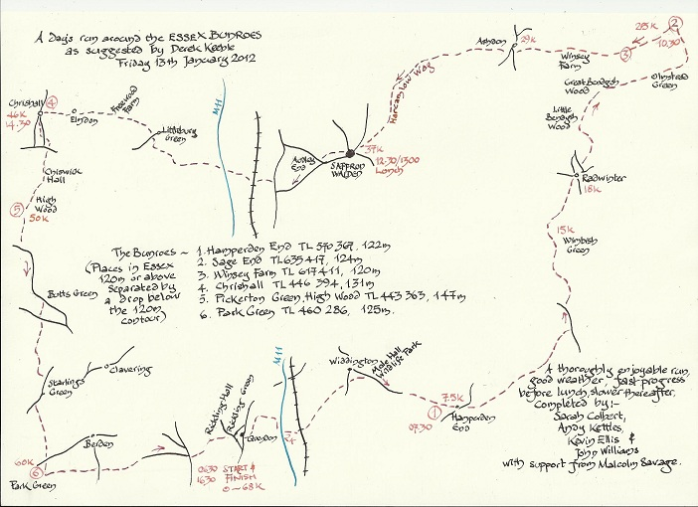
To see the map at full size, click http://www.stragglers.info/newsletter/vol21no11bunroesbig.jpg.
Malvern Urban Race (March 2012) - John Collyer

In woods every Sunday, out of public gaze,
Ordinary folk don't see our strange kit, or ways.
In parks, other sports have their own coloured strip,
But what do 'townies' think, of our urban trip?
On side of bare heights, serrated, Pre-Cambrian,
Here from many wells, spout waters Malvernian,
Across Severn's plain, where streams tumble and run,
What do locals make of our street race fun?
Thorpe Park, festooned with O banners and signs,
An isolated man, with Tai Chi, unwinds.
Watch early runners, over first route choice ponder,
Then out to town centre, where slow shoppers wander.
Local crowds wait, for green man's beep and flash,
We, swift and decisive, o'er busy roads dash,
Whizzing round corners, up steep steps we stride,
Surprised weekend shoppers; the lanes are not wide.
We're of all ages, up to Septuagenarian, alright!
In trainers, tights, shorts and thin club tops, bright.
Mixing strangely with locals, work and school free,
Dressed up, or down, for their Saturday spree.
Across some Commons, twice under rail line,
Near Tennis Club courts, brambles entwine.
At Bluebird Café, it's control 51,
Next, Elgar, 34, to whose stone feet we run.
Right around playground, children are screaming,
Along past Priory, shoppers stare, with bags bulging,
Once more into town, then to the Finish in park,
But what does Joe Soap think, of our weekly lark?

Our first experience of the British Orienteering Championships by Daisy Partridge and Chloe Cracknell age 11

On Friday 4th May Chloe and I set off for the Lake District and arrived just in time for the training session. We didn't know what crags were until then - but we definitely do now! It was Chloe's first time camping and it was great fun. We got wet playing on the rafts. On the Saturday Chloe and I were running in the British Orienteering Championships against children from all over the country. It took us 45 minutes just to climb the mountainside to get to the start. We really enjoyed running around the hills but it was very tiring. The course was very different to the courses here and the marshland was very tricky to get across without getting very muddy bottoms. Chloe hasn't run many orange standard courses and she found the map reading a bit tricky but did really well on the second half of the course. I had a couple of little hiccups but managed to secure tenth place. We also enjoyed watching the other SOS competitors running up the home straight, especially Alex Ware with his flowing hair as he sprinted to the finish. The weather was lovely and we all got sun tans.

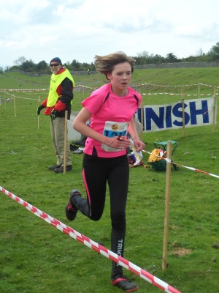 | 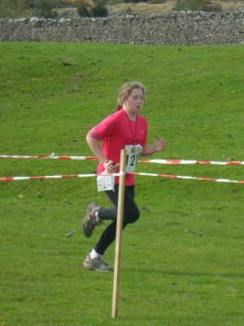
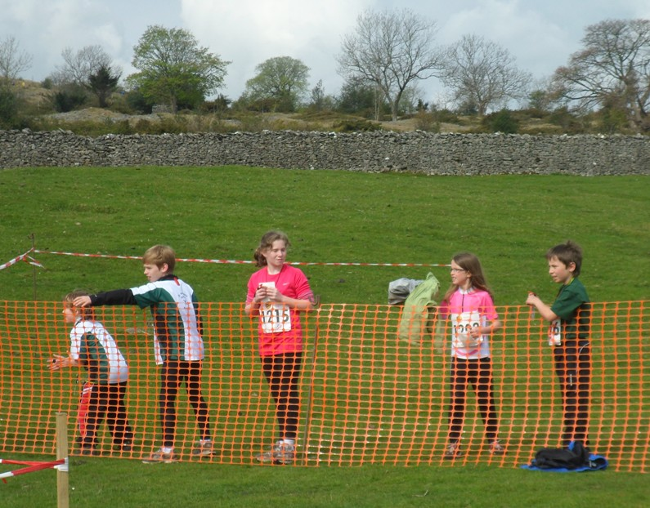
On Sunday we were joined by Joshua Buist, Lucy and Jack Edwards and Dominic Emmerson for the relay championships. All the SOS relay team names were made up by the children from the St Andrew's School orienteering club. The boys were called SOSpicious STOATS and the girls team who were joined by Lucy Edwards from The Ramsey were called Two STAGs and a Ram. Daisy and Jack took part in the mass start with 21 other children - it was very exciting to watch. I then stood in the pen waiting for Daisy to return and touch my hand before I could go. Jack and Daisy came back together sprinting up to Joshua and me then we were off, It was hard running and opening my map at the same time! Luckily the hill wasn't as high as the day before and there was a good path network. I found my 9 controls as quickly as I could and then returned to touch Lucy's hand. We then went to the finish to cheer everyone in. We all had a really good time and did very well against the other teams from all over Britain with the boys finishing 6th and the girls finishing 8th.
On Monday we had a day off so we took the little steam train up the mountain before we drove home. We are so glad we were introduced to this really great sport - we love it!
