 | Essex Stragglers Orienteering Society (SOS) |   accredited

Newsletter Volume 21 No. 12

October 2012
Editors: Geraldine Russell and Rachel Barford- editors@stragglers.info
Club website - http://stragglers.info

Editorial - Rachel Barford 1
Notes from the Chair - John Collyer 2
Captain's Corner - Jenny Collyer 2
ESSOL News - Julie Laver 3
Winter Mid Week Street O Series - Chris Childs 5
Event No.1 Wed 17th October Welshwood Park Colchester 6
Junior Roundup - Julie Laver 7
Peter Palmer Relays 7
Junior InterRegional Championships (JIRCs) 9
Awards 10
Yvette Baker Trophy 11
Fixtures - David Skinner 12
Bunroes Again - Derek Keeble 16
World Masters Championships - Jenny Collyer 16
Bad Harzburg - John Collyer 18
A Midsummer's Day Dream - Derek Keeble 19
London Moonwalk 2012 Spot the Straggler 'Competition' 20

Editorial - Rachel Barford
The orienteering season is now in full swing, as we enjoy looking back on events and activities over the summer, both our own orienteering activities, as well as the great sporting event of the Olympics. To remind us of these occasions, Jenny and John Collyer's contributions from the World Masters in this Newsletter are a great read, and might make us wonder why orienteering is not yet an Olympic sport. After all, we have the participation, the technology and the enthusiasm - bring it on!

Notes from the Chair - John Collyer
My three-year term of office ends at our forthcoming AGM, and I hope there will be a good turnout by members to help vote in a new Chairman. As usual the main business is expected to be dealt with quickly and there will then be a buffet, and a speaker from the Woodland Trust.
During my term of office I have been heartened by the amount of thought and time that our Committee members have devoted to the affairs of the Club. Nothing seems to stand still in the external forces which we are subject to; Grant Schemes, BOF registration requirements, Forestry ownership and charges, plus many more.
I would therefore like to say a big THANK YOU to all of those on the Committee as well as all the other members who have given freely of their time to help in the running of events over the past three years.

Captain's Corner - Jenny Collyer
The major team events in 2013 to put in your diaries now are -
17th Feb the Compass Sport Trophy qualifying round. This will be either at Fineshade Woods (between Peterborough and Corby) or somewhere in the South East. We will be hoping to take a coach to this event.
1st April the JK Relays at Hambledon, near Reading. This is on the 4th day of a weekend of orienteering. There is a Sprint Race at Reading University on the first day followed by two classic distance races in the Reading area before the relays on the last day.
5th May the British Relays are at Holmbury near Dorking on the Sunday following the British Individual Championships the previous day. There is an Urban Race in Dorking on the following day - so another weekend packed with events.
This year we did well with teams travelling the long distances to Scotland for the JK and the Lakes for the British. Next year we are spoilt with both major events on our doorstep so I hope to be entering lots of teams to all these events.
It is not too early to let me know if you want a run in any of these - it will save me chasing you up nearer the time! Email:jcollyer48@btinternet.com.

ESSOL News - Julie Laver
We have just had the first ESSOL event of the new season and after a lovely if muddy day at Chalkney Woods we have the following results. New for this season we have introduced some new classes to widen the appeal of the league and to better enable participants to judge their own and their schools/groups performance against those of similar age and ability. The best six individual scores count towards your schools/group league total. Leaders after the first event -
Y 3/4 Boys |  |  | Y 3/4 Girls
1st | David Low | Morley Memorial | 1st | Rosy Bird | St Andrews, Halstead
2nd | Samuel Bell | St Andrews, Halstead | 2nd | India Hook | St Andrews, Halstead
3rd | Liam Polley | St Andrews, Halstead | 3rd | Ellie Low | KCS
Y 5/6 Boys |  |  | Y 5/6 Girls
1st | Jack Edwards | St Andrews, Halstead | 1st | Tilly Salmon | St Andrews, Halstead
2nd | Tom Steed | St Andrews, Halstead | 2nd | Isobel Perry | Barnardiston Prep
3rd | Thomas Harrington | St Andrews, Halstead | 3rd | Elizabeth Dudley | Meldreth
Y7/8 Boys |  |  | Y7/8 Girls
1st | Matthew Clarke | Barnardiston Prep | 1st | Daisy Partridge | Hedingham School
2nd | Callum Turner | The Ramsey College | 2nd | Chloe Cracknell | Hedingham School
3rd | Jack Kremple | Barnardiston Prep | 3rd | Lucy Edwards | The Ramsey College
Y9/10 Boys |  |  | Y9/10 Girls
1st | Josh Partridge | Hedingham School | 1st | Bronwen Mansel | County Upper
 |  |  | 2nd | Stephanie Ware | Philip Morant
 |  |  | 3rd | Emma Clarke | The Perse
Y11/12/13 Boys |  |  | Y11/12/13 Girls
1st | Bryn Wilkinson | Copleston High | 1st | Rhiannon Ware | CCHS
2nd | Roderick Mansel | County Upper
3rd | Sam Bolam | Colchester Institute
Whole Team Trophy
1st - Barnardiston Preparatory School
2nd - St Andrews, Halstead
3rd - The Ramsey College
Junior (up to Y6) Team results
1st - St Andrews, Halstead
2nd - Barnardiston Preparatory School
3rd - Morley Memorial
Senior (Y7+) Team results
1st - Barnardiston Preparatory School
2nd - The Ramsey College
3rd - Hedingham School
Well done to all of the above!
For full listings please go to ESSOL page on the SOS website http://stragglers.info/schools.
If you know any schools which might be interested in the League I would be happy to send further details.
To be included in the league you do not have to enter through your school but please ensure your School and year are included on the registration form when you fill it in. No shadowing is allowed although junior pairs are.
A related adult or supervising person who wishes to run the same course as the competitor must leave at least 10 minutes after competitor has started their run before setting off on their own run for white and yellow courses and at least 15 minutes for other courses.
Competitors having a second run on the day must declare themselves non-competitive for the second course and will not receive points for the second run and neither will any partner who runs with them.
Full details and comprehensive rules are available on the SOS website http://stragglers.info/schools but I can deal with any enquiries or corrections. julie.laver@virgin.net or phone 01206 826152.
Preliminary ESSOL fixtures for the remainder of this season
14 Oct 2012 | Ickworth | SUFFOC
11 Nov 2012 | Wivenhoe Park | SOS
20 Jan 2013 | Daisy's Wood | SUFFOC
27 Jan 2013 | Pods Wood | SOS
14 Apr 2013 | Roman Valley | SOS
28 Apr 2013 | Langdon Hills | HAVOC
19 May 2013 | The Naze | SOS
Please note these are preliminary fixtures and participants are advised to check Club websites before travelling
http://stragglers.info
http://www.suffoc.co.uk
http://www.waoc.org.uk
http://www.orienteering-havoc.co.uk

Winter Mid Week Street O Series - Chris Childs
A series of 7 Street Orienteering Events to be held mid week through the winter as follows -
Wed 17th October | Welshwood Park Colchester | Les & Chris Childs
Wed 7th November | Colchester Town Centre | Lyn & Colin West
Wed 28th November | Lexden | David Lumby
Wed 19th December | Brightlingsea | Julie Laver
Wed 9th January | Sudbury | John & Jenny Collyer
Wed 13th February | Halstead | Andrew Cordle
Wed 13th March | Springfield | John Williams
The details, dates and times to be confirmed prior to each event.
Nature of event is at planner's discretion but Street Orienteering on the lines of the events held this year is envisaged so that we have the benefit of street lights and safety.
A head torch should be carried. Bring a pen and map bag.
Competitors will get a recorded time and the best 4 results will decide the series winner - rules to be finalised.
Under 16's must be accompanied by an adult.
These will be fairly low key events and hopefully a bit of fun while keeping us all in peak condition! So put the dates in your diary and remember to get off a bit early from work on those days. Street maps easily downloaded from www.oobrien.com/oom/
John Collier has kindly offered to assist anyone with maps if need be. Fire hydrants have proved useful control points without the hassle of setting out the course and retrieving controls thereafter but again planners may have their own ideas.
The course planners are Les Childs, David Lumby, Lyn & Colin West, Julie Laver, John & Jenny Collyer, Andrew Cordle, and John Williams. So please support their efforts and let us hope for a good turn out.

Event No.1 Wed 17th October Welshwood Park Colchester
Start times 6.30-7.30pm.
Start : 26 The Glade Colchester Post Code CO4 3JD O.S. ref. TM 0243 2664. Just off the Harwich Road on the north side of Colchester. Follow Welshwood Park Road, turn right into Woodlands and right again into the Glade then down to the end of the road on the right http://streetmap.co.uk/postcode/co43jd.
Long course 6km (map 1:7500), Short course 4 km (map 1:4000).
The controls are fire hydrants. You will be asked to record the number of the hydrants. Please bring a pen and map bag.
Entry £2.00 and £1.00 juniors.
Parking is in a residential street so please park with consideration.
As with any Street Orienteering this requires participants to cross roads and you asked to take due care and attention at all times.
Remember to bring clothes appropriate for the weather conditions.
After your run Les & Deb will be offering tea and cake for competitors at 26 The Glade!
More information from Chris Childs chris.childs@tiscali.co.uk, Tel 01206 574748.

Junior Roundup - Julie Laver

Peter Palmer Relays
This is a National Inter club Junior Relay with the first and second legs run in the dark but including legs from yellow to green standard to include as many juniors as possible. This year the event was held in Sutton Park, Birmingham, and the SOS team comprised of Josh Partridge, Daisy Partridge, Rhiannon Ware, Stephanie Ware, Ben Warland and Sam Bolam.
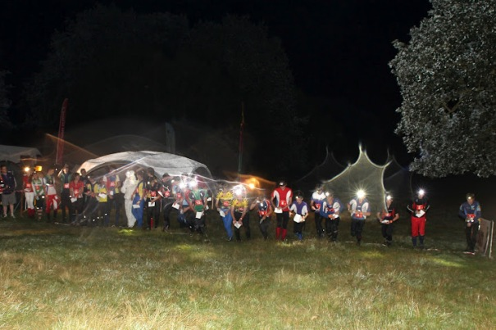
Mass Start in the dark

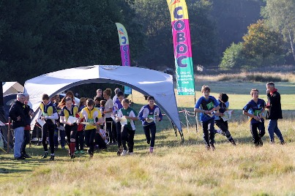  Daisy at the Start... | 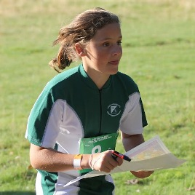  ... and on her way

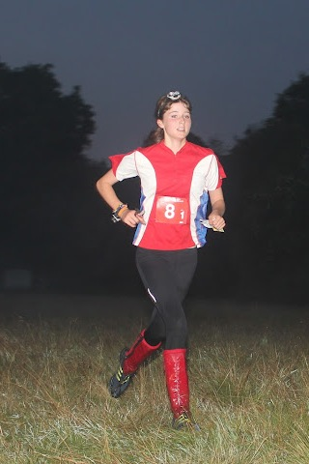  Rhiannon | 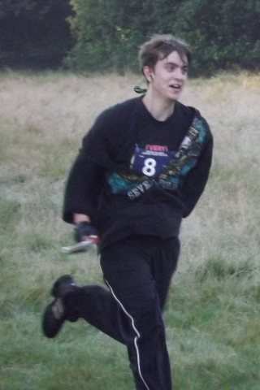  Sam

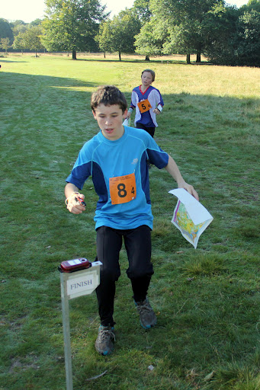
Josh at the finish

Junior InterRegional Championships (JIRCs)
The Junior Interregional Champs held in a different region each year and are a regional Junior Squad Competition with participants from all over the country. East Anglia hosted it this year at Sandringham, Norfolk. It is a two day event with Individual races on the Saturday and relay races on the Sunday.
To become a member of the East Anglian squad and train regularly with them you have to be running confident orange courses and considering starting at Light Green Standard. They have six training sessions around the region each winter as well as a weekend trip to the lake district and the JIRCS.
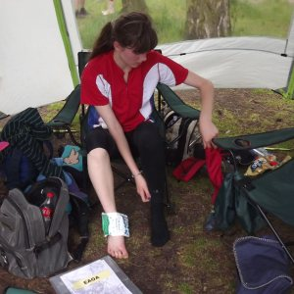  Rhiannon hurt her ankle on Day 1... | 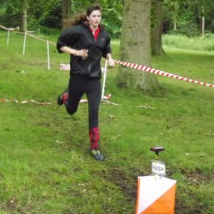  ...but finished in the Relays on Day 2!

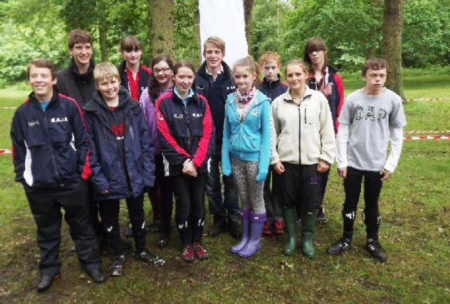
Some of the East Anglia Squad

Awards
The colour coded badge scheme is open to ALL club members - junior and senior. You must complete three colour coded courses within par time then contact me for a badge with the dates and venues at which you achieved this feat. All courses should be run singly except the White course which can be run as a pair unless one of the partners has already achieved a White badge.
This is a regional scheme and is run alongside the national award scheme, details of which are on the British Orienteering website.
Any club junior who is 'picked' to represent the club at various competitions throughout the year is awarded a club T-shirt.
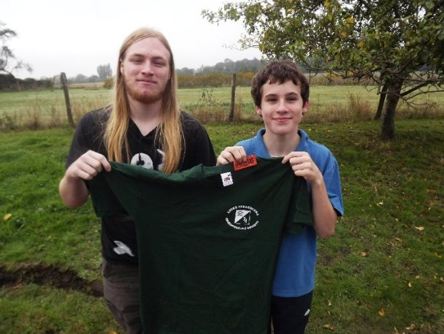
Junior Captain Alex presents Josh with his Orange Colour Coded Award and his club T-shirt

Yvette Baker Trophy
Well done to all the Club Juniors who contributed to the SOS Victory at the at Chalkney Woods. The final results were SOS - 889, NOR - 887, SUFFOC - 886 and WAOC - 472. The final is on 9th December, organised by SARUM at Collingbourne Wood, Wiltshire (to be confirmed). So all juniors keep this date free in your diary - your club needs you!!!!!!!!!
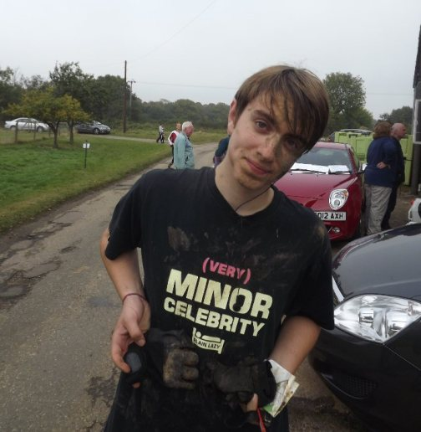
Sam enjoyed the muddy conditions at Chalkney

Fixtures - David Skinner
Fixtures in East Anglia and Nearby Regions - National Events which SOS members regularly attend are also included
The information provided below normally consists of Event Date, Club, Region(eg EA = East Anglia), Event Grade , Event & Location Names and map reference. Organiser's contact details. Contact details, costs, closing date etc. for Pre-entry when provided. Whether Entry on the Day (EOD) is possible and the surcharge payable. The range of courses offered. The address of a website from which additional information can be obtained. Additional information in plain language.
At Essex Stragglers' events registration normally opens at 1000hrs, starts are from 1030hrs until 1230hrs and courses close at 1430hrs, but this may vary.
SOS Club Nights are generally not included - see SOS website for details - http://stragglers.info
October 2012
17th | SOS  EAOA  Level D | SOS Winter Mid-Week Evening Street Event Welshwood Park Colchester
21st | WAOC  EAOA  Level C | WAOC Mildenhall North Colour Coded and EA League , Mildenhall , TL735752  Entry times: 10.00 to 12.00. Dogs: See event web page on WAOC website.  Organiser: Catherine Pennington , cath_pennington@hotmail.com  www.waoc.org.uk/n.humphries/waoc/details/2012-10-21-MildenhallN.php
25th | CHIG  SEOA  Level D | North London Streets League , Loughton
28th | HAVOC  EAOA  Level C | HAVOC Snail Trail Trophy, SE League + SWELL Event , Epping SW, Chingford, TQ393950  Dogs: Dogs to be kept under control.  Organiser: Barbara Fothergill , publicity@orienteering-havoc.co.uk , 01277 213758

November
4th | NOR  EAOA  Level C | Colour Coded Event inc. EAL , Shouldham Warren, Downham Market, TF680104  Entry times: 10.30 to 12.30. Dogs: Doge on Lead.  Organiser: Helen Lloyd , helenlloyd59@btinternet.com , 01760 337189  www.norfolkoc.co.uk
7th | SOS  EAOA  Level D | SOS Winter Mid-Week Evening Street Event Colchester Town Centre  http://stragglers.info
11th | SOS  EAOA  Level C | SOS Colour Coded incorporating ESSOL , Wivenhoe Park, Colchester  Entry times: Registration from 10.00. Dogs: Dogs under control.  Organiser: Peter Warland , smwarland@aol.com , 01359 231078  stragglers.info
13th | SLOW  SEOA  Level D | SLOW London Street-O , Bank, London
18th | SUFFOC  EAOA  Level C | West Harling Heath Colour Code Event, inc.EAL and ESSOL , West Harling Heath, Thetford,TL967838  Entry times: Starts : 10:30 to 12:30 - Registration from 10:00. Dogs: Dogs welcome but must be kept under control..  Organiser: Andrew Elliott , andrew_yyy@tiscali.co.uk  www.suffoc.co.uk
22nd | CHIG  SEOA  Level D | North London Streets League , Walthamstow
25th | DVO  EMOA  Level B | East Midlands Champs and Masters Cup , Eyam Moor & Bretton Clough, Bakewell , SK210778  Organiser: Stuart Swalwell , stuart.swalwell2412@mac.com , 01335 347814  www.dvo.org.uk/
28th | SOS  EAOA  Level D | SOS Winter Mid-Week Evening Street Event Lexden  http://stragglers.info

December
2nd | NOR  EAOA  Level D | North Norfolk Colour Coded Event , NT Felbrigg Estate, Cromer, TG196394  Entry times: 10.00 to 12.00. No dogs allowed.  Organiser: Alan Bedder , alanb.noroc@btinternet.com , 01603 424589  www.norfolkoc.co.uk
9th | HAVOC  EAOA  Level D | HAVOC Bedfords Local Score Event , Bedfords Park, Romford, TQ520924  Entry times: 10am to 12noon. Dogs: To be kept under control.  Organiser: Tim Jones , juniorrep@orienteering-havoc.co.uk
11th | SLOW  SEOA  Level D | SLOW London Street-O , Pimlico, London
12th | SOS  EAOA  Level D | SOS Winter Mid-Week Evening Street Event Brightlingsea  http://stragglers.info
16th | NOR  EAOA  Level D | NOR Club Championships , Hockering Wood, Dereham , TG072150  Entry times: 10.00 to 12.00. Dogs: NO Dogs in the Wood..  Organiser: Alan Bedder , alanb.noroc@btinternet.com , 01603 424589  www.norfolkoc.co.uk
20th | CHIG  SEOA  Level D | North London Streets League , Loughton

January 2013
1st | SOS  EAOA  Level D | New Years Day Novelty Event - tba
6th | HAVOC  EAOA  Level C | HAVOC Belhus SWELL Event , Belhus Woods Country Park, Upminster, TQ564825  Entry times: 10am to 12noon. Dogs: Dogs to be kept under control..  Organiser: Gillian Edgar , captain@orienteering-havoc.co.uk
9th | SOS  EAOA  Level D | SOS Winter Mid-Week Evening Street Event Sudbury  http://stragglers.info
13th | SMOC  EAOA  Level D | SMOC local event , Northampton  www.smoc.info
19th | WAOC  EAOA  Level D | Rowney Warren Night Event , Rowney Warren, Shefford , TL123403  Entry times: 5:30pm - 6:30 pm. Dogs: Dogs on lead in car park, and must be on lead when crossing minor road..  Organiser: Peter Woods , peter_woods@ntlworld.com  www.waoc.org.uk/n.humphries/waoc/details/2013-01-19-Rowney-Night.php
24th | CHIG  SEOA  Level D | North London Streets League , Loughton

Bunroes Again - Derek Keeble
I literally read a map in the last Stragglers Newsletter. It told me that last January Straggler John Williams with three running companions and a fourth companion in a back-up vehicle did compile the top six Essex Bunroes into a 68 km run which they duly completed in 12 hours.
How can I draw a response map which says Happy 60th birthday John Williams. Congratulations. I am pleased you had good weather and enjoyed the excursion. The multi-summit of Essex should henceforth become known as the JOHN WILLIAMS ROUND.
Twelve hours! I needed all my fingers, both my thumbs and some of my toes to count the years it took me to complete the loop from Rickling Green.
Bravo
Derek Keeble - compiler of the Bunroe list

World Masters Championships - Jenny Collyer
These are big events - 220 competitors in my W65, 440 in John's M65, 3 heats/qualification races in mine, 6 in Johns. This is the popularity of the World Masters Championships which caters for M/W35 up to W85/M90.
This years event at the beginning of July was in the Harz Mountains in Germany and comprised a Sprint and a Classic Distance Championship.
The Sprint Qualification races took place in Bad Harzburg using the wide town centre streets and parkland and was fairly straight forward with route choices around the built up areas. I just lost a few seconds (but a lot of places) by stopping at a thicket about 40m short of the correct one. 27 competitors from each of my heats go through to the next day's "A Final" which I was relieved to make, next 27 the "B Final" and so on. With John's 6 heats only 14 make the A Final and he was disappointed to only make the "C Final" - just missing out on the "B".
The Sprint Final was in the lovely old town of Goslar with narrow cobbled streets and alleys and a little river wending its way through the town. This time I had to look very carefully at the route choices which often crossed the river and I was pleased to finish in 13 th place without any problems. Unfortunately John didn't notice an uncrossable wall on the map near the end of his course and lost a lot of time retracing his steps.
The next day we drove to the model event on an area close to the first qualification race. It was good to be in a forest at last and we enjoyed strolling around an undergrowth free forest and taking it in turns to do the navigating. When we got back we found out that if we had persevered a bit further up the hillside we would have had some wonderful views over the Harz Mountains. After this we became tourists and visited the lovely colourful little town of Wernigerode.
The first Classic Distance race was near Drei Annen Hohe high up in the Harz Mountains. We took the opportunity of accessing the area by a narrow gauge steam train on its way up to Brocken - the highest Mountain. There was a very rocky area on the map which John visited but my course was relatively flat, though I felt I was lucky to find the controls in the "green" areas which many runners had problems with.
The second Qualification Day was in a forest on the edge of the town of Clausthal. I wasted time ploughing through a marsh only to discover I needed to be back where I had come from! It was a more runable wood than the previous day's and generally the straight line route was the best option. Everyone had a 320m taped route along a dam at the end of the course and this seemed endless especially when tired. I finished 14th overall so again made the A Final.

After an easy “rest day” when we just pottered around on our bikes the Final was just south of Bad Harzburg. The Parking and Assembly were squeezed into a narrow area between a huge working quarry and the forest. The area was steep and rocky and I got caught out on one occasion by some confusing rides. The shooting platforms didn’t help with relocation as there was one on each of the junctions! Most of us had a killing 80m climb straight up the hillside towards the end of our courses. Having gone out in 42nd place I finished 53rd.

The whole atmosphere at this event is very friendly and relaxed and it was lovely meeting up with old friends from other countries. I was pleased to be at the Finish just as my Swedish friend’s father-in-law came in to win the M90 class.

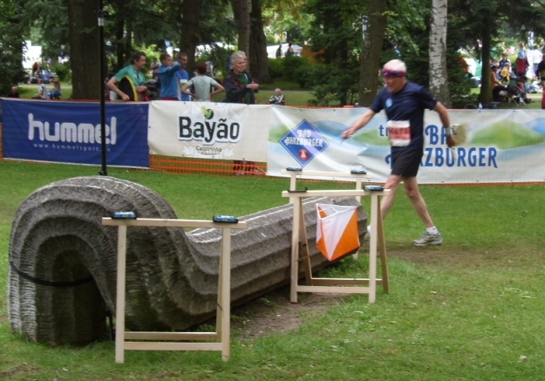
John at the final control of the Sprint Race in Bad Harzberg

Bad Harzburg - John Collyer
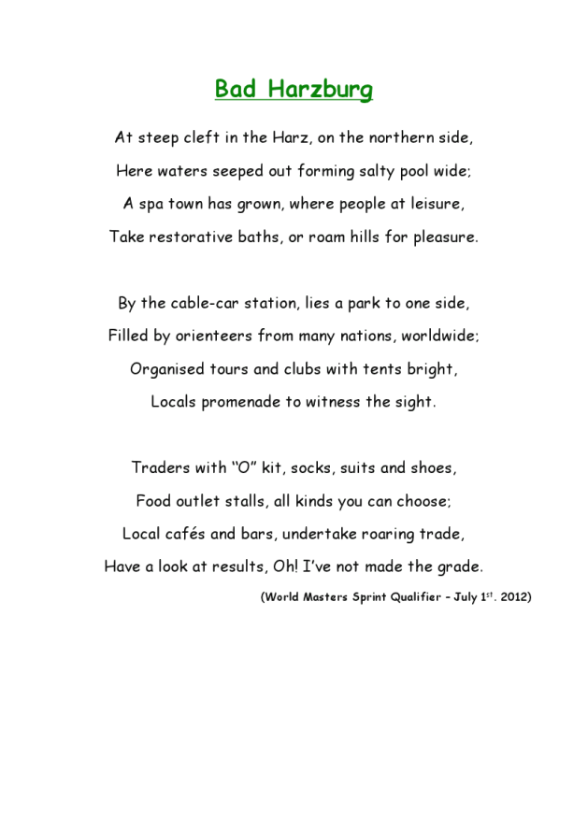

A Midsummer's Day Dream - Derek Keeble
How did I get in this unfamiliar situation where I seem to have a role of responsibility? Is this a school? Am I on playground duty? Why is there a cattle grid at the portal? How did the Groundsman allow the grasses like Woodside Green to grow so extensively? Has he gone AWOL? Uniforms are as shoddy as the lawn, black and white or white and black without common portion of pattern. Blimey, all the pupils are four-legged girls! Did you not know Derek? Must be the fact you have never taught in an all-girls' school?
That one over there has a huge yellow earring: I bet she is a ringleader. I'll mooch over and chat her over to my side. Tell her that any hint of a stampede will find them all in after-school detention. She should know my Orwellian rule regarding the gate beside the cattle-grid is "Two legs pass: four legs stay content as they are". And I'd like to know her name for my report.
The shocking response is "Look here Four-eyes, you can detain us as you will: we are all boarders anyway. We don't stampede, we are more subtle than that. Our aim is to get one of us through that gate and delight in your consequent sacking. We are not girls: we are nursing mothers deprived of our youngsters and (she adds with an extra chew for emphasis) we suffer artificial suckling. We don't have names, our numbers are painted on our bums. We know each others' numbers but not our own, and we don't have much allegiance to the school, more for our family connection with the Hallingbury Herd."
I get back to gatepost - literally - and ruminate. I am not guilty of suckling, not for nearly eight decades. Less confidently I re-assess them. Some are already on sit-down strike; many more are performing a slow-motion manoeuvre as they imperceptibly crowd into my focus. One with just enough white trim to both comply and yet defy the uniform, stands four-square on the road impeding a parent driving his son home. That seems reasonable from a girls' school, but it impresses not our Blackhide Beauty. I assure the parent I am in charge and will remove the picket.
Two steps and WHOSH. I realise I have been lured from my primary duty. I swivel with difficulty, needing my stick which is where I should be, by the gate. Then another parent appears, this one afoot accompanied by a dog on a lead. The girls - deprived mothers or otherwise - sense more fun in that direction and their ambush has been decoyed. Gasping for breath I return to the dutiful stance yelling when lungs allow, that the NFU have sanctioned dogs-on-leads and there is no need for them to interfere. Surprisingly the migration reverses at the same energy-efficient pace.
A replacement colleague arrives. Another male, this one from Nippon, obviously an Orient-here. Is Japanese on the curriculum? I retire to the Staffroom which is a replica of my Toyota Verso and I drive away to sleep. My snores choke and awake me. Okay I am alive and well, safely off-road in Great Tey.
I tell myself "Get a decent old age life: teaching Bovinity is the stuff of nightmares".

London Moonwalk 2012 Spot the Straggler 'Competition'
One Straggler and his team raised some £2,300 for Breast Cancer Research by taking part in the 2012 London Moonwalk. Spot the Straggler in the pics below and win, at best, a used decorated bra!
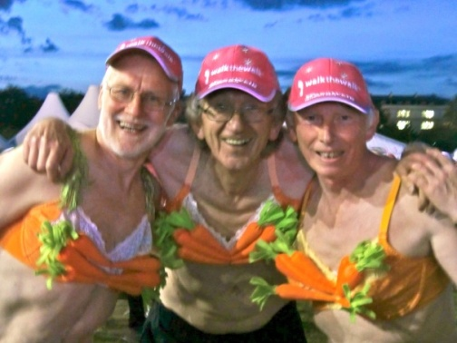

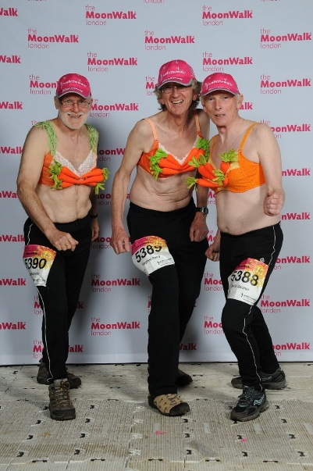
Hint: go to http://www.walkthewalkfundraising.org/city_class_of_67__friends and click the 'Sponsor me' link!

