 | Essex Stragglers Orienteering Society (SOS) |   accredited

Newsletter Volume 21 No. 13

December 2012
Editors: Geraldine Russell and Rachel Barford- editors@stragglers.info
Club website - http://stragglers.info

Editorial - Rachel Barford 2
Chairman's Chat - Colin West 2
Captain's Corner - Jenny Collyer 3
ESSOL News - Julie Laver 4
Junior Awards - Julie Laver 6
Fixtures - David Skinner 9
Summer Series Down Under - David Lumby 12
British Schools Score Championships 2012 - Alison cracknell 14
British Schools Championship 15
Report - Alison Cracknell 15
Report - Daisy Partridge 15
Orienteering Silver Success - Paul Taylor 16
Zoe is going in the right direction - Jack Edwards and Dominic Emmerson 17
Yvette Baker Trophy Final 9th December 2012 - Julie Laver 19

Photographs by Alison Cracknell, Julie Laver and Ray Barnes/BSOA.

Editorial - Rachel Barford
Thank you for the contributions this month, including a most interesting article from David Lumby describing his orienteering exploits Down Under. The Summer Series in Sydney sounds a great challenge, and David's interesting article describes beating the jet lag and the heat - hard to imagine in our current weather conditions back here in the UK!
The club needs as many members as possible to take part in the Compass Sport Trophy to be held near Farnham in Surrey on 17 February. Do try to come even if you are a novice. Everyone can score points for the club. See Captain's Corner.
It is that time of year when some of us sit back a bit and gaze into the fire, but I know many of you will be out orienteering and planning many interesting trips in the New Year.
Geraldine and I would be really grateful for your articles describing your orienteering experiences in 2013!
Happy Christmas!

Chairman's Chat - Colin West
December, and a time for orienteering pursuits. In particular, perusing the fixture lists for next year and deciding on the major events that might be pencilled into the diary - and checking the dates for ensuring the lowest entry fees! For the West household, plans include the JK near to Reading at Easter (first key date January 3rd!); British Sprint and Middle Championships (until January 27th for lowest rates); BOC in Surrey (entries don't open until December 21st); Scottish-6 in Moray (first increase in price from January 31st).
Earlybird deals for accommodation are also possible, with the same aim of saving some money - important at a time of buying presents, turkey and festive cheer!
The innovation of the Stragglers' midweek Winter series gives a chance to practice your night-O skills. There are seven events in total - the first three have been street events in and around Colchester, although the format is not prescribed and may be different for the others. Early success in the associated (handicap) league goes to John Williams with a perfect 300 points. Who can challenge him?
Perhaps a bit more fitness is called for, and plenty of opportunities coming up to help you - for those looking for a training run on Boxing Day, there is the annual Man v Bike at Fridaywood Farm. On December 29th there is Jack's Apple Run from Hull Farm, Spring Valley Lane, Ardleigh - a trail run of either thirteen miles or six miles, starting at 10am or 10.30am respectively. To round off the festive week of exercise, or perhaps more up your street for degree of effort, the Stragglers' New Year's Day novelty event is at Castle Park (starts from 11am to 12 noon) - parking at the cricket ground off Catchpool Road - a great way to start 2013 and blow away the Hogmanay cobwebs. See you there!

Captain's Corner - Jenny Collyer
I will need to do the entries for the JK Relays and Compass Sport Trophy by the end of January.
The JK is taking place in the Reading area over Easter with the Relays at Hambledon on Monday 1st April. (If you want to enter the individual events the cheapest closing date is 3rd Jan). Please let me know as soon as possible if you want to run in a relay team and I will put teams together. Your entry fee for the relays is £8 seniors and £5 juniors (cheques payable to SOS) - this is subsidised by the club. The event is using EMIT rather than SI so could you let me have your EMIT no. if you have your own - otherwise I will put you down for "hire". I want to enter our teams by the cheapest entry date which is 3rd February.
The Compass Sport Trophy qualifying round is on the 17th February near Farnham in Surrey. At this event we want as many club members as possible to take part. Courses range from Orange to Brown and you will run the course for your age group. These are:-
Brown: Men Open
Blue: Women Open, M20-, M45+
Green: W45+, W20-, M60+
Short Green: M75+, W60+
Light Green: M/W 18-
Orange: M/W14-
You will all score points according to your time and the club's best 13 scores are added together to make the final score.
To save being pestered by me let me know as soon as possible if you want to be entered for this event. The entry fee is £6 seniors and £2.50 juniors (subsidised by the club). Cheques payable to SOS, please and sent to me at 48 Meadow View Road, Sudbury, Suffolk, CO10 7NY. If you would like further information about this event please contact me at jcollyer48@btinternet.com.
The British Relays are at Holmbury near Dorking on 5th May, the day after the British Individual Championships. There is an Urban Race in Dorking on the following day - so another weekend packed with events. More about this in the next newsletter.

ESSOL News - Julie Laver
After three ESSOL events we have the following results. New for this season we have introduced some extra classes to widen the appeal of the league and to better enable participants to judge their own and their schools/groups performance against those of similar age and ability. Check out the website for full details. Let me know if you like the changes or not! You could try to use the Stragglers Forum to air your views. The best six individual scores count towards your schools/group league total.
Y 3/4 Boys |  |  | Y 3/4 Girls
1st | Ben Styman-H | St Andrews, Halstead | 1st | Lucy Walker | St Andrews, Halstead
2nd | Daniel Hague | Morley Memorial | 2nd | Rosy Bird | St Andrews, Halstead
3rd | Liam Polley | St Andrews, Halstead | 3rd | Ellie Low | KCS
Y 5/6 Boys |  |  | Y 5/6 Girls
1st | Jack Edwards | St Andrews, Halstead | 1st | Tilly Salmon | Barnardiston Prep
2nd | Samuel Hague | Morley Memorial | 2nd | Isobel Perry | Barnardiston Prep
3rd | Thomas Harrington | St Andrews, Halstead | 3rd | Maisie Waller-Toyne | Monkwick Jnrs
Y7/8 Boys |  |  | Y7/8 Girls
1st | Callum Turner | The Ramsey College | 1st | Daisy Partridge | Hedingham School
2nd | Matthew Clarke | Barnardiston Prep | 2nd | Georgia Gower | The Ramsey College
3rd | Angus Dudley | Barnardiston Prep | 3rd | Chloe Plumb | The Ramsey College
Y9/10 Boys |  |  | Y9/10 Girls
1st | Timmy Harrison | The Perse | 1st | Bronwen Mansel | County Upper
2nd | Josh Partridge | Hedingham School | 2nd | Stephanie Ware | Philip Morant
3rd | Ben Warland | Thurston | 3rd | Emma Clarke | The Perse
Y11/12/13 Boys |  |  | Y11/12/13 Girls
1st | Bryn Wilkinson | Copleston High | 1st | Rhiannon Ware | CCHS
2nd | Roderick Mansel | County Upper | 2nd | Rachel Harrison | The Perse
3rd | Jack Rodgers | Suffolk New College
Whole Team Trophy
1st - St Andrews, Halstead
2nd - The Ramsey College
3rd - Barnardiston Preparatory SchoolThe Ramsey College
Junior (up to Y6) Team results
1st - St Andrews, Halstead
2nd - Barnardiston Preparatory School
3rd - Morley Memorial
Senior (Y7+) Team results
1st - The Ramsey College
2nd - Barnardiston Preparatory School
3rd - Hedingham School
Well done to all of the above!
For full listings please go to ESSOL page on the SOS website http://stragglers.info/schools.
If you know any schools which might be interested in the League I would be happy to send further details.
To be included in the league you do not have to enter through your school but please ensure your School and year are included on the registration form when you fill it in.
No shadowing is allowed although junior pairs are. A related adult or supervising person who wishes to run the same course as the competitor must leave at least 10 minutes after competitor has started their run before setting off on their own run for white and yellow courses and at least 15 minutes for other courses.
Competitors having a second run on the day must declare themselves non-competitive for the second course and will not receive points for the second run and neither will any partner who runs with them.
Full details and comprehensive rules are available on the SOS website http://stragglers.info/schools but I can deal with any enquiries or corrections. julie.laver@virgin.net or phone 01206 826152.
Preliminary ESSOL fixtures for the remainder of this season
20 Jan 2013 | Daisy's Wood | SUFFOC
27 Jan 2013 | Pods Wood | SOS
14 Apr 2013 | Roman Valley | SOS
28 Apr 2013 | Langdon Hills | HAVOC
19 May 2013 | The Naze | SOS
Please note these are preliminary fixtures and participants are advised to check Club websites before travelling
http://stragglers.info
http://www.suffoc.co.uk
http://www.waoc.org.uk
http://www.orienteering-havoc.co.uk

Junior Awards - Julie Laver
The following SOS Juniors and members of the St Andrews and the Ramsey after school club have been awarded colour code badges and Explorer Challenge Certificates -
Tree Explorer Challenge | Bethany Collins
 | Maisie Coburn
 | Lewis Plumb
 | Thomas Harrington
 | Rosie Bird
 | George Baldwin
 | Bradley Cattermole
 | Amber Hart
 | Ben Styman-Heighton
 | Thomas Martin
 | Lucy Walker
Copse Explorer Challenge | Phoebe Pearse
 | George Pearse
White colour code badge | Becky Howard
 | Tommy Harrington
 | Ben Styman-Heighton
 | Amy Bocking
Orange colour code badge | Tom Lock
 | Callum Turner
Light Green colour code badge | Daisy Partridge
 | Ben Warland
To enter for the Explorer Challenge you need to pick up a log book from enquiries at any SOS event, record the number of controls you visit in your first run (even if you do not complete the course), then for every 25 points you get a certificate is awarded. Participants may be shadowed for this award.
To obtain a colour code badge you must complete 3 runs at that colour course in par time without shadowing. For the white badge only pairs may be counted if neither partner has earned their colour badge at that level and the course just has to be successfully completed. Open to Adults and Juniors.
To obtain any of these awards please contact Julie Laver.
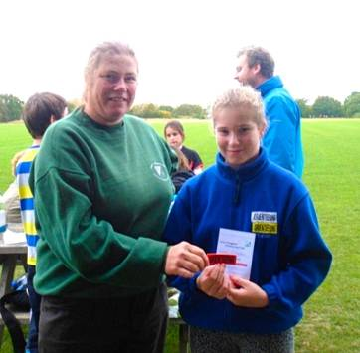
Chloe received her Orange Colour Code Badge from Julie Laver at a training event at Notley Discovery Centre on 20th October

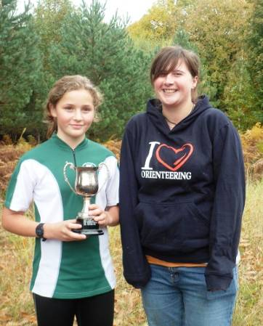
Daisy was presented with the Mark Johnson Trophy for Outstanding Junior by Emma Johnson at the Mildenhall North event

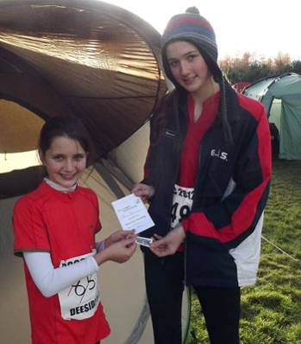

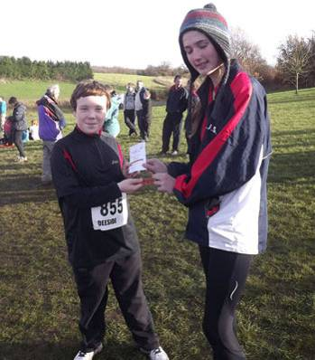
Amy and Tom recieve their White colour coded awards from Junior Captain Rhiannon Ware

Fixtures - David Skinner
Fixtures in East Anglia and Nearby Regions - National Events which SOS members regularly attend are also included
The information provided below normally consists of Event Date, Club, Region(eg EA = East Anglia), Event Grade , Event & Location Names and map reference. Organiser's contact details. Contact details, costs, closing date etc. for Pre-entry when provided. Whether Entry on the Day (EOD) is possible and the surcharge payable. The range of courses offered. The address of a website from which additional information can be obtained. Additional information in plain language.
At Essex Stragglers' events registration normally opens at 1000hrs, starts are from 1030hrs until 1230hrs and courses close at 1430hrs, but this may vary.
SOS Club Nights are generally not included - see SOS website for details.
January
1st | SOS  EAOA  Level D | New Year Novelty Colchester Castle Park, Hilly Fields and Colchester Town, Castle Park plus Hilly Fields and Colchester Town, Colchester, TL998256  Entry times: Start times 11.00-12.00. Registration in car park.. Dogs: In Car Park only..  Organiser: Lyn West , orienteering@grovehillhouse.wanadoo.co.uk , 01206 322905  stragglers.info/home/index.php
6th | HAVOC  EAOA  Level C | HAVOC Belhus SWELL Event, Belhus Woods Country Park, Upminster, TQ564825  Entry times: 10am to 12noon. Dogs: Dogs to be kept under control..  Organiser: Gillian Edgar , captain@orienteering-havoc.co.uk
9th | SOS  EAOA  Level D | SOS Mid-week Winter Street Event, Sudbury  Organiser: John Collyer , johncollyer@live.co.uk , 01787 370947  stragglers.info/home/
13th | SMOC  EAOA  Level D | SMOC local event, Brackmills, Northampton, SP769583  Entry times: 1015-1230. Dogs: Dogs to be kept on leads at assembly and on courses..  Organiser: Ros James  www.smoc.info
13th | NOR  EAOA  Level C | Mid Norfolk Colour Coded Event, Cockley Cley, Swaffham, TF790055  Entry times: 10.00 to 12.00. Dogs: On Lead Only.  Organiser: Alan Bedder  www.norfolkoc.co.uk
19th | WAOC  EAOA  Level D | Rowney Warren Night Event, Rowney Warren, Shefford, TL123403  Entry times: 5:30pm - 6:30 pm. Dogs: Dogs on lead in car park, and must be on lead when crossing minor road..  Organiser: Peter Woods , peter_woods@ntlworld.com  www.waoc.org.uk/n.humphries/waoc/details/2013-01-19-Rowney-Night.php
20th | SUFFOC  EAOA  Level C | Daisy's Wood Colour Code inc. ESSOL, Daisy's Wood, Woodbridge, TM345503  Dogs: Must be kept on leads.  Organiser: Sally Wilkinson , clive.sally@btinternet.com , 01473 219059  www.suffoc.co.uk
24th | CHIG  SEOA  Level D | North London Streets League, Stratford  Organiser: Sue Carter
27th | SOS  EAOA  Level C | SOS Colour Coded Pods Wood incorporating ESSOL and SWELL, Pods and Conyfield Woods Tiptree, Tiptree / Colchester  Organiser: Nancy Powell Davies , powell.davies@btinternet.com , 01376 562657  stragglers.info/home/index.php
February
3rd | NOC  EMOA  Level A | Midland Championships, Sherwood, Mansfield, SK626675  Organiser: Paul Beresford , org20130203@noc-uk.org , 01302 751549  www.noc-uk.org
3rd | SAX  SEOA  Level C | SAX Sunday Series, Ightham, Sevenoaks
9th | CUOC  EAOA  Level B | Thetford Thrash Day 1 - Icenian, Bromehill, Brandon, Thetford, TL795881  Dogs: Dogs welcome on a lead..  Organiser: Tom Dobra , icenian@cuoc.org.uk  www.waoc.org.uk/n.humphries/waoc/details/2013-02-09-10-thetford-thrash.php
10th | WAOC  EAOA  Level B | Thetford Thrash Day 2, Thetford Warren, Thetford, TL839842  Entry times: See event web page on WAOC website. Dogs: See event web page on WAOC website.  www.waoc.org.uk/n.humphries/waoc/details/2013-02-09-10-thetford-thrash.php
13th | SOS  EAOA  Level D | SOS Mid-week Winter Street Event Halstead, Halstead  Organiser: Andrew Cordle , andrew@cordle.net , 07968 567529  stragglers.info/home/
17th | SLOW  SEOA  Level B | Compass Sport Cup Round 1, Hankley Common, Farnham  www.sloweb.org.uk
21st | CHIG  SEOA  Level D | North London Streets League, Finsbury Park  Organiser: Alan Brett
24th | NOR  EAOA  Level C | Nth Central Norfolk Colour Coded Event, Pond Hills, Hempstead, Holt, TG100357  Entry times: 10.00 to 12.00. No dogs allowed.  Organiser: Alan Bedder  www.norfolkoc.co.uk
March
3rd | SMOC  EAOA  Level C | SMOC EA League Event/span>, Bucknell & Hazelborough Woods, Silverstone, SP658448  Entry times: 10.00-12.30. No dogs allowed.  Organiser: Ros James  www.smoc.info
10th | WAOC  EAOA  Level C | Chicksands Wood Colour Coded and Yvette Baker Heat, Chicksands Wood, Shefford, TL106411  Entry times: Starts 10:30 - 12:30. Dogs: See event specific web page on WAOC web site nearer the time of the event.  Organiser: Ian Lawson , ianh.lawson@ntlworld.com  www.waoc.org.uk
13th | SOS  EAOA  Level D | SOS Mid-week Winter Street Event Springfield, Chelmsford  Organiser: John Williams , jcw351@hotmail.com , 01245 351583  stragglers.info/home/
17th | SOS  EAOA  Level C | Colour-coded event Writtle Forest incorporating EA League, Writtle Forest, Chelmsford  Organiser: Geraldine Russell , grmrussell@gmail.com , 01206 272761  stragglers.info
24th | NOR  EAOA  Level C | Sth Norfolk Colour Coded Event, Lynford Forest, Thetford, TL819940  Entry times: 10.00 to 12.00. Dogs: Dogs on Lead Please.  Organiser: Alan Bedder  www.norfolkoc.co.uk
29th | SCOA  Level A | Jan Kjellstrom Orienteering Festival - Sprint (UKOL5), Whiteknights Campus, Reading, SU733719  Entry times: 12:00 - 16:00. Dogs: On leads at all times.  Organiser: Luke McNeill  www.thejk.org.uk/jk2013/
30th | SCOA  Level A | Jan Kjellstrom Orienteering Festival (UKOL6), Hambleden, Henley, SU772855  Dogs: On lead at all times, in car park and assembly only.  Organiser: Jon Wheatcroft  www.thejk.org.uk/jk2013/
31st | SCOA  Level A | Jan Kjellstrom Orienteering Festival (UKOL6), Cold Ash, Newbury, SU520737  Dogs: On leads at all times, in car park/assembly only.  Organiser: Liz Yeadon  www.thejk.org.uk/jk2013/

Summer Series Down Under - David Lumby
Before setting off on a work related foray to Australia I googled "Sydney Orienteering" and discovered that there was a Summer Series of evening events running and I was in town for the events on Monday 29th and Wednesday 31 October. In fact there are 39 events in all in three separate series. I packed my shoes and Stragglers O-shirt.
Event 1, Marickville, Monday 29th October
I managed to get away from the office at 17.00, nipped back to the hotel to change and caught the train down to Tempe station near Markey Park in Marrickville which was the event base. The first navigational challenge was to find the start which I achieved by map memory from Google Maps. Out of the railway station, cross over the bridge and head toward the setting sun - that would be North-West!
I completed the registration card and was immediately lucky - they gave me the $3 discount for being a club member despite it being 11,000 miles away. Nancy, I promised them a reciprocal deal so look kindly on any reduced fees paid by visitors from Uringa Orienteers.
The event was a 45 minute score with ample time to study the map before the start. 30 controls were available with numbers 1-10 worth 10 points each, 11-20 worth 20 points each and 21-30 worth 30 points each for a maximum score of 600 points. 10 penalties for each minute or part over time. The course was either side of Cook's River with the North mostly urban and the South a mix of urban, grassland and "bush". Whilst not necessarily the most sensible route choice I decided to go South first as that meant I was sure to get a run through the bush.
I checked my watch and was off. The first control was easy - the bench near the park entrance that I had spotted on my way in. Unfortunately this gave a sense of over confidence and I ran off the edge of the map into the station car park, only realising my mistake when I spotted a fellow competitor the other side of the stream punching a control (SI boxes cable locked to immovable objects were in use). I was soon back on track and collected the next three controls with no difficulty before heading along a footpath into the bush - I suppose we would call it fight forest - where I promptly lost my way and wasted 3 minutes. I was now getting confused by not being able to find the major path which was indicated by the black line. Once I realised this was a linear rock face I was back on track but breathing heavily as it is surprisingly hilly in the Sydney suburbs.
After a few poor route choices I had to modify my plan a bit but still covered the majority of the controls I was aiming for. As I approached the finish I had two minutes to spare so detoured to pick up the extra 10 points from a control I had identified as an option on the way to the finish and punched in with 43m 56s on the clock and 380 points. Not bad I thought though running off the map, my issues in the bush and a couple of other slip ups should have allowed me to get over 400. At the post run discussion I saw another few controls I could have collected and reckoned 450 would have been on. Looking at the results board I was sure no-one would have got all 600. Correct - the leading score was 580. By the time the final results hit the website I saw the winning score was 600 in 44m 36s and I was 22nd out of 40 competitors. A clever bit of software calculates the shortest possible route connecting all points and gives this as 9894m plus 140m of ascent - pretty impressive in less than 45m.
All in all a fine evening out and I knew I would be less jet lagged by the second event on Wednesday night.
Event 2, The Glebe, Halloween
I again got away from the office around 17.00, changed and walked over the bridge across Darling Harbour to catch the tram to Jubilee Park. I was amazed to see runners everywhere. They had over 200 competitors out and I had to wait for a hire SI card to come back before I could start. Again the event was a 45 minute score with a maximum of 600 points. The delay gave me a chance to see the real experts at work with pieces of string in use trying to find the optimum route. I had a quick look and decided on a rough plan and as soon as a dibber was available I was off.
Again first control was a doddle - the wind tower straight across the park followed by another two on the edge of the park and then off into the streets. Suddenly something was wrong. The streets didn't match the map but as it was a grid system and virtually every junction a crossroads (and I didn't have a compass) it took ages of wandering around until I found control 4. And it was hot. And steep. And full of ghouls and gremlins. Seriously, I ran quite a bit of extra distance going round groups of kids and parents out trick-or-treating!
I was now back in the groove but had not looked at the contours closely enough and did a lot of extra ascent over the next few controls which cost me some time. Finally I had picked up all the controls to the West of White's Creek and made my way into the larger part of the map but with over 20 minutes of my 45 gone. The second part was even hillier and I was blowing hard. It became clear that I was going to struggle to hit the time limit so modified my route and bit although the dithering over the decision probably cost me a minute. Still up and down hills and then I missed a narrow road and with it the 10 point control just down it. By now the mistakes were coming thick and fast and I was choosing 10 pointers instead of 30 pointers and still the hills came. It looked like I would be late back so tried to up the pace and shot into the park at the same time as someone I recognised from Monday. I dibbed the last control just before him but chose the wrong way round the toilet block to the finish and he sneaked in ahead of me.
The result? 390 points so more than Monday but finish time 49.12 meant 50 penalties and a final score of 340 and a tie for 155th place. The final indignity was being beaten by one each of the men and women who entered as walkers. I even got a mention (as a visiting pom) in the event report. Just goes to show that navigation and route choice mean more than speed over the ground. Five runners managed the maximum score, one of them in 39.34! I found the guy I recognised from Monday (an ex-pat Brit) and we retired to "The Australian" a famous pub in The Rocks area to compare notes. He had managed all 600 points but lost 150 in penalties with a 59.36 finish for a final score of 450 and well into the top half. Still he was pleased with 600 in under an hour.
Thanks to those from Garingal Orienteers and Uringa for two great events and a warm welcome. If you find yourself in Sydney have a look at the website http://onsw.asn.au/ which will point you in the right direction. They're a friendly bunch and it's a great way to see some less visited parts of the city and beat the jet lag.

British Schools Score Championships 2012 - Alison cracknell
Hedingham School Year 7 Girls had success at the British Schools Score Championships at Kingsbury Water Park, West Midlands on 13th October. Olivia Baldwin came 5th, Daisy Partridge 7th and Chloe Cracknell 13th in a field of 27. The team finished 6th overall only beaten by full teams of six or more.
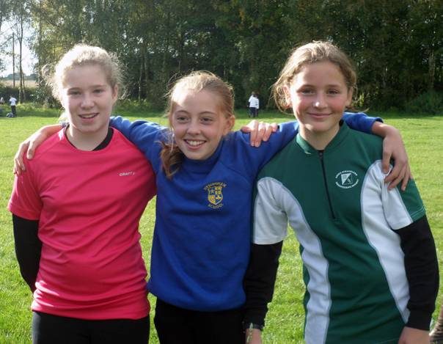

British Schools Championship

Report - Alison Cracknell
On Sunday 18th November teams from St Andrews Primary School, Ramsey College and Hedingham School competed in the British Schools Orienteering Championships in Delamere Forest, Cheshire alongside more than 900 children. All three schools had a fantastic day and came home with medals.
Zoe Hartnup from St Andrews put in the performance of the day to take gold in the Year 5 Girls class. Zoe, Rosie Bird (15th) and Lucy Walker (19th) also took home bronze medals in the Year 5 Girls team event. Dominic Emerson (7th), Jack Edwards (13th) and Joshua Buist (16th) all had great runs in the Year 6 Boys category to secure silver medals in the team event. Amelia Juniper (20th), Elena Gower, Ben Styman-Heighton (24th) and Tom Turner (27th) were unfortunately part of incomplete teams for Year 6 Girls and Year 5 Boys but were all part of the St Andrews team who came away with bronze medals in the Primary Schools category. Special mention must go to Elena Gower who was given a Year 9 map at the start instead of a Year 6 map and put in the most fantastic effort trying to navigate a course much harder than anything she had run before.
The Ramsey College had great runs from Georgia Gower (11th), Lucy Edwards (24th) and Chloe Plumb and Amy Bocking running as a pair (43rd) competing in the Year 8 Girls class; Thomas Lock finished 44th out of 85 running in the largest field of the day in the Year 8 Boys class; Callum Turner ran up a year and finished 24th in the Year 9 Boys class; and Josh Emmerson was 49th in the Year 10 Boys class. This super team performance secured them 2nd place in the Small Secondary Schools category for schools with 600 pupils or less.
Although Hedingham School were unable to field a full team of nine for the Large Secondary Schools trophy in which 84 schools competed Daisy Partridge (6th), Lily Amos (27th), Chloe Cracknell (28th) and Olivia Baldwin (42nd) in the Year 7 Girls class all completed the course and were delighted to win team bronze out of the 13 teams participating. Josh Partridge in Year 9 also had an excellent run finishing 16th out of 68 starters. Fingers crossed for a full team next year!

Report - Daisy Partridge
At the British Schools Orienteering Championships in Delamere Forest I think I did really well. I tried the best I could and I thoroughly enjoyed it! In my age class I came 6th which I think is amazing so I feel really proud of myself. The event took place in woods but it was still a little open. I liked this because when I got hot, the trees cooled me down and also I could see the controls in front of me. Overall I thought that the map reading was easy but next time I should maybe run a bit faster! At the prize giving we were really surprised when they called our names. The Hedingham School Year 7 girls team had won the bronze medal and we were delighted.
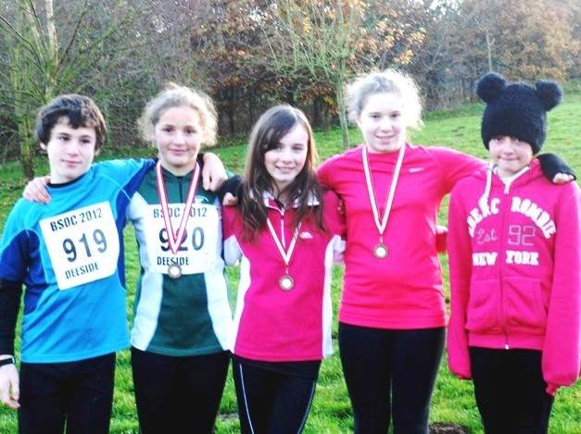
The Hedingham School Team

Orienteering Silver Success - Paul Taylor
On Saturday 17th November The Ramsey College orienteering team comprising of Lucy Edwards, Georgia Gower, Chloe Plumb, Amy Bocking, Callum Turner, Tom Lock and Joshua Emmerson headed off to Delamere Country park in Cheshire to compete in the British Schools Orienteering Championship. The team competed against schools from all over the country and were alongside some of the best orienteering athletes from Great Britain.
Once again all the students put in a great performance and worked extremely well as a team to support each other through the testing event.
The year 8 girls team finished in 5th place which was a fantastic achievement. However the main highlight of the competition was when The Ramsey College gained Second place in the Whole School Team Competition small secondary category.
It has been an aim of the college over the past 2 years to gain a place on the podium at one of the National events so it was absolutely amazing to see the student's hard work rewarded and acknowledged with them proudly standing on the podium with a silver medal around their neck.
We are now looking to strengthen the team for next year's event in order to push to be National Champions.
A big thank must go out to all the students' parents who have helped support along the way.
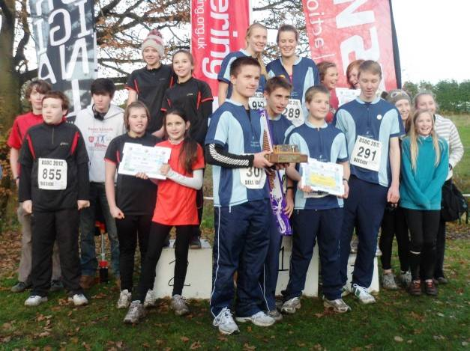
The Ramsey College team (partly) on the podium

Zoe is going in the right direction - Jack Edwards and Dominic Emmerson
On Sunday 18th November 10 competitors from St. Andrew's went to Delamere Forest in Cheshire. It took four hours to get there and then we had a good night's sleep. On arriving at the forest we headed to the start and we had to wait till we were called up. In the meantime we worked out where we were and which way was north. We were called up 5 minutes before our time and got our dibber, checked the dibber to see if it was clear, got control descriptions and after that we looked at blank maps. Then we had the proper maps and we set off. The Year 5 girls had a 1.4km run and 9 controls, Year 6 girls had 1.5km and 9 controls, Year 5 boys had 1.7km and 11 controls and Year 6 boys had 1.8km and 11 controls. After everyone had finished the results were in and prize giving came:
Zoe Hartnup secured individual 1st place in the Year 5 girls' race!
Year 6 boys' team grabbed 2nd place (Dominic Emmerson 7th, Jack Edwards 13th, Joshua Buist 16th)
Year 5 girls team came in 3rd place (Zoe Hartnup 1st, Rosy Bird 15th, Lucy Walker 19th)
St. Andrew's were 3rd and won bronze medals in the Primary School section (top 4 positions to score - Zoe Hartnup, Dominic Emmerson, Jack Edwards, Rosy Bird)
Well done to our other team members Elena Gower, Amelia Juniper, Ben Styman-Heighton and Thomas Turner.
We would like to thank our parents for taking us and the organisers for making it a fun day.
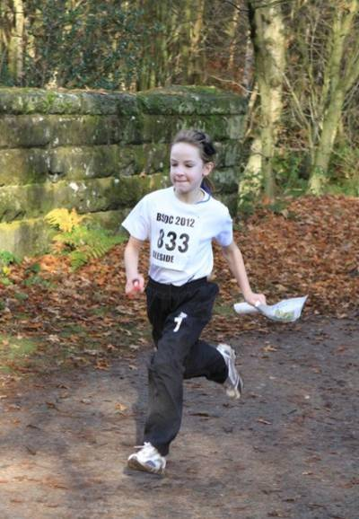
Zoe going in the right direction

Yvette Baker Trophy Final 9th December 2012 - Julie Laver
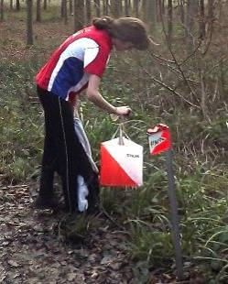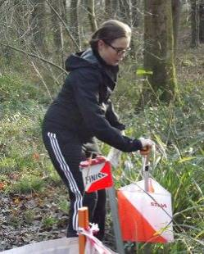

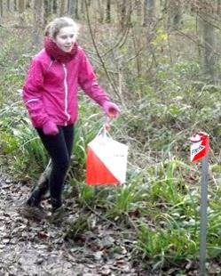
Rhia, Ellie and Chloe at the finish
A team of 12 juniors participated in the Yvette Baker 2012 competition on behalf of SOS which for those of you who don't know is a National inter club Competition attracting a strong field of competitors each year.
It was a fine day and Collingbourne Woods Near Andover was a great if muddy venue for the competition. There were some good individual performances from our squad but not quite strong enough to see off the opposition. Still all enjoyed the day out - there's always next year...!
Full results are available from the SARUM website.
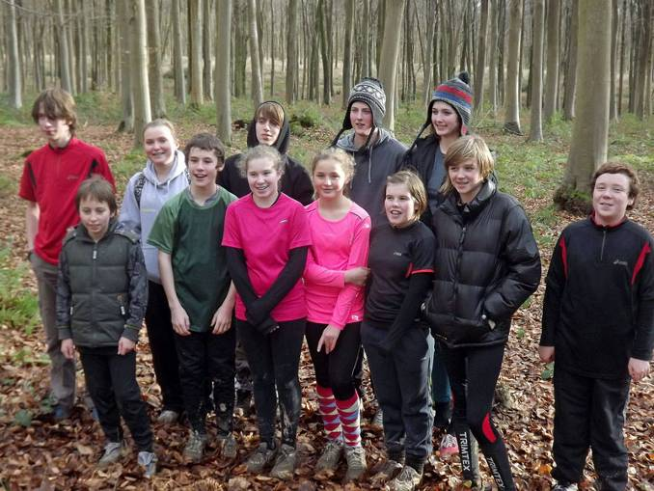
Back Row - Callum Turner, Ellie Lumby, Sam Bolam, Jack Rodgers, Rhiannon Ware
Front Row - Joshua Buist, Josh Partridge, Chloe Cracknell, Daisy Partridge, Chole Plumb, Lucy Edwards, Tom Lock

