 | Essex Stragglers Orienteering Society (SOS) |   accredited

Newsletter Volume 22

May 2010

Editors: Geraldine Russell and Rachel Barford- editors@stragglers.info
Club website - http://stragglers.info

Editorial - Geraldine Russell 2
Editorial - Rachel Barford 2
Noises from the Chair – John Collyer 3
Club Activity Sessions – Julie Laver 3
Come and try Orienteering at Highwoods Country Park, Colchester 4
Sell your old ‘O’ kit 4
For New Club ‘O’ kit see Lyn West. 4
Essex & Suffolk Schools Orienteering League - Julie Laver 5
Captain's Corner – Jenny Collyer 6
Stragglers' League - Andrew Cordle 10
Fixures – Dave Skinner 11
Oyvind who? - Jack Isbester 15

  Essex Stragglers support the Woodland Trust and its objectives |   Essex Stragglers' development activities are supported by Awards For all

Editorial - Geraldine Russell
Our Club Activities are going from strength to strength as you will see on page 3.
There will be SOS Club night as from Monday June 7th - a new project from the Development Committee. I hope as many members and friends will go to make it a success.
Many congratulations to Jenny Collyer who was the overall winner in her class at the recent JK held over two days in Devon.
Over her illustrious career this is one of the only championships she had not won and was therefore delighted.
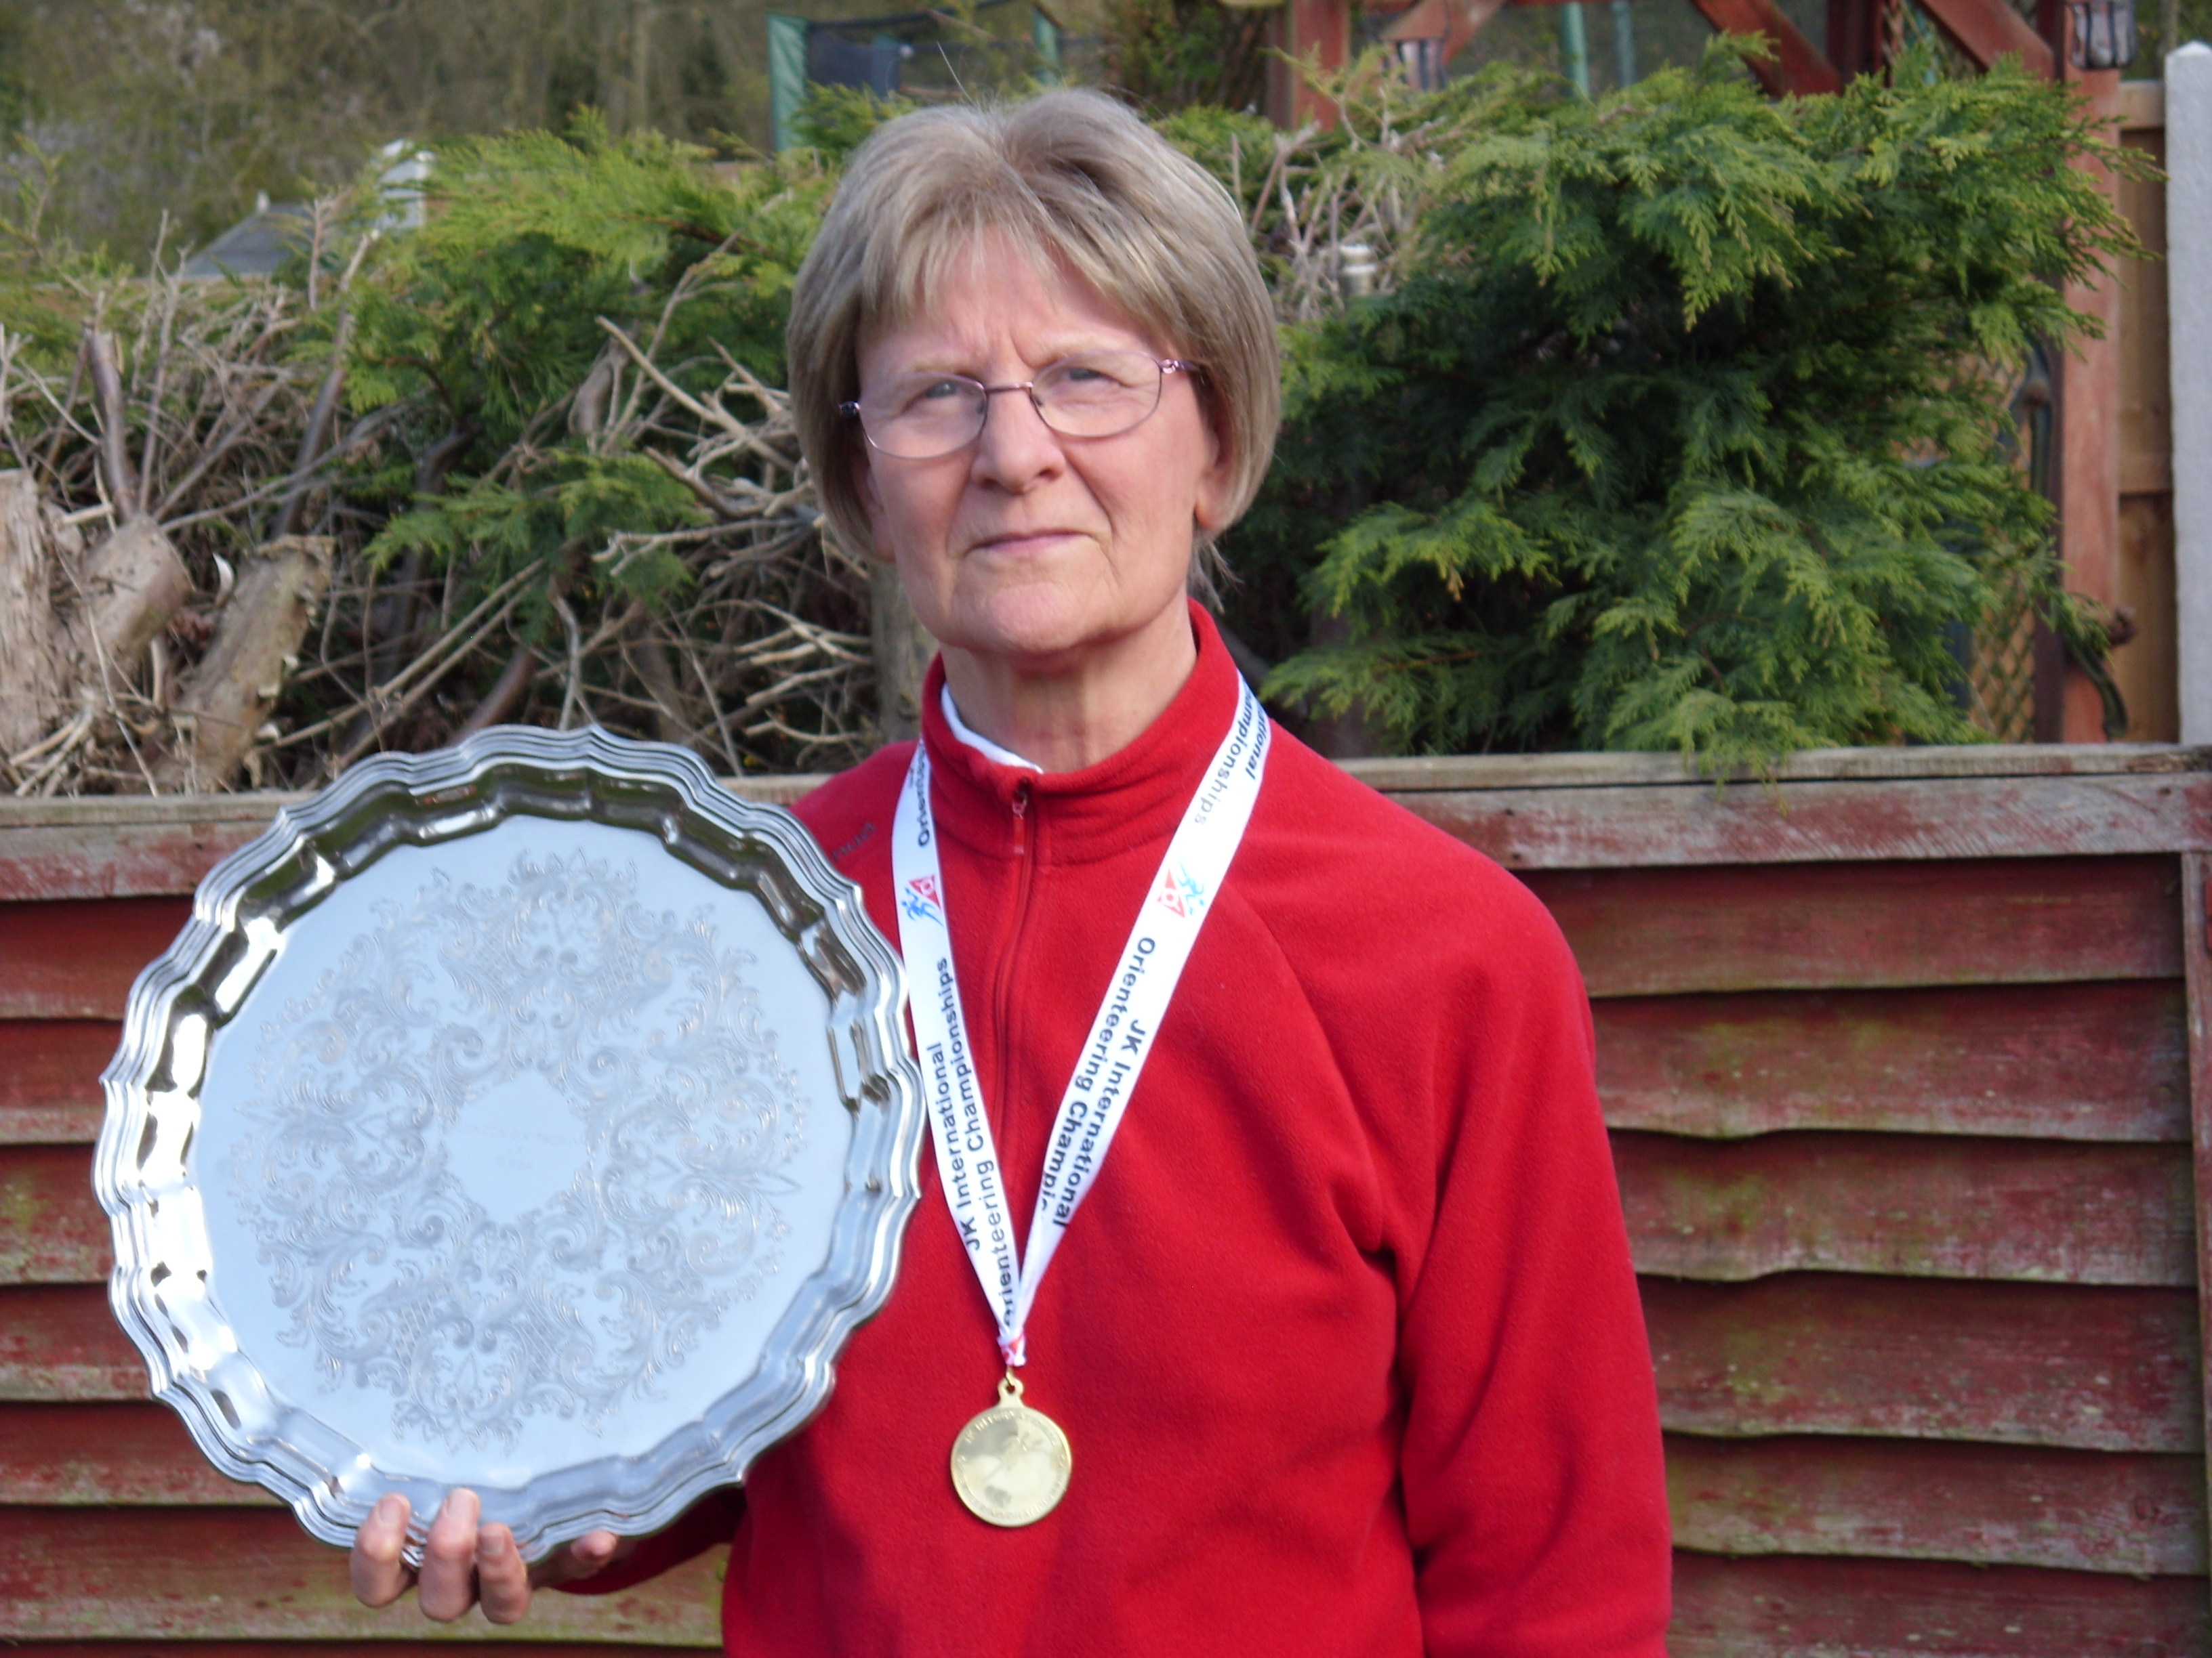

Editorial - Rachel Barford
I commented in the last newsletter about the mud – at least that time of year has (hopefully) passed, and we can enjoy orienteering amongst the bluebells and fresh green growth, appreciating our lovely countryside. I always try and hear a cuckoo whilst orienteering at this time of year – but this year (so far) have not been lucky. Hopefully not a sign of the times

Noises from the Chair – John Collyer
Previous articles, including mine, have touched on the problems we have in getting enough main officials for events. We still hope to resolve this, partly by encouraging/nurturing some members to take on organising and planning.
However we do need to look at this from the angle of the number and kind of events which we put on. At the moment most of our events (East Anglian League, Regional and ESSOL) require a large amount of equipment, several sets of courses (usually 6-7) and a full work force of helpers. These are time consuming and require experienced officials at the sharp end; people do not readily come forward and we need to resolve this. The two likely methods are:
1. Reducing our total number of events.
2. Replacing some events with a simpler, more informal structure. Many clubs have informal events where the number of courses is reduced to say 3 (Easy, Medium, Harder) and the entry and organisation are reduced to as low a key as possible.
At our May committee meeting we discussed the range of possibilities and have decided that we need to consult you, the membership on what you want from the club in terms of the events we put on.
I will begin compiling a questionnaire which after being put to committee members, will be passed to you for your reactions. Please spend as long as you need to complete your answers as the future of the Club will be guided by them.

Club Activity Sessions – Julie Laver

New for Spring 2010 – SOS Club Night From June 7th
Announcing a new project from the Development Committee.
We will be meeting every Monday at the Highwoods Sports centre in the grounds of The Gilberd School. There will be a variety of activities including map skills and fitness.
We will be using the hall for circuit training and wet weather activities and the school grounds and Highwoods Country Park for outside exercises. There may also be a run either before or after main session depending on numbers and enthusiasm!
All welcome including non-club members who are interested in what we do but might not want to come to events at first. Also suitable for experienced orienteers. Come and meet your fellow club members, get fit and have fun.
There will be a minimum of 2 coaches available each week so you can to bring your map from your last run and talk through it.
We will also try to arrange specialist coaching on occasion which may include running skills, fitness training and sports science.
The provisional times are 8pm to 9pm although this may be extended if there is a demand. The first 3 weeks will be free then there will be a nominal cost to cover hall rental etc TBC
Further details will be announced on the website and a programme of activities published nearer the time.

Come and try Orienteering at Highwoods Country Park, Colchester
We will be meeting at the Chanterelle Car Park off Eastwood drive, signposted with brown Country Park signs from the Tesco’s roundabout.
Saturdays – May 22nd, 29th & June 5th from 10.30 to 12.00,
Summer Activity Mornings - All ages and abilities welcome.
Come and try orienteering in an informal setting with plenty of support from well qualified and friendly coaches.
If you are new to orienteering or want to improve your skills and confidence come to our Summer Activity Mornings.
Sessions will teach map reading and navigation skills and is a good way to explore the country side and improve fitness for all the family.
Dress suitable for weather conditions preferably with full leg cover (ie no shorts). Bring a drink and snack – all other resources provided.
There will be different activities each week so come to as many as liked.
This is a free activity for adults and children – junior school age children must be accompanied by an adult.
Contact Julie Laver julie.laver@virgin.net 01206 826152 for more details and to register.

Sell your old ‘O’ kit
Bring your good quality unwanted ‘O’ kit to the enquiries point at our events and we will display it for sale.
All items to be marked with the price and sellers name and contact number. Please collect unsold kit before you leave as we cannot store items.
Also for sale are some club T-shirts and sweatshirts.

For New Club ‘O’ kit see Lyn West.

Essex & Suffolk Schools Orienteering League - Julie Laver
The results for this season (09-10) so far are as follows after 7 events:
Up to Y6 Boys | Up to Y6 Girls
Timmy Harrison | Ellie Harrison
Thomas Addison | Bronwen Mansel
Matthew Clarke | Emma Clarke
Y7/8 Boys | Y7/8 Girls
Bryn Wilkinson | Rachael Harrison
Nicolas Harrison | Kitty Becher
Thomas Birkett | Scarlett Simmons
Y9/10 Boys | Y9/10 Girls
Michael Archer | Rhiannon Ware
 | Rebecca Lyne
 | Erica Williamson
Y11/12/13 Boys | Y11/12/13 Girls
James Park | Sarah Roach
Will Hooton | Hannah Newton
Alex Ware
The top three schools -
Barnardiston Hall Preparatory
Beyton Middle
St Andrews Halstead
For the full list of competitors please visit the ESSOL pages of our website. If I have missed your details please contact me and I will amend them.
Anyone up to year 13 can enter the league by just turning up to the designated events listed below and entering your school details on the registration form
We badly need entries for the Y9/10 age group so if you know anyone of that age who might like to have a go direct them to the websites below and we will try to get them going!!!
Final Fixture of the year!!! 20-06 Wivenhoe SOS
Prize giving after the last runner has returned. Medals for 1st, 2nd and 3rd individuals in each age class and Trophy for best school team.
Please note these are preliminary fixtures and participants are advised to check Club websites before travelling - http://stragglers.info and http://pdl.demon.co.uk/suffoc.
New for the 2010-2011 season - we will include fixtures from other EA clubs. Both HAVOC and WAOC will be contributing a fixture each. Details will be publicised on ESSOL and club websites when finalised. This should encourage new participants especially in the older age classes and encourage existing participants to try evens further afield.

Captain's Corner – Jenny Collyer
Since the last newsletter we have had the JK and British Relays.
A good number of Stragglers made the long journey to Devon at Easter to take part in four very good days of orienteering at the JK. The relays were on the last day at Braunton Burrows and used the same area of open sand dunes that we had used for the previous days individual race. We had six senior and 1 junior team and everyone managed well on the complicated terrain. In these relays age classes can be mixed to fit a minimum total age of the three runners (maximum in the case of juniors) and in all teams there is a shorter middle leg so this makes sorting out teams a lot easier than the more rigid British relays.
The British Relays followed the Individual races on Cannock Chase over the May Day bank holiday weekend. We entered six senior and two junior teams. Teams for the British are a lot more difficult to sort out as they are in age classes (adults – long and short open and 40+, 50+ and 60+). With our varied ages I had to run some people in teams other than their age class and I was also left with people who I couldn’t fit in and so had to enter two ad hoc teams. The day started with the mini relay for the under 12’s with Ben Warland, Alex Birkett and Stephanie Ware doing well. Everyone seems to have enjoyed their runs and being part of a large event.
SOS and SUFFOC have run in a combined team organised by Peter Warland at the Harvester Relays Peter is also organising a team at the Greensand Ridge Relay in June.
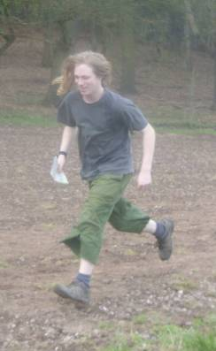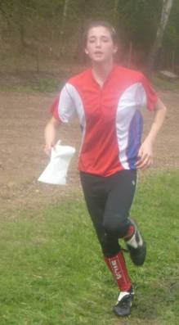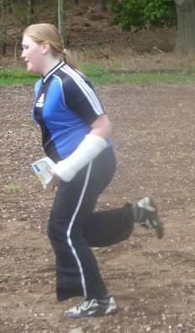
Alex, Rhiannon and Stephanie Ware finishing at the British Championships

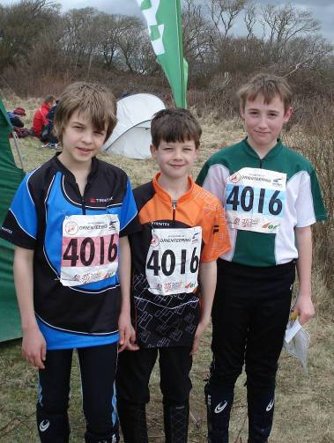 | Tom and Alex Birkett and Ben Warland at the JK relays
A determined Ben Warland in the  British Championship relays | 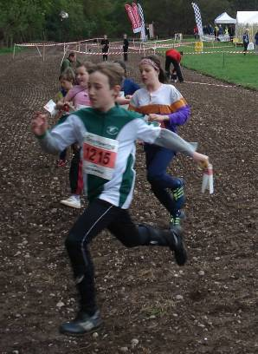

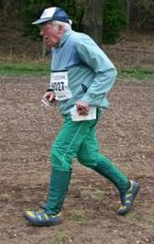 | Jack Isbester
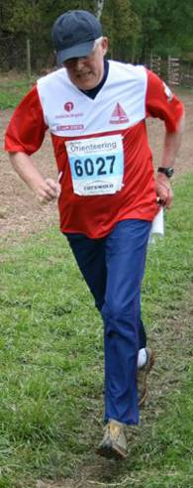
Tracy Apperley, Colin West and Lyn West
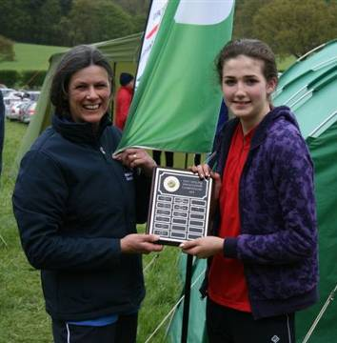

Rhiannon Ware receiving the W14 East Anglian Championship trophy she won at Doneylands from Lyn West

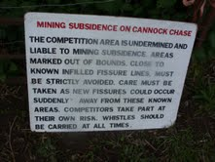
Signs at the British Championships

Stragglers' League - Andrew Cordle
Top ten positions are (position at time of the last newsletter in brackets) –
Posn | Prev-Posn | Name | Best-6 | Runs
1 | (1) | Richard Bonnett | 600 | 18
2 | (3) | Jenny Collyer | 598 | 13
3 | (2) | John Collyer | 586 | 13
4 | (5) | Geraldine Russell | 573 | 14
5 | (11) | James Park | 545 | 12
6 | (7) | Tracey Apperley | 536 | 13
7 | (8) | Lyn West | 534 | 11
8 | (6) | Steve Robertson | 533 | 7
9 | (13) | Chris Childs | 528 | 18
9 | (14) | Claire Harrison | 528 | 11
Congratulations to James, Chris and Claire for breaking into the Top Ten, and to Jenny who is now only two points behind Richard on maximum points.
The next event is the Stragglers Schools League etc. at Wivenhoe on June 20th. There won’t be any more League events until September – details in the next Newsletter and the website http://www.stragglers.info/league.
If you are disappointed with your performance in the Stragglers League so far, you might gain some satisfaction from looking at your performance against your age class in the East Anglian League http://eaoa.org.uk/league.php, or your club mates or age class (or both) in the national Rankings http://www.britishorienteering.org.uk/event/ranking.php.

Fixures – Dave Skinner
Fixtures in East Anglia and Nearby Regions – National Events which SOS members regularly attend are also included
The information provided below normally consists of Event Date, Region (eg EA = East Anglia), Event Grade , Event & Location Names and map reference. Organiser's contact details. Contact details, costs, closing date etc. for Pre-entry when provided. Whether Entry on the Day (EOD) is possible and the surcharge payable. The range of courses offered. The address of a website from which additional information can be obtained. Additional information in plain language.
At Essex Stragglers' events registration normally opens at 1000hrs, starts are from 1030hrs until 1230hrs and courses close at 1430hrs.

May
20th | SEOA  LOK  Local | Park-O in Hyde Park , Hyde Park London  Entry On Day: Senior £TBC, Junior £TBC, Student £TBC. , Punch Type: SI, Start Times: Mass start at 7pm. Bring a watch!
22nd | SOS  Activity | SOS Club coaching/training activity (Grow Project), Highwoods, Colchester – see details elsewhere in Newsletter
22nd | SOS  Activity | SOS Club coaching/training activity (Grow Project), Highwoods, Colchester
23rd | EAOA  SUFFOC  Local | SUFFOC Come and Try It (CATI) Event , Bridge Wood ( Orwell Country Park) Ipswich , TM186405  Organiser: Neil Carter, nj.carter@lineone.net, 01473 728802 Entry On Day: Senior £4.00, Junior £1.00, Student £TBC. , Punch Type: None, www.suffoc.co.uk
25th | SEOA  SLOW  Local | SLOW Park Race Series , Dulwich Park Dulwich  Entry On Day: Senior £TBC, Junior £TBC, Student £TBC. , Punch Type: None,
26th | EAOA  SUFFOC  Local | Summer Series - Event 1 , Nowton Park Bury St Edmunds , TL864623  Organiser: Simon Peck, simon589@btinternet.com Entry On Day: Senior £1.00, Junior £0.00, Student £TBC. , Punch Type: None, www.suffoc.co.uk
29th | SOS  Activity | SOS Club coaching/training activity (Grow Project), Highwoods, Colchester – see details elsewhere in Newsletter
June
3rd | SEOA  LOK  Local | Park-O in Grovelands Park , Groveland Park Enfield  Entry On Day: Senior £TBC, Junior £TBC, Student £TBC. , Punch Type: SI, Start Times: Start times 6.30-7.30.Location of starts TBC.
5th | SOS  Activity | SOS Club coaching/training activity (Grow Project), Highwoods, Colchester – see details elsewhere in Newsletter
6th | SEOA  HH  Local | HH SE Relays , Whippendell Woods Watford , TQ090978  Organiser: Maire Convery, whippendell-06-06-10@happyherts.org.uk, 01727 868023 Postal Entry: Maire Convery, 23 College Road St Albans, Herts, AL1 5ND, 01727 868023, whippendell-06-06-10@happyherts.org.uk. Cheques payable to HHOC No Entry On Day. Entries Close: 21/05/2010. Senior £5.00, Junior £3.00, Student £5.00 , Punch Type: SI, happyherts.org.uk
9th | EAOA  SUFFOC  Local | Summer Series - Event 2 , Bourne Park Ipswich , TM151419  Organiser: Simon Peck, simon589@btinternet.com Entry On Day: Senior £1.00, Junior £0.00, Student £TBC. , Punch Type: None, www.suffoc.co.uk
12th | EMOA  LEI  Regional | Regional & EM League Event , Bradgate Park Leicester , SK542114  Organiser: Rachel Simonetti, 0116 2996174 Entry On Day: Senior £9.00, Junior £2.00, Student £TBC. , Punch Type: SI, Dogs: on Lead Start Times: 10.30am to 12.30om leioc.org.uk
13th | SCOA  BAOC  National | British Age Class Sprint Championships , HMS Sultan Gosport  Organiser: Allan Farrington, allan@emituk.com Online entry through www.ntrees.co.uk Entry On Day: Senior £TBC, Junior £TBC, Student £TBC. , Punch Type: EMIT, Start Times: TBC www.baoc.org.uk
13th | EAOA  NOR  Local | NOR Score Event & Club AGM , TBC Norfolk , TG317311  Organiser: Alan Bedder, alan.bedder@virgin.net, 01603 424589 Entry On Day: Senior £TBC, Junior £TBC, Student £TBC. , Punch Type: None, www.norfolkoc.co.uk
13th | EAOA  SMOC  Local | Keyne O , Willen Lake Milton Keynes , SP873405  Organiser: Stephen Hardy, steve-hardy@hotmail.com Entry On Day: Senior £3.00, Junior £2.00, Student £2.00. , Punch Type: None, Dogs: On leads please. Start Times: 10.00 am to 12.00 www.smoc.info
19th | EAOA  HAVOC  Local | Score + yellow Weald Park , Weald Country Park Brentwood , TQ568941  Organiser: Chris Shaw Entry On Day: Senior £TBC, Junior £TBC, Student £TBC. , Punch Type: SI, Dogs: Under control Start Times: 10.30:12:30
19th | EAOA  WAOC  Local | WAOC Milton Country Park Smile , Milton Country Park Cambridge , TL476621  Organiser: Helen Bickle, hnbickle@hotmail.com Entry On Day: Senior £3.00, Junior £1.00, Student £1.00. , Punch Type: None, Dogs: Dogs allowed on a lead. Start Times: 10.30 to 12.00 www.waoc.org.uk
20th | EAOA  SOS  Local | SOS Colour Code Event , Wivenhoe Colchester , TM033247  Organiser: Julia Robertson, 01206 242283 Entry On Day: Senior £7.00, Junior £2.00, Student £2.00. , Punch Type: SI, Start Times: 10.30-12.30 www.stragglers.info
 | EAOA  SUFFOC  Local | SUFFOC Come and Try It (CATI) Event, Bridge Wood ( Orwell Country Park) Ipswich, TM186405  Organiser: Neil Carter, nj.carter@lineone.net, 01473 728802 . Entry On Day: Senior £4.00, Junior £1.00, Student £TBC. , Punch Type: None,www.suffoc.co.uk
  23rd
26th | EAOA  WAOC  Local | WAOC Wandlebury Country Park Smile , Wandlebury Country Park Cambridge , TL492533  Organiser: Helen Bickle, hnbickle@hotmail.com Entry On Day: Senior £3.00, Junior £1.00, Student £1.00. , Punch Type: None, Start Times: 10.30 to 12.00 www.waoc.org.uk
27th | SEOA  CHIG  Local | CHIG Frolics , Gunpowder Park Waltham Abbey , TQ386993  Organiser: Ray Curtis Entry On Day: Senior £0.00, Junior £0.00, Student £0.00. , Punch Type: None, chig.org.uk
29th | SEOA  SLOW  Local | SLOW Park Race Series , Tooting Bec Common tbc  Entry On Day: Senior £TBC, Junior £TBC, Student £TBC. , Punch Type: None,

July
3rd | SOS  Activity | SOS Club Coaching/Training Activity - TBA
4th | EAOA  WAOC  Local | WAOC Wimpole Hall Smile , Wimpole Hall Cambridge , TL343511  Organiser: Helen Bickle, hnbickle@hotmail.com Entry On Day: Senior £3.00, Junior £1.00, Student £1.00. , Punch Type: None, Start Times: 10.30 to 12.00 www.waoc.org.uk
 | EAOA  SUFFOC  Local | Summer Series - Event 4, Holywells & Landseer Park Ipswich, TM177433  Organiser: Simon Peck, simon589@btinternet.com . Entry On Day: Senior £1.00, Junior £0.00, Student £TBC. , Punch Type: None, www.suffoc.co.uk
  7th
11th | EAOA  SOS  Local | SOS Relays , Hylands Park Chelmsford , TL680048  Organiser: David Skinner, dave.skinner@btinternet.com, 01245 381266 Entry On Day: Senior £TBC, Junior £TBC, Student £TBC. , Punch Type: None, www.stragglers.info
13th | SEOA  SLOW  Local | SLOW Park Race Series , Brockwell Park tbc  Entry On Day: Senior £TBC, Junior £TBC, Student £TBC. , Punch Type: None,
20th | SEOA  SLOW  Local | SLOW Park Race Series , Bishops Park tbc  Entry On Day: Senior £TBC, Junior £TBC, Student £TBC. , Punch Type: None,
21st | EAOA  SUFFOC  Local | Summer Series - Event 5 , Foxhall & Rushmere Ipswich , TM218446  Organiser: Simon Peck, simon589@btinternet.com Entry On Day: Senior £1.00, Junior £0.00, Student £TBC. , Punch Type: None, www.suffoc.co.uk
25th | SEOA  DFOK  Local | DFOK Frolics , Dartford Dartford , TQ593717  Organiser: David Cave-Ayland, dave.cave@tesco.net Entry On Day: Senior £TBC, Junior £TBC, Student £TBC. , Punch Type: SI, www.dfok.co.uk
28th | SEOA  DFOK  Local | DFOK Evening Event , Danson Park Welling , TQ472754  Organiser: Philip Basford, philb@ntrg.u-net.com Entry On Day: Senior £TBC, Junior £TBC, Student £TBC. , Punch Type: None, www.dfok.co.uk
August
4th | SEOA  DFOK  Local | DFOK Evening Event , Lesnes Abbey Wood Welling , TQ478783  Organiser: Philip Basford, philb@ntrg.u-net.com Entry On Day: Senior £TBC, Junior £TBC, Student £TBC. , Punch Type: None, www.dfok.co.uk
8th | EAOA  SMOC  Local | Keyne O , Caldecotte Milton Keynes , SP883357  Organiser: Ric Brackenbury, tpfkar@bigfoot.com Entry On Day: Senior £TBC, Junior £TBC, Student £TBC. , Punch Type: None, www.smoc.info
11th | SEOA  DFOK  Local | DFOK Evening Event , Bostall Woods and Heath Welling , TQ466773  Organiser: Philip Basford, philb@ntrg.u-net.com Entry On Day: Senior £TBC, Junior £TBC, Student £TBC. , Punch Type: None, www.dfok.co.uk
18th | SEOA  DFOK  Local | DFOK Evening Event , Shooters Hill Woodlands Welling , TQ445763  Organiser: Philip Basford, philb@ntrg.u-net.com Entry On Day: Senior £TBC, Junior £TBC, Student £TBC. , Punch Type: None, www.dfok.co.uk
22nd-27th | NWOA  Regional | Lakes 5 Day Regional Events 22nd Lakes 5 Day 1 , North end of Haweswater Penrith , NY510164  Organiser: Dick Whitworth Postal Entry: Lakes 5 2010, 7 Ashbourne Court Shirebrook Park, Glossop, Derbyshire, SK13 8RT. Cheques payable to Lakes 5 Online entry through www.fabian4.co.uk Entry On Day: Senior £18.00, Junior £5.00, Student £5.00. Pre-Entry Fees: 31/07/2010. Senior £16.00, Junior £5.00, Student £5.00 , Punch Type: SI, Start Times: tbc www.lakes5.org.uk
 | NWOA | 23rd Lakes5 Day 2 , tbc Coniston , SD304973  Postal Entry: Lakes 5 2010, 7 Ashbourne Court Shirebrook Park, Glossop, Derbyshire, SK13 8RT. Cheques payable to Lakes 5 Online entry through www.fabian4.co.uk Entry On Day: Senior £18.00, Junior £5.00, Student £5.00. Pre-Entry Fees: 31/07/2010. Senior £16.00, Junior £5.00, Student £5.00 , Punch Type: SI, Start Times: tbc www.lakes5.org.uk
 | NWOA | 24th Lakes5 Day 3 , Steel End Farm Lake District , NY321128  Organiser: Roger Jackson Postal Entry: Grahame Crawshaw, 7 Ashbourne Court Shirebrook Park, Glossop, Derbyshire, SK13 8RT. Cheques payable to Lakes 5 Online entry through www.fabian4.co.uk Entry On Day: Senior £18.00, Junior £5.00, Student £5.00. Pre-Entry Fees: 31/07/2010. Senior £16.00, Junior £5.00, Student £5.00 , Punch Type: SI, www.lakes5.org.uk
 | NWOA | 25th Lakes 5 Day Regional Events Lake District  No Entry On Day. Entries Close: TBC , Punch Type: SI,
 | NWOA | 26th Lakes5 Day 4 , Bracelet Moor Coniston , SD243919  Organiser: Norman Hall Postal Entry: Grahame Crawshaw, 7 Ashbourne Court Shirebrook Park, Glossop, Derbyshire, SK13 8RT. Cheques payable to Lakes 5 Online entry through www.fabian4.co.uk Entry On Day: Senior £18.00, Junior £5.00, Student £5.00. Pre-Entry Fees: 31/07/2010. Senior £16.00, Junior £5.00, Student £5.00 , Punch Type: SI, www.lakes5.org.uk
 | NWOA | 27th Lakes5 Day 5 , Old Racecourse Kendal , SD501917  Organiser: Susan Denmark Postal Entry: Grahame Crawshaw, 7 Ashbourne Court Shirebrook Park, Glossop, Derbyshire, SK13 8RT. Cheques payable to Lakes 5 Online entry through www.fabian4.co.uk Entry On Day: Senior £18.00, Junior £5.00, Student £5.00. Pre-Entry Fees: 31/07/2010. Senior £16.00, Junior £5.00, Student £5.00 , Punch Type: SI, www.lakes5.org.uk
28th-30th | YHOA  EBOR  Regional | White Rose Weekend 28th White Rose Regional Event (EBOR Prize Event) , Collis Rigg Helmsley  Organiser: Bill Griffiths No Entry On Day. Entries Close: TBC , Punch Type: None, No dogs allowed. www.eborienteers.org.uk
 | YHOA | 29th White Rose Regional Event (EBOR Prize Event) , Collis Rigg Helmsley  Organiser: Bill Griffiths No Entry On Day. Entries Close: TBC , Punch Type: None, No dogs allowed. www.eborienteers.org.uk
 | YHOA | 30th White Rose Team Race , Collis Rigg Helmsley  Organiser: Bill Griffiths No Entry On Day. Entries Close: TBC , Punch Type: None, No dogs allowed. www.eborienteers.org.uk
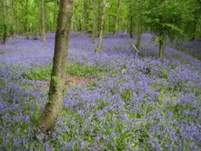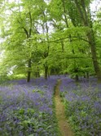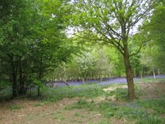
'The bluebells won't be out in Pods Wood on 27th November 2011 when SOS hold our first orienteering event in the area. Now is a good time to take a look at this pleasant piece of Essex woodland, just North East of Tiptree.'

Oyvind who? - Jack Isbester
You may have noticed some unfamiliar names at the head of the Brown Course results at the recent East Anglian Championships at Middlewick Ranges & Donyland Woods. The winner, with a time of 56m 41s was Norwegian Jon Pedersen, four minutes slower was Andrew Quin, an Irishman living long term in Stockholm and placed third a further one minute back was M35 Oyvind Stokseth, also from the Halden SK on the Norway / Sweden border. You might assume that Jon had had a perfect run, but not so - he told me that he had made about 1m 25s of errors, so it was definitely a case of 'must do better'.
What brought them to Essex? Well, as Jon put it, 'Very much snow in Norway now, and cheap flights to Stansted.' He proposed to arrive on Saturday and train in Hatfield Forest on arrival, to compete at the East Anglian Championships on Sunday and then to train again at Hatfield before returning to Norway on Monday. We were able to improve on that programme with the help of friends in CHIG and to provide him and Oyvind with copies of last year's Mitre Brown Course in Epping Forest East for their Monday run. Their eyes lit up when they saw the impressive map!
The foregoing gives a less than full picture of their programme. In addition to their run each morning with O-map in hand they went for a training run each afternoon, in the fields around the Marks Tey Motel. They also took the opportunity to provide orienteering masterclasses, as a consequence of which Dave Skinner and I are now elite standard in the use of the Emit brikke.
Jon is a dedicated semi-professional orienteer who works four hours a day for a firm making and selling roller skis. This allows him to train twice a day. His wages are supplemented by sponsorship from a number of businesses and, he explained, even in Norway it is possible to live simply. His clubmate Oyvind Stockseth is an IT professional.
I'm thinking that we should follow the Norwegian example and sponsor some Stragglers. I reckon that Dave Skinner and John and Geraldine Russell, to name but three, could benefit from living simply, a regime of training twice daily, refusing alcohol and getting to sleep by 9.00pm.
The photos that John Pedersen took during his visit to Essex can be seen at http://www.flickr.com/photos/superjon/sets/72157623494526901/

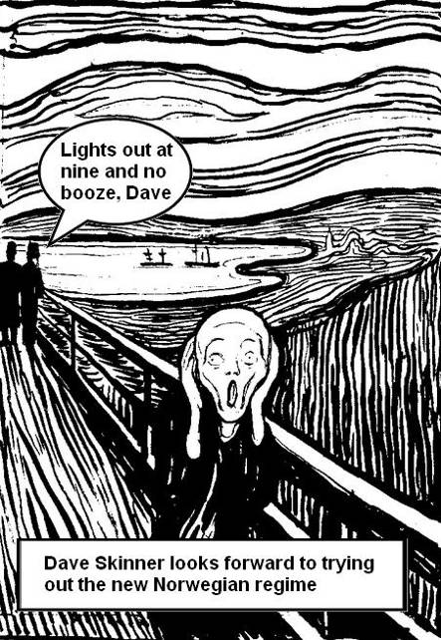

NEXT SOS Newsletter
The next edition of the newsletter will be available 15 August 2010. Copy to the Editors - editors@stragglers.info - before 10 August 2010.

