 | Essex Stragglers Orienteering Society (SOS) |   accredited

Newsletter Volume 21 No. 4

August 2010

Editors: Geraldine Russell and Rachel Barford- editors@stragglers.info
Club website - http://stragglers.info

Contents
Editorial – Rachel Barford ……………………………………………………………………….. Page 2
Noises from the Chair – John Collyer …………………………………………………….. Page 2
World Masters Orienteering Championships – John Collyer …………………. Page 3
The British Orienteering Championships 2010 – Jack Isbester ……………. Page 4
The Harvester Relay – Peter Warland & Neil Carter …………………………….. Pages 5 & 6
Greensand Ridge Relay – Neil Carter ……………………………………………………. Pages 7 & 8
2010 SOS Relays – An Organiser’s Perspective – Dave Skinner …………. Pages 9 & 10
Trois Jours de Franche-Compte – Jenny Collyer …………………………………… Page 11
Orienteering for my Duke of Edinburgh’s Award – Michael Archer …….. Page 12
Fixtures Information ………………………………………………………………………………. Pages 12 to 14

  Essex Stragglers support the Woodland Trust and its objectives |   Essex Stragglers' development activities are supported by Awards For all

Editorial - Rachel Barford

During the summer months maybe it’s a quieter time of the orienteering year for some – although for the keen, there are always activities available to take part in. Well done to Julie Laver for organising the summer club evenings in Colchester, to keep everyone on their toes, and, as you will read later in the Newsletter, Jenny and John Collyer have taken part in various overseas events in Switzerland and France. Well done to Dave Skinner too for organising the SOS Relays at Hylands Park – I had first hand experience of this, and really enjoyed taking part in the “Waifs and Strays” team. s I am sure many of you have also taken part in other events too – it would be great to hear about them for the newsletter!

If all else fails, and you don’t have the time or the resources to travel, you could always make the most of our permanent courses locally. For example, the course at Hylands Park in Chelmsford is suitable for everyone from the pram upwards. If you have relatives staying for the summer, and run out of ideas for entertaining, try taking them along to one of the permanent courses; you may convert them!

It would be great to have some more contributions for the November Newsletter – please do consider putting into words your experiences at any event you take part in, and email them to me as soon as you like!

Noises from the Chair – John Collyer
Firstly a thank-you to all who completed the questionnaire, the results of which I will present to the next committee meeting for discussion. The initial response to the possibility of both simpler events and a summer series have been generally positive, and a number of people have stepped forward to help as major officials.

Many of the summer events are under way and we hope to meet as many of you as possible at the coming Lakes and White Rose. Having been abroad to some events already, we have amassed a large number of flyers for next summer; World Masters in Hungary, and the Scottish 6-days are now in the diary. We even found two NOR members also running in Idre in Sweden, who had surfed the Summer O list published in Compass sport and picked it out more or less by chance. Needless to say they found the technicality of the terrain very different to East Anglia!

Many thanks to Julie Laver and Emma Johnson for all their efforts in putting on the club evening sessions at The Gilberd School during the summer term. We have more funding to take this forward and after reviewing the recent series will be making decisions for the future.

World Masters Orienteering – Neuchatel, Switzerland – John Collyer
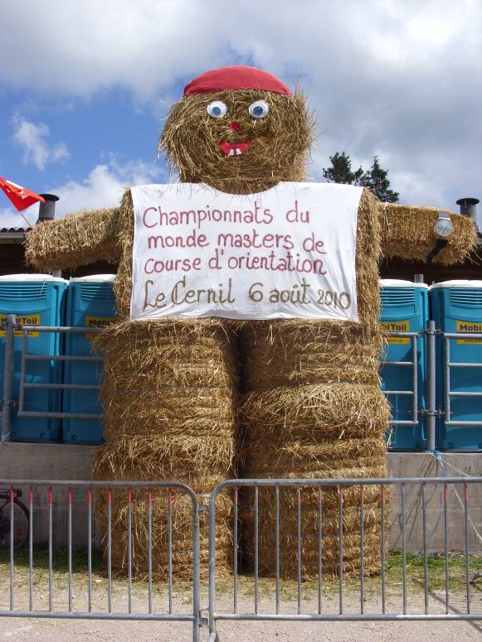
This yearly competition is open to those aged 35
and over, this year over 5,000 entrants came from
all over the world to the “Watch Valley” of eastern
Switzerland’s Jura.

The Event Centre and campsite were at the Sports
Stadium in La Chaux-de-Fonds, the town where Rolex
and Cartier factories are found. Our entry also gained
free access to local buses and trains, and with the
organisers linking shuttle buses to the competition
areas, we were able to keep the van at the campsite
all week.

The racing format has been established for a few
years; Sprint Races with one qualifying and one final
round, and a Long Event with two qualifying and one
final round. In each case the qualifying result is used
to place people in graded finals (A-E for H65).

Sprint Races:
The qualifying round was in La Chaux, and involved a 20 minute walk from the pre-start, uphill and over a railway footbridge to the start. They made no allowance for age here and Elizabeth Brown (only entry in W90) tripped on the bridge and ended up in hospital with a broken hip.
The race was a pleasant run down through the town to a main square close to where all sorts of food stalls and entertainments had been arranged for the Swiss National day. Unfortunately the local SI expert used his own software for the download and finishers queued for up to an hour.
The final was in Neuchatel, Jenny making the A final, whilst I got squeezed out into the B. The steep uphill run from the lakeside level left me gasping and unable to get within a minute of the winning time, with Jenny finishing 17th..

Long Distance:
The first qualifying race was over a flattish Alpine meadow with lots of small forest blocks and clearings, unfortunately I failed to leave my dibber in long enough to register at one control (immediate consignment to F final group) while Jenny had a competitive time. The second qualifier was in a forested limestone area, the floor was very rough with deep moss covered clints and grykes, plus brashings, and everyone seemed to struggle ( I ran at about 18 mins/K!) The final was in a similar area and times were just as long, Jenny went for broke in the A final and came unstuck.
After previous years in beautiful Portuguese sand dunes, and lovely Australian Eucalyptus, the rough nature of this year was a shock. I must point out to IOF or someone of rank that, given that the vast majority of runners are in older retired groups, putting us out into a succession of extremely tough forests will hardly make us want to go back again.

The British Championships 2010 - blow by blow from Jack Isbester

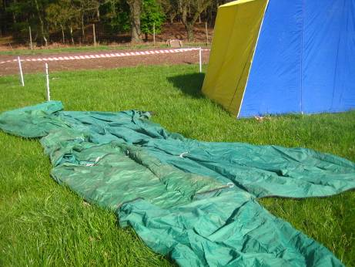

'Thirty two minutes 25 secs! That's a remarkable performance, Jack'. Those were the kind of remarks that greeted my achievements at BOC 10. But it was simple, really. I just used my knowledge and experience - my fitness helped, too. Oh, no, I'm not talking about my competitive run, which was nothing to boast about. My achievement was erecting the club tent, single handedly.

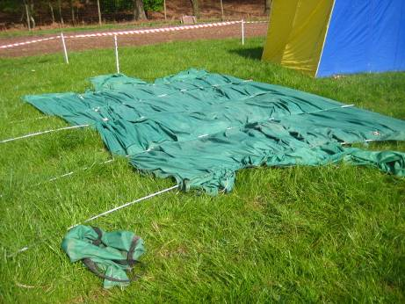
Now everyone will want to do it, so I had better describe the technique.
1. Spread the tent on the ground, placed and aligned roughly where you want it to stand.
2. Reeve the poles through their channels leaving both ends free.
3. Stretch one side of the tent and peg it down in its intended final position.
4. On the side that is pegged down, fit the ends of the poles into their receiving eyelets.

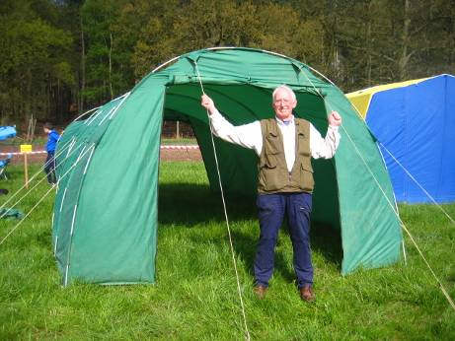
5. Grasp the end pole at its free end and force it into 'tent shape', pegging the loose end down.
6. Set up one of the end guy ropes to hold the tent end upright.
7. Work along the unsecured side of the tent forcing and pegging the poles into position.
8. Set up all the guy ropes.
9. Assemble and erect the SOS banner.
10. Sit back and await the praise from grateful clubmates.

If you can beat my time let us all know!

So what is the Harvester Relay all about? – Peter Warland & Neil Carter

Well a combined Suffolk & SOS team (SUFFOC+SOS Alliance) went to Eridge Park in May to find out.

The race was initiated by a long defunct Combined Harvesters club, hence the name. As you might guess the trophies are toy combined harvesters mounted on wooden bases. The event is based on similar relays in Sweden (Tiomila) and Finland (Jukola).

The Harvester is an orienteering relay with a difference – just two classes A (7 person team) and B (5 person team) but it starts late in the day, very late! The A course mass start for the first leg is midnight and the B team 2am so the first few runners complete night legs and the rest run in varying degrees of daylight. The event rotates around the country each year. Saxons OC put it on this time and delivered a great weekend of orienteering with a chasing sprint event nearby on the Saturday afternoon, the Harvester relay overnight and a regional event on the Sunday morning (the latter two both at Eridge). This meant you could camp at Eridge and the starts for the relay and regional were only a few hundred metres from your bed.

The Alliance team (in running order) comprised Eleanor West, Neil Carter, Lyn West, Peter Warland and Duncan Harrison. As a mixed club entry we ran as a non-competitive team and were the only representatives from East Anglia. In total there were 21 teams on the A course and 25 on the B, so a good few hundred runners. The entries ranged from club ‘fun’ runners like ourselves to elite competitors in some of the A teams and one team from Norway, who managed to fly over despite the volcanic ash!

The area was used for the JK Relays in 2008 and will be memorable to some of you by virtue of the weather then (snow, sleet and rain). However for the Harvester the weather was better, much better, no rain but still a bit chilly for May. Eridge is a large private estate near Royal Tunbridge Wells, the central area of which is an open deer park, surrounded by extensive mixed woodland cut by significant valleys with contour detail containing streams and areas of marsh. It is technical by East Anglian standards (i.e. with a few contours) and the mix of wood and parkland is ideal for a relay venue.

The B course leg lengths range from 4 to 7km and TD3 to TD5, so something for everyone be it in darkness or daylight. Eleanor had a storming run on the first leg with her past night O experience setting her up for a good time despite head torch problems. Neil (who has been going on about night O forever) was pleased with a good run, gaining valuable night experience and just can not wait to do it all again! At the start of the third leg the light was such that Lyn was able to run without a light and whizzed round her course. Peter put in an excellent performance with a fast run setting Duncan up for the final leg. Duncan ran one of the fastest final legs on the B course, despite badly knocking his knee on the way round.

How did we finish? We were non-competitive but our overall time would have put us in 15th place out of a starting line up of 25 on the B course, so a good result for a National competition and one to improve upon next year. Historically at its peak there were up to 100 teams taking part in the Harvester but in recent years numbers have declined and there has been some question over how much longer it will continue. There are rumours of the event being staged in South Yorkshire in 2011 and it would be great to see us enter a couple of teams.

Neil said “This is one of my best orienteering experiences ever. Having watched Tiomila and Jukola live on the web and thought ‘One day!’ it was great to enter a team in the Harvester and experience a night relay for real. From the camaraderie of the SUFFOC+SOS Alliance ‘base-camp’ tent, to running in some excellent terrain in total darkness, this is my orienteering highlight of the year so far!”

It is certainly a unique event with the mix of night and day orienteering, the fun of a team relay and certainly well worth taking part in the future? Lookout for details in 2011 and talk to any of the team about running next time.

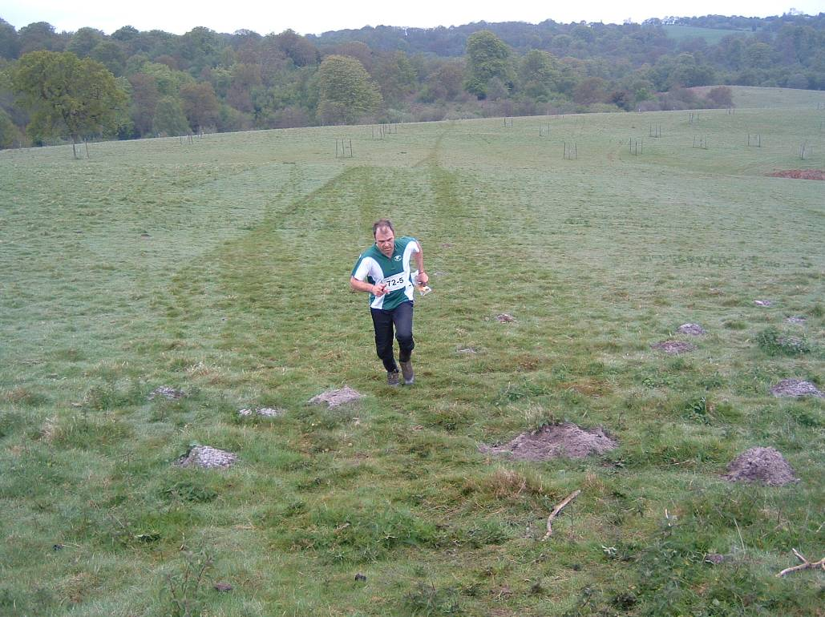
Duncan at the last control at the Harvester

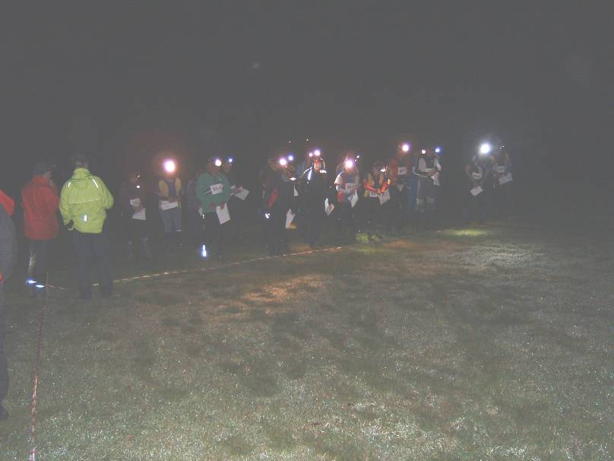
Experiencing “Night O” at the Harvester

The Greensand Ridge Relays 2010 - Neil Carter

Following some post O event discussions Peter Warland and I hatched a plan to finally enter the Greensand Ridge Relays this year. It seemed like an excellent idea to keep us running over the summer, build on the success of the Harvester and finally tick off another East Anglian orienteering (well almost!) event.

Organised by South Midlands Orienteering Club (SMOC) this is a handicap Relay Race for teams of six who run consecutive legs from Leighton Buzzard to Northill Church. The “way-marked” long distance footpath known as the Greensand Ridge Walk (see http://www.greensandridgewalk.co.uk/) governs the majority of the route, however there are a couple of small exceptions where a detour is made for safety or logistical reasons. The principle of the race is that finding your way is part of the challenge (hence the orienteering). Unlike most running races there are no marshals to guide you en route so some navigation is required. I understand that some teams have found this difficult to adjust to in the past, but talking to other runners at the event it was apparent that most knew the area well or had reconnoitred their routes. Due to the distance to the event we relied on our navigation skills, maps and numerous way-markers, but as orienteers we clearly did not want to get lost!

At the start each team is issued with an SI dibber, which is the relay baton and used to record each leg time before being passing to the next leg runner. Each team’s start time is determined by their overall team handicap, which is based on the sex and age group of each runner. The aim of the handicap system is for teams to finish at 5pm; however trophies for the event include “The Greensand Ridge Shield” which is awarded to the first team across the Finish Line i.e. the team that beats its handicap time by the greatest margin.

The total race distance is 33.4 miles, with leg lengths ranging from 3.9 to 8 miles (that’s 6.3 to 12.9 km to us orienteers). The course record is held by a running club and is 3hrs 27min 29sec. There is also an option for individuals to tackle all six consecutive legs as an endurance run (current solo record is 5hrs 20min 7sec!).

We entered a combined Suffolk and SOS team “SUFFOC+SOS Alliance” who (in running order) comprised Duncan Harrison, Nick (and Claire) Harrison, Alan Anstead, Neil Carter, Goff Hill and Peter Warland. Apart from SMOC themselves we were the only orienteering clubs competing, however I understand that another East Anglian club just missed out as there is a cap on the total number of teams participating. As East Anglian orienteering clubs it was good to support SMOC and participate in the event as I understand from them that entries from orienteers have dwindled over the years since the event began in 1987 and now the majority come from running clubs. The event certainly suits orienteers as it involves off road running, navigation and careful logistics to ensure each runner is in place at the right time along the 33 mile route. This we handled really well with excellent planning and cooperation amongst the team.

We successfully navigated ourselves to the finish in a total time of 5hrs 2min 5sec. Other running teams were spotted missing turns and going the wrong way, however were still able to post strong times and we finished as 22nd fastest team (25th in the handicap competition). The weather was very hot and sunny so times were down on previous years with team finish times ranging from 3hrs 45min 10sec to 6hrs 37min 43sec. One team was notable as they had an average age of 73, with all runners at least 70 years old.

Further event details, including photos and results from this year and the route description can be found on the SMOC web site at http://www.smoc.info/GSRR/index.shtml

The next Greensand Ridge Relay will be held on Saturday 25th June 2011 – Talk to any of the team about running next time. There’s a record for us to beat!

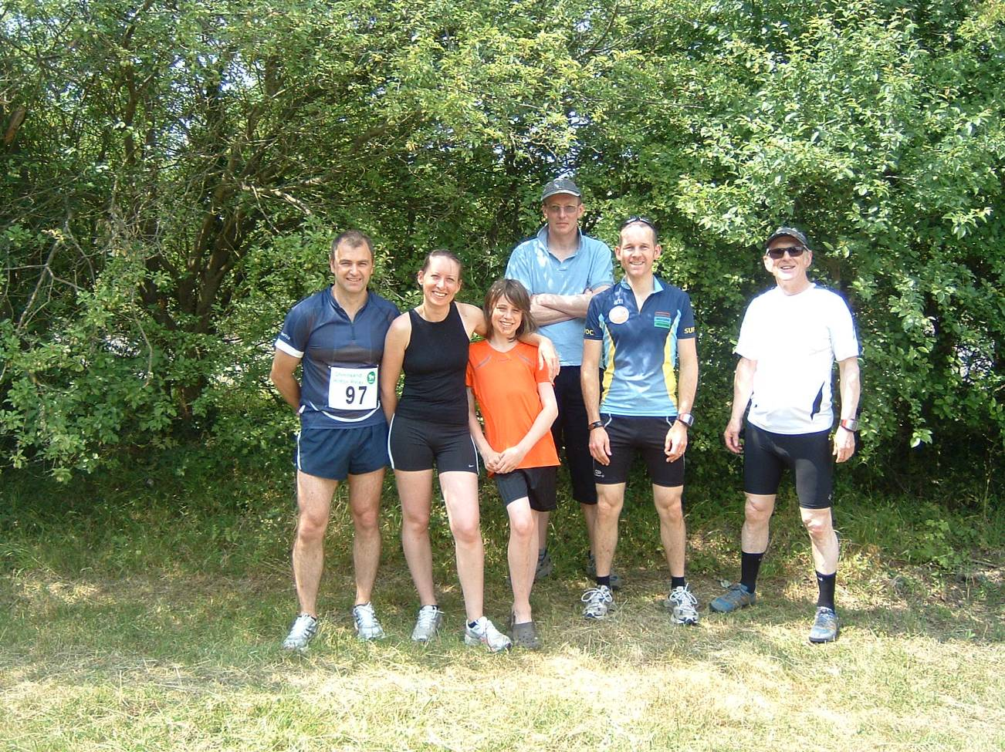
The majority of the SUFFOC and SOS Alliance team at Greensand Ridge Relay
2010 SOS Relays – an Organiser’s perspective – Dave Skinner

During the 5 years I been involved in orienteering and our club I have somehow found myself elsewhere at the time of the SOS Relays, so with no previous experience of this unique event it was with some ‘fear’ that I set off for Hylands Park early that Sunday morning! I was however armed with good advice from those experienced in organising our Relays event, but.....

In the days leading up to the event I had ‘agonised’ on some specifics: should I try to make this a ‘posh’ event by issuing running bibs? (decided yes, but hunting down sufficient volumes of safety pins was a challenge for me – I now know a great little shop in Witham!); and how could I best post results as the event progressed (ultimate design was flawed – reference to this later).

A summary of my perspective of the day:

07:05 Arrive at Hylands – Planner and Controllers already there
07.10 It is noticed that the gate to a fenced-off area is not locked – padlock loose –car access to this area will speed deliver of equipment to start area – take temporary custody of padlock to avoid potential ‘lock-in’
07:35 Roads signs installed
07:50 ‘Inspect’ toilet block – still locked – oh dear!
09.00 Control cards completed and collated with bibs to form packs for each team
09.30 Registration area set up (1 table, 2 chairs and sail banner – didn’t take long!)
10:15 Panic over set up of start area – how should this be done? Solution simple: one Start banner; four poles to define hand-over area (which was little used actually!)
11:06 First team starts
11:10 Additional team constructed, named ‘Late Arrivals’ – they depart 10-15 minutes after their handicapped time
11:51 Last team starts
12:10 Abandon ‘real-time’ team progress chart – impossible to maintain (simpler mechanism required next time)
12:18 First team finishes
12:25 Wind defeats collation of control cards in open air – retire to tent – not much better!
13:07 Last team finishes
13:10 Presentation of Trophy to winning team
16:00 Get home, lie down in a dark place!

For those of you who are not familiar with the unique format of the SOS Relays, a brief description...Teams of 4 run a total of 9 legs – 2 Light Green, 3 Orange and 4 Yellow; team member s can run a particular course only once; each team has three maps, one for each course so at most three members of the team are running simultaneously; teams are start-time handicapped by age and gender, so the first team completing their 9 legs wins.

Results of the event are published on the SOS website. Congratulations to all who took part – nobody mispunched! Highlight achievements were:

Team Results:
1st Flying Monkeys (SUFFOC), pictured with Trophy below
2nd HAVOC Snails (HAVOC) who started 7th on the grid
3rd Hash Hares (SOS/IND)
9th Wagglolders (WAOC/ex-WAOC) who started 45 minutes after the first team and recorded the fastest overall time by 10 minutes – their handicap defeated them!

Individual Results (fastest legs):
Light Green – Harold Wyber (Hey CHIG Spenders)
Orange – Jonny Cronk (Wagglolders)
Yellow - Simon Gardner (Wagglolders)

A very enjoyable day despite the chaos that generally surrounded my activities! I believe that all those who took part had fun and plenty of exercise! Thirteen teams was a good turnout but I think there is potential to increase this further. I am aware that some do not take part in Relays, being concerned perhaps that they may “let the team down”. My view is that those who take part in SOS Relay teams primarily do so for fun and to extend their experience (and this applies to JK and BOC Relays events as well). OK there is competitive element of course but would assure that all levels of skill and experience are welcome.
Our Relay event next year will be at Wivenhoe – I hope to see you there.
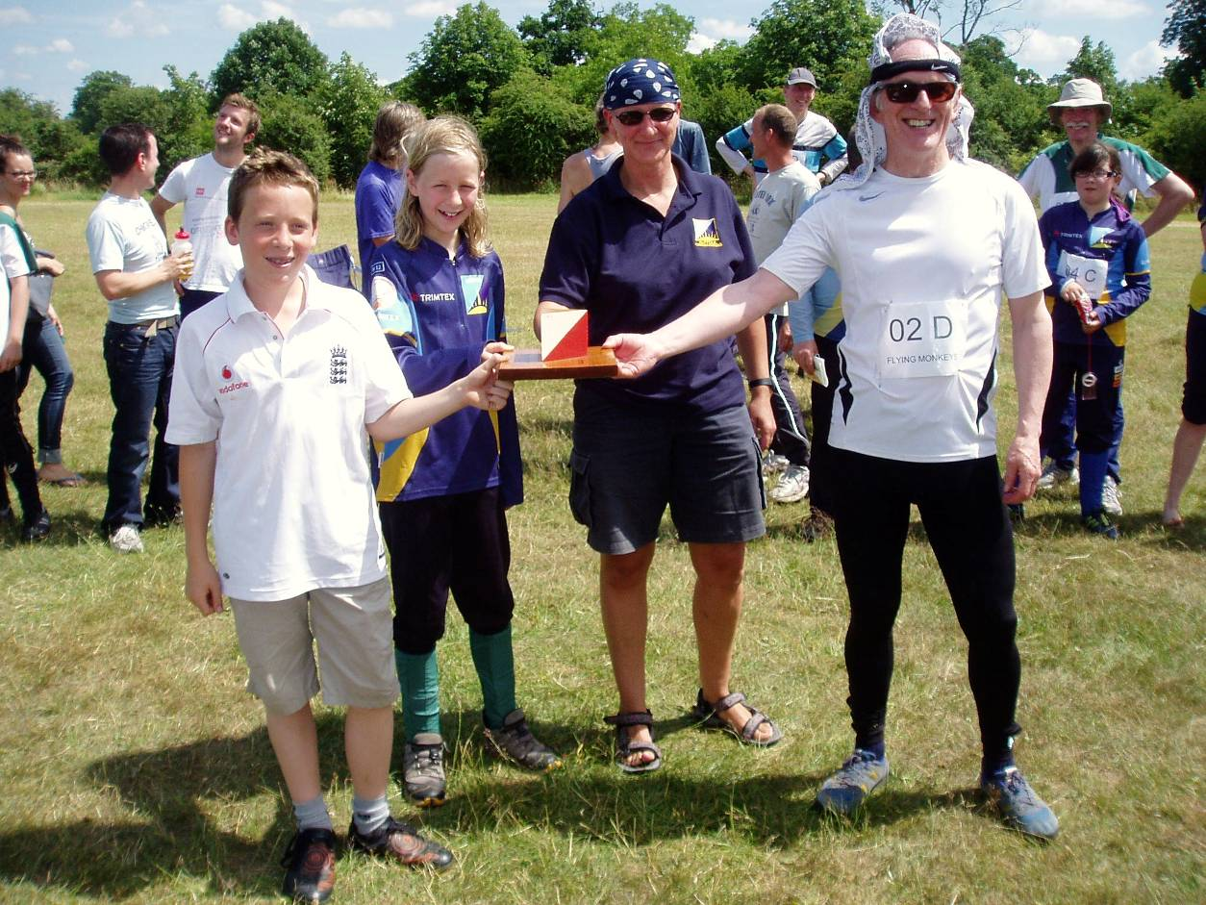

Trois Jours de Franche-Compte – Jenny Collyer

By way of a different approach I’ve committed to verse (of a sort) our impressions of the 3-day event in the French Jura that we took part in the weekend before WMOC.

At Citadel ramparts, steep walk up to start,
Then urban dash through Becanson’s heart,
Canal tunnel, quarter mile through,
Then Parc Chamars by the banks of the Doubs.

Naisey-le-Grange, think White Rose there,
Foggy and damp, low brambles catching,
Shrubs, droplets spraying, glasses misting,
Dim light, faint map, slow, take care.

Gonsans, a beautiful day was dawning,
Dolines, depressions deep, crags encircling,
Delightful wood for straight navigating,
Oh! If all woods were this enchanting.

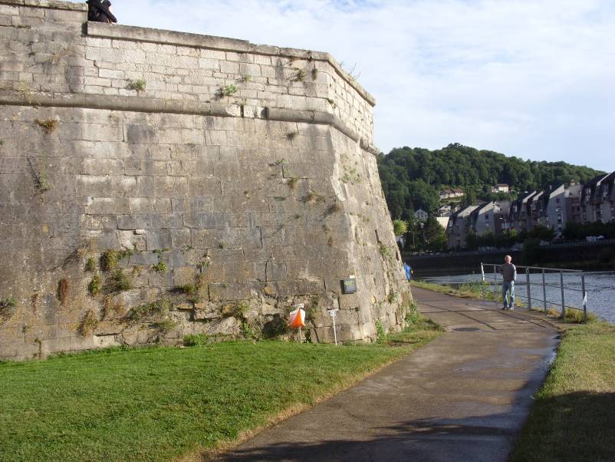
My control at Besancon urban race

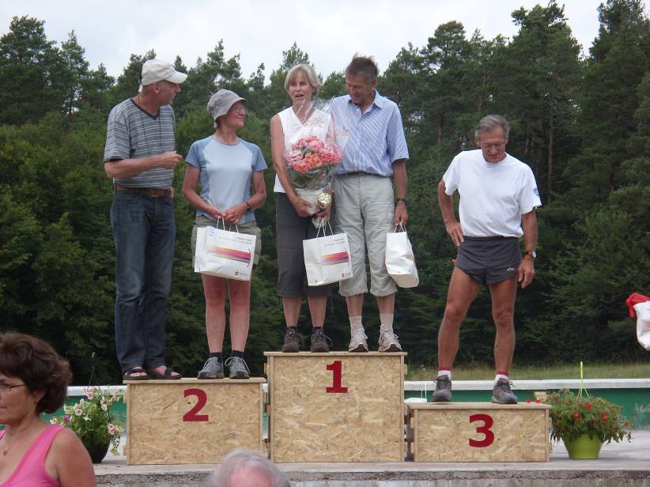

1st Edith Brand (Germany)
2nd Jenny Collyer
3rd Pauline Ward

Orienteering for my Duke of Edinburgh’s Award – Michael Archer
I am in Year 10 at Moulsham High School in Chelmsford and last September most of Year 10 started doing their Bronze Duke of Edinburgh’s Award. To qualify for this you have to do a skill or hobby (I do drama), some volunteering (I did litter picking), two expeditions (ours were to Danbury and to the Isle of Wight) and a sport. As I had been doing orienteering for years, I chose orienteering as my sport, which is quite an unusual one to do (according to my teacher). To qualify for my Bronze Award, I had to show improvement in orienteering over a few months. I have tried to improve from an Orange to a Light Green course over this time, and I think I have been successful. I take part in quite a lot of orienteering events, and enjoy doing it. The skills that I have learnt orienteering helped when we were on our expedition to the Isle of Wight, as we had to navigate (including compass work) for 15 miles over two days, and our group not only didn’t get lost, but we were the fastest team from our school! I am now going to do my Silver D. of E.

Fixtures in East Anglia and Nearby Regions – National Events which SOS members regularly attend are also included
The information provided below normally consists of Event Date, Region (eg EA = East Anglia), Event Grade , Event & Location Names and map reference. Organiser's contact details. Contact details, costs, closing date etc. for Pre-entry when provided. Whether Entry on the Day (EOD) is possible and the surcharge payable. The range of courses offered. The address of a website from which additional information can be obtained. Additional information in plain language.
At Essex Stragglers' events registration normally opens at 1000hrs, starts are from 1030hrs until 1230hrs and courses close at 1430hrs.
2010
September
4th | SEOA  SO  Local |  | SO - Sussex Sprint Series 2010 - event 7 - East Court, East Grinstead , East Court, East Grinstead East Grinstead  Entry On Day: Senior £TBC, Junior £TBC, Student £TBC. , Punch Type: None, www.southdowns-orienteers.org.uk
5th | SEOA  SLOW  Local |  | SLOW Trail Challenge Half Marathon , The Hawker Centre Kingston  Entry On Day: Senior £TBC, Junior £TBC, Student £TBC. , Punch Type: None,
11th | SEOA  DFOK  Local |  | DFOK North West Kent Series , Jubilee Park Petts Woods , TQ435680  Organiser: Rod Harrington Entry On Day: Senior £4.00, Junior £0.00, Student £0.00. , Punch Type: SI, Start Times: Mass start at 11:30 am www.dfok.co.uk
11th | SEOA  SO  Local |  | SO - Sussex Sprint Series 2010 - event 8 - Tilgate Park, Crawley , Tilgate Park, Crawley Crawley  Entry On Day: Senior £TBC, Junior £TBC, Student £TBC. , Punch Type: None, www.southdowns-orienteers.org.uk
12th | EAOA  SOS  Local |  | SOS Colour Code Event , Hockley Woods Hockley , TQ830915  Organiser: David Skinner Entry On Day: Senior £7.00, Junior £2.00, Student £2.00. , Punch Type: SI, Start Times: 10.30-12.30 www.stragglers.info
18th | SEOA  SLOW  Regional |  | SLOW - City of London Race , City of London London , TQ325803  Organiser: Alan Leakey, alanleakey@bigfoot.com, 01932 864347 Entry On Day: Senior £TBC, Junior £TBC, Student £TBC. , Punch Type: SI, No dogs allowed. Start Times: 10.30 - 13.00 www.sloweb.org.uk
19th | EAOA  NOR  Local |  | NOR Try-O & Score Event , U.E.A. Norwich , TG194083  Organiser: Alan Bedder, alan.bedder@virgin.net, 01603 424589 Entry On Day: Senior £TBC, Junior £TBC, Student £TBC. , Punch Type: None, www.norfolkoc.co.uk
19th | SEOA  LOK  Local |  | LOK District Event , Hampstead Heath tbc  Entry On Day: Senior £TBC, Junior £TBC, Student £TBC. , Punch Type: None,
25th | SEOA  SAX  Local |  | SAX KOL , Challock Ashford , TR024500  Organiser: Simon Maytum, simon.maytum@tiscali.co.uk, 01622 746011 Entry On Day: Senior £TBC, Junior £TBC, Student £TBC. , Punch Type: None, www.saxons-oc.org
26th | EAOA  HAVOC  Local |  | Thorndon North SWELL , Thorndon North Country Park Brentwood , TQ604928  Organiser: Chris Shaw Entry On Day: Senior £TBC, Junior £TBC, Student £TBC. , Punch Type: SI, Dogs: Under control Start Times: 10.30:12:30
October
2nd | SEOA  HH  Local |  | HH Saturday Series & Youth League , Verulamium St Albans , TL145071  Organiser: Debbie Charlton Entry On Day: Senior £TBC, Junior £TBC, Student £TBC. , Punch Type: None, www.happyherts.org.uk/
3rd | EAOA  SUFFOC  Local |  | SUFFOC Colour Code Event & Yvette Baker Regional Qualification Round , Haughley Park Elmswell , TM002623  Organiser: Rob Coulter, rob.coulter@ntlworld.com, 01473 258430 Entry On Day: Senior £7.00, Junior £2.00, Student £TBC. , Punch Type: SI, www.suffoc.co.uk
9th | SEOA  CHIG  Local |  | CHIG CATI , Hainault forest Country Park Romford , TQ478929  Organiser: Ray Weekes, RayWeekes@BTIntenet.com, 020 8530 3011 Entry On Day: Senior £2.00, Junior £2.00, Student £2.00. , Punch Type: None, Dogs allowed. www.chig.org.uk
10th | EAOA  SOS  Local |  | SOS Colour Code Event , Baddow Ridge Danbury , TL790065  Organiser: David Skinner, dave.skinner@btinternet.com, 01245 381266 Entry On Day: Senior £7.00, Junior £2.00, Student £2.00. , Punch Type: SI, Start Times: 10.30-12.30 www.stragglers.info
16th | SEOA  DFOK  Local |  | DFOK North West Kent Series , Shooters Hill Welling , TQ438762  Organiser: Andrew Evans Entry On Day: Senior £4.00, Junior £2.00, Student £TBC. , Punch Type: SI, Dogs allowed. Start Times: 11:30 am www.dfok.co.uk
17th | EAOA  NOR  Local |  | NOR Colour Code Event , Pretty Corner Sheringham , TG317311  Organiser: Alan Bedder, alan.bedder@virgin.net, 01603 424589 Entry On Day: Senior £TBC, Junior £TBC, Student £TBC. , Punch Type: SI, Dogs: DOGS ON LEAD Start Times: From 10.30 To 12.30 hours www.norfolkoc.co.uk
20th | SEOA  HH  Local |  | HH Street Race , Winchmore Hill tbc  Entry On Day: Senior £TBC, Junior £TBC, Student £TBC. , Punch Type: None, www.happyherts.org.uk/
24th | EMOA  LEI  Regional |  | LEI Midlands Middle Distance Championships , Irchester Country Park Wellingborough , SP914660  Organiser: Robert Haskins, bobh@piperdrive.co.uk, 01509 842449 Entry On Day: Senior £TBC, Junior £TBC, Student £TBC. , Punch Type: SI, www.leioc.org.uk
24th | SEOA  SAX  Local |  | SAX District Event , Knole Park sevenoaks , TQ544540  Organiser: Nick Hope, chairman@saxons-oc.org, 01634 231487 Entry On Day: Senior £TBC, Junior £TBC, Student £TBC. , Punch Type: None, www.saxons-oc.org
30th | SEOA  DFOK  Local |  | DFOK Kent Orienteering League , Jeskyns/Ashenbank Gravesend , TQ663693  Organiser: Chris Baker, chrisw.baker@ntlworld.com Entry On Day: Senior £4.00, Junior £1.00, Student £1.00. , Punch Type: SI, Start Times: 11am to 12:30pm www.dfok.co.uk
31st | EAOA  WAOC  Local |  | WAOC Colour Coded Event , Mildenhall Thetford , TL728750  Organiser: Roger Horton, xmhcman@yahoo.co.uk, 01223 473953 Entry On Day: Senior £8.00, Junior £3.00, Student £3.00. , Punch Type: SI, Dogs: Dogs welcome but must be kept under control. Please check WAOC club website shortly before the event for further details. Start Times: 10:30 - 12:30 www.waoc.org.uk
November
6th | SEOA  HH  Local | HH Saturday Series & Youth League , Stanborough Lakes Welwyn Garden City  Entry On Day: Senior £TBC, Junior £TBC, Student £TBC. , Punch Type: None,
7th | EAOA  SUFFOC  Local | SUFFOC Colour Code Event , EA League & ESSOL , West Harling Heath Thetford , TL947841  Organiser: Andrew Elliott, andrew_yyy@tiscali.co.uk, 01359 230221 Entry On Day: Senior £7.00, Junior £2.00, Student £TBC. , Punch Type: None, www.suffoc.co.uk
13th | EAOA  HAVOC  Local | Weald Park , Weald Park Brentwood , TQ568941  Organiser: Chris Shaw Entry On Day: Senior £TBC, Junior £TBC, Student £TBC. , Punch Type: SI, Dogs: Under control Start Times: 10.30:12.30 orienteering-havoc.co.uk
14th | EAOA  NOR  Local | NOR Colour Code Event , Hockham Thetford , TG152413  Organiser: Alan Bedder, alan.bedder@virgin.net, 01603 424589 Entry On Day: Senior £TBC, Junior £TBC, Student £TBC. , Punch Type: SI, Start Times: 10.30 to 12.30 hourscourses close 14.30 www.norfolkoc.co.uk
20th | EAOA  WAOC  Local | WAOC Colour Coded Event , Rowney Warren Shefford , TL123403  Organiser: Ian Lawson, ianh.lawson@ntlworld.com, 01438 359042 Entry On Day: Senior £8.00, Junior £3.00, Student £3.00. , Punch Type: SI, Dogs: Dogs welcome but must be under control at all times. Check WAOC club website near to date of event for further details. Start Times: 10:30 - 12:30 www.waoc.org.uk
21st | SEOA  CHIG  Regional | The Michael Brandon Mitre Regional Event , Paradise Wildlife Park Wormley/Broxbourne , TL337078  Organiser: David Lund, lundd@logica.com Entry On Day: Senior £TBC, Junior £TBC, Student £TBC. , Punch Type: SI, Dogs: Keep on a lead chig.org.uk
28th | EAOA  SOS  Regional | SOS Regional Event, EA League & Essex & Suffolk Schools League , Hatfield Forest Bishop's Stortford , TL547203  Organiser: Jack Isbester, JackIsbester@aol.com, 01621 815501 Entry On Day: Senior £TBC, Junior £TBC, Student £TBC. , Punch Type: SI, No dogs allowed. www.stragglers.info

NEXT SOS Newsletter
The next edition of the newsletter will be available 15 November 2010. Copy to the Editors - editors@stragglers.info - before 10 November 2010.

