 | Essex Stragglers Orienteering Society (SOS) |   accredited

Newsletter Volume 21 No 5

November 2010

Editors: Geraldine Russell and Rachel Barford- editors@stragglers.info
Club website - http://stragglers.info

Contents

Editorial – Rachel Barford 2
From the Chair - John Collyer 3
Captain’s Corner -Jenny Collyer 4
Development News - Julie Laver 5
ESSOL News - Julie Laver 6
Fixtures 7
Club Equipment Store - John Collyer 10
Lakes 5 – Tales of the lost and the lonely! - Steve Cartwright 10
Puglia 5-Days - John Collyer 12
Foresta Umbra - John Collyer 15
Award Winners’ Photos 16
Fordham Special Event 18

  Essex Stragglers support the Woodland Trust and its objectives |   Essex Stragglers' development activities are supported by Awards For all

Editorial – Rachel Barford
Many members are very involved in orienteering activities that keep them both busy and well travelled. This newsletter contains some interesting articles submitted by the Collyers about their travels, and Steve Cartwright in the Lake District. If anyone else would like to tell us about their experiences, please feel free!
Congratulations should also go to various members winning awards lately – Nancy Powell Davies won the night score event for super vet women at the White Rose event, and Steve Cartwright was surprised and pleased to be presented with a Certificate of Merit by Tendring District Council. This was for his coaching with the children of the Colchester and Tendring Alliance Clubs Clacton Satellite. Although this is not strictly orienteering training, Steve sometimes includes orienteering evenings. For others wishing to achieve glory, there is also potential for progress up the Stragglers’ League – details in this newsletter!
In the dark and dismal days of winter, when there are no orienteering events on the horizon, orienteers could consider trying geocaching. The website www.geocaching.com gives all the details of how to get started. It is like a giant permanent orienteering course, and GPS systems are not essential – good mapwork (and a bit of luck) will easily find your local geocaches.

SOS Club Nights
GLASS PAVILLION @ WIVENHOE PARK,
UNIVERSITY of ESSEX , COLCHESTER, CO4 3SQ TM030240
Thursdays 7.30pm - 8.30pm then refreshments available till 9pm

Dress suitable for weather conditions. Bring drink and torch if possible – all other resources supplied.
Help available. Non-members welcome – bring a friend!! Under 16 yrs must be accompanied by an adult

Enquiries to julie.laver@virgin.net or phone 01206 826152

Please pass this on to anyone who might be interested especially non-club members

From the Chair - John Collyer

During the summer I received almost 30 questionnaire replies from members about orienteering participation. I analysed these and reported back to the September committee meeting. The main points were as follows:

Cost of events
The vast majority were happy with current costs although a few people are put off by the higher costs associated with Regional events. (£10 is a typical adult entry fee)
(We have recently received details of the new agreement that the Forestry Commission is pushing through for use of their land for orienteering. BOF are unhappy at the scale of the increased charges and we will need to think carefully about these when arranging new permissions for the 2012 season)

Helping as Main Officials:
A third of the respondents have already taken on a major role, of the others one half said they would consider being trained up by a mentor for an eventual main role.
(We have already started assigning interested members to “shadow” an experienced official)

Simpler format of event.
The vast majority supported a more limited and easier organisational event format, but a small minority would like to see a longer course than that suggested of about green standard.
Two thirds of respondents would prefer a mixture of Saturday and Sunday, whilst a third wanted Sunday only.
(Julie used the recent Saturday event at Wivenhoe event as a starter and are putting on another at Fordham on Saturday 4th. December – keep an eye on the website for details)

Summer Series.
Over two thirds supported this, with the majority happy with a Wednesday, although with Club Night being moved to Thursday we may decide to use that evening .
(No action taken yet)

Training Nights.
A third of people said they were interested, but the rest commented generally that it was not compatible with their working life and other commitments.
(We will be reviewing the situation after the current series of sessions is completed)

The committee have already made some movement on the preferences that you, the membership, have shown and we hope that they will help the club move forward as well as providing you with the orienteering experiences you require.

Captain’s Corner -Jenny Collyer

Our first round of the Compass Sport Trophy takes place on Sunday January 16th. There is no East Anglia venue this year and I will be asking for Ranmore Common, near Dorking as first choice and Beacon Hill, near Loughborough as second choice. We hope to take a coach to the event if there is enough interest. The entry fees, subsidised by the club, are £5 /£2. (Students in full time education can claim travel expenses with appropriate documentary support).

If you haven’t already let me know that you would like to run I would appreciate it if you could let me know by Friday Dec 24th at the latest.

For those who have not run in a Compass Sport Trophy event before - this is an inter club competition where you run a colour coded course as appropriate to your age class eg M21 – M40 run brown, M45 – M55 run blue, M60 and 70 run green and M75 short green. W21 – W40 run blue, W45 – W55 run green and W60+ short green. Juniors run light green (M/W18-) and orange (M/W14-). Points are scored according to your finishing position and the best 13 over all used for the final score.

The more club members taking part the better our chances. We usually have a very good entry from Stragglers and a good club atmosphere at the event. If you would like to know more please contact me.

I will be making up teams for the JK relays for those of you making the journey to Northern Ireland at Easter. The area being used is of sand dunes on the edge of Dundrum Bay, south of Belfast. The entry fees, subsidised by the club, are £8 and £3. Could you let me know asap if you would like to run in a relay team and by February 28th at the latest.

The British Relays are at Tankersley Woods, north of Sheffield on Sunday 15th May. Entry fees will be as for JK. Let me know if you would like a run but I will be contacting you later for this event when I know the closing dates for entries.

Jenny Collyer jcollyer48@btinternet.com

Development News - Julie Laver

Club Night– We have been running sessions on Thursday evenings from 7.30pm using the Glass Pavilion at Wivenhoe Park as a venue. It is much easier for Emma Johnson to plan interesting sessions as the grounds are more varied than the Gilberd School. Even given the darker evening we are able to practice our skills due to the well lit areas of the University Grounds. When Emma does put controls out in the unlit areas it just makes it more of a challenge and accurate navigation is essential!
The format is 3 weeks technique practice and fitness exercises and a mini event for the 4th week.
All ages and abilities are catered for and you can participate at your own pace.
So far there has been a night score and a Mini Night O with two courses - easy and medium (yellow & light green ish)
Tea, coffee, hot chocolate and biscuits are available from 8.30pm to revive participants. This gives a chance for participants to chat about how the weekends events went and work out what went right or wrong.
We put on a Spooky Trail in half term week and advertised it to local schools which had a good turnout. Bats were hung in the trees near the controls and the children enjoyed finding them.

Saturday Activity Mornings – These are happening once per month on the first Saturday (if possible!)
We held a CATI and score in Castle Park in October with plenty of newcomers trying the easy courses around the Park. Daniela Brohm just beat Chris Childs to first place in the Score.
A Student Challenge Race at Wivenhoe Park was our October event with Daniela also winning the fastest Woman’s trophy and Clive Wilkinson (SUFFOC) winning the best Mens Run. The fastest run from a student was by Espen Sjoberg. It is hoped we can entice some students along to the Thursday Club Night sessions.

These are intended as low key events and training sessions to give club members an extra less competitive run with a chance to socialise with other club members. Also for new and inexperienced participants to gain confidence away from our bigger events.
In order to keep these interesting we will be using different coaches and other club members to plan these although they will be co-ordinated by the Development Committee.

They are also a good way for new planners to practice without the stress of a full event so if there are any budding planners or coaches who would like to come and ‘Have a Go’ at planning part or all of a morning activity you will get plenty of support from other experienced club members.
Also if you have suitable idea for the Saturday or Thursday slots but don’t want to be involved in planning them please let one of the committee know.
These activity sessions are for ALL club members so please support them.
The next Saturday session will be on Dec 4th At Fordham with John and Jenny planning and using our new SI training kit download computer.

ESSOL News - Julie Laver

Welcome to a new season of the Essex and Suffolk Schools orienteering league. We have already had 5 events with 4 remaining so still plenty of time to improve your scores. The best five count towards your league total.
Up to this season the league was for Juniors in the SOS and SUFFOC areas but new for this year we have included WAOC and HAVOC juniors. It is hoped this will make the older age group classes more interesting as there are fewer juniors running in these.
To be included in the league you do not have to enter through your school but please ensure your School and year are included on the registration form when you fill it in. No shadowing is allowed although junior pairs are allowed. Please make it clear in your registration form if you are shadowing /being shadowed and also declare non-competitive second runs.
Full details and comprehensive rules are available on the SOS website but I can deal with any enquiries or corrections. julie.laver@virgin.net or phone 01206 826152

Results so far:

Up to Y 6 Boys Up to Y 6 Girls
Matthew Clarke - Barnardiston Prep Saskia Baldrey - Barnardiston Prep
Angus Dudley - Barnardiston Prep Lizzie Robinson- Barnardiston Prep
David Jimoh - Barnardiston Prep Catherine Mole - Stonham Aspal

Y7/8 Boys Y7/8 Girls
Timmy Harrison - Barnardiston Prep Bronwen Mansel - Beyton Middle
Jack Gilbey - Barnardiston Prep Jessica Woodgate- Barnardiston Prep
Edward Jones - Barnardiston Prep Scarlett Simmons- Barnardiston Prep

Y9/10 Boys Y9/10 Girls
Roderick Mansel - County Upper Rhiannon Ware - Colne Community
Bryn Wilkinson - Copleston High Rachael Harrison
Nicholas Harrison - Debenham High Miriam Norris

Y11/12/13 Boys Y1/12/13 Girls
Jonathan Cronk Sushruta Chandraker
Alex Ware - Colchester 6th form Sarah Roach - St Marys
Thomas Norris Rebecca Lyne – Hedingham

Team Trophy Places after 5 rounds

1st - Barnardiston Preparatory School
2nd - St Andrews, Halstead
3rd - Kings College School,Cambs

for full listings please go to ESSOL page on the SOS website http://stragglers.info/schools/index.php

Well done to all who have taken part so far.

ESSOL fixtures remaining

2010
28-11 Hatfield Forest SOS
2011
09-01 Knettishall SUFFOC
27-03 Hylands Park SOS
22-05 Highwoods SOS

Please note these are preliminary fixtures and participants are advised to check Club websites before travelling
http://stragglers.info
http://pdl.demon.co.uk/suffoc

Fixtures
Fixtures in East Anglia and Nearby Regions – National Events which SOS members regularly attend are also included
The information provided below normally consists of Event Date, Region (eg EA = East Anglia), Event Grade , Event & Location Names and map reference. Organiser's contact details. Contact details, costs, closing date etc. for Pre-entry when provided. Whether Entry on the Day (EOD) is possible and the surcharge payable. The range of courses offered. The address of a website from which additional information can be obtained. Additional information in plain language.
At Essex Stragglers' events registration normally opens at 1000hrs, starts are from 1030hrs until 1230hrs and courses close at 1430hrs.
2010
December
2nd | EAOA  SOS  Training | SOS Club Night – Wivenhoe Park TM030240 see http://stragglers.info
4th | EAOA  SOS  Mini-event | SOS Saturday Coaching/Training plus 2 colour-coded courses – Fordham Hall Estate - http://stragglers.info
9th | EAOA  SOS  Training | SOS Club Night – Wivenhoe Park TM030240 see http://stragglers.info
12th | EAOA  NOR  Local | NOR Colour Code Event , Roydon & Grimston Kings Lynn , TF681230  Organiser: Julia Paul, juliacpaul@aol.com, 01485 541031 Entry On Day: Senior £TBC, Junior £TBC, Student £TBC. , Punch Type: SI, No dogs allowed. Start Times: From 10.30 to 12.30 hours www.norfolkoc.co.uk
14th | SEOA  SLOW  Local | SLOW Night Street-O , Pimlico tbc  Entry On Day: Senior £TBC, Junior £TBC, Student £TBC. , Punch Type: None, www.sloweb.org.uk
16th | SEOA  SAX  Local | SAX Kent Night Cup - Street O , Maidstone South Maidstone  Entry On Day: Senior £TBC, Junior £TBC, Student £TBC. , Punch Type: None, www.saxons-oc.org
19th | SCOA  TVOC  Regional | TVOC Regional Event , TBC Wendover , SP889090  Organiser: Martin Ricketts, martinricketts@phone.coop Entry On Day: Senior £TBC, Junior £TBC, Student £TBC. , Punch Type: None,
29th | SCOA  BAOC  Local | The Military Challenge , Woolmer & Longmoor Bordon , SU792312  Organiser: Allan Farrington, allan@emituk.com, 0773 4455838 Entry On Day: Senior £TBC, Junior £TBC, Student £TBC. , Punch Type: EMIT, Dogs: On lease in camp, OK on courses Start Times: 0930 to 1200hrs www.baoc.org.uk
2011
January
1st | EAOA  SOS  Local | Novelty O Event , Fordham Hall Estate Colchester , TL928256  Organiser: Andrew Cordle, andrew@cordle.net, 07968 567529 Entry On Day: Senior £5.00, Junior £2.00, Student £2.00. , Punch Type: SI, Start Times: 10.30-12.30 stragglers.info
2nd | EAOA  NOR  Local | NOR Informal New Year Score Event , Beeston Regis (Roman Camp) Norfolk , TG194083  Organiser: Alan Bedder, alan.bedder@virgin.net, 01603 424589 Entry On Day: Senior £TBC, Junior £TBC, Student £TBC. , Punch Type: None, Start Times: Registration from 10.15Mass Start at 11.00Orange Course starts from 10.30 to 11.15 www.norfolkoc.co.uk
9th | EAOA  SUFFOC  Local | SUFFOC Colour Code Event inc. Essex & Suffolk Schools League , Knettishall Heath Thetford , TL956806  Organiser: Clive Wilkinson, clive.sally@btinternet.com Entry On Day: Senior £7.00, Junior £3.00, Student £3.00. , Punch Type: SI, Dogs: Dogs welcome but must be kept under control. Start Times: Registration: 10:00 - 12:00Starts: 10:30 - 12:30 www.suffoc.co.uk
11th | SEOA  SLOW  Local | SLOW Night Street-O , Dulwich tbc  Entry On Day: Senior £TBC, Junior £TBC, Student £TBC. , Punch Type: None, www.sloweb.org.uk
15th | SEOA  CHIG  Local | CHIG Local Event , Harlow Town Park Harlow  Entry On Day: Senior £TBC, Junior £TBC, Student £TBC. , Punch Type: None, www.chig.org.uk
16th | SEOA  MV  Regional | MV Regional Event (inc Compass Sport Cup/Trophy heat) , Ranmore Common Dorking , TQ135504  Organiser: Tony Burton Entry On Day: Senior £TBC, Junior £TBC, Student £TBC. , Punch Type: SI, www.mvoc.org
22nd | EAOA  HAVOC  Local | Hadleigh Country Park , Hadleigh Country Park Hadleigh  Entry On Day: Senior £TBC, Junior £TBC, Student £TBC. , Punch Type: SI, Dogs: Under control Start Times: 10.30:12.30
23rd | SEOA  HH  Regional | HH Regional Event , Ashridge Berkhamstead , SP975118  Organiser: Hedley Calderbank Entry On Day: Senior £TBC, Junior £TBC, Student £TBC. , Punch Type: None, happyherts.org.uk
29th-30th | EAOA  CUOC  Regional | Thetford Thrash 29th Day 1 Icenian Regional Event , Thetford Forest Thetford , TL811852  Organiser: Ben Windsor, benwindsor@gmail.com Entry On Day: Senior £TBC, Junior £TBC, Student £TBC. , Punch Type: None, www.cuoc.org.uk
 | EAOA | 30th Day 2 Regional Event & EA Championships , Croxton Heath Thetford , TL877894  Organiser: Peter Allen, science@huccombe.org.uk, 01954 211446 Entry On Day: Senior £TBC, Junior £TBC, Student £TBC. , Punch Type: SI, Dogs allowed. www.waoc.org.uk
February
1st | SEOA  SO  Local | SO SONIC 5 - Horsham (night street-o) , Horsham Horsham  Entry On Day: Senior £TBC, Junior £TBC, Student £TBC. , Punch Type: None, www.southdowns-orienteers.org.uk
6th | EAOA  SMOC  Regional | SMOC Regional Event , Bucknell & Hazelborough Milton Keynes , SP658448  Organiser: John Shaw, john.s.shaw@ntlworld.com, 01525 632919 Entry On Day: Senior £TBC, Junior £TBC, Student £TBC. , Punch Type: None, No dogs allowed. www.smoc.info
13th | EAOA  SOS  Regional | SOS Regional Event incorporating EA League , Writtle Forest Chelmsford , TL640020  Organiser: Geraldine Russell, grmrussell@gmail.com, 01206 272761 Entry On Day: Senior £TBC, Junior £TBC, Student £TBC. , Punch Type: None, stragglers.info
19th-20th | EAOA  NOR  National | Norfolk Weekend incorporating Midland Championships 19th Retro Event at NT Felbrigg Estate , NT Felbrigg Estate Cromer , TG195405  Organiser: Pat Bedder, 01603 424589 Postal Entry: Alan Bedder, 21 Tills CloseSprowston,NORWICH, NR6 7QS, 01603 424589, dumpling@norfolkoc.co.uk. Cheques payable to Norfolk Orienteering Club Online entry through www.fabian4.co.uk Entry On Day: Senior £TBC, Junior £TBC, Student £TBC. , Punch Type: None, Dogs: Dogs on Lead, Livestock area. Start Times: TBC www.norfolkoc.co.uk
 | EAOA | 20th National Event & Midland Championships , Sherringham Park & Weybourne Wood Sheringham , TG139410  Organiser: Alan Bedder, alan.bedder@virgin.net, 01603 424589 Postal Entry: Alan Bedder, 21 Tills Close,Sprowston,NORWICH, NR6 7QS, 01603 424589, dumpling@norfolkoc.co.uk. Cheques payable to Norfolk Orienteering Club Online entry through www.fabian4.co.uk Entry On Day: Senior £TBC, Junior £TBC, Student £TBC. , Punch Type: SI, www.norfolkoc.co.uk
26th | SEOA  DFOK  Local | DFOK Kent Orienteering League , Downe tbc  Entry On Day: Senior £TBC, Junior £TBC, Student £TBC. , Punch Type: None,
27th | EAOA  WAOC  Local | WAOC Colour Code Event , Maulden Woods Clophill , TL074392  Organiser: Peter Woods, peter_woods@ntlworld.com, 01223 721433 Entry On Day: Senior £TBC, Junior £TBC, Student £TBC. , Punch Type: SI, Start Times: 10:30 - 12:30 www.waoc.org.uk

Club Equipment Store - John Collyer

At the moment Hilary Sellens is our Equipment Officer, and stores the bulk of our kit in the old pigeon loft in her garden. From next Autumn she would like to pass this job onto someone else and we clearly need to make plans for this well ahead of that date. Therefore I am asking if there is anyone who would be able to take on this role?

We estimate that the volume required would be that of an 8 X 6 garden shed, indeed the club would probably supply one if anyone needed to add storage space to take up the role of Equipment Officer.

We are also aware that other clubs use a separate storage facility such as a garage or lock-up store and would like to know if anyone has knowledge of such facilities.

We thank Hilary for her recent efforts and I assume that she would be willing to discuss the role with anyone interested.

Lakes 5 – Tales of the lost and the lonely! - Steve Cartwright

This year’s week festival of Orienteering was held in the Lake District, centring on the lovely town of Coniston, famous for its beautiful lake, Donald Campbell’s’ disastrous crash in his speed boat and the marvellous hills. A lovely week it proved to be with me not really wanting to go home.

Day 1: Swindale North near Shap.
Must admit I never made this one. Terrible grinding sounds emanating from the car necessitated a call to the AA. There was a certain element of fear, worry and panic but fortunately it only cost me £20 and some petrol to have it checked out at a garage, a bounced stone in the brakes being the problem.
I’m told it was a good event although quite a long way to the start.
Day 2: Guards Wood and Tarn Hows South.
This really was a day for those who like walking. We were recommended to leave cars and travel from the campsite. I think it was something like 60 mins walk to assembly and then a way on from there.
Lovely Orienteering though in the Woods with usual odd 1 in 0.25 climb! Encouraging in that I got round without any major hiccups.
Day 3: Harrop Tarn
Cancelled due to a rather damp car park. Although it was hoped to reschedule for the next day, still too damp. I went sightseeing and for a trip on Coniston water and the next day (the proposed Rest day) I went Hill Walking. Amazing to see lots of Orienteers Fell Running on the tops - Bit worried about the lack of a small pack, map, compass and water though for some, even if experienced.
Day 4: Caw Fell.
And fell I did on this one. Today I was tired and I guess they may have been too! We had a couple of mile walk to the start from assembly, and then a mile back afterwards, not to mention the odd notable 1 in 1 through the bracken on my course anyway. Funny day really, worried my compass wasn’t working properly again, my eyes seemed to think Control 1 had the same number as Control 2, and I’m still worried how a hill that seemed distinctly lower on my map seemed to have the same number of contours as the one I was on. It may just of been me though I guess. Apart from that it was good Orienteering and certainly challenging enough for me earlier on simply from the navigational point of view. I’m still not sure contours are the way to understand terrain. I’m not a crow, but I’m not sure they’d understand them either at times!
Day 5: Helsington Barrows
Based on the Old Kendal Race Course with only a very short walk to the start this one set a new standard in Orienteering. It was nice to have a warm and dry day for the last event and even nicer to know young Alex Birkett had won a Coaster for being the best on his course the previous day.
Being a little less tired than the day before I was hoping to jog round fairly sensibly yet the planner and my own inability got me again. Two attempts from re-entrants on one of the controls still left me in trouble and it was only when I chose to attack the Control from a totally different angle that I finally found it. The rest of the course was fine. You win some, you lose some. 16th out of 16!
Nice afternoon canoeing on Coniston, and some more hill walking before going home the next day.

Tremendous Orienteering really but a bit worried about the walks, particularly for children. Bit worried about the cancellation too. If you’ve thousands of people going to an event don’t you ensure the car park will be usable, although of course that may be very cruel in the circumstances. Nice going to the pub for a meal and pint and to read my book in the evening, and like I say didn’t really want to go home even if the ground was a bit hard and it was a bit chilly in the mornings.



Puglia 5-Days - John Collyer
We have often been tempted to try one of the holiday orienteering trips that are advertised at all the major events, and we finally decided to go to southern Italy with its lure of runnable beech forests, and sprint racing around steep alley-lined towns.
The events were put on in conjunction with the Park World Tour organisation which provides the back-up for any area who wants to organise their own series of races.

We were based at Rodi Garganico, a small town on the Adriatic coast roughly opposite Naples. The area is the Gargano peninsular, often called the bump on the heel of Italy’s boot – in fact a 3,000-plus foot lump of Karst-eroded limestone dropping down steeply on two sides into the sea.

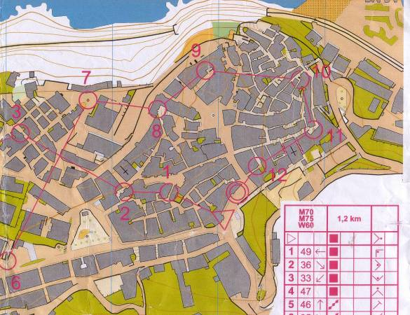
We began with a prologue on stabilised dunes and then had three street events and a long and a classic race in the mountains. The street events were held in three different villages, all with steep steps and winding alleys to negotiate – the first one at Rodi being at night when a headlamp or torch was essential. Town parties with food and music finished off each of the street races.

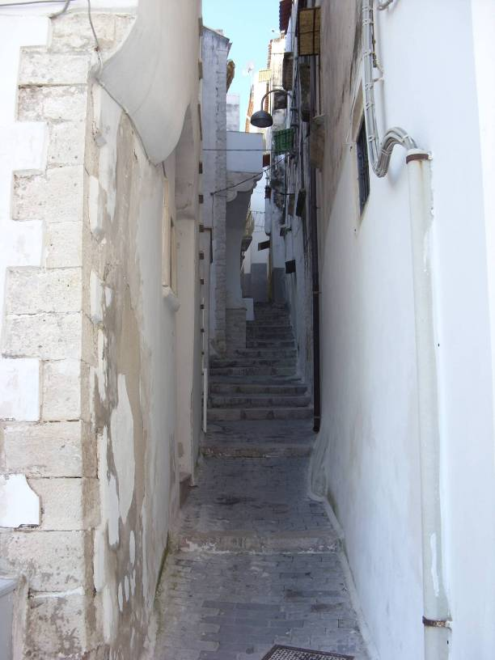

The forest events were based in the Foresta Umbra, an area of limestone which had been eroded into a series of deep depressions (dolines) often lined with crags. The forest floor was a bit rough and required very careful navigation round rocks, depressions and thickets.

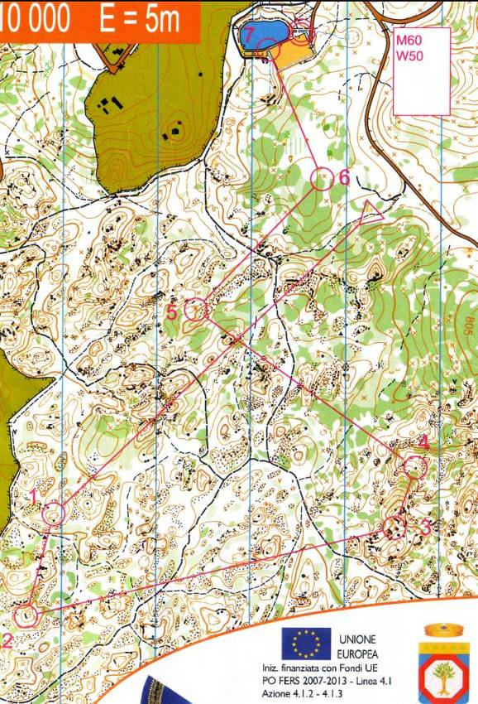

We thoroughly enjoyed all the races, especially given the weather, which was very sunny and warm throughout, and the international flavour, with a few Brits scattered amongst Scandinavians and Eastern Europeans. We would certainly recommend one of these events, for although the pre-event information was often sparse (parking tomorrow is same as last year!) everything held together well.

There is an event in Sicily early in March, which tempts us, especially with the opportunity to go up Etna.

Foresta Umbra - John Collyer

From Rodi’s beach on Adriatic side,
Where olive and orange groves lie,
Up, up high away on mountainous road,
To the deepest, dark Beech shades we ride.

Fungi, burst forth, here all kinds,
Locals, bag and trowels in hand,
Collect Autumn’s fare for homely pots,
A bounty from Nature’s safe land.

Cyclamen, brave flowers standing out,
Above the deep, leaf-littered floor,
White to deep purple, all shades are found there,
And Butcher’s Broom, red berries does bear.

Ancient limestone, white lumps lie around,
Rain, deep rocky dolines has formed,
Acidic dissolving the carbonate heart,
Of Gargano, Puglia’s highest ground.

Award Winners’ Photos
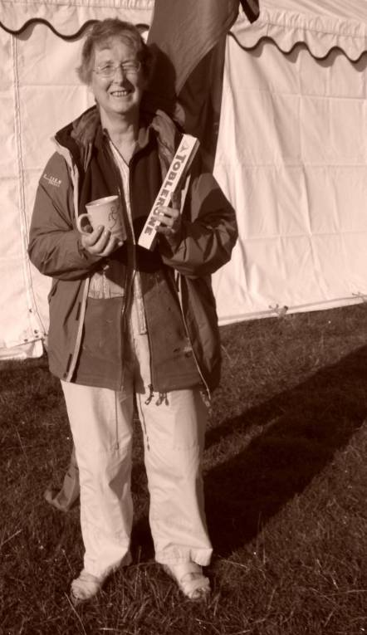
Congratulations to Nancy Powell Davies on winning the Super Veteran Women (W55+) in the Night Score Event, at the White Rose in August.

gratulations to the winners of the recent student challenge races – Lynn West presents the prizes.
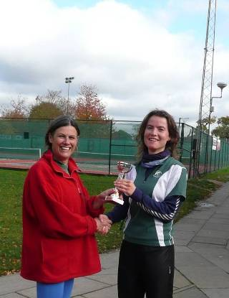
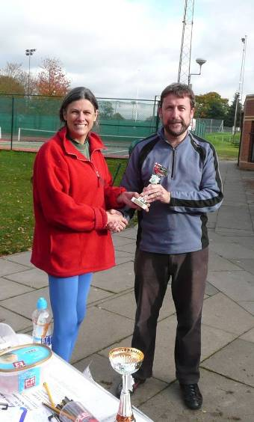
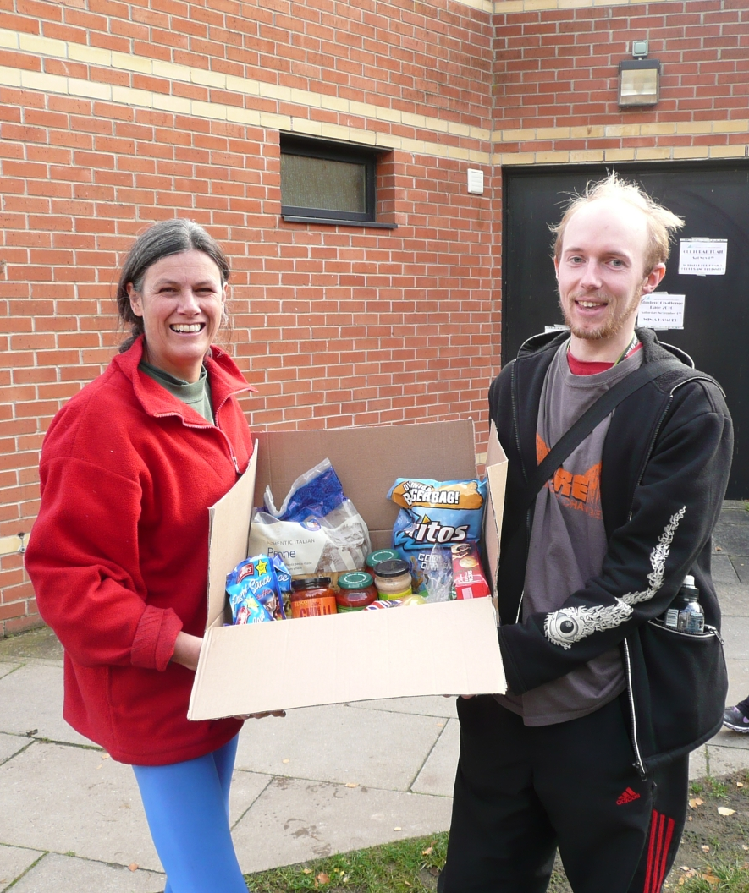

Fordham Special Event

Special event – Saturday Activity

Free event

Saturday 4th December @ Fordham
400 metres south of public car park (TL928286) on Ponders Road

Mini Event
Yellow and Green courses.
Planned by John & Jenny Collyer.

Register from 10 am, starts 10.30 – 11.30
Courses close at 13.00

Dress suitably for weather conditions.
Bring drink – all other resources supplied. Refreshments available.
No toilets. Help available.
Non-members welcome – bring a friend!!
Under 10 yrs must be accompanied by an adult

It helps with map numbers if you can let us
know you are coming but this is not essential

Contact me if you have any queries julie.laver@virgin.net

Please pass this on to anyone who might
be interested - especially non-club members!

