 | Essex Stragglers Orienteering Society (SOS) |   accredited

Newsletter Volume 21 No. 7

May 2011

Editors: Geraldine Russell and Rachel Barford- editors@stragglers.info
Club website - http://stragglers.info

Editorial - Rachel Barford 2
Chairman's Chat - John Collyer 2
Captain's Corner - Jenny Collyer 3
Schools League - Julie Laver 4
Writtle Forest Coaching - Richard Barker 6
Maes y Lade Outdoor Pursuit Centre - Derek Keeble 7
Photos taken at the JK Relays - Geraldine Russell 8
Big 5 O Week 10
Fixtures in East Anglia and Nearby Regions - Dave Skinner 11

  Essex Stragglers support the Woodland Trust and its objectives |   Essex Stragglers' development activities are supported by Awards For all

Editorial - Rachel Barford
Spring is well and truly upon us - as are the new growths of brambles and nettles! Hopefully everyone will survive more or less unscathed, with gaiters at the ready, for the events that are coming up. Julie Laver has been working hard to promote the club nights at Wivenhoe, which always promise a good get-together and a chance to practise skills. She has also put together two CATIs - in Chelmsford and in Colchester, before the main events at Hylands and Highwoods, to try and encourage new members.
For the more adventurous, enclosed in this newsletter are details of an event in South Africa in January 2012 - a great opportunity to orienteer in that beautiful country.
Don't forget that we always welcome contributions, including photos, from members sharing their experiences.

Chairman's Chat - John Collyer
With the lighter evenings (and some unseasonal warm, dry weather) there are increased opportunities for members to take part in local, informal events.
Writing this after returning home from the Saturday event at Castle Park where about 50 people took part in either a couple of easier courses within the park, or an Urban race of about 5K using adjacent streets, open spaces and paths, made me wonder why sometimes we get a very good turnout and at others bump along with just a handful.
Nancy Powell-Davies was planning her first event, ably supported by Julie Laver, and everyone said how much they enjoyed themselves.
These are the events which many members in their answers to my questionnaire of 12 months ago said they would be interested in. As part of that response I have been organising our first Summer Series and Andrew Cordle will be using his handicapped scoring system to provide a league for club members. We hope to see as many of you as possible at these events.
We shall be starting at Sudbury Meadows on May 19th. and have deliberately chosen Thursdays to fit in with the regular club training nights put on by Julie Laver and her team. These events alternate weekly with the SUFFOC series on Wednesdays. As a result of this (i.e. a chance to orienteer every week) Julie will be stopping the regular Thursday evenings at Essex University. These will return in the autumn and I would like to thank Julie and Emma in particular, for all their efforts over the past year.

Captain's Corner - Jenny Collyer
Four Stragglers teams competed in the JK Relays in Northern Ireland. The area was the same sand dune area we had used for the first classic race but this time a section of urban orienteering was added to the courses. The two veteran men's teams (combined ages of 165+) were in competition with each other - the team of Peter Warland, Dave Skinner and John Russell finishing nine minutes ahead of Colin West, Steve King and John Collyer. Praise must go to Ben Warland (M14) who did well running in place of his injured Mum on a very technical course.
By the time you read this we will have had the British relays. Seven teams are entered in this event near Sheffield on the 15th May. We are entering a combined women's open team with SUFFOC under the "Neighbouring Club Alliance" scheme.
The Harvester Relays are on the 16th/17th July in the Sheffield area and are combined with other events. (For details read Peter Warland's article in the February newsletter). We hope to enter teams combined with SUFFOC so please let Peter know if you would like a run (smwarland@aol.com).
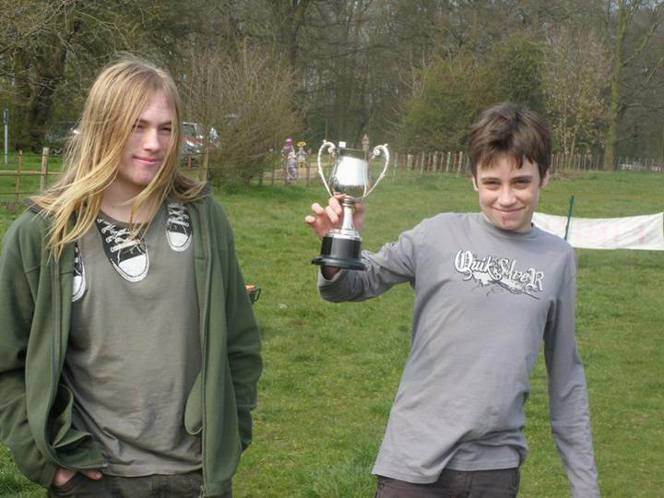
Nick Harrison won the Mark Johnson Trophy for Club Junior of the year for good results, regular participation, helping at events and setting a good example to other club juniors.
The cup was presented by Alex Ware, the Junior Club Captain.

Schools League - Julie Laver
With just one event left for the Essex and Suffolk Schools orienteering league the excitement is mounting. Your best five scores count towards your league total. Up to this season the league was for Juniors in the SOS and SUFFOC areas but new for this year we have included WAOC and HAVOC juniors and so we have some new names and faces at the events.
To be included in the league you do not have to enter through your school but please ensure your School and year are included on the registration form when you fill it in. No shadowing is allowed although junior pairs are. Please make it clear in your registration form if you are shadowing/being shadowed and also declare non-competitive second runs. Full details and comprehensive rules are available on the SOS website but I can deal with any enquiries or corrections - julie.laver@virgin.net or phone 01206 826152.
Results so far:
Up to Y 6 Boys | Up to Y 6 Girls
Matthew Clarke - Barnardiston Prep | Georgia Gower - St Andrews Halstead
Angus Dudley - Barnardiston Prep | Catherine Mole - Stonham Aspal
Callum Turner - St Andrew's | Saskia Baldrey - Barnardiston Prep
Y7/8 Boys | Y7/8 Girls
Timmy Harrison - Barnardiston Prep | Bronwen Mansel - Beyton Middle
Jack Gilbey - Barnardiston Prep | Jessica Woodgate - Barnardiston Prep
Kit Philips - Barnardiston Prep | Emma Clarke - Barnardiston Prep
Y9/10 Boys | Y9/10 Girls
Bryn Wilkinson - Copleston High | Rhiannon Ware - Colne Community
Roderick Mansel - County Upper | Rachael Harrison - The Perse
Nicholas Harrison - Debenham High | Miriam Norris
Y11/12/13 Boys | Y11/12/13 Girls
Jonathan Cronk - Hills Rd 6th form | Beth Albon
Alex Ware - Colchester 6th form | Steph Tucker
Thomas Louth - The Perse | Sarah Roach - St Marys

Team Trophy Places after 8 rounds -
1st - Barnardiston Preparatory School
2nd - St Andrews, Halstead
3rd - Kings College School, Cambridge
For full listings please go to ESSOL page on the SOS website http://stragglers.info/schools.
Well done to all who have taken part so far. There will be a medal and team trophy presentation at the last event at Highwoods, Colchester which is also the East Anglian School Champs so I hope to meet plenty of you there. Please ensure I have your correct name, School name and year before then.
Preliminary ESSOL fixtures for next season:
11 Sep 2011 | Danbury Park | SOS
02 Oct 2011 | Woodbridge | SUFFOC
09 Oct 2011 | The Broaks | SOS
30 Oct 2011 | Thorndon | HAVOC
29 Jan 2012 | Thetford | WAOC
26 Feb 2012 | Thetford | SUFFOC
18 Mar 2012 | Hockley | SOS
22 Apr 2012 | Epping | WAOC
13 May 2012 | Hylands | SOS
Please note these are preliminary fixtures and participants are advised to check Club websites before travelling –
http://stragglers.info
http://pdl.demon.co.uk/suffoc
http://www.orienteering-havoc.co.uk
http://www.waoc.org.uk

Writtle Forest Coaching - Richard Barker
Is this you?
- Been orienteering for many years but frustrated at still having problems with one leg of your course and losing a single big chunk of time?
- Not losing a lot of time on one leg but instead a minute here, thirty seconds there and two minutes somewhere else while you run or walk in ever-decreasing circles until you fall over the control kite?
- Came into the sport later in life and progressed rapidly to the longer courses to get the distance but at the expense of really getting to grips with some of the more technical aspects and building your 'technique tool box'?
- A good runner but frequently finding yourself lower down the results list than people whom you know are slower and less fit?
If any of the above sound familiar, or if you just want to practice your techniques in a friendly non-competitive environment, why not join us at a training session at Writtle Forest on Saturday 11th June.
I will be planning exercises focussing on some of the more advanced skills and specifically intended for adult orienteers. There will not be the same intensity of one-on-one instruction that I would normally give to younger orienteers but if anybody needs or wants more individual help, I am very happy to provide this. The general format will be that maps will be provided for a variety of exercises and at the beginning of the session I will briefly discuss the techniques you might use for each. You can then do whichever you want at whatever pace you wish. I, and other qualified coaches, will be available to help as and when required.
Additionally, it is intended that we will adjourn to a local hostelry for refreshment. This would be a good opportunity to bring along, for discussion, any maps of courses where you had particular difficulty or even bring maps where you were particularly pleased with your run so that you can share your experiences. Much can be learned from hearing how others choose to navigate in different types of terrain.
Whether you want to come to just the practical part or just the après-O, or both, you will be very welcome. Further details of times, meeting place etc. will be made available nearer the time but it would be helpful for planning purposes if you could give me (BarkerRichardC@gmail.com) an indication, without final commitment, of whether you might be interested in attending either or both parts.

Maes y Lade Outdoor Pursuit Centre - Derek Keeble
Aroused from my dormant memory recently was the fact that Essex County Council has, or had, an Outdoor Pursuit Centre situated by the highest treeline of Hay Forest on a western flank of the Black Mountains in Wales. Sometime in the early Eighties Jessie and I spent a weekend there making an O-map of the forest. Copies were left at the Centre for the use of visitors. The map reverse gave information about contacting the Stragglers when back in Essex.
All this was recalled when a 2011 visitor was telling me how she was helping her daughter prepare for a sponsored run. "I haven't done anything like it since I was her age orienteering at Maes y Lade", she exclaimed. Have any current or former Stragglers any recollections of enjoying, or otherwise, navigating the sylvan slopes of Hay Forest, or was it a waste of my bait? Please let me know via future copies of this newsletter.
Keep happy feet.

Photos taken at the JK Relays - Geraldine Russell
Fourteen SOS members went to the JK in Northern Ireland and most stayed on for the Irish Championships in Dublin the following weekend. Jenny Collyer won the Irish Championship but because she is English is not officially allowed to hold the title and John Russell won the Day 2 individual at the JK.
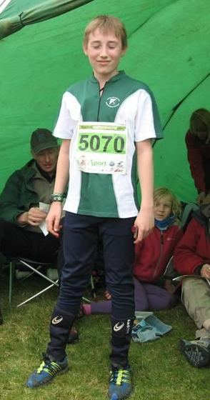 | 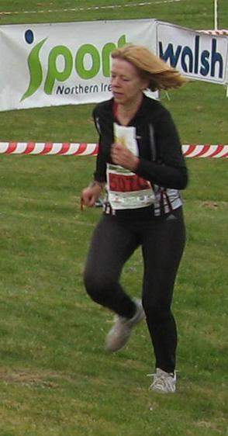
Ben Warland who ran a TD 4 (light Green) for the first time and Bridget King who excelled in her first JK relay.

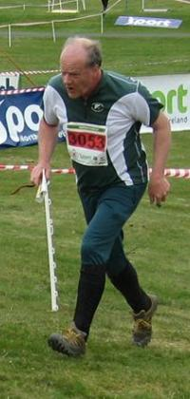 | 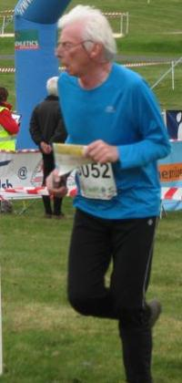 | 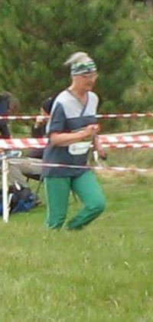
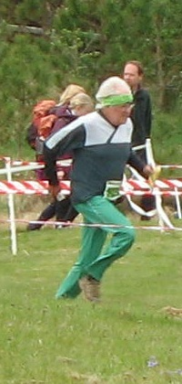 | 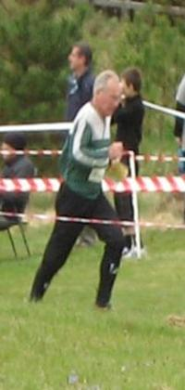 | 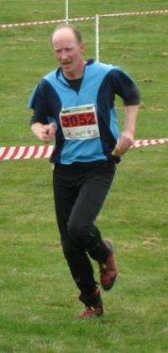
Colin West, Dave Skinner, Jenny Collyer, John Collyer, John Russell and Peter Warland on the run in to the finish at the JK relays.

Big 5 O Week
The South African Orienteering Federation is pleased to announce the Bi-annual Big 5 O Week. The Big 5 Orienteering Week will take place in South Africa from 4th-8th January 2012, The areas that will be used are all in Mpumulanga which is perfectly located for game viewing excursions before or after the events. The event will incorporate two World Ranking events that enable competitors to earn ranking points towards the world ranking list.
The event will take place in Mpumalanga at five separate venues. It will be a mixture of short fast races in Nelspruit and Dullstroom and longer more challenging courses in the forests of Belfast, Lydenburg and Sabie.
The event will be open to all competitors and we aim to combine high performance with grass roots Orienteering Development in Mpumalanga. Competitors will range in age from seven to seventy with a variety of courses to suit different skill levels. We anticipate that we will attract all top local Orienteers and several top European Orienteers, many of whom use the area for high altitude training in the South African summer. We will also attract recreational Orienteers who can combine the event with the magnificent attractions in Mpumalanga.
Date | Organising Club | Type | Town | Winning Time
4th January | Witsoc | Middle | Lakenvlei | 60
5th January | AR Club | Urban | Dullstroom | 25-30
6th January | ROC | Long WRE | Lydenburg | 75
7th January | RACO | Classic | Sabie | 90
8th January | ROC | Sprint WRE | Nelspruit | 20
For more information view the website at http://www.bigfive-o.co.za or contact Richard Lund at marketing@orienteering.co.za.

Fixtures in East Anglia and Nearby Regions - Dave Skinner
National Events which SOS members regularly attend are also included
The information provided below normally consists of Event Date, Region (eg EA = East Anglia), Event Grade, Event & Location Names and map reference. Organiser's contact details. Contact details, costs, closing date etc. for Pre-entry when provided. Whether Entry on the Day (EOD) is possible and the surcharge payable. The range of courses offered. The address of a website from which additional information can be obtained. Additional information in plain language.
At Essex Stragglers' events registration normally opens at 1000hrs, starts are from 1030hrs until 1230hrs and courses close at 1430hrs.
SOS Club Nights are not included - see SOS website for details.
May
19th | EAOA  SOS  Level D | SOS Summer Series 1 , Sudbury Meadows Sudbury , TL867417  Organiser: John Collyer, jcollyer48@btinternet.com, 01787 370947 Entry On Day: Senior £2.00, Junior £1.00, Student £1.00. , Punch Type: None, Start Times: 18.30-19.30 stragglers.info
22nd | EAOA  SOS  Level C | SOS Colour Code Event inc. EA School Championships and ESSOL , Highwoods Colchester , TM008282  Organiser: Edwin Banks, banksy.eddie@gmail.com, 01376 321658 Entry On Day: Senior £7.00, Junior £2.00, Student £2.00. , Punch Type: SI, Dogs: Dogs under control allowed on courses Start Times: 10.30-12.30 http://stragglers.info
25th | EAOA  SUFFOC  Level D | SUFFOC Summer Series ~ Event 1 , Brazier's Wood & Piper's Vale Ipswich , TM190410  Organiser: Simon Peck Entry On Day: Senior £2.00, Junior £1.00, Student £1.00. , Punch Type: None, Start Times: 18:30 to 19:30 www.suffoc.co.uk/events/summer11.htm
28th-30th | WMOA  HOC  Level B | 28th Springtime-in-Shropshire Weekend , Brampton Bryan Shropshire , SO355712  Organiser: Lesley Brown, 01694 724330 Entry On Day: Senior £TBC, Junior £TBC, Student £TBC. , Punch Type: None, http://www.harlequins.org.uk
 | WMOA | 29th Springtime-in-Shropshire Weekend , Mortimer Forest - High Vinnals Ludlow , SO474733  Organiser: Brian Morris Entry On Day: Senior £TBC, Junior £TBC, Student £TBC. , Punch Type: None, www.sins.org.uk
 | WMOA | 30th Springtime-in-Shropshire Weekend , Bringewood Ludlow , SO474733  Organiser: Mike Callow Entry On Day: Senior £TBC, Junior £TBC, Student £TBC. , Punch Type: None, www.sins.org.uk

June
2nd | EAOA  SOS  Level D | SOS Summer Series 2 , Admirals Park Chelmsford , TL694073  Organiser: Emma Johnson, 01245 442866 Entry On Day: Senior £2.00, Junior £1.00, Student £1.00. , Punch Type: None, Start Times: 18.30-19.30 stragglers.info
4th | SEOA  DFOK  Level D | DFOK NW Kent League , Foots Cray Meadows Bexley , TQ477717  Organiser: Mark Collins, markcollins444@hotmail.com Entry On Day: Senior £4.00, Junior £0.00, Student £0.00. , Punch Type: SI, Dogs allowed. Start Times: Mass start at 11:30am www.dfok.co.uk
5th | EAOA  SUFFOC  Level D | SUFFOC 'Come and Try it' Event , Hardwick Heath and surrounding Urban estate roads Bury St Edmunds , TL855628  Organiser: Philip Halford, phil.halford2@btinternet.com, 01638 717715 Entry On Day: Senior £4.00, Junior £2.00, Student £2.00. , Punch Type: SI, Dogs allowed. Start Times: Registration: 10:00 - 12:00Starts: 10:30 - 12:30 www.suffoc.co.uk
5th | EAOA  HAVOC  Level D | Thorndon North CATI , Thorndon North Country Park Brentwood  Entry On Day: Senior £TBC, Junior £TBC, Student £TBC. , Punch Type: None, orienteering-havoc.co.uk
8th | EAOA  SUFFOC  Level D | SUFFOC Summer Series ~ Event 2 , Broomhill & the Dales Ipswich , TM154459  Organiser: Simon Peck Entry On Day: Senior £2.00, Junior £1.00, Student £1.00. , Punch Type: None, Start Times: 18:30 to 19:30 www.suffoc.co.uk/events/summer11.htm
11th | EAOA  WAOC  Level D | WAOC Summer Series Event 1 , Milton Country Park Cambridge , TL476621  Organiser: Rakesh Chandraker Entry On Day: Senior £3.00, Junior £1.00, Student £1.00. , Punch Type: SI, Start Times: 1.30 to 2.30 www.waoc.org.uk
12th | EAOA  NOR  Level D | NOR Score plus Orange inc. NOR AGM , Whitlingham Country Park Norwich , TG244079  Organiser: Pat Bedder, alanb.noroc@btinternet.com, 01603 424589 Entry On Day: Senior £TBC, Junior £TBC, Student £TBC. , Punch Type: None, Dogs: On lead please Start Times: Registration from 10.15-10.55Orange starts 10.30 t0 11.00Mass srtart for Score Event at 11.00 www.norfolkoc.co.uk
16th | EAOA  SOS  Level D | SOS Summer Series 3 , Notley Country Park, Braintree, TL214734  Organiser: Edwin Banks, banksy.eddie@gmail.com, 01376 321658 Entry On Day: Senior £2.00, Junior £1.00, Student £1.00. , Punch Type: None, Start Times: 18.30-19.30 stragglers.info
18th | SEOA  DFOK  Level D | DFOK Kent Orienteering League , Trosley Country Park, Wrotham, TQ633610  Organiser: Sean Cronin, seancronin1001@hotmail.com Entry On Day: Senior £4.00, Junior £1.00, Student £1.00. , Punch Type: SI, Start Times: 11am to 12:30pm www.dfok.co.uk
19th | EAOA  HAVOC  Level D | Thorndon North CATI Follow up , Thorndon North Country Park Brentwood  Entry On Day: Senior £TBC, Junior £TBC, Student £TBC. , Punch Type: None, orienteering-havoc.co.uk
22nd | EAOA  SUFFOC  Level D | SUFFOC Summer Series ~ Event 3 , Eye Town Eye , TM145739  Organiser: Simon Peck Entry On Day: Senior £2.00, Junior £1.00, Student £1.00. , Punch Type: None, Start Times: 18:30 to 19:30 www.suffoc.co.uk/events/summer11.htm
26th | EAOA  WAOC  Level D | WAOC Summer Series Event 2 , Audley End Park Saffron Walden , TL531380  Organiser: John Marshall Entry On Day: Senior £3.00, Junior £1.00, Student £1.00. , Punch Type: SI, Start Times: 1.30pm to 2.30pm www.waoc.org.uk
30th | EAOA  SOS  Level D | SOS Summer Series 4 , Wivenhoe Woods Colchester , TM033247  Organiser: Colin West, colin@grovehillhouse.wanadoo.co.uk, 01206 322905 Entry On Day: Senior £2.00, Junior £1.00, Student £1.00. , Punch Type: None, Start Times: 18.30-19.30 stragglers.info
July
2nd | SEOA  DFOK  Level D | DFOK NW Kent League , Franks Park Bexley , TQ500787  Organiser: Chris Baker, chrisw.baker@ntlworld.com Entry On Day: Senior £4.00, Junior £0.00, Student £0.00. , Punch Type: SI, Dogs: Dogs on lead Start Times: Mass start at 11:30am www.dfok.co.uk
6th | EAOA  SUFFOC  Level D | SUFFOC Summer Series ~ Event 4 , Needham Lake Needham Market , TM097548  Organiser: Simon Peck Entry On Day: Senior £2.00, Junior £1.00, Student £1.00. , Punch Type: None, Start Times: 18:30 to 19:30 www.suffoc.co.uk/events/summer11.htm
9th | EAOA  WAOC  Level D | WAOC Summer Series Event 3 , Hinchingbrooke Country Park Huntingdon , TL221717  Organiser: Maurice Hemingway Entry On Day: Senior £3.00, Junior £1.00, Student £1.00. , Punch Type: SI, Start Times: 1.30pm to 2.30pm www.waoc.org.uk
10th | EAOA  SOS  Level C | SOS Relays , Wivenhoe Colchester , TM033247  Organiser: David Skinner, dave.skinner@btinternet.com, 01245 381266 Entry On Day: Senior £5.00, Junior £2.00, Student £2.00. , Punch Type: None, No dogs allowed. Start Times: Start times for teams pre-advised http://stragglers.info
14th | EAOA  SOS  Level D | SOS Summer Series 5 , Hilly Fields Colchester , TL985255  Organiser: John Williams, jcw351@hotmail.com, 01245 351583 Entry On Day: Senior £2.00, Junior £1.00, Student £1.00. , Punch Type: None, Start Times: 18.30-19.30 stragglers.info
20th | EAOA  SUFFOC  Level D | SUFFOC Summer Series ~ Event 5 , Finborough Park & Woods Stowmarket , TM016578  Organiser: Simon Peck Entry On Day: Senior £2.00, Junior £1.00, Student £1.00. , Punch Type: None, Start Times: 18:30 to 19:30 www.suffoc.co.uk/events/summer11.htm
23rd | EAOA  HAVOC  Level D | Hadleigh Country Park HAVOC v CHIG , Hadleigh Country Park Hadleigh  Entry On Day: Senior £TBC, Junior £TBC, Student £TBC. , Punch Type: None, orienteering-havoc.co.uk
23rd | EAOA  WAOC  Level D | WAOC Summer Series Event 4 , Ampthill Park Ampthill , TL023382  Organiser: Dil Wetherill Entry On Day: Senior £3.00, Junior £1.00, Student £1.00. , Punch Type: SI, Dogs: Dogs welcome if kept on a lead. Start Times: 1.30pm to 2.30pm www.waoc.org.uk
24th | SEOA  DFOK  Level D | DFOK Frolics , tbc tbc  Entry On Day: Senior £TBC, Junior £TBC, Student £TBC. , Punch Type: None,
28th | SEOA  SAX  Level D | SAX Summer Thursday Evening Series , Cranbrook School tbc  Entry On Day: Senior £TBC, Junior £TBC, Student £TBC. , Punch Type: None, www.saxons-oc.org
31st-6th | SOA  Level B | Scottish 6 Days 31st Scottish 6 Days - 2011 - Day 1 , Dunollie & Ganavan Oban , NM865325  Organiser: Louise Longhurst Entry On Day: Senior £TBC, Junior £TBC, Student £TBC. , Punch Type: SI, Dogs: Only in car park and assembly, on lead at all times www.scottish6days.com/2011/
 | SOA | 1st Scottish 6 Days - 2011 - Day 2 , Ardnaskie Near Oban , NM964333  Organiser: Richard Oxlade Entry On Day: Senior £TBC, Junior £TBC, Student £TBC. , Punch Type: SI, Dogs: Only in car park and assembly, on lead at all times www.scottish6days.com/2011/
 | SOA | 2nd Scottish 6 Days - 2011 - Day 3 , Creag Mhic Chailein Near Oban , NM930310  Organiser: Margaret Dalgleish Entry On Day: Senior £TBC, Junior £TBC, Student £TBC. , Punch Type: SI, Dogs: Only in car park and assembly, on lead at all times www.scottish6days.com/2011/
 | SOA | 3rd Scottish 6 Days - 2011 - Rest Day , Fearnoch Forest Near Oban , NM965310  Organiser: Andrew Dale Entry On Day: Senior £TBC, Junior £TBC, Student £TBC. , Punch Type: None, www.scottish6days.com/2011/
 | SOA | 4th Scottish 6 Days - 2011 - Day 4 , Torinturk Near Oban , NM916278  Organiser: David Eades Entry On Day: Senior £TBC, Junior £TBC, Student £TBC. , Punch Type: SI, Dogs: Only in car park and assembly, on lead at all times www.scottish6days.com/2011/
 | SOA | 5th Scottish 6 Days - 2011 Day 5 , Lochnell & Shenavillie Near Oban , NM890402  Organiser: Rhona Fraser Entry On Day: Senior £TBC, Junior £TBC, Student £TBC. , Punch Type: SI, Dogs: Only in car park and assembly, on lead at all times www.scottish6days.com/2011/
 | SOA | 6th Scottish 6 Days - 2011 - Day 6 , Ardchattan Near Oban , NM969364  Organiser: Jonathan Musgrave Entry On Day: Senior £TBC, Junior £TBC, Student £TBC. , Punch Type: SI, Dogs: Only in car park and assembly, on lead at all times www.scottish6days.com/2011/

August
11th | SEOA  SAX  Level D | SAX Summer Thursday Evening Series , Mote Park tbc  Entry On Day: Senior £TBC, Junior £TBC, Student £TBC. , Punch Type: None, www.saxons-oc.org
13th | EAOA  WAOC  Level D | WAOC Summer Series Event 5 , Fairlands Valley, Stevenage Stevenage , TL255238  Organiser: Ian Lawson Entry On Day: Senior £3.00, Junior £1.00, Student £1.00. , Punch Type: SI, Dogs: Dogs welcome if kept on a lead. Start Times: 1.30pm to 2.30pm www.waoc.org.uk
20th | EAOA  WAOC  Level D | WAOC Summer Series Event 6 , Wimpole Hall Cambridge , TL343511  Organiser: Peter Allen Entry On Day: Senior £3.00, Junior £1.00, Student £1.00. , Punch Type: SI, Start Times: 1.30pm to 2.30pm www.waoc.org.uk
25th | SEOA  SAX  Level D | SAX Summer Thursday Evening Series , Manor Park CP tbc  Entry On Day: Senior £TBC, Junior £TBC, Student £TBC. , Punch Type: None, www.saxons-oc.org
26th | YHOA  EBOR  Level D | White Rose Sprint Race , Harwood Dale Scarborough , SE989967  Organiser: Bill Griffiths, wr2011org@gmail.com, 07710002961 Entry On Day: Senior £TBC, Junior £TBC, Student £TBC. , Punch Type: None, www.eborienteers.org.uk
27th-29th | YHOA  EBOR  Level B | White Rose Weekend 27th White Rose Day 1 Classic Ditance Race , Stony Marl Moor and Pye Rigg Scarborough , SE989967  Organiser: Mike Ridealgh Online entry through www.whiteroseweekend.org.uk Entry On Day: Senior £15.00, Junior £6.50, Student £6.50. , Punch Type: SI, Dogs: On lead and only in assembly area Start Times: 10.00 to 14.00 www.whiteroseweekend.org.uk
 | YHOA | 28th White Rose Day 2 Classic Distance Race , Harwood Dale Forest Scarborough , SE989967  Organiser: Mike Ridealgh Online entry through www.whiteroseweekend.org.uk Entry On Day: Senior £15.00, Junior £6.50, Student £6.50. , Punch Type: SI, Dogs: On lead and only in assembly area Start Times: 10.00 to 14.00 www.whiteroseweekend.org.uk
 | YHOA | 29th White Rose Team Score Race , Harwood Dale Forest Scarborough , SE989967  Organiser: Bill Griffiths, wr2011org@gmail.com, 0771 000 2961 Online entry through www.whiteroseweekend.org.uk No Entry On Day. Entries Close: 22/08/2011. Senior £TBC, Junior £TBC, Student £TBC , Punch Type: SI, Dogs: On lead and only in assembly area Start Times: 10.00 to 11.00 www.whiteroseweekend.org.uk
27th | SEOA  GO  Level B | GO Guildford Urban , Guildford Guildford , TQ995495  Organiser: Linda Pakuls Entry On Day: Senior £TBC, Junior £TBC, Student £TBC. , Punch Type: None, www.guildfordorienteers.co.uk
27th | YHOA  EBOR  Level D | White Rose Hill Race , Harwood Dale Scarborough , SE989967  Organiser: Bill Griffiths, wr2011org@gmail.com, 07710002961 Entry On Day: Senior £TBC, Junior £TBC, Student £TBC. , Punch Type: None, www.eborienteers.org.uk
27th | YHOA  EBOR  Level D | White Rose Night Score , Harwood Dale Scarborough , SE920980  Organiser: Bill Griffiths, wr2011org@gmail.com, 07710002961 Entry On Day: Senior £TBC, Junior £TBC, Student £TBC. , Punch Type: None, www.eborienteers.org.uk
28th | SEOA  GO  Level D | GO Guildford Long-O , tba Guildford  Entry On Day: Senior £TBC, Junior £TBC, Student £TBC. , Punch Type: None, www.guildfordorienteers.co.uk

NEXT SOS Newsletter

Copy to the Editors - editors@stragglers.info please.

