 | Essex Stragglers Orienteering Society (SOS) |   accredited

Newsletter Volume 21 No. 9

December 2011

Editors: Geraldine Russell and Rachel Barford- editors@stragglers.info
Club website - http://stragglers.info

Editorial - Rachel Barford 2
Notes from the Chair - John Collyer 2
Captain's Corner - Jenny Collyer 3
CompassSport Cup 2012 3
JK Relays 3
The British Relay Championships 4
An email from Slovenia 4
Mark Johnson Trophy 5
News from the British Schools Orienteering Championships 2011 6
Sunday, Sunday - John Collyer 10
Diamond Wood - a note from Jack Isbester 11
Forest Challenge! 12
Pods Wood - a dream come true 13
Mike Powell Davies Trophy 15
ESSOL - Julie Laver 16
Fixtures - David Skinner 17

  Essex Stragglers support the Woodland Trust and its objectives |   Essex Stragglers' development activities are supported by Awards For all

Editorial - Rachel Barford
Thank you for the contributions this month; some most amusing verses from John, which go some way to explaining the orienteer's views on why weekends are not all slippers and rest. Thanks as always to Jack for providing a lot of very interesting material for the Newsletter
I also received an email from a Slovenian orienteering club, who have an event planned, if anyone fancies a trip to this beautiful country.

Notes from the Chair - John Collyer
Through orienteering Jenny and I have met many people, who we have got to know well and who have made important contributions to the club. I am sure that there are many others who will appear in the future, but it is always sad to say goodbye to members who have done so much for us over the years.
The Robertson family fall into this category; they have decided to relocate back to the West Country, which is a family base for both Julia and Steve. Any rumours that Steve has retired are, according to Julia, untrue! Nicola and Susie have gone their separate ways for some time, and with Thomas now at University, it seems the right time for them to make the move.
We will miss their hospitality at Moatfields and their efforts to keep the club moving forward. Both have had many roles within the club, Julia in organising events, looking after the equipment and as social secretary, whilst Steve has planned and controlled many times as well as being fixtures secretary.
On behalf of the club, I would like to wish them well in their new club (Quantock Orienteers) and I am sure we will be bumping into them at various events. Both have shoes we will find hard to fill.

Captain's Corner - Jenny Collyer jcollyer48@btinternet.com

CompassSport Cup 2012
The East Anglian round is at Thetford Warren, Thetford on the 19th February. The courses are Colour Coded from orange upwards covering the age classes as follows:
1. | Brown | Men's Open
2. | Blue Women | Women's Open
3. | Blue Men | M45+ M20+
4. | Green Women | W45+ W20+
5. | Green Men | M60+
6. | Short Green Veterans | M75+ W60+
7A. | Light Green Men | M18-
7B. | Light Green Women | W18-
8A. | Orange Men | M14-
8B. | Orange Women | W14-
Every competitor receives a score based on their finishing position and the total of the best 13 scores gives the club score. Last year we were beaten by two points and the previous year by just one point - so we are due to win this year!
This is a very popular event with our club members and always a great team event. Last year we entered over 60 members in this event which was held near Dorking in Surrey. With it on our doorstep this time maybe we can beat that.
The entry fee (subsidised by the club) is £5 seniors and £2 juniors. (Students in full time education can claim up to £50 travel expenses).
Please let me know if you would like to be entered.

JK Relays
These take place at Newtyle near Coupar Angus, Scotland on 9th April.
The JK is an excellent four days of orienteering over the Easter weekend. There is a sprint race in Livingston on the Friday followed by two individual events in very technical areas on the Saturday and Sunday. The relay area is a mixture of deciduous and coniferous woodland and open hillside.
As last year I will do the bulk of our relay entries by the first (cheaper) closing date of the 26th February. If you let me know before then that you would like a run the entry fee (subsidised by the club) is £8 seniors and £3 juniors. (After that the "late entry" supplement will be added).

The British Relay Championships
These are on the 6th May in the Lake District (following the Individual Championships on the 5th). The entry fee will be as for the JK above but I have no entry information yet.
Please let me know if you would like to be entered in any/all of these events or contact me if you would like any further information.

An email from Slovenia
Dear O- friends,
Please note that in 2012 there will be again some exciting orienteering events organized in Slovenian karst terrain.
Lipica Open - the popular season opener with a 2 day warm up event and training camps on request; 10.- 11. March, Lipica. And of course the OOcup, Slovenian 5 day event, 1.- 5. August, Postojna.
As you might already know OOcup offers some specialties - like the Ultimate classes (M21U, W21U, M35U and M35U), which are run on maps without paths.
Ultimate challenge for ultimate fun! In 2012 we will also for the first time organize TrailO. Postojna is easily accessible by public transport and if you opt for the shuttle bus, you don't need your car at all.
Lipica Open: www.lipicaopen.com
OOcup: www.oocup.com
Slovenia is small and compact and extremely diverse, which makes it a great holiday destination. Alps, Adriatic coast, Karst (with hundreds of caves), Panonian plane, old cities and of course the endless forests.... that is Slovenia :)!
Thanks for your attention and see you next season!
OOcup team

Mark Johnson Trophy
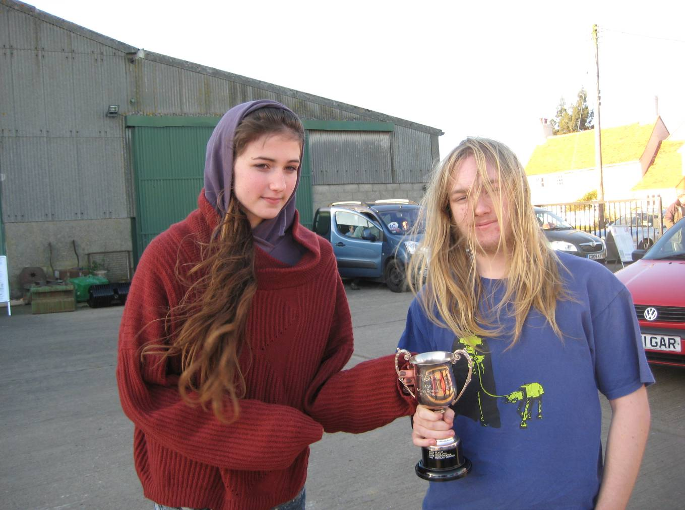
Rhiannon Ware receives the Mark Johnson Trophy for most improved club junior of the year in recognition of her personal progress and in representing the club and region in junior activities.

News from the British Schools Orienteering Championships 2011
The pupils of St Andrews Primary School and The Ramsey College, Halstead have been training hard at orienteering club, and set off to travel to Scotland for this year's Schools Orienteering Championships.
The boys Y5 team came 3rd as did the whole school team in the Primary class. The individual results are as follows -
Girls Y6 - 35 starters |  |  | Boys Y5 - 33 starters
11 |  | Chloe Cracknell | 2 | Jack Edwards
12 |  | Lily Amos | 15 | Dominic Emmerson
 |  |  | 16 | Joshua Buist
 |  |  | 23 | Luke Harrington
 |  |  | Boys Y6 - 26 starters
 |  |  | 20 | Benjamin Harrington
Girls Y7 - 39 starters |  |  | Boys Y7 - 65 starters
16 |  | Georgia Gower | 20 | Callum Turner
17 |  | Lucy Edwards
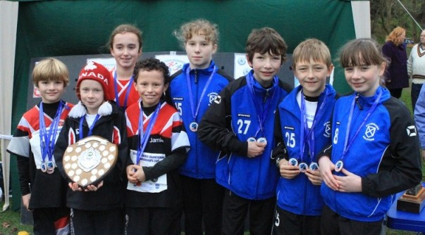
Some of the Halstead pupils with their medals
St Andrews Primary boys and girls both won their classes for the British Schools Score competition at Beaulieu Estate, 08/10/2011 with the individual results as follows -
 | Y5 girls |  | Y5 boys
 | 6/10 | Elena Gower & Madeline Press | 2/23 | Joshua Buist
 |  |  | 6/23 | Jack Edwards & Luke Harrington
 |  |  | 0/23 | Dominic Emmerson
 | Y6 girls |  | Y6 boys
 | 1/14 | Olivia Baldwin | 3/20 | Jonathan Quinn
 | 4/14 | Daisy Partridge | 9/20 | Benjamin Harrington
 | 7/14 | Lily Amos & Amelia Juniper
 | 8/14 | Chloe Cracknell
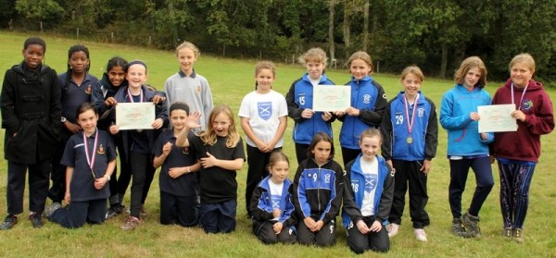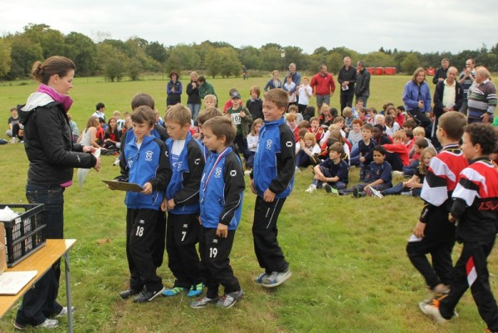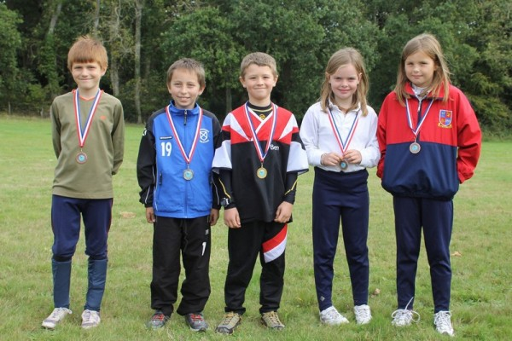
The Ramsey College students came 4th out of 7 in the lower secondary school category which was really good considering their numbers.
Y7 girls |  | Y7 boys
2/16 | Georgia Gower | 20/22 | Lewis Crow
11/16 | Lucy Edwards

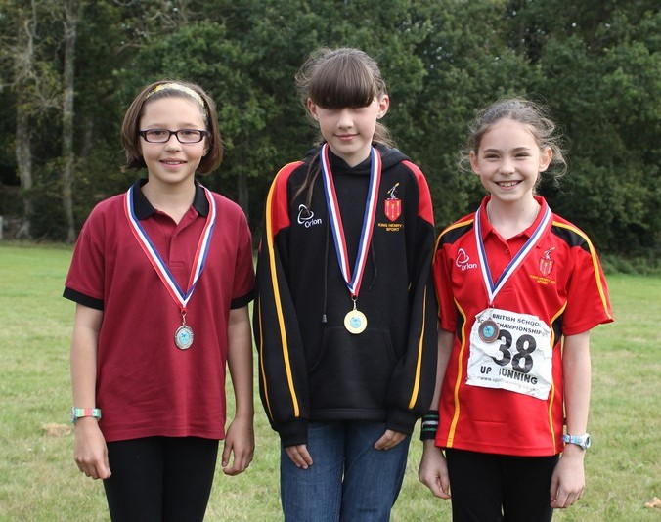
Nancy and Julie who have been coaching the club this term are really pleased with the pupils. They have been training well every Monday and it is really paying off. They have done a mixture of exercises including score and point to point courses around the grounds of both schools which is a linked site. The have also had a go at planning their own courses. Well done to all.

Sunday, Sunday - John Collyer
Sunday's the day we're all mugs for this game,
No lounge with papers, no roast for our lunch;
Early to rise, but today who'll we blame?
Talking through runs with the usual bunch.
Short Green, or Green, will it be Blue?
Decision to make, pay entry dues;
Compass in hand, lacing up shoes,
Dibber on finger, last trip to the loo.
Clearing and checking at start, dib the chip,
Recording controls on arboreal trip;
Wait in course box, each a minute apart,
Pick up map, then run to the start.
Check direction, around trees duck and weave,
Count off the rides, look at contours, believe;
You're on right route, safe, sure, secure,
Ignore other runners, they'll falsely allure.
Nearer control, slow, eyes open wide,
Look for feature where flag should reside,
What's best way round to thicket west side?
Red and white seen, check number beside.
A beep and a flash then out to the ride,
Check next leg, what will you decide?
Clean route through woods to navigate,
Or will it be missed, and then relocate?
On round the course, all legs to complete,
Nettles sting thighs, stones hard on feet;
Dib at finish, results go and seek,
Good, bad, indifferent? See you next week.

Diamond Wood - a note from Jack Isbester
Orienteers love trees - the majestic beeches of Epping Forest, the sturdy oaks of Baddow Ridge, the conifers of King's Forest or the lonely rowans of mid Wales. Whether met as a copse or a forest, a thicket or a landscape dotted with isolated trees they are the raw material of the fascinating sport of orienteering and life would be much less fun without them. Trees provide shade to keep us cool in summer and shelter us from the icy blast in winter. We love trees but we British have been cutting them down for the last thousand years and now England is one of the most treeless countries of Europe.
The Woodland Trust is a charity which is trying in the long term to double the wooded area of Britain by buying land and planting native species of trees. In recent years volunteers from the ranks of Essex Stragglers have helped with the planting of thousands of trees at the new Woodland Trust site at Fordham, near Colchester where, fifteen years from now, Stragglers can expect to be navigating their way amongst mature trees to reach that elusive Control 11.
Now, in preparation for the Queen’s Diamond Jubilee, the Woodland Trust is trying to raise £3.3m to buy Diamond Wood a 460 acre site within The National Forest where they plan to plant 300,000 trees, creating the largest continuous woodland under single ownership in the National Forest in North West Leicestershire. There is no need for the general public to raise the entire £3.3m - the Woodland Trust has access to various funds by way of partnerships with commercial organisations and government funds but some must be triggered or matched by donations from the public, so your contributions are needed. The endeavour deserves the support of orienteers.
For more information about the site or to make a donation please visit
jubileewoods.org.uk/diamond appeal
Then click on 'About Jubilee woods' and then 'Our flagship wood'

Forest Challenge!

The orienteering board game for 2-6 players
Available now. Ideal for:
- Christmas and birthday presents;
- club evenings;
- prizes for winners of club events;
- teaching youngsters about orienteering and letting them have fun at the same time.
"We had such fun that we immediately had another game ... We've already got plans to put one of our favourite areas onto the hexagons" "I think it's a brilliant game - the kids love it."
- The game includes everything you need to "step over the line" - laminated map, kites, punch cards, "Control" cards, "Advantage" cards, instructions, dice, tokens etc;
- Design a different course each time you play by using the moveable control stickers;
- The map sections can be fitted together in different combinations for more variety;
- Choose score or line orienteering;
- Add even more variety by drawing your favourite terrain on the blank map grids supplied.
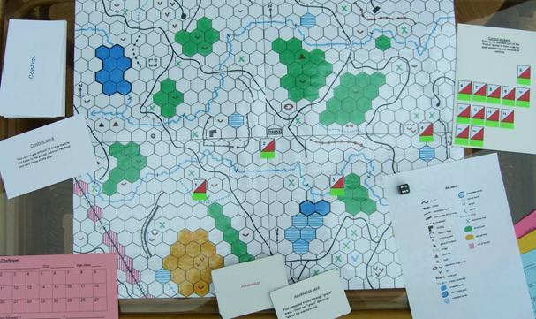
You can buy your copy for £7.50 through the post (please add £1.50 for postage, cheques payable to NGOC) from Alan Brown, 10 Brizen Lane, Cheltenham, GL53 0NG. All profits to the Woodland Trust. Email legend@ngoc.org.uk for further information.

Pods Wood - a dream come true

Jack Isbester provides the background
I first orienteered while on a two year secondment to Anglesey in 1971. When I returned to Tiptree in 1973 and joined the reconstituted Stragglers with Derek and Jesse Keeble and Bill and Pauline Stephens I looked for likely orienteering venues in the neighbourhood. Pods Wood looked a good possibility but when I explored I found that it contained an extensive plantation of young conifers - it would be best to wait a few years until they matured.
By 1987 the wood was well developed but that was the year of the Great Storm which wreaked havoc on Baddow Ridge and also flattened the conifers in Pods Wood. Happily the Forestry Commission chose to replant the wood with deciduous trees and, by 2005 it began again to look fit for orienteering!
By then I was SOS Fixtures Secretary and I nursed the ambition to link Pods, Coneyfield and the nearby Layer Woods for what, in those days, we called a Badge Event. I applied to the Forestry Commission for the necessary permissions, only to be given an unexpected and disappointing response. They owned Layer Wood and we could use it, but Pods and Coneyfield Woods were held on a 250 year lease commenced in the 1960s which specified 'no recreational use'.
We did use Layer Wood for an event in 2007 or thereabouts and I didn't give up on Pods Wood. I was able to speak to the Agents for the owners of the woods who said that they could see no problem with orienteering in their woods. With this information I returned to the Forestry Commission who said they were fearful of complaints arising from our use of the woods but, when pressed, admitted that they had never known of any problems arising from use by SOS of Broaks or Chalkney over many years.
In a final throw of the dice I told the Forestry Commission ranger that I was aged 75 and my ambition was to orienteer in Pods Wood before I died! He agreed to one event, with any return to be conditional on no complaints being received. Sadly by then the conifers occupying much of Layer Wood had been felled rendering it unusable for the time being.
Even then a final problem remained. Mark Lyne had found a 'set aside' field between Pods and Layer Woods for parking when we orienteered in Layer Wood but, unexpectedly, that field was no longer available - scheduled to be ploughed a few weeks before our event. We were very close to our final possibility when Park House Farm agreed to provide parking for us amongst the farm buildings.
In the competition area we were following in the footsteps of Roman Britons and their Icenian foes. The impressive Rampart earthworks are from Roman times as is the substantial Mound in the NW corner of Conyfield Wood. It is comforting to think that almost 2,000 years ago some Roman or Icenian in the same area might have been even more distressed than I was when searching for Control 18 on the Green course!

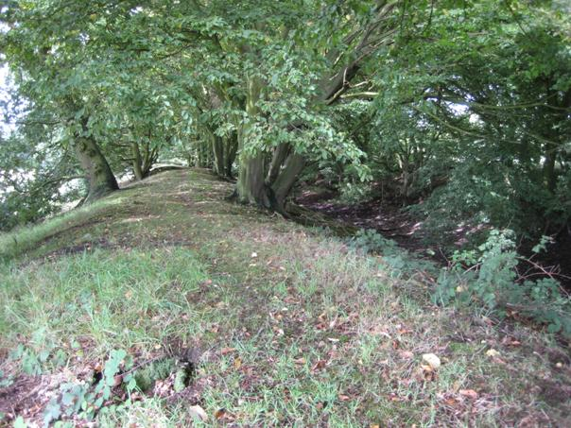
Pod's Wood - the Rampart (Photo: Jack Isbester)
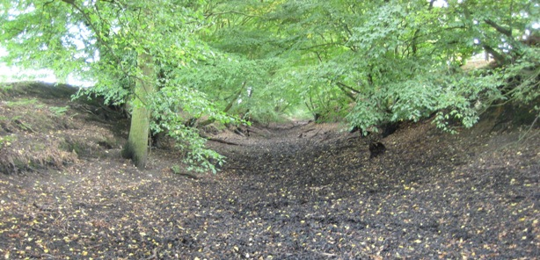
Pod's Wood - The Trench (Photo: Jack Isbester)

Mike Powell Davies Trophy
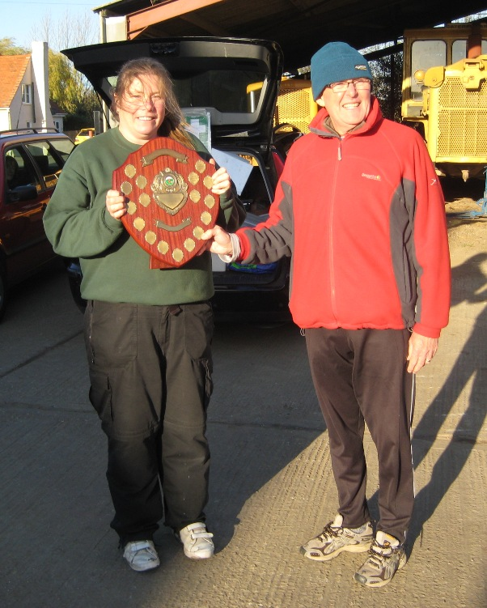
Julie Laver receives the Mike Powell Davies Trophy for Club Member of the Year in recognition of all her hard work as Chairman of the Development Sub-committee, running Club Nights and all the general training activities she is involved in.

ESSOL - Julie Laver
We have already had 6 events for this seasons Essex and Suffolk Schools Orienteering League. The results so far are as follows. The best five scores count towards your league total.
Up to Y6 Boys |  |  |  | Up to Y6 Girls
1st | Matthew Clarke | Barnardiston Prep | 1st | Daisy Partridge | St Andrews, Halstead
2nd | Joshua Buist | St Andrews, Halstead | 2nd | Chloe Cracknell | St Andrews, Halstead
3rd | Jack Edwards | St Andrews, Halstead | 3rd | Lily Amos | St Andrews, Halstead
Y7/8 Boys |  |  |  | Y7/8 Girls
1st | Kieran Palmer | CRGS | 1st | Bronwen Mansel | Beyton Middle
2nd | Callum Turner | The Ramsey College | 2nd | Georgia Gower | The Ramsey College
3rd | Nick Butler | Barnardiston Prep | 3rd | Lucy Edwards | The Ramsey College
Y9/10 Boys |  |  |  | Y9/10 Girls
1st | Bryn Wilkinson | Copleston High | 1st | Rachael Harrison | The Perse
2nd | Roderick Mansel | County Upper
3rd | Andrew Stemp | Impington College
Y11/12/13 Boys |  |  |  | Y11/12/13 Girls
1st | Alex Ware | Colchester 6th form | 1st | Rhiannon Ware | Colne Community
2nd | Sam Bolam | St Helena | 2nd | Elena Lumby | CRGS
 |  |  | 3rd | Beth Albon | Saffron Walden CHS
Whole Team Trophy Places after 6 rounds
1st - St Andrews, Halstead
2nd - Barnardiston Preparatory School
3rd - The Ramsey College
Well done to all of the above!
For full listings please go to ESSOL page on the SOS website http://stragglers.info/schools/index.php.
If you know any schools which might be interested in the League I would be happy to send further details.
To be included in the League you do not have to enter through your school but please ensure your school and year are included on the registration form when you fill it in. No shadowing is allowed, although junior pairs are.
Full details and comprehensive rules are available on the SOS website http://stragglers.info/schools/index.php but I can deal with any enquiries or corrections. julie.laver@virgin.net or phone 01206 826152.
Preliminary ESSOL fixtures for the remainder of this season
26th February | Thetford | SUFFOC
18th March | Hockley | SOS
22nd April | Thorndon North | HAVOC
13th May | Hylands | SOS
Please note these are preliminary fixtures and participants are advised to check Club websites before travelling
http://stragglers.info
http://www.suffoc.co.uk
http://www.waoc.org.uk
http://www.orienteering-havoc.co.uk

Fixtures - David Skinner
Fixtures in East Anglia and Nearby Regions - National Events which SOS members regularly attend are also included
The information provided below normally consists of Event Date, Region(eg EA = East Anglia), Event Grade , Event & Location Names and map reference. Organiser's contact details. Contact details, costs, closing date etc. for Pre-entry when provided. Whether Entry on the Day (EOD) is possible and the surcharge payable. The range of courses offered. The address of a website from which additional information can be obtained. Additional information in plain language.
At Essex Stragglers' events registration normally opens at 1000hrs, starts are from 1030hrs until 1230hrs and courses close at 1430hrs.
SOS Club Nights are not included - see SOS website for details.
2011
December
10th | SOS  EAOA  Activity | SOS Family Coaching & Night O Tiptree Heath  stragglers.info
11th | SAX  SEOA  Level C | SAX Sunday series, Sevenoaks  Organiser: Sarah Howes , sarahmhowes@hotmail.co.uk , 01892-723327  www.saxons-oc.org
15th | SAX  SEOA  Level D | Sax KNC, Maidstone south, Maidstone  www.saxons-oc.org
18th | MV  SEOA  Level C | MV South East Families and Veterans Champs, Ranmore, Dorking, TQ135504  Dogs: Under control.  Organiser: Tony Burton  www.mvoc.org
18th | TVOC  SCOA  Level C | TVOC Regional Event &SCOA League, Wendover Woods, Wendover, Bucks, SP891098  Entry times: 10:00-12:00. Dogs: On leads in car park and woods.  Organiser: Paul Greenough , paul-greenough@supanet.com , 01494 674766  tvoc.org.uk
26th | HH  SEOA  Level C | HH Boxing Day Score, Trent Park, Enfield, TQ281983  Entry times: Registration: from 10 am to 10:45 am. Starts: 11 am mass start. Dogs: under control.  Organiser: Penny Parkes , trent-park-26-12-11@happyherts.org.uk  www.happyherts.org.uk/
2012
January
1st | SOS  EAOA  Level D | New Year Novelty, TBA  stragglers.info
2nd | NOR  EAOA  Level D | Informal Score Event, Horsford Heath, Norwich, TG184176  Entry times: 10.15 to 11.00 for orange course. Dogs: Dogs preferred on lead.  Organiser: Pat Bedder , 01603 424589
8th | HAVOC  EAOA  Level C | Langdon Hills SWELL Event, Langdon Hills Country Park, Basildon, TQ681865  Dogs: To be kept under control.  Organiser: Colin Jackson , treasurer@orienteering-havoc.co.uk  orienteering-havoc.co.uk
12th | SAX  SEOA  Level D | Sax KNC, Canterbury urban, Canterbury  www.saxons-oc.org
14th | DFOK  SEOA  Level D | DFOK Kent Orienteering League, Limpsfield Chart, Westerham  Organiser: Philip Basford , philb@ntrg.u-net.com  www.dfok.co.uk
15th | NOR  EAOA  Level C | NOR Colour Coded and EA Championships, Lynford, Thetford  Entry times: 10.00 to 12.00 hours. Dogs: Dogs on lead.
22nd | HH  SEOA  Level C | HH Ace of Herts Regional Event, Northaw Great Wood, Cuffley, TL 299 037  Entry times: Start times from 10.30 to 12.30. Courses close at 14.30. Dogs: Permitted in the car park (on a lead) and on the route to start and finish. Not on courses as they cross the land of multiple owners not all with permission for dogs.  Organiser: Jacob Sharpe , northaw-22-01-12@happyherts.org.uk , 01223 426599  www.happyherts.org
26th | CHIG  SEOA  Level D | North London Street Events, TBC, Stratford, TQ354834  Organiser: Josh Jenner  www.chig.org.uk
February
2nd | SAX  SEOA  Level D | Sax KNC, Sevenoaks and Riverhead, Sevenoaks  www.saxons-oc.org
5th | SOS  EAOA  Level C | SOS Colour Coded Event incorporating EA League, Baddow Ridge, Danbury  stragglers.info
11th | CHIG  SEOA  Level D | Local, Schools League and SWELL, Claybury, Chigwell  www.chig.org.uk
12th | NOR  EAOA  Level C | NOR Colour coded, Kelling, Sheringham
19th | EAOA  Level B | EAOA CompassSport Cup & Trophy Heat, Thetford Warren, Thetford  Organiser: Barbara Fothergill , publicity@orienteering-havoc.co.uk
23rd | HH  SEOA  Level D | HH North London Street League, tbc, tbc  www.happyherts.org.uk/
25th | SARUM  SWOA  Level A | British Night Championships, Hamptworth, Salisbury, SU228167  Entry times: Pre- entry only via Fabian4. Dogs: Only allowed in CP & Registration areas. Not allowed on courses.  Organiser: Mary Nixon , mary_david_nixon@yahoo.co.uk , 01794 516298  www.sarumo.org.uk
26th | SUFFOC  EAOA  Level C | West Harling Colour Code Event, inc. ESSOL, West Harling , Thetford, TL968836  Entry times: Starts : 10:30 to 12:30 - Registration from 10:00. Dogs: Dogs welcome but must be kept under control.  Organiser: Philip Halford , phil.halford2@btinternet.com , 01638-717715  www.suffoc.co.uk
March
4th | SMOC  EAOA  Level C | SMOC Regional Event, Holcote and Reynolds Wood, Brogborough, SP969393  Organiser: Ros James , ros.james@btinternet.com  www.smoc.info
10th | WAOC  EAOA  Level D | WAOC Wimpole Hall Colour Coded, Wimpole Hall, Cambridge, TL343511  Entry times: Registration 10.00 to 12.00. Starts 10.30 to 12.30. Dogs: Dogs are allowed but they must be kept on a lead at all times as there are cattle and sheep in Wimpole Park .  www.waoc.org.uk
11th | NOR  EAOA  Level C | NOR Colour Coded, Bilney, King's Lynn  www.norfolkoc.co.uk
18th | SOS  EAOA  Level D | Hockley Woods Colour Coded inc. ESSOL, Hockley Woods, Hockley  stragglers.info
22nd | SAX  SEOA  Level D | Sax KNC, Millbank, Sevenoaks  www.saxons-oc.org
24th | EBOR  YHOA  Level A | British Sprint Orienteering Championships, York University, York, SE620504  No dogs allowed.  Organiser: Keith MacDermott , 01904 761120  www.york2012orienteering.org.uk
25th | EBOR  YHOA  Level A | British Middle Distance Orienteering Championships, Srensall Common, York  No dogs allowed.  Organiser: Mike Ridealgh , 01904 761120  www.york2012orienteering.org.uk

