A SPORT FOR ALL
Orienteering is not just an enjoyable way for all ages and abilities to keep fit and enjoy the countryside, it also helps develop a number of life skills such as problem solving, navigation and self-confidence.
Orienteering is a sport involving navigating between control points marked on a specially prepared map. The challenge is in deciding on the best route in the quickest time.
It does not matter how young, old or fit you are. You can run, walk or jog – you decide your own pace.
You are able to start orienteering at a level which suits you and progress at your own rate.
Orienteering is a great sport to take up with friends and family, allowing you to share your adventures afterwards.
COME AND JOIN US!
Essex Stragglers Orienteering Society (SOS) are holding a series of fun, family friendly, informal events in the Colchester area this summer.
Why not bring your whole family for some fun at any or all of these events?
Saturday April 21st
Tiptree Heath
10:30am-1:00pm
Saturday May 12th
Lower Castle Park
10:30am -3:00pm
Sunday June 17th Highwoods Country Park
From Sports Centre car park
10:30am -1:00pm
Saturday July 15th
Wivenhoe Park
University car park, Wivenhoe end
10:30am -3:00pm

Courses:
Free String (For toddlers upwards)
White (Very easy – for youngsters on their own)
Yellow (Easy – for youngsters and groups)
Orange (Suitable for adult beginners and family groups)

Cost:
£2 adult
£1 junior/student/unemployed
£4 family

Plenty of help on hand for newcomers.
To start, all you need is a sense of adventure, a pair of trainers and outdoor clothes – so what’s stopping you?
More details from - http://www.stragglers.info
Lyn West 01206-322905 lyn@stragglers.info
HAVING A GOOD TIME!
Get the whole family active and enjoy yourselves in the great outdoors.

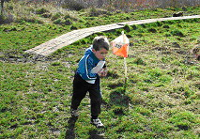

It's fun, active, challenging, exciting and exhilarating!

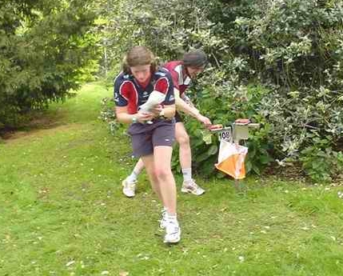
JOIN THE CLUB!
Essex Stragglers Orienteering Society was formed in 1968 and centres its activities in North East Essex - our membership extends from Chelmsford to Colchester and Sudbury to Southend.
Membership costs from £10 for adults or £15 for Families. Membership for individual juniors under 19 or full time students is free.
Joining the club has a number of benefits:
- Free newsletter
- Free membership of East Anglian Orienteering Association
- Coaching sessions
- Family membership entitles children to free entry at Club events
Details can be obtained from the Membership Secretary -
01206-322905
membership@stragglers.info

ORIENTEERING
A Sport for all the Family

It’s more adventurous than any computer game
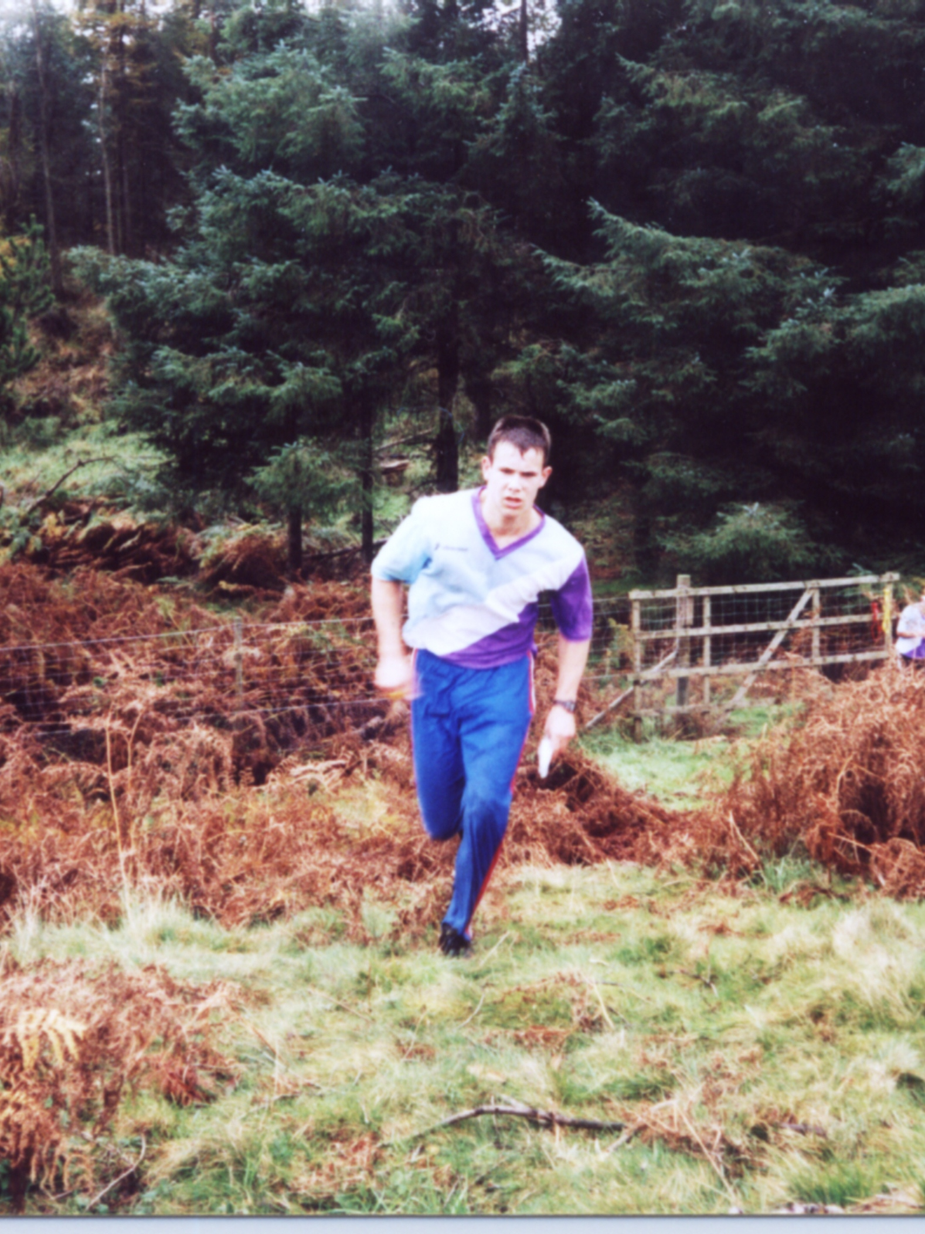
and more exciting than the TV!

http://www.stragglers.info

